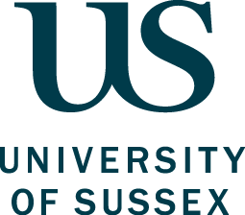

US Financial Aid Federal Direct Loan Distance Learning Declaration

Federal regulations stipulate that foreign institutions cannot provide financial aid for degrees where the entire degree or part of the degree is offered through distance learning. The degree you have selected is eligible for financial aid as students registered on the degree do not have the option, at any point in their studies, to apply for the distance learning mode of study.

By signing this form, you are declaring that you agree to and have understood the following statement:

I am a postgraduate research student applying for USA financial aid. I understand that I am not eligible to apply for the distance learning mode of study during my PhD degree at the University of Sussex.

Name:
University of Sussex ID No:
Social Security Number:
Signature:
Date:

Return this completed form via email, signed, and dated, scanned PDF copy to usfinancialaid@sussex.ac.uk

