INFONETICA ETHICS RM

PART A. APPLYING FOR SPONSORSHIP

PART B. APPLYING TO MODIFY A SPONSORED STUDY

GUIDE FOR APPLICANTS


Contents
Part A. Applying for sponsorship 3
1. Creating a Sponsorship Application Form 3
2. Completing the Sponsorship Application Form 4
3. Signing and submitting your application 6
4. Review of your application 7
5. Viewing reviewer comments 8
6. Responding to reviewer comments 9
7. Re-submission of your application form 9
8. Approval of your application 10
Part B: Applying to modify a sponsored study 10
1. Generating a Sponsorship Modification Form 10
2. Completing the Sponsorship Modification Form 11
3. Signing and submitting your application 12
4. Review of your application 12
5. Approval of your application 13
Additional information 13

Part A. Applying for sponsorship

Creating a Sponsorship Application Form

Access the Infonetica Ethics RM system at https://apply.ethics.sussex.ac.uk/.

You will be diverted to the Okta login page to log on to the site. Use your University of Sussex username and password.

On the landing page, click ‘Create/manage applications’.
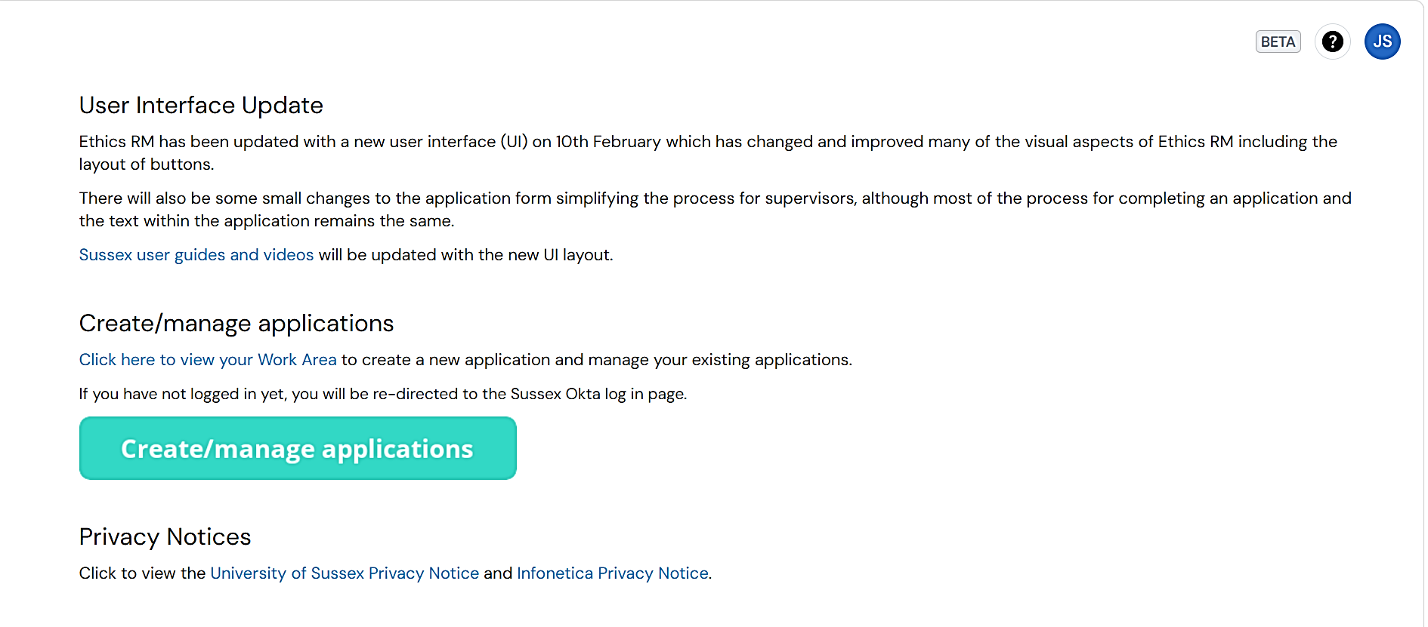

You will be taken to your Work Area where you will see a list of the projects you have created (and those that may have been shared with you), and various Action Buttons across the middle of the page.

To start your application, click ‘Create Project’ (the left-hand action button).
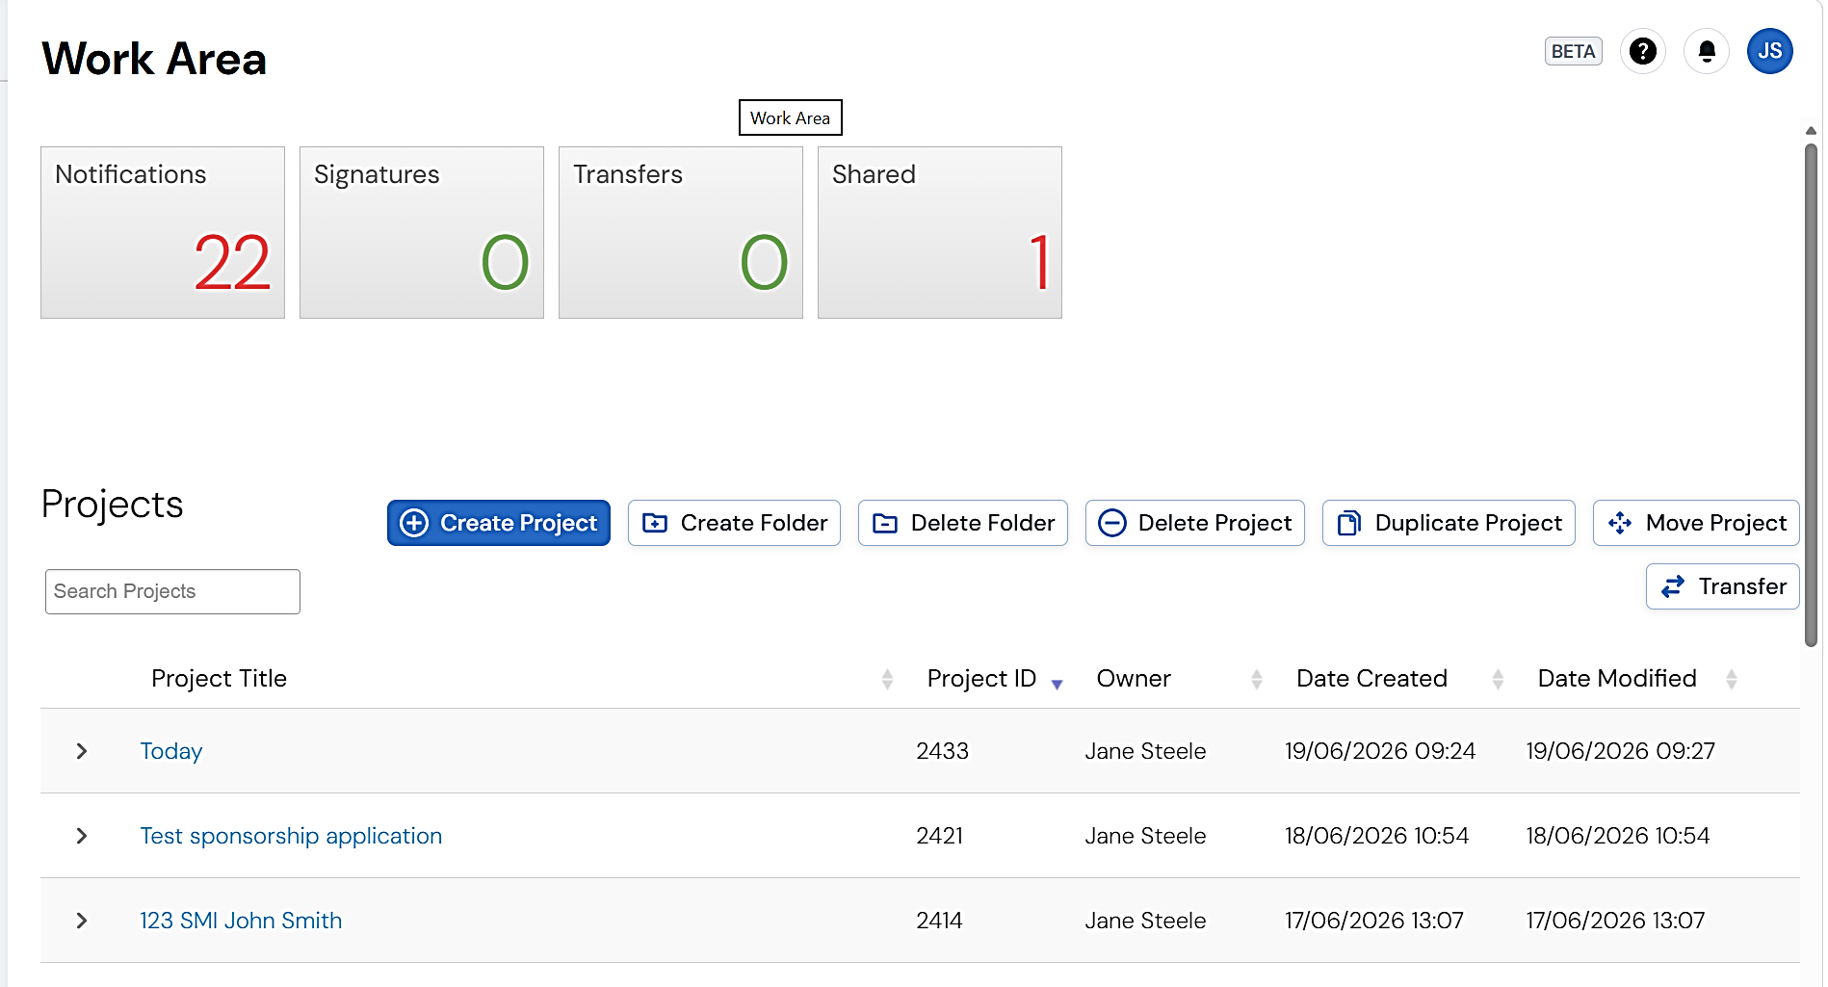

On the pop-up, enter the Project Title using the format “Sponsor Reference” “Chief Investigator” e.g., 135 BLO Joe Bloggs.

If you do not know your sponsor reference, please contact the sponsorship team at researchsponsorship@sussex.ac.uk.

Select ‘Sponsorship Application Form’ from the dropdown.

Check the box to confirm you are happy to share the application with the sponsor team.

Click ‘Create'.
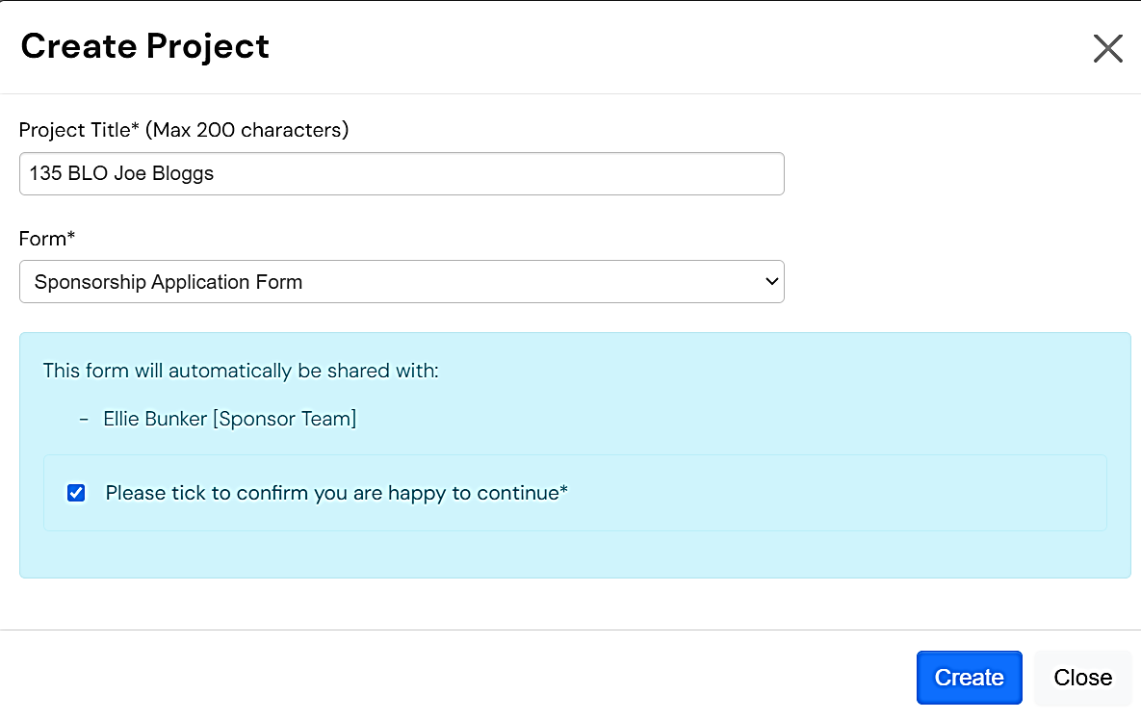

Completing the Sponsorship Application Form

Questions are grouped within sections. Some sections (and questions within the sections) will be dependent on answers to previous questions.
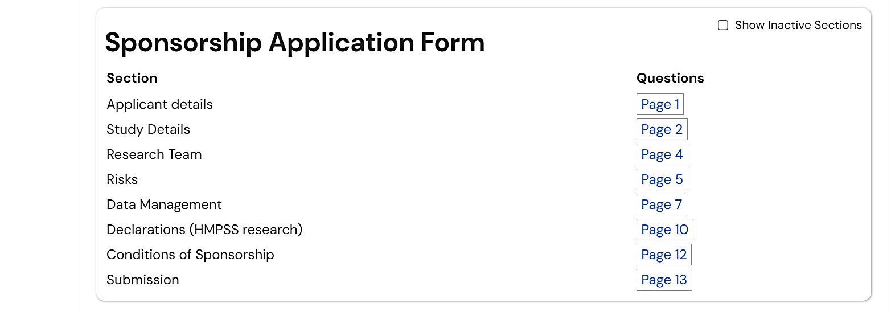

Navigate to different sections by either:
- Clicking on the corresponding page numbers.
- Using the ‘Navigate’ action button.
- Using the ‘Next’ and ’Previous’ buttons at the bottom of each page.

As you complete the questions, you will be asked to upload the various documents that support your application.

When you reach the Conditions of Sponsorship, the Chief Investigator must check the confirmation boxes.
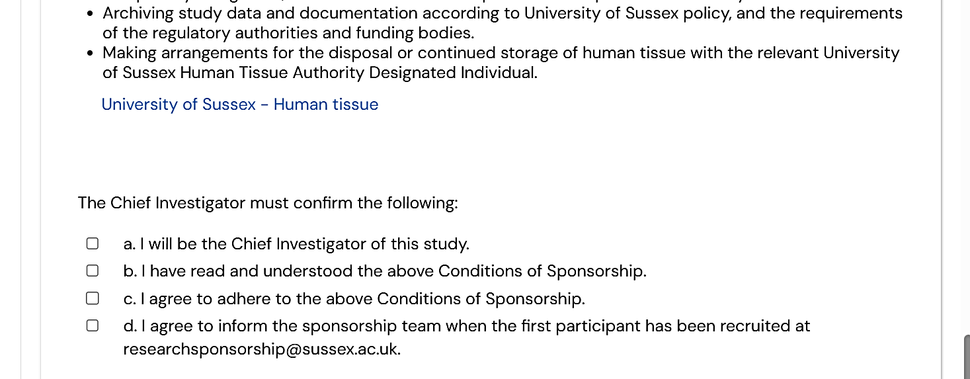

When you reach the Declarations section:
- Check all boxes.
- Select ’This is the first submission’ from the dropdown at the bottom.
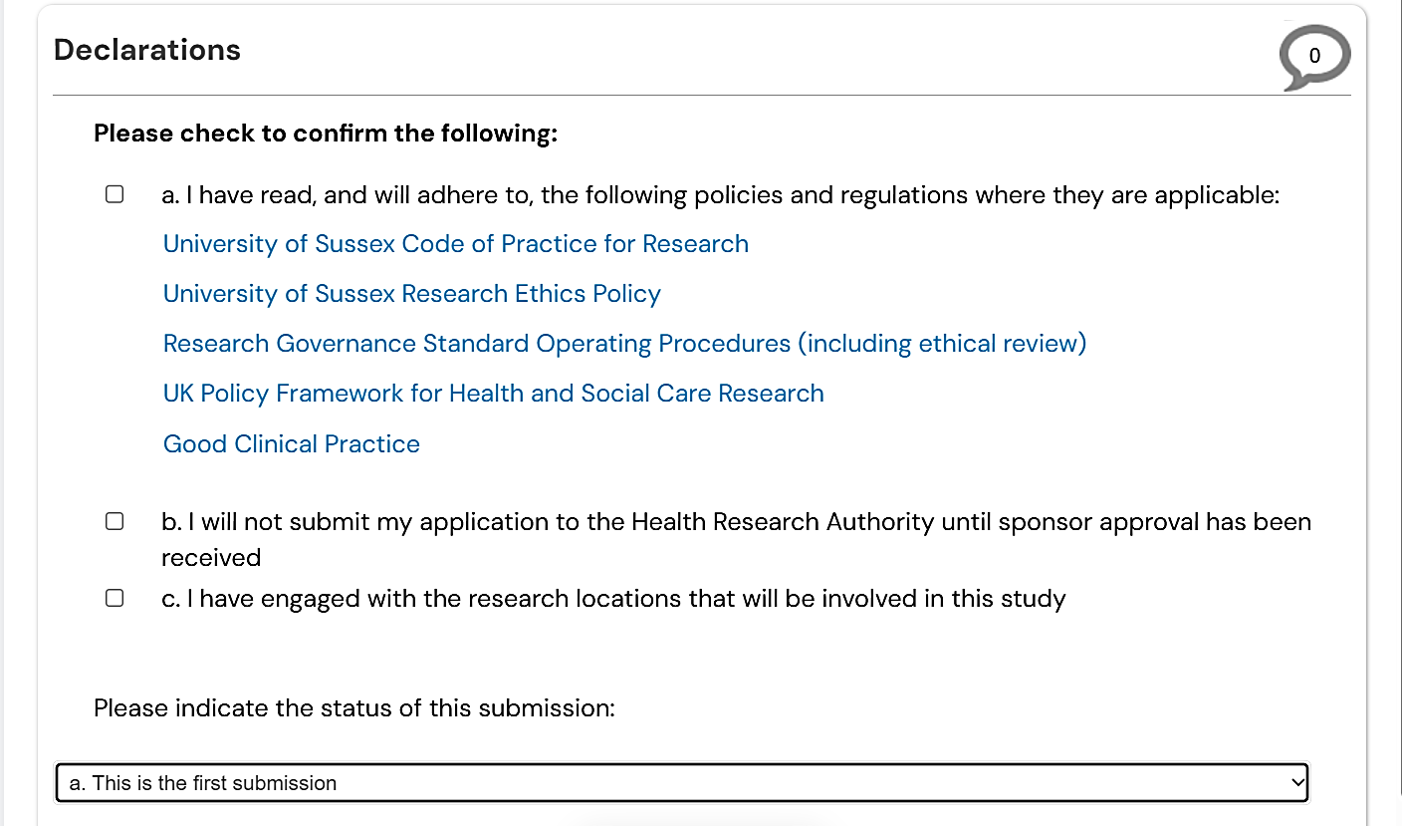

Signing and submitting your application

When you are ready to submit your application, navigate to the Submission section.

You are asked to indicate whether the study is a post-graduate student project using the radio buttons.

If the answer to this is ‘No’:
- Enter your name.
- Click ‘Sign’.
- The application will be submitted automatically when you sign the form.
- You will receive email confirmation of a successful submission.
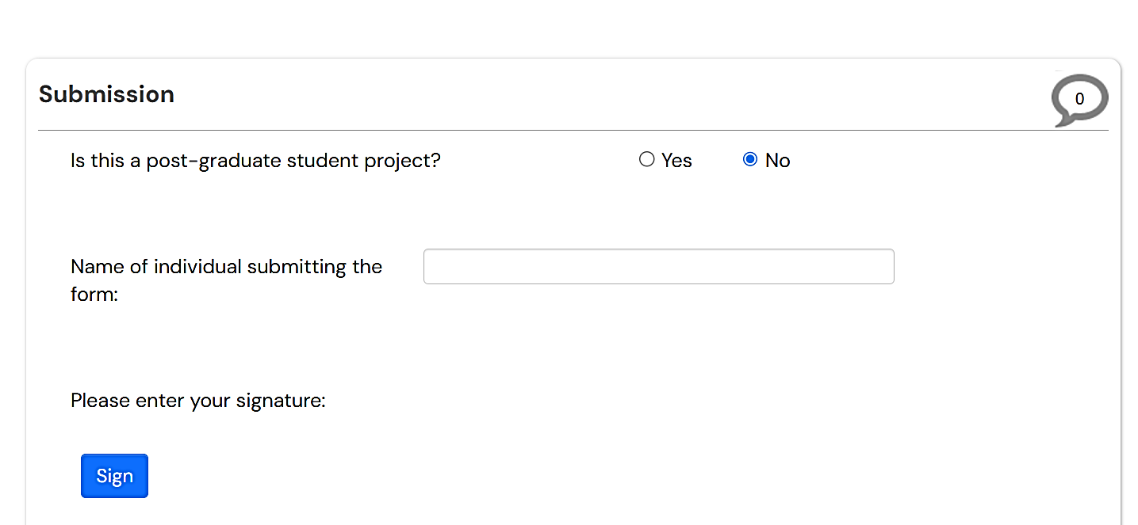

If the answer is ‘Yes’:
- You will need to request a signature from your lead academic supervisor BEFORE you sign the form yourself.
- Enter their name and click ‘Request Signature’.
- On the pop-up, enter their email address (and a message if required) and click ‘Request’.
- Once your supervisor has signed the form, return to the Submission section, enter your own name and click ‘Sign’.
- The application will be submitted automatically when you sign the form.
- You will receive email confirmation of a successful submission.
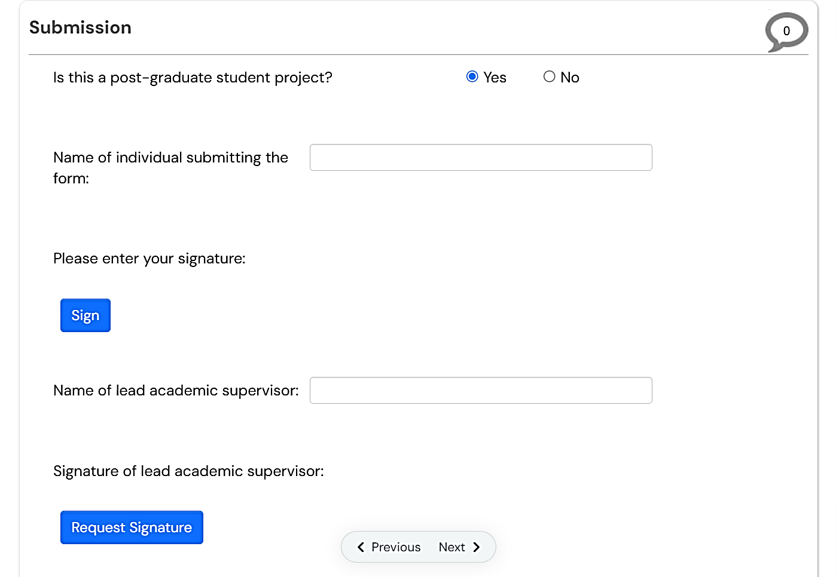

Review of your application

Your application will go through various stages of review:
- Following submission, it will be screened by a member of the sponsorship team.
- It will then be reviewed by the Health and Social Care Sponsorship Sub-Committee.
- Following this, it is likely to undergo a further proportionate review before approval is issued.

Reviewers will add comments to your application form.

You will receive an email asking you to address the comments. This is termed a ‘Change Request’.

Attached to the email will be a tabulated version of all reviewer comments.

Log back into Infonetica Ethics RM, view the comments (see Step 5), and make any requested changes (see Step 6).

Note that you are likely to receive more than one Change Request during the review process.
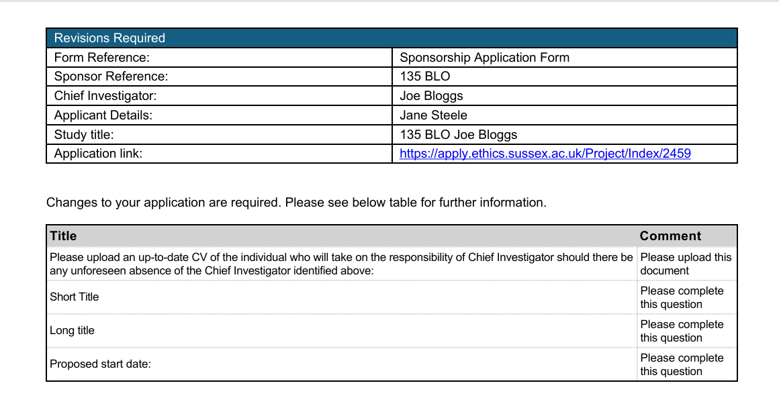

Viewing reviewer comments

Comments can be viewed from the Overview panel on the right-hand side of your screen.

Note that the Overview tab is collapsible so you may need to click on ‘Overview’ to open the tab.

Click the small blue arrow against Reviewers Comments.
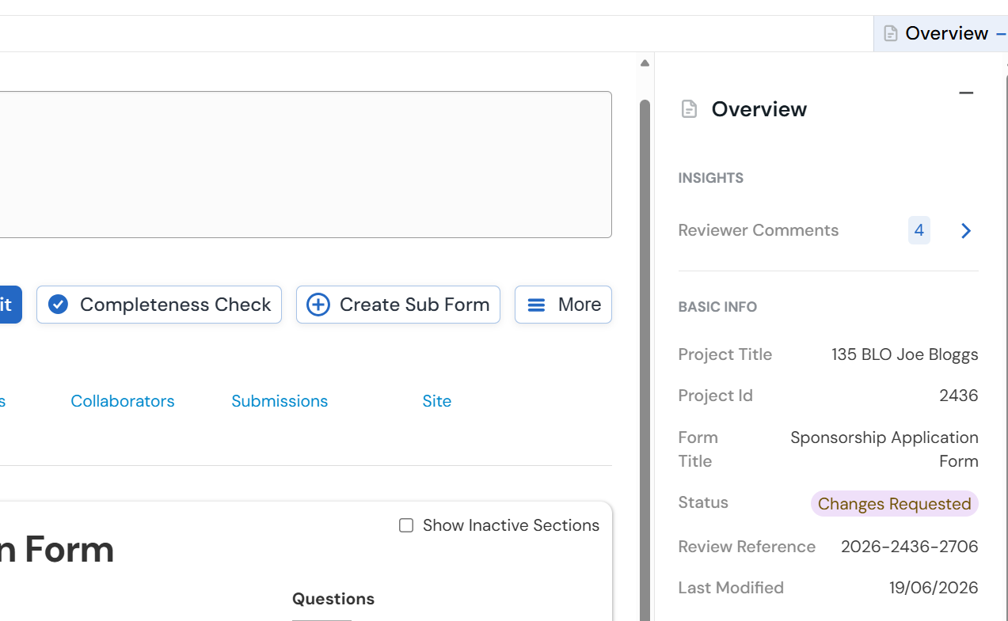

A pop-up listing of all comments will appear.

Click onto an individual comment to be taken directly to that question in your application.
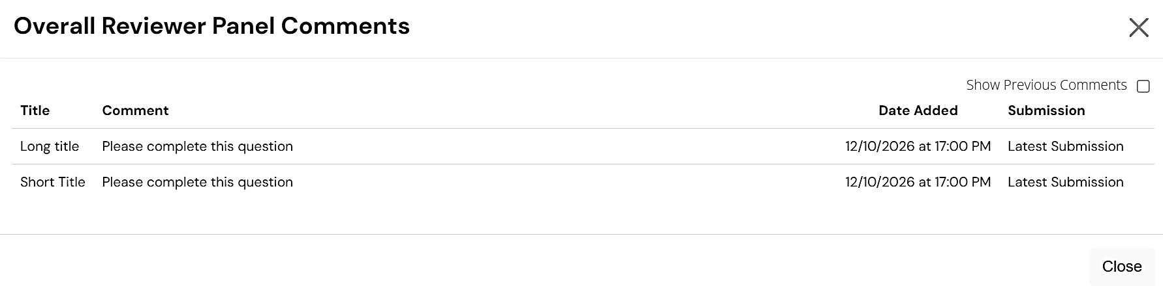

The question you need to address will be highlighted by a red box.
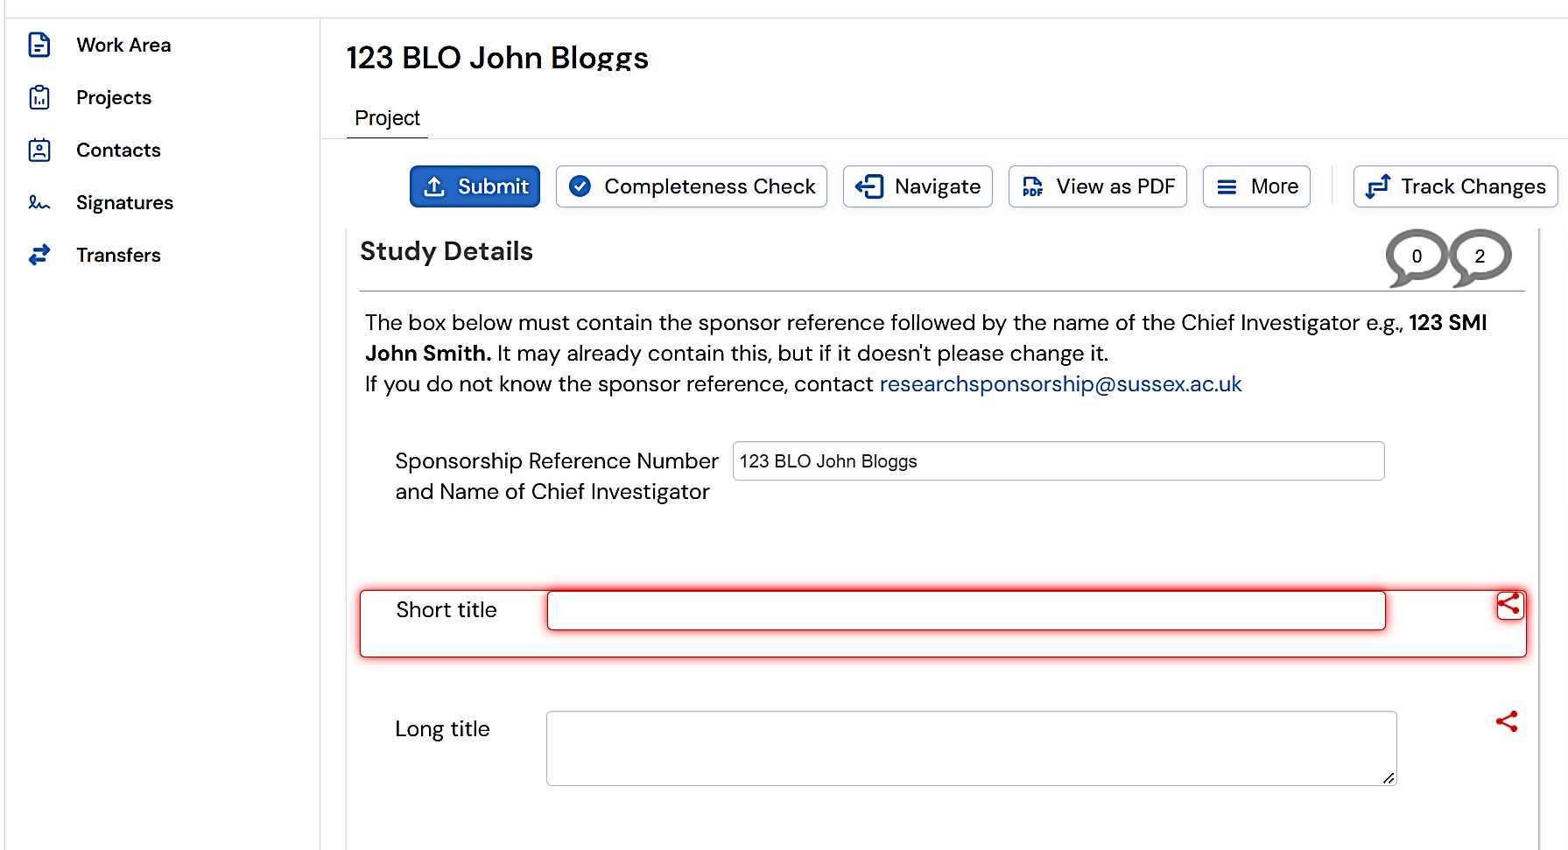

Responding to reviewer comments

Respond to reviewer comments by updating text (or changing selected radio buttons etc.) on the application form.

If you need to make changes to attached documents, you should upload a revised document (both clean and tracked change versions) with an updated version number and date.

Reviewers will be able to see where you have made changes to the form and updated documents after you re-submit the form.

Re-submission of your application form

When you are ready to re-submit the form, navigate to the Declarations section.

From the dropdown at the bottom of the page select ‘This is a re-submission following changes requested by the sponsor’.
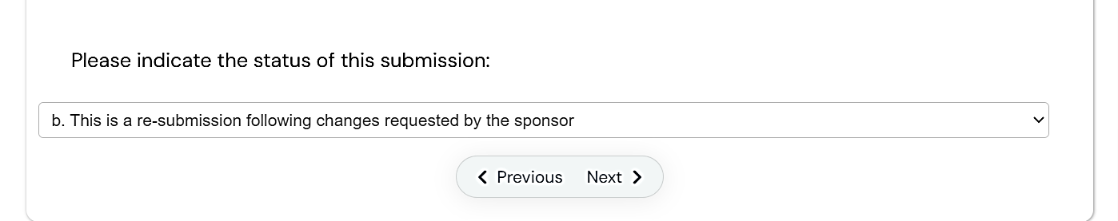

Navigate to the Submission section.

Follow Step 3 above.

Approval of your application

Once the reviewers agree that all comments and changes have been sufficiently addressed, your application will be approved.

You will receive an email confirming approval with the Sponsor Approval Letter attached.

Part B: Applying to modify a sponsored study

Generating a Sponsorship Modification Form

From your Work Area select the project you wish to modify.

Click ‘Create Sub Form’.
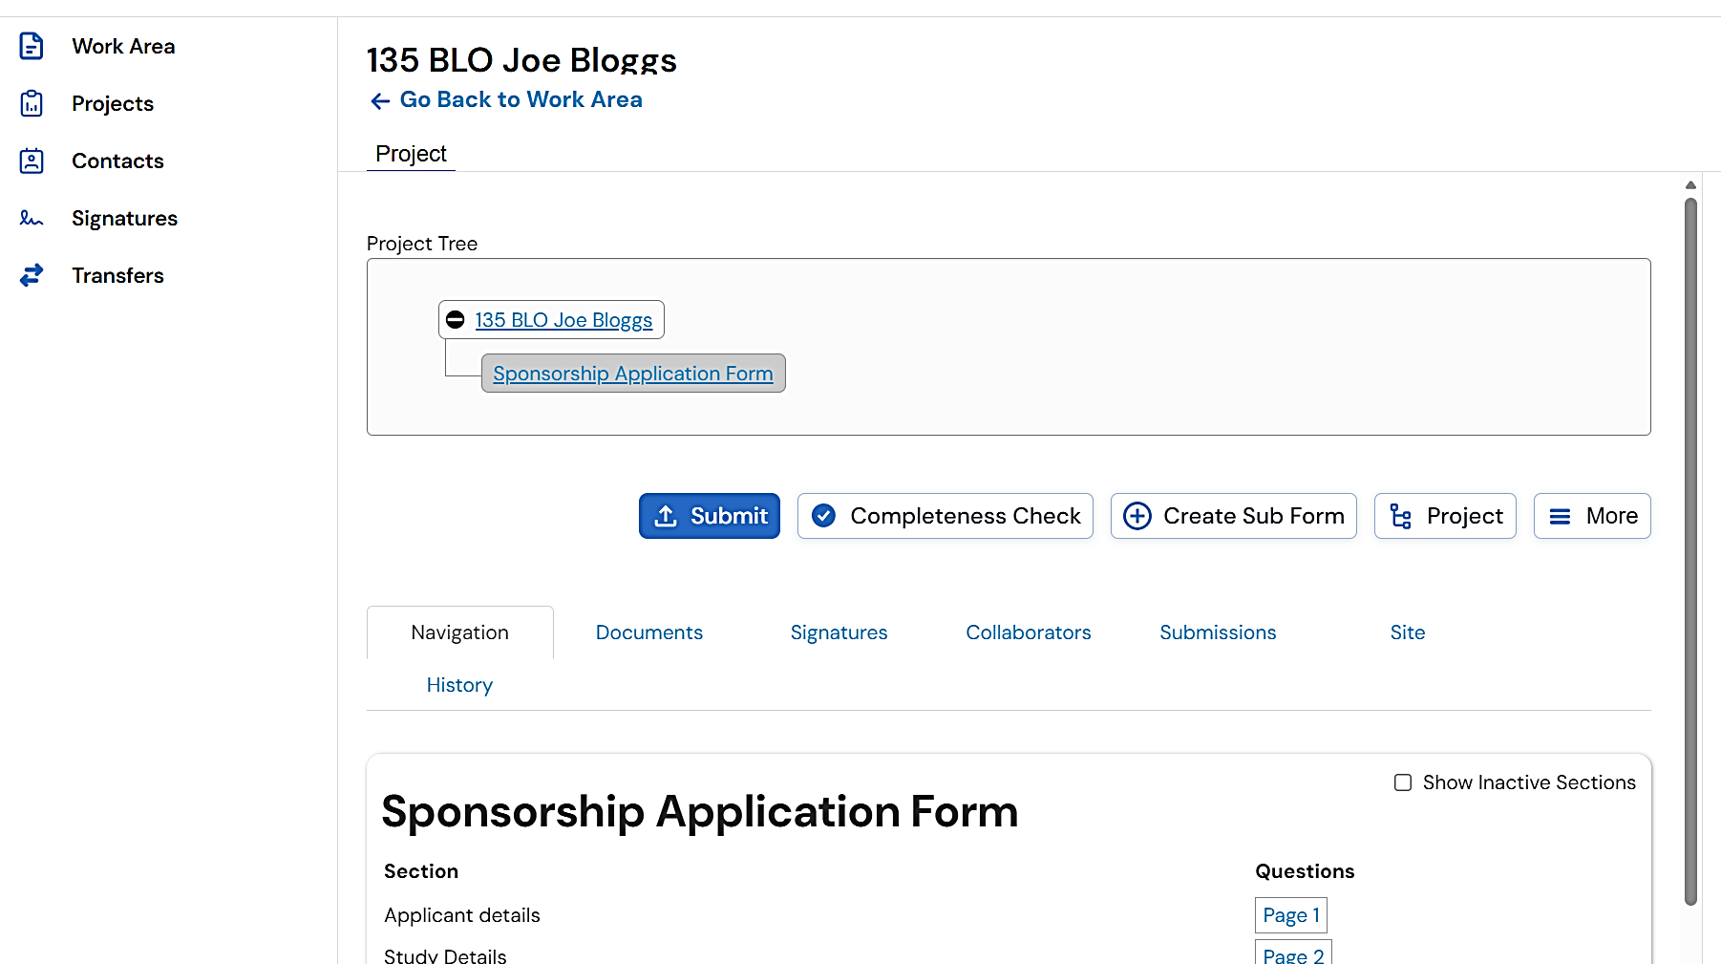

On the pop-up, select ‘Sponsorship Modification Form’ from the drop-down.

Click ‘Create’.
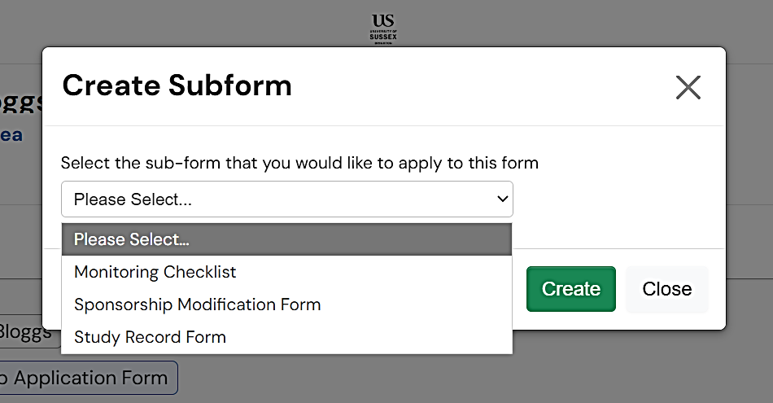

Completing the Sponsorship Modification Form

As with the main Sponsorship Application Form, questions are grouped within sections. Again, some questions will be dependent on answers to previous questions. Some will be pre-populated.

As you complete the questions, you will also be asked to upload various documents where this is applicable.
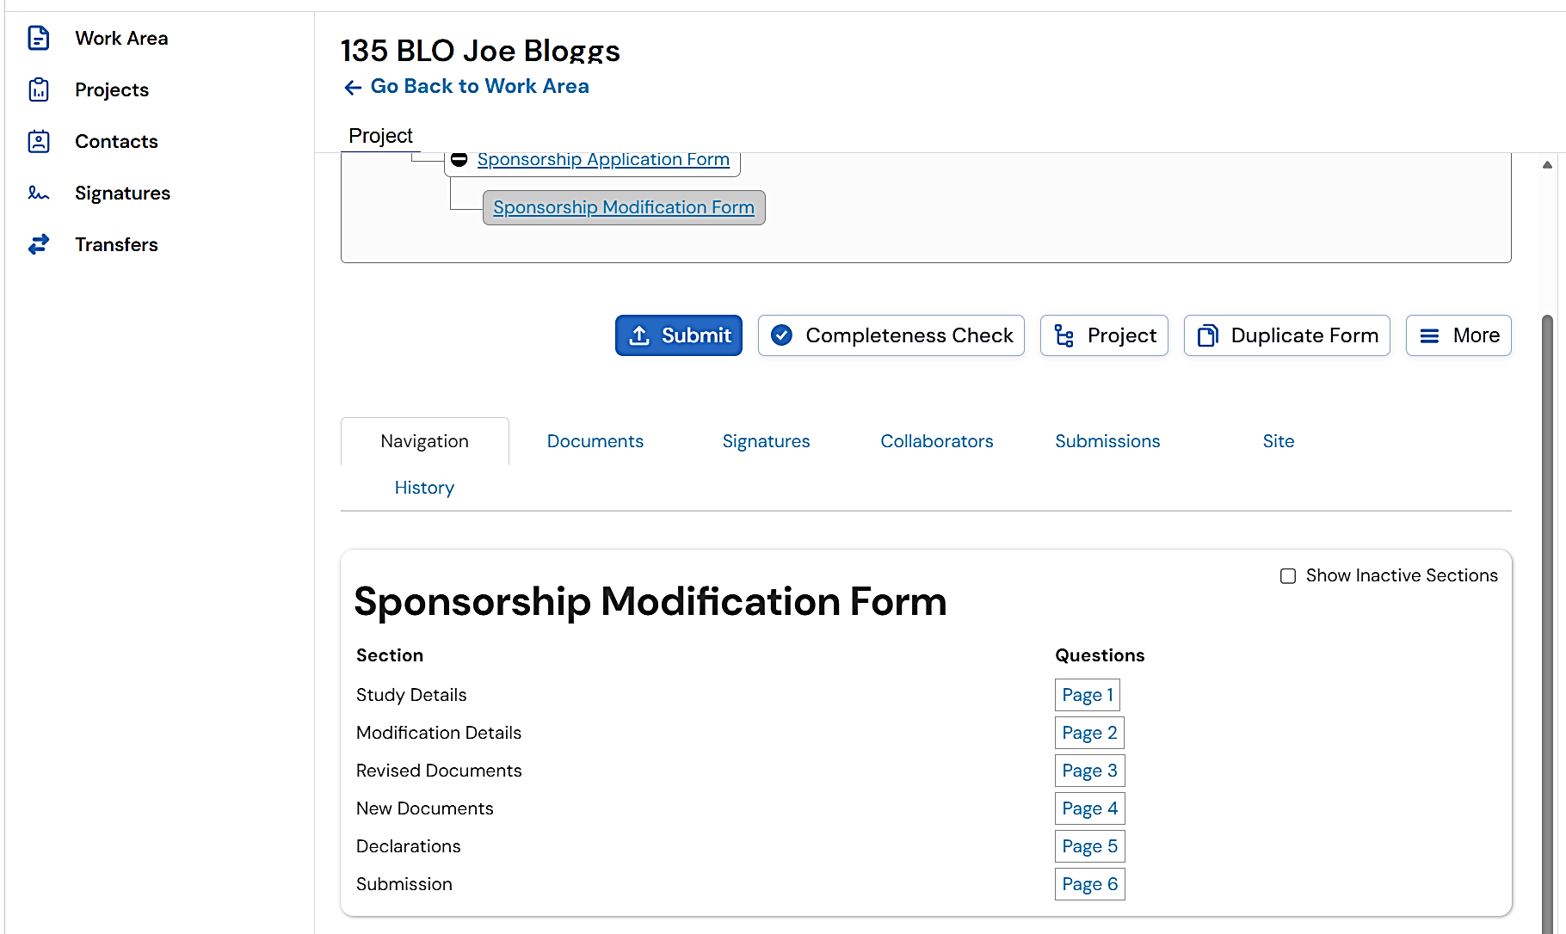

When you reach the Declarations section, ensure you check all boxes.
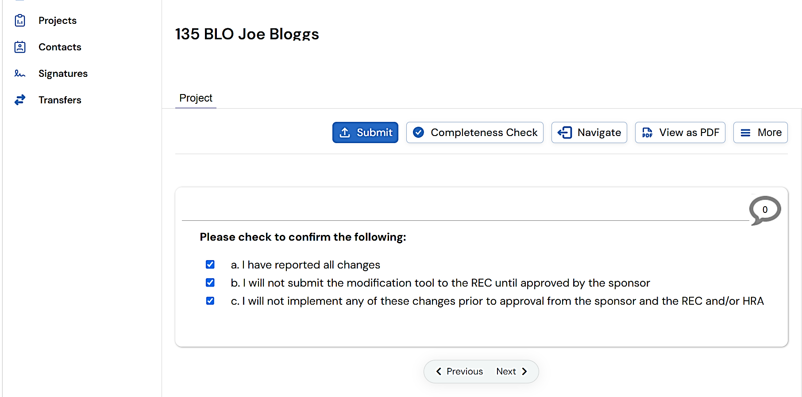

Signing and submitting your application

When you are ready to submit your application, navigate to the Submission section.
- From the dropdown at the select ‘This is the first submission’.
- Enter your name and the date.
- Click ‘Sign’.
- The application will be submitted automatically when you sign the form.
- You will receive email confirmation of a successful submission.
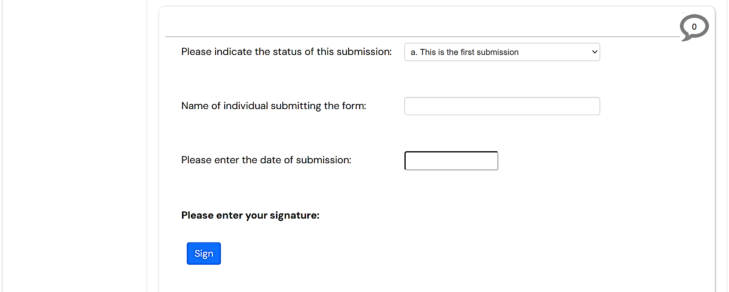

Review of your application

Your application will go through various stages of review:
- Following submission, it will be screened by a member of the sponsorship team.
- If there are no major issues associated with the intended modification, the application will undergo proportionate review by members of the Health and Social Care Sponsorship Sub-Committee.
- If there are issues with the modification, then the application will be reviewed and discussed by all members of the Health and Social Care Sponsorship Sub-Committee.

Reviewers will add comments to your application form.

You will receive an email asking you to address the comments. Attached to the email will be a tabulated version of all reviewer comments. This is termed a ‘Change Request’.

Note that you may receive more than one Change Request during the review process.

To view the comments and make changes follow Part A. Steps 5 and 6 above. Ensure you are working with the Modification Application Form.

Approval of your application

Once the reviewers agree that all comments and changes have been sufficiently addressed, your application will be approved.

You will receive an email with the Sponsor Modification Approval Letter attached, and a separate email with the locked modification tool attached

Additional information
If using a laptop, such as the standard laptop provided by the University, or another small screen, you may need to zoom out on your web browser to see all available information and buttons.
For most web browsers using Windows, press the ‘Ctrl’ and ‘+’ keys together to zoom in, or ‘Ctrl’ and ‘-’ to zoom out. For Mac, use the ‘Command’ with the + or - keys.
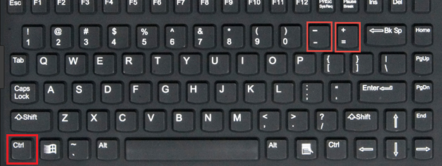
On occasion, the Sponsorship Application Form will be updated. If this happens you may see an indication on your application that your form needs updating to the newer version.
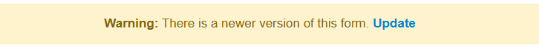
You can then update the form, but any signatures you have already obtained for the form will no longer be valid and will need to be requested again.
