INFONETICA ETHICS RM

PART A. APPLICATIONS FOR SPONSORSHIP

PART B. APPLICATIONS TO MODIFY A SPONSORED STUDY

USER GUIDE FOR REVIEWERS



Contents
PART A. APPLICATIONS FOR SPONSORSHIP 3
1. Logging onto Infonetica RM as a reviewer 3
2. How will I know if I have an application(s) to review? 3
3. Locating applications for review 3
4. Conducting your review 6
5. Finishing your review 10
6. Viewing comments made by other reviewers 10
7. Viewing changes made by the applicant 11
PART B. APPLICATIONS TO MODIFY A SPONSORED STUDY 13
1. Logging onto Infonetica RM as a reviewer 13
2. How will I know if I have an application(s) to modify a study for review? 14
3. Locating applications to modify a study for review 14
4. Conducting your review 15
5. Finishing your review 15
6. Viewing comments made by other reviewers 15
7. Viewing changes made by the applicant 15
ADDITIONAL INFORMATION 16

Part A. Applications for sponsorship

Logging onto Infonetica RM as a reviewer

Access the Infonetica Ethics RM system at https://review.ethics.sussex.ac.uk/.

You will be diverted to the Okta login page to log onto the site. Use your University of Sussex username and password.

On the landing page, click ‘Click here to view your Work Area’.
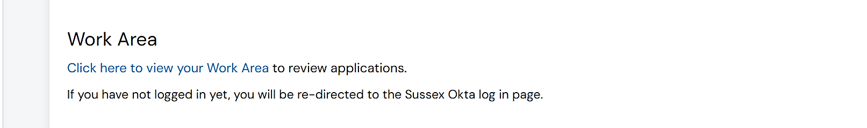

How will I know if I have an application(s) to review?

For the review of sponsorship applications prior to discussion at a meeting of the Health and Social Care Sponsorship Sub-Committee (HSC SCC) (by ALL members):
- You will receive an email from the Infonetica system with details of the HSC SSC meeting.
- The email will advise you to click on the ‘Meetings’ tile in your Work Area to find the projects for review (see Step 3.1).

For the proportionate review of sponsorship applications outside of a meeting of the HSC SCC (by SOME members):
- You will receive an email from the Infonetica system when a proportionate review has been assigned to you.
- There will be a link to the application requiring review within the email (see Step 3.2).

Locating applications for review

For the review of sponsorship applications prior to discussion at a meeting of the Health and Social Care Sponsorship Sub-Committee (HSC SCC) (by ALL members):
- Method 1:
  - Click the ‘Meetings’ tile in your Work Area
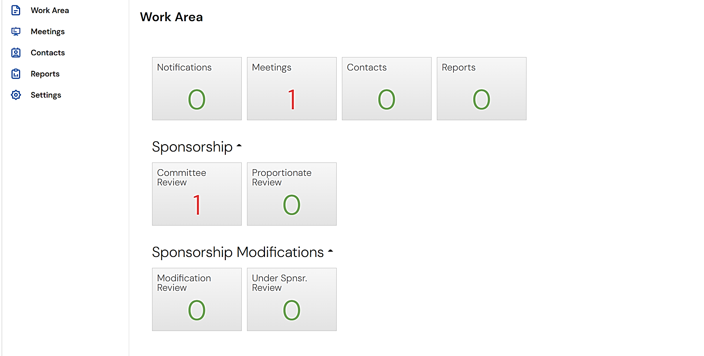
  - On the screen that appears click on the relevant ‘Meeting Reference’.
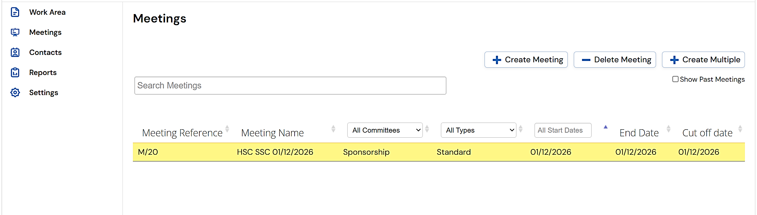
  - Then click ‘Review Reference’.

Note that in the example below there is only one review assigned to the meeting. There may be up to three (3).
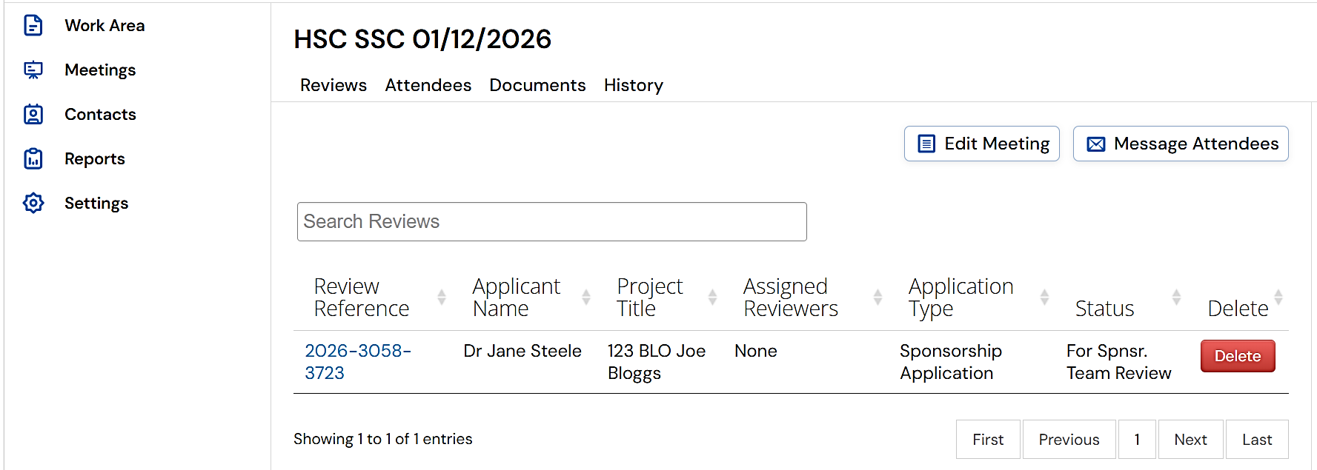
- Method 2:
  - Click ‘Committee Review’ in the Sponsorship panel in your Work Area.

Note that in the example below there is only one (1) application to review. There may be more than one (1).
  - Then click on ‘Sponsorship Application’ to view the application.
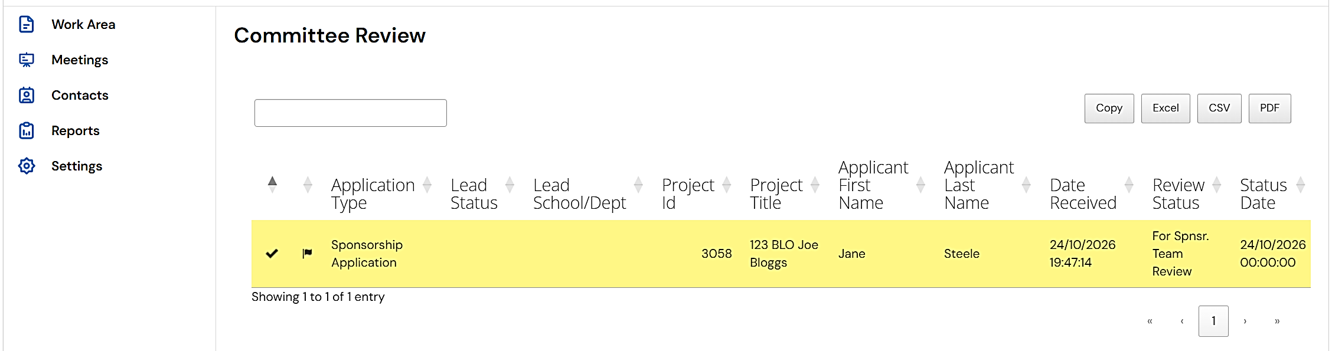
- Both Method 1 and Method 2 will take you to the project Timeline for the application.

For the proportionate review of sponsorship applications outside of a meeting of the HSC SCC (by SOME members):
- Method 1: Click the application link in the email you have received.
- Method 2:
  - Click ‘Proportionate Review’ in the Sponsorship panel in your Work Area.

Note that in the example below there is only one (1) application for proportionate review. There may be more than one (1).
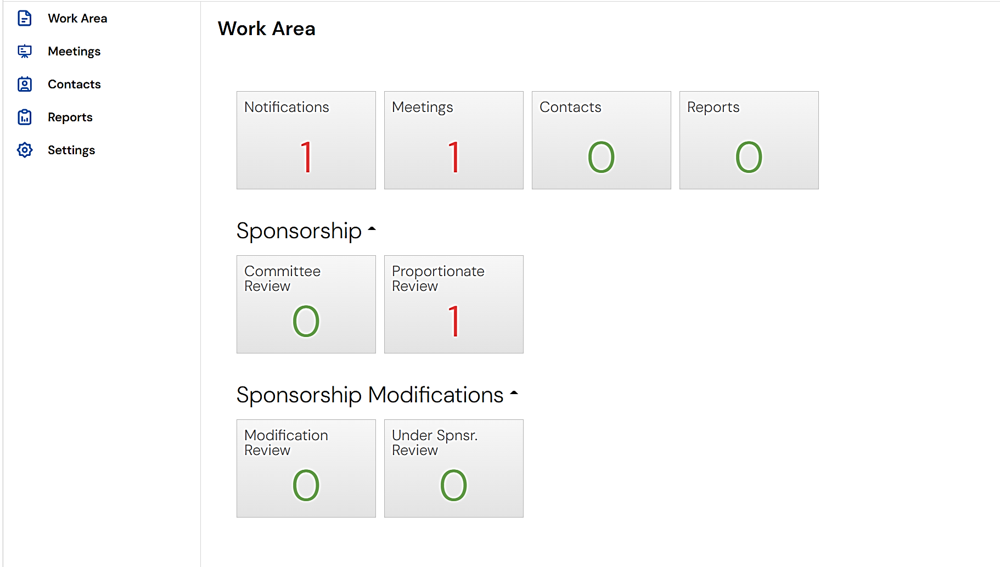
  - Then click ‘Sponsorship Application’ to view the application.
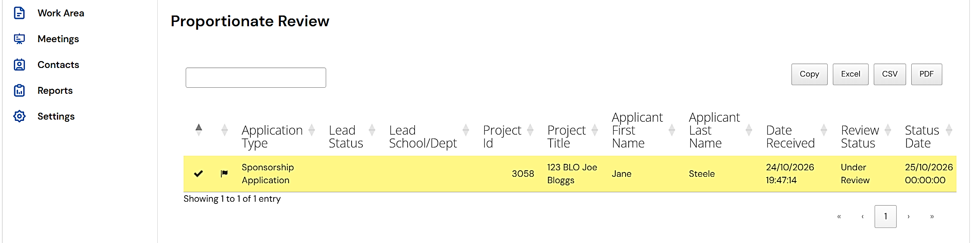
- Both Method 1 and Method 2 will take you to the project Timeline for the application.

Conducting your review

Reviewing the application form
- You must be on the project Timeline to start your review.
- Click ‘Review Application’.
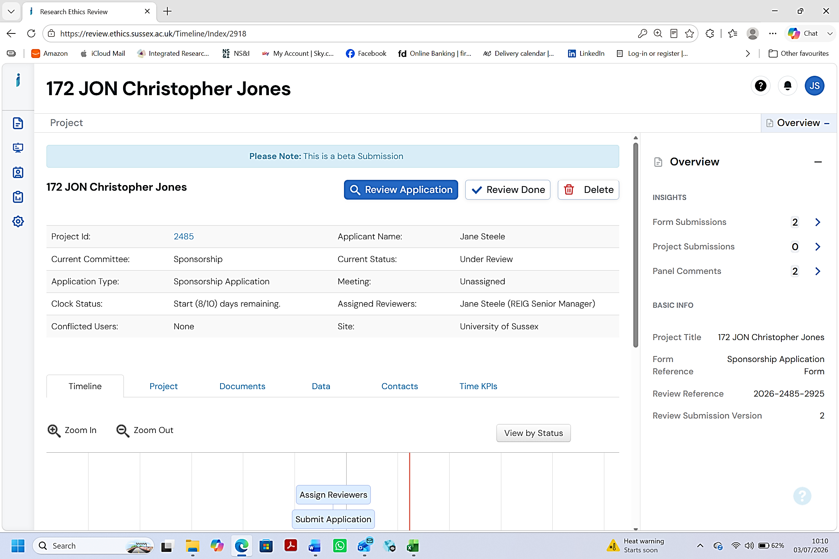
- Questions are grouped within sections. Some sections (and questions within the sections) will be dependent on answers to previous questions.
- According to your preference:
  - Either review the application on the system by clicking on the Page numbers sequentially to review each section (or use the Navigate action button, or the ‘Next’ and ’Previous’ buttons at the bottom of each page that will appear when you start), or
  - Download a PDF copy of the application form to review.
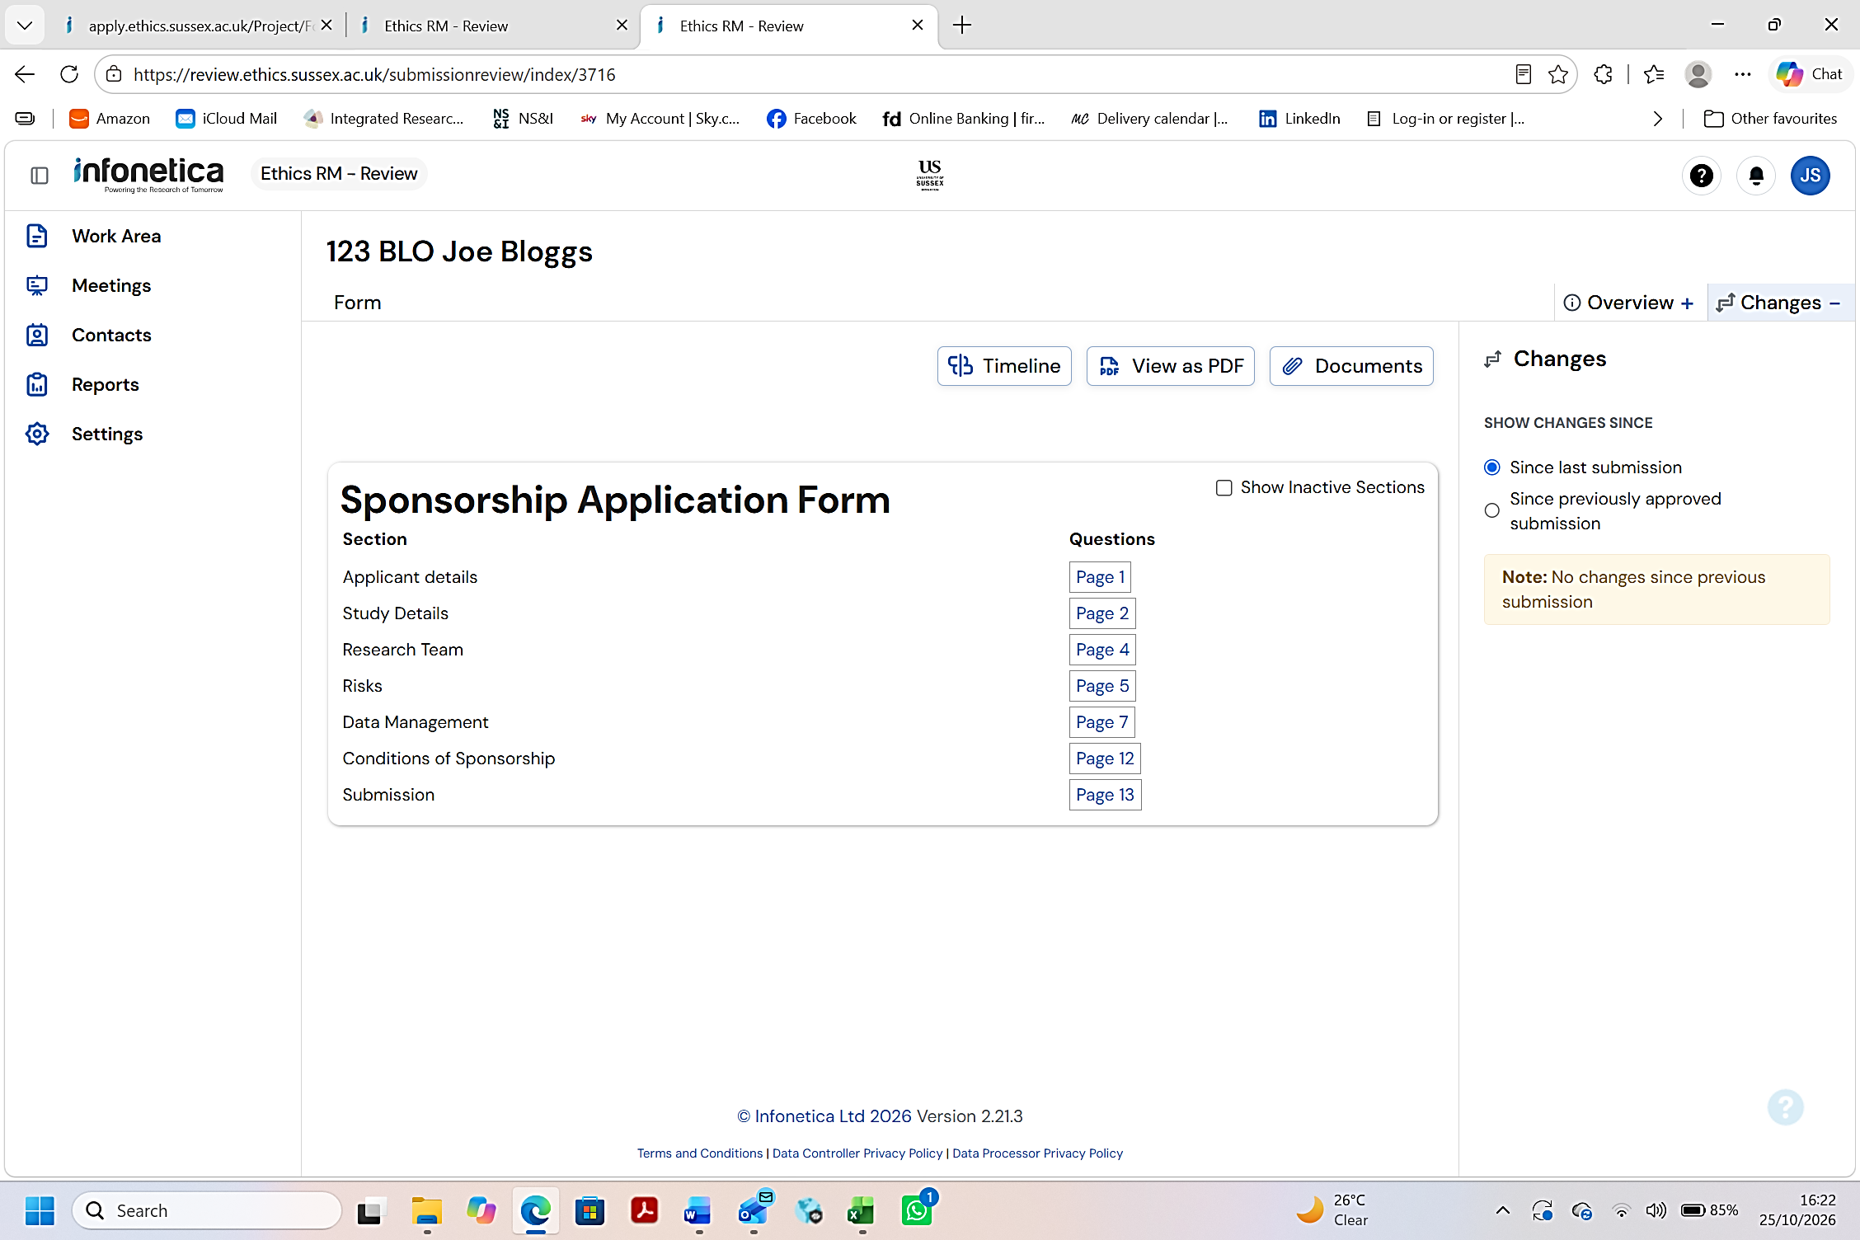

Adding comments
- In the simple example shown below, the applicant has not provided details of the Faculty or Department they belong to. Click ‘New Comment’.
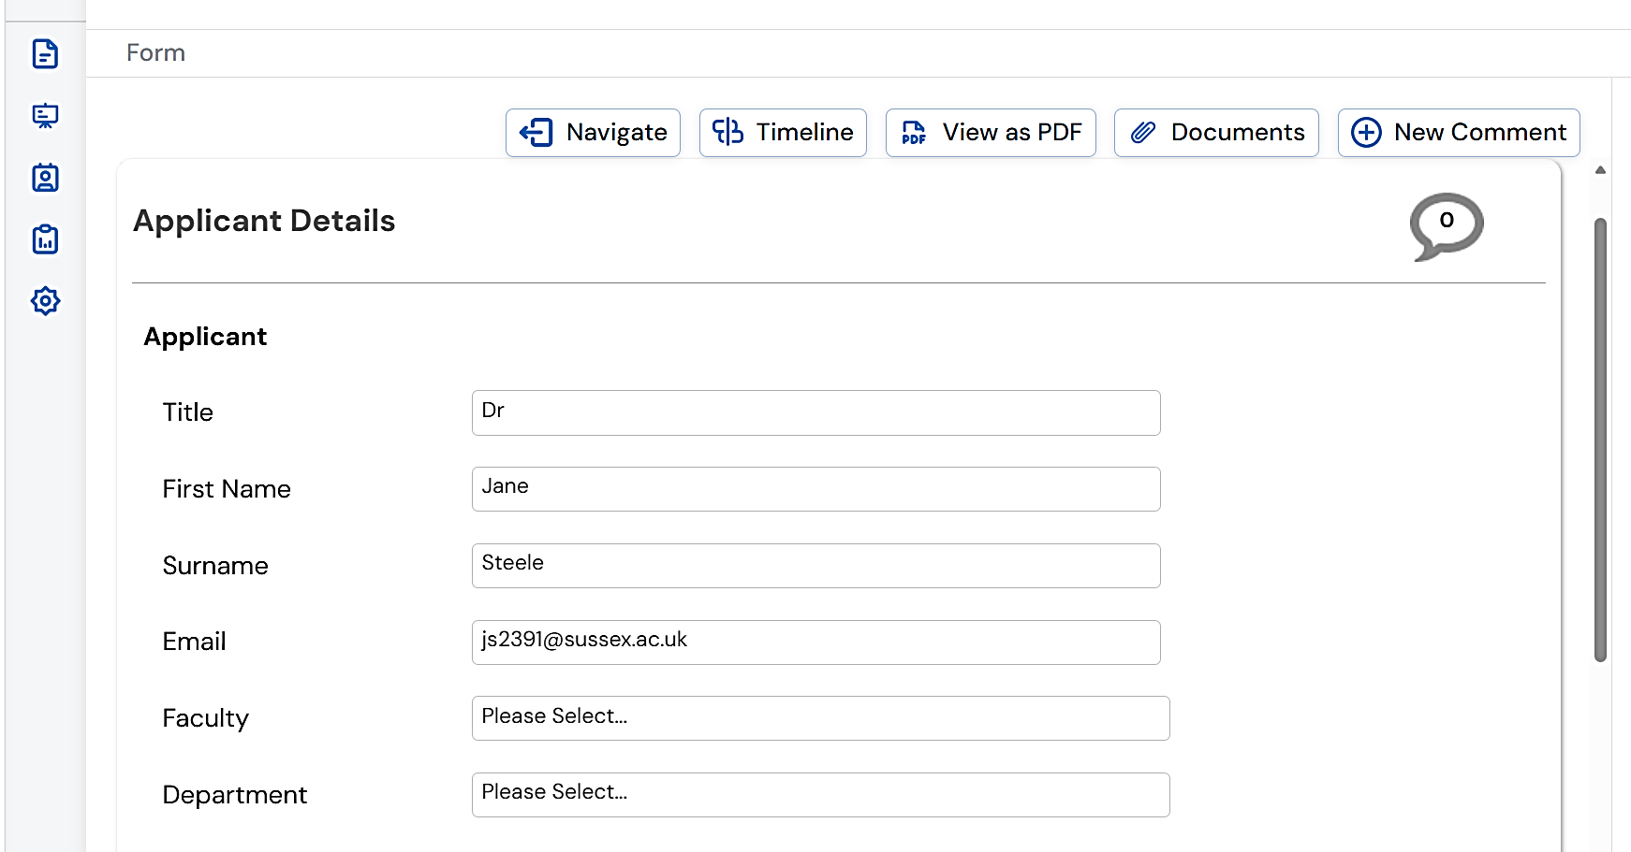
- On the pop-up, click ‘Select Me’ in the top right corner of the panel containing the question(s) you wish to address.
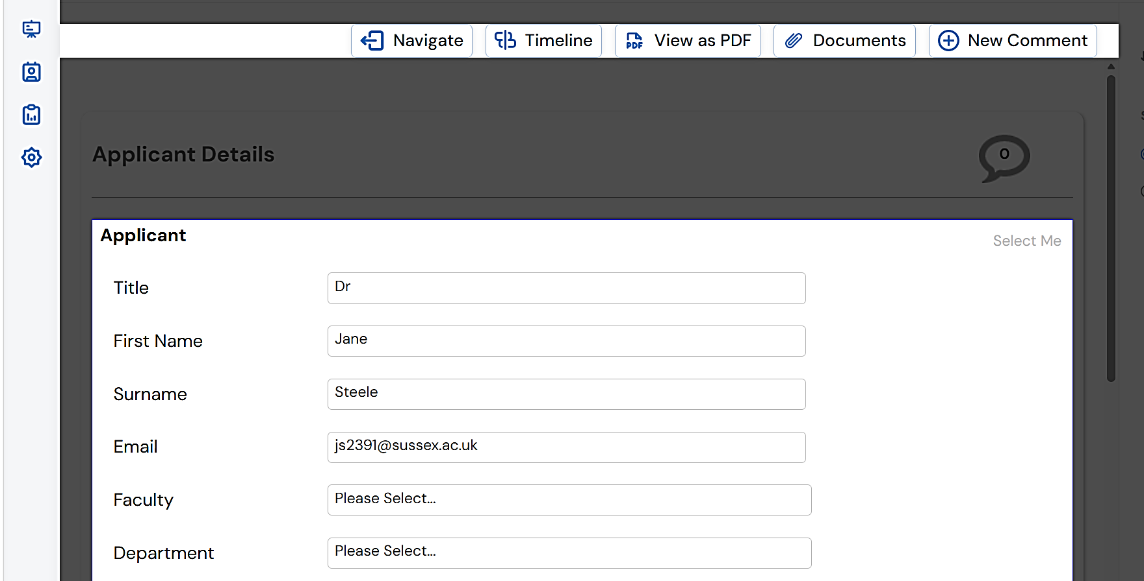
- On the next pop-up, click ‘Change Request’ and ‘Visible to Applicant’ so that both are green.
- Add your comment to the box and click ‘Save’.
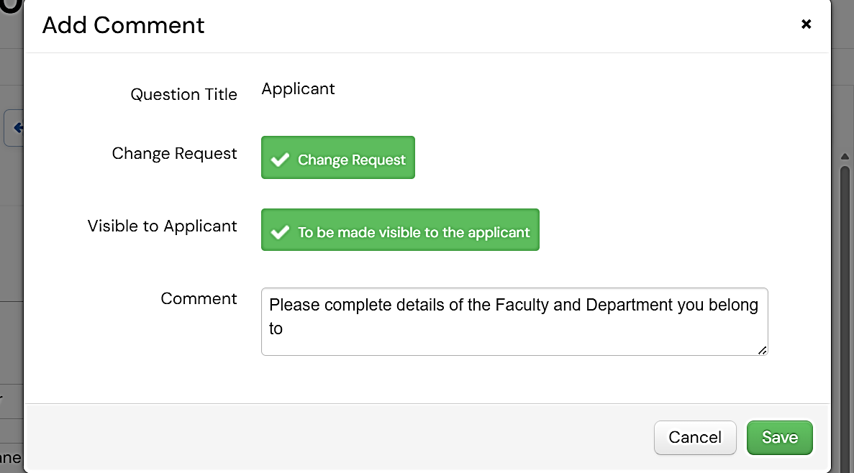

Reviewing accompanying documents
- Locating the accompanying documents for review:
  - Method 1: As you move through the application form on the system it will be apparent where the applicant has been asked to upload a document. To review the document, click ‘Download’.
  - Method 2: On the project Timeline click ‘Review Application’. Then click ‘Documents’. A list of all accompanying documents will appear. You can select any, or all documents to download for review.
- You cannot add comments to the documents themselves. Instead, you must locate the document within the application form on the system.
- Once located click ‘New Comment’ and follow the instructions for adding comments in Step 4.2 above.
- In the example shown below, it is a Participant Information Sheet.
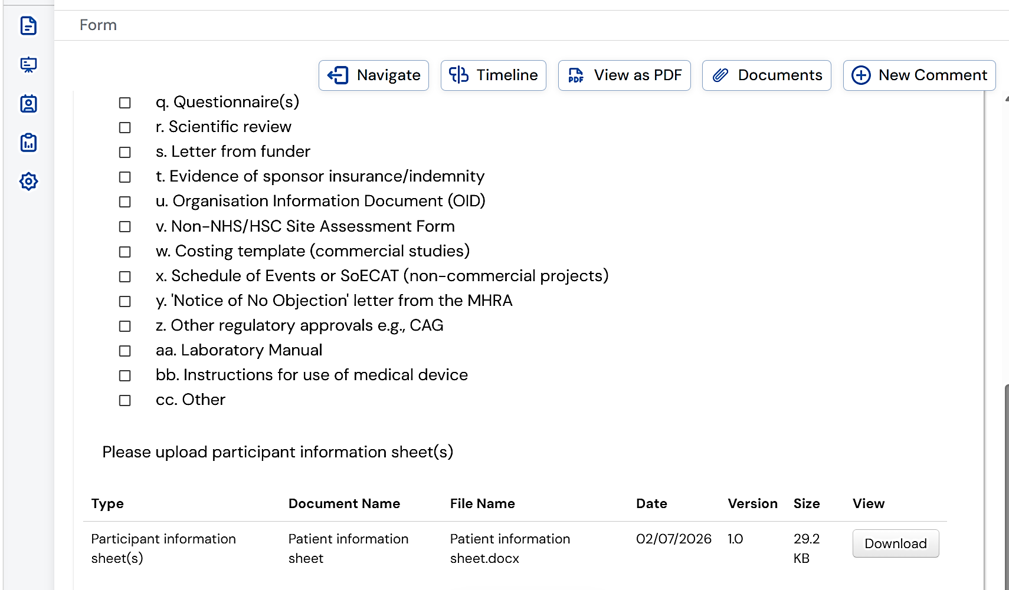
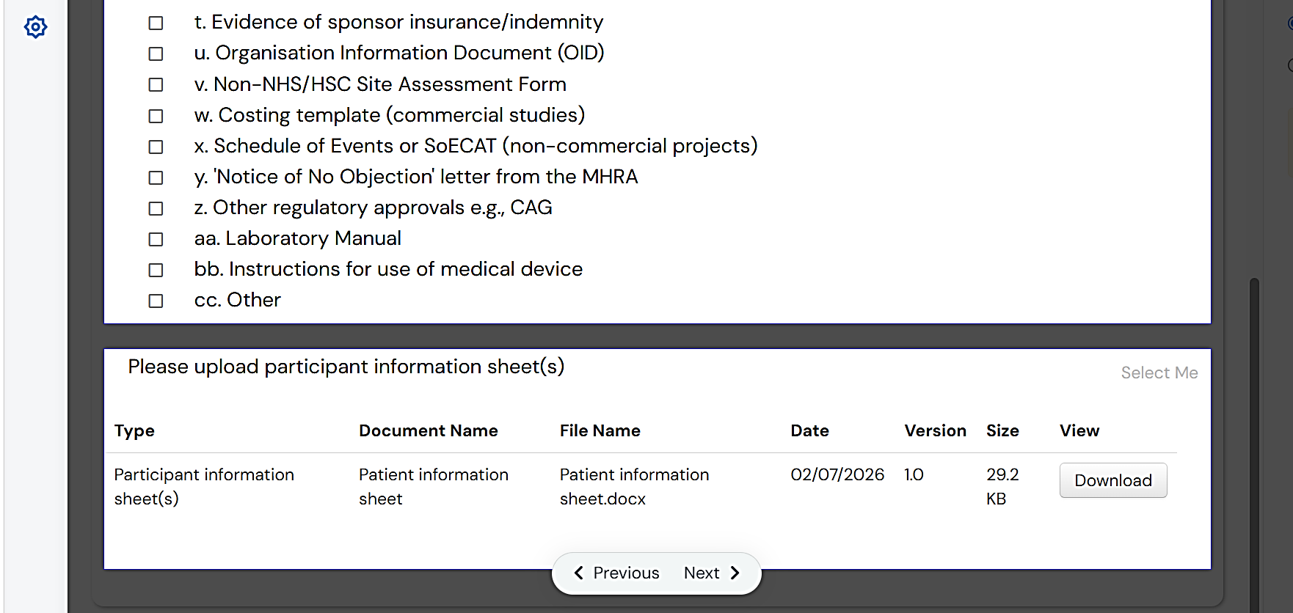

Finishing your review

When you have finished reviewing the application form and accompanying documents, and have no further comments to add, return to the project Timeline.

Click ‘Review Done’ and confirm the review is complete in the pop-up screen that follows.
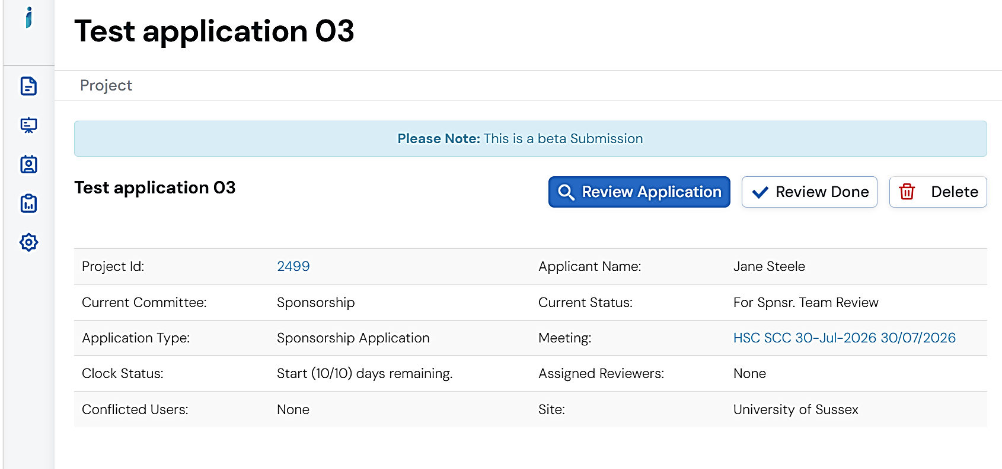

Viewing comments made by other reviewers

You can view comments made by other reviewers within the Overview section on the right side of the project Timeline.

Note that the Overview tab is collapsible so you may need to click ‘Overview’ to open the tab.

Click the small blue arrow to the right side of Panel Comments indicating that two (2) comments have been made in the example below.

A pop up will list comments made by other reviewers.

You can look at Current, Previous, or the History of comments that have been added.
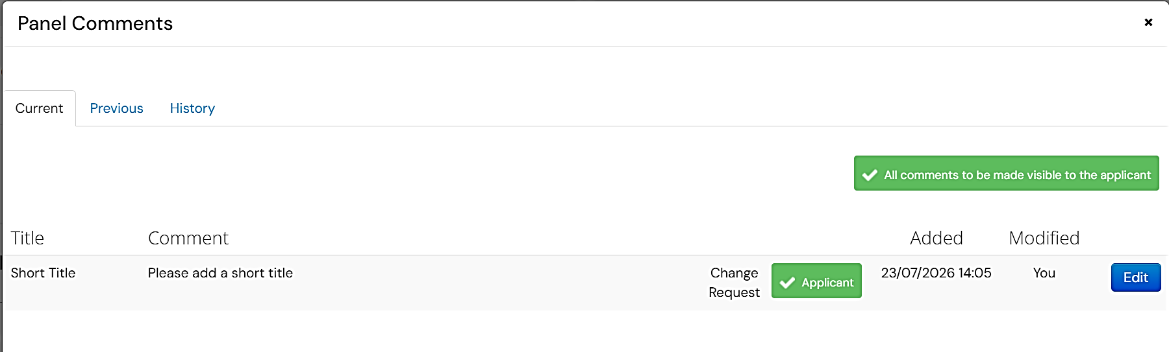

Viewing changes made by the applicant

Changes made to the application form
- Navigate to the project Timeline and click ‘Review Application’.
- Click the Page numbers sequentially.
- If the applicant has made changes in response to reviewers’ comments, this will be displayed.
- The example below indicates that changes have been made since the last submission within the Study Details section.
- Click ‘Read more’.
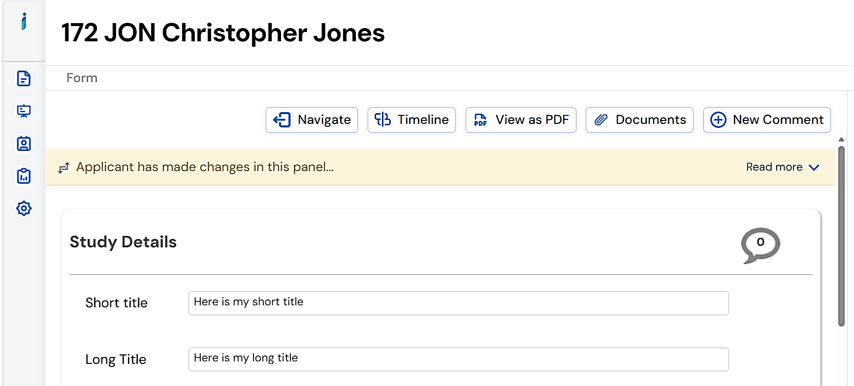
- Click ‘View Latest’.
- The latest changes made are highlighted in green.
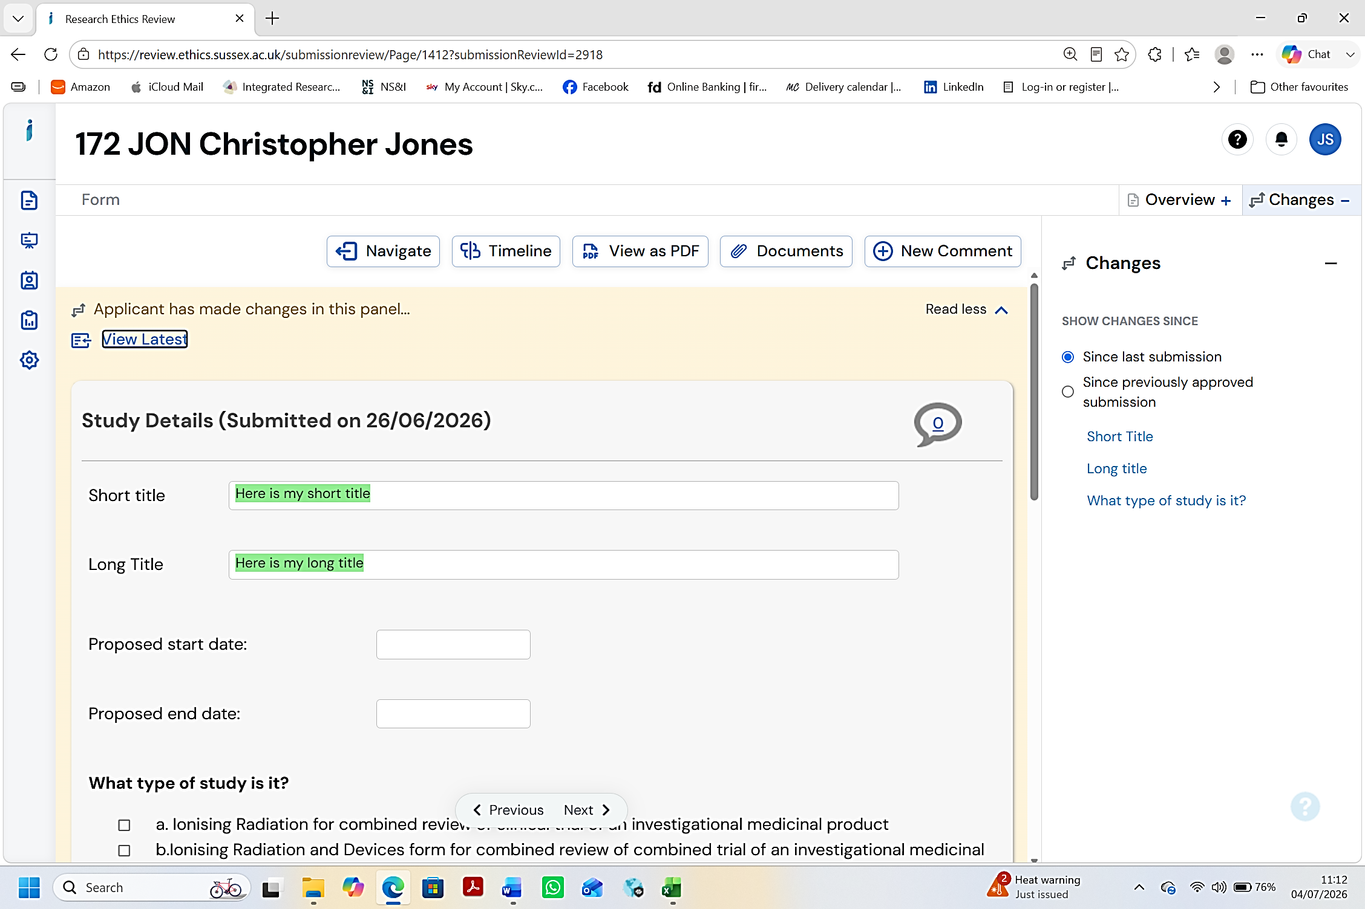
- You can view all changes ever made within the Changes section on the right side of the screen.

Note that the Changes tab is collapsible so you may need to click ‘Changes’ to open the tab.

Changes made to accompanying documents
- Navigate to the project Timeline and click ‘Review Application’.
- Click ‘Documents’.
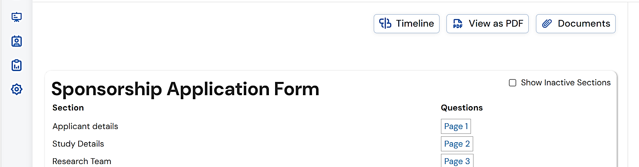
- From the pop-up listing all documents, select the latest version of the document you are interested in and click ‘Download’.
- Any changes to the document will be visible as track changes.
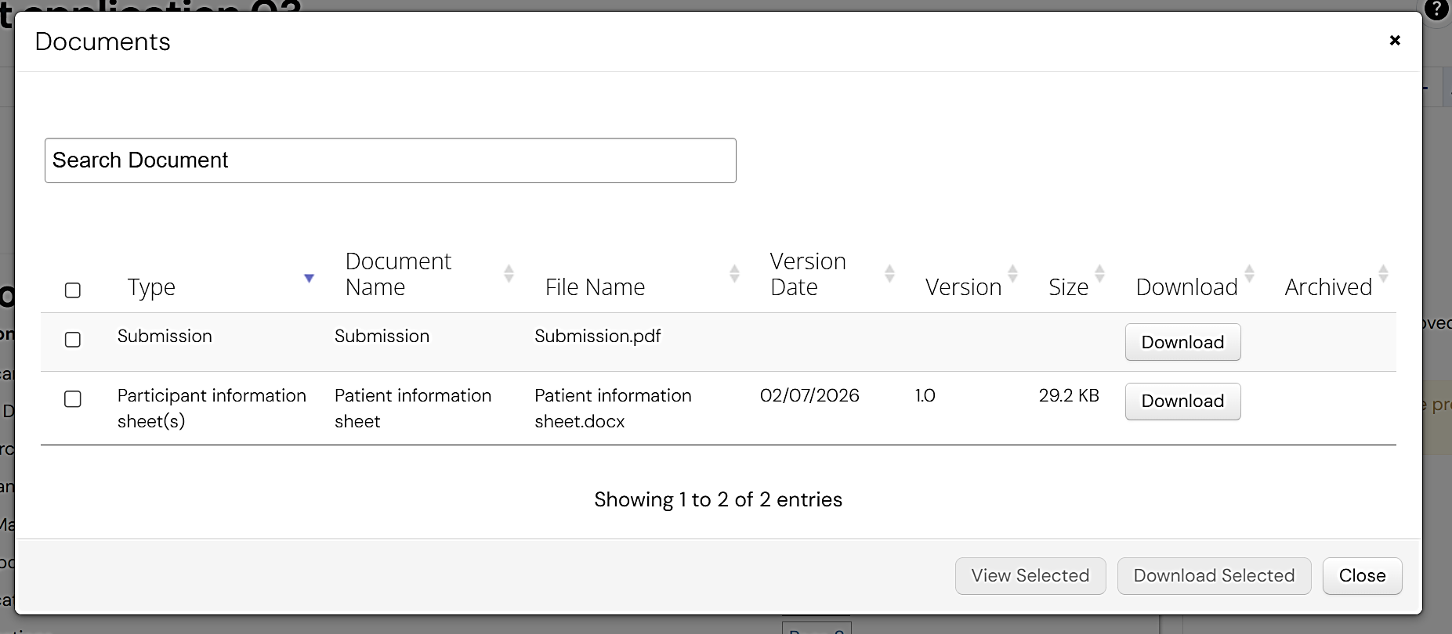

Part B. Applications to modify a sponsored study
Most applications to modify a sponsored study undergo proportionate review by SOME members the HSC SCC outside of a meeting.
Only those modifications that raise significant issues will be reviewed and discussed by ALL members at an HSC SSC meeting.

Logging onto Infonetica RM as a reviewer

See Part A. Step 1.

How will I know if I have an application(s) to modify a study for review?

See Part A. Step 2.

Locating applications to modify a study for review

See Part A. Step 3 but note the following differences:
- Applications to modify studies for review by ALL members of the HSC SCC:
  - For Method 1, when you click on the relevant ‘Meeting Reference’ the Application Type will say Sponsorship Modification (and not Sponsorship Application).
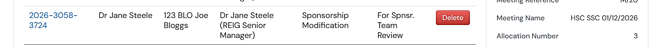
  - For Method 2, you will need to click ‘Under Spnsr Review’ in the Sponsorship Modifications panel in your Work Area.
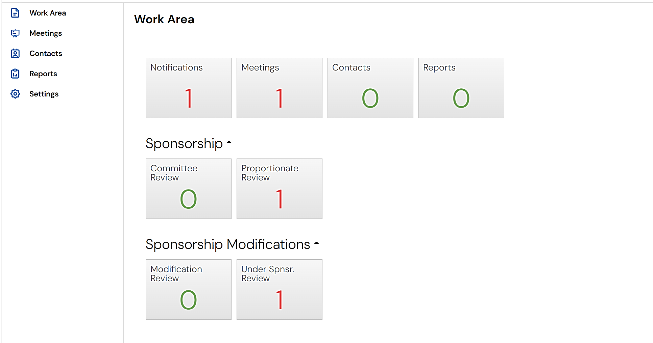
  - Then click on ‘Sponsorship Modification’ to view the application.
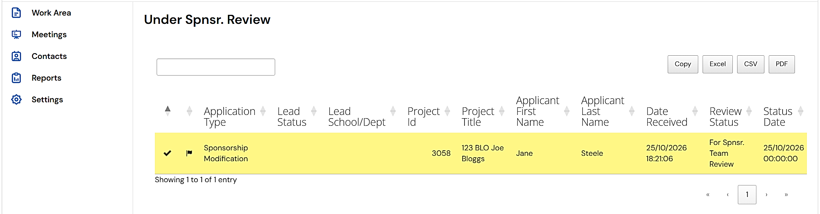
- To locate applications to modify studies for proportionate review by SOME members of the HSC SCC:
  - For Method 2, you will need to click ‘Modification Review’ in the Sponsorship Modifications panel in your Work Area.
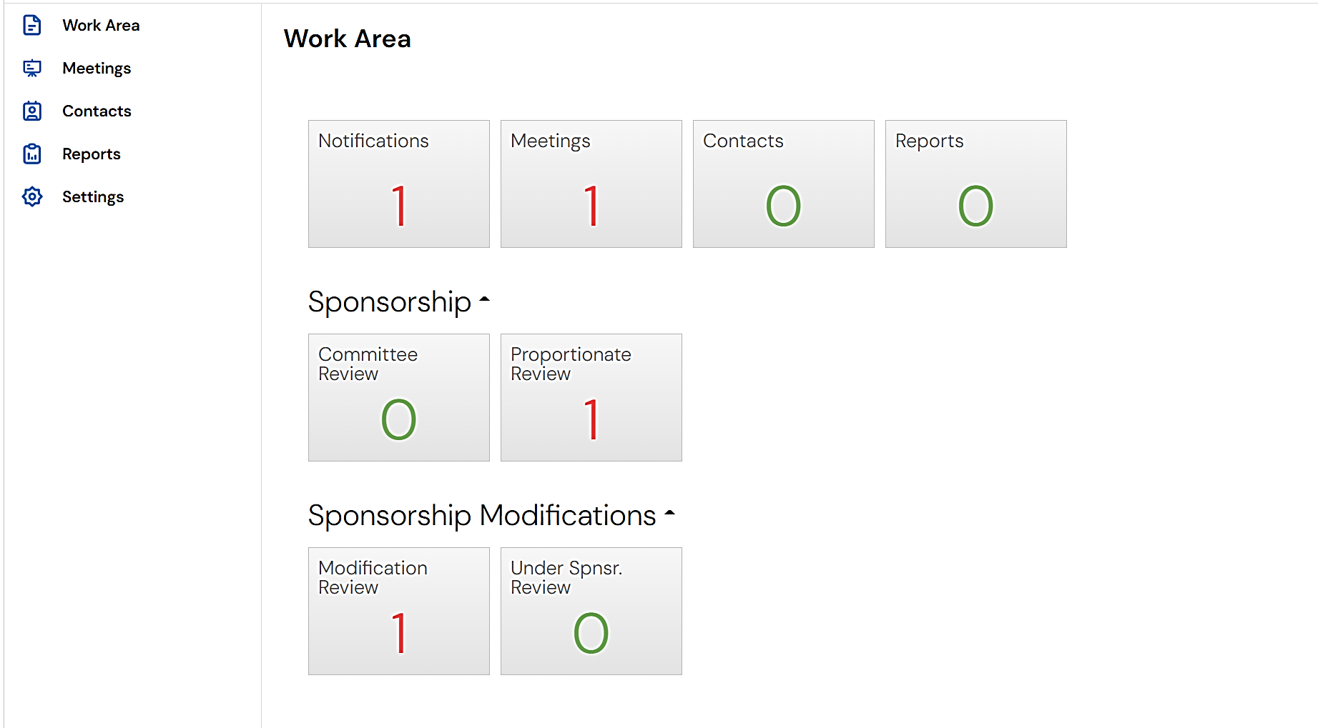
  - Then click on ‘Sponsorship Modification’ to view the application.
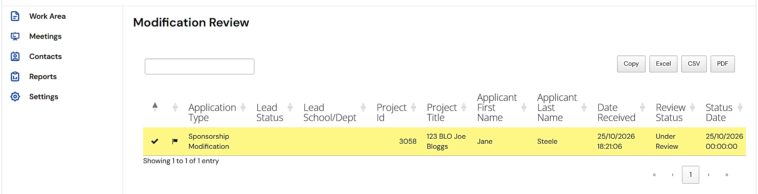

Conducting your review

See Part A. Step 4.

Finishing your review

See Part A. Step 5.

Viewing comments made by other reviewers

See Part A. Step 6.

Viewing changes made by the applicant

See Part A. Step 7.

Additional information
If using a laptop, such as the standard laptop provided by the University, or another small screen, you may need to zoom out on your web browser to see all available information.
For most web browsers using Windows, press the ‘Ctrl’ and ‘+’ keys together to zoom in, or ‘Ctrl’ and ‘-’ to zoom out. For Mac, use the ‘Command’ with the + or - keys.
