PERSONAL

NAME

January 2021

Status as a Critical Worker

University critical worker authorisation for [title first last name]

This letter is to confirm that you are employed by the University of Sussex in the [faculty/department/role] and are part of a very small group of business critical workers who provide the University’s response to Covid-19 or are required to maintain absolutely essential activity for the University, its students and to support the national efforts to counter the spread of the virus.

To confirm your identify if required, your University staff ID card contains your name and person number, including a photograph.

The attached statement from the Department for Education provides support in terms of access to school places (if applicable), university premises and travel to help us maintain essential activities during the current national restrictions.

If applicable, you should take this letter to your children’s school requesting that your child or children be admitted to enable you to continue essential work on behalf of the University.

It is very important that your School or Division is aware of who is on campus so that they can ensure the numbers present are able to work safely and in case an emergency should arise. Please ensure that any work you do on campus is agreed in advance with your line manager.

Your continuing co-operation is appreciated on this important matter.

Please also ensure that when not required to attend work as a critical worker that you are following the current government guidance to stay at home.

Thank you for your continued support at this difficult time. If you have any queries or concerns please do not hesitate to contact human.resources@sussex.ac.uk.

Yours sincerely
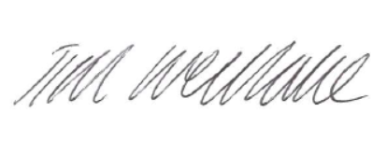
Tim Westlake
Chief Operating Officer

