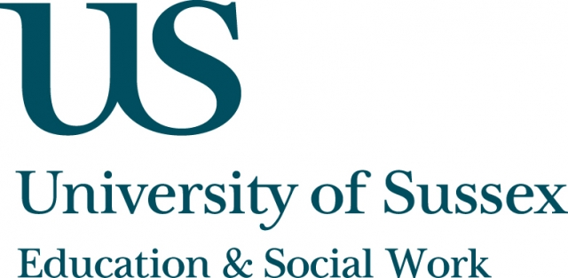

ESW Open Seminar Series
CIRCY

Monday 17th November, 5pm
Room 104, Fulton
Speaker
Dr Sarah Wilson, Senior Lecturer, Applied Social Science,
University of Stirling, presents:
Contemporary Greek Myths: Visual resources
for young people’s self-care and transformation
____________________________________

Dr Wilson explores the use of visual, digital resources by ‘looked after’ young people to blank out - but also to engage with and re-think - difficult histories and current circumstances. It is argued that such resources may be considered a helpful, if individualised and often devalued, form of self-care and exploration in constrained material circumstances.
In this seminar, Dr Wilson will draw on the ESRC-funded
research project ‘Young People Creating Belonging: Spaces, sounds and sights’ which employed visual and audial methods to explore how ‘looked after’ young
people can construct a comfortable sense of (non) belonging in new placements.
____________________________________
This seminar can be joined remotely by logging on to:
https://connectpro.sussex.ac.uk/circy_wilson17nov14
A recording of this event will be available to view retrospectively
at: www.sussex.ac.uk/education/seminars

