Personal Scholarship Plan (PSP) Template

Personal Scholarship Plan

Name
Job title
School
Home unit
Name of Reviewer
Date of meeting
Highest level of qualification and date of attainment

Introduction
The Personal Scholarship Plan (PSP) is intended as an aid to assist you in structuring the development of your scholarship; a reflective tool to facilitate discussion about scholarship and your aims for the year ahead; and to inform planning for scholarship support at the school and university level.
Unlike appraisal documents, the PSP may be shared with relevant professional services staff, your PSP mentor, Subject Head and Dean. Any confidential comments should be made on the separate appraisal form, which is confidential to the Appraiser, the Appraisee, the Dean and HR.

Guidance
The PSP form should be completed in draft prior to your PSP meeting, and shared with the designated person. As part of the meeting, you will be expected to review and discuss your scholarship profile, progress against your previous PSP and your plans as documented in the current PSP. The PSP should then be revised following the meeting, taking relevant feedback into account.
The finalised PSP should be submitted for review at appraisal. The Dean will identify the School’s approach to review of PSPs within their School.

- Scholarship profile
Your web profile should include an up-to-date account of your scholarship interests and activities.
Profile
Is your Elements profile up-to-date?
Paste the link to your profile here so it can be discussed in your PSP meeting.

- Scholarship priorities, planned outputs and aspirations
The potential for scholarship is wide-ranging and, as such, portfolios are likely to be diverse. As colleagues develop their scholarship and leadership profiles the range of activities is also likely to evolve. Scholarship can be broadly organised into 4 categories: Scholarly Teaching; Practice of Teaching; Sharing about Teaching; Scholarship of Teaching and Learning. These are illustrated in the figure below, along with examples. The suggested outputs in the figure below do not intended to form an exhaustive list. Other forms of outcomes, impact and evidence are acceptable and expected.

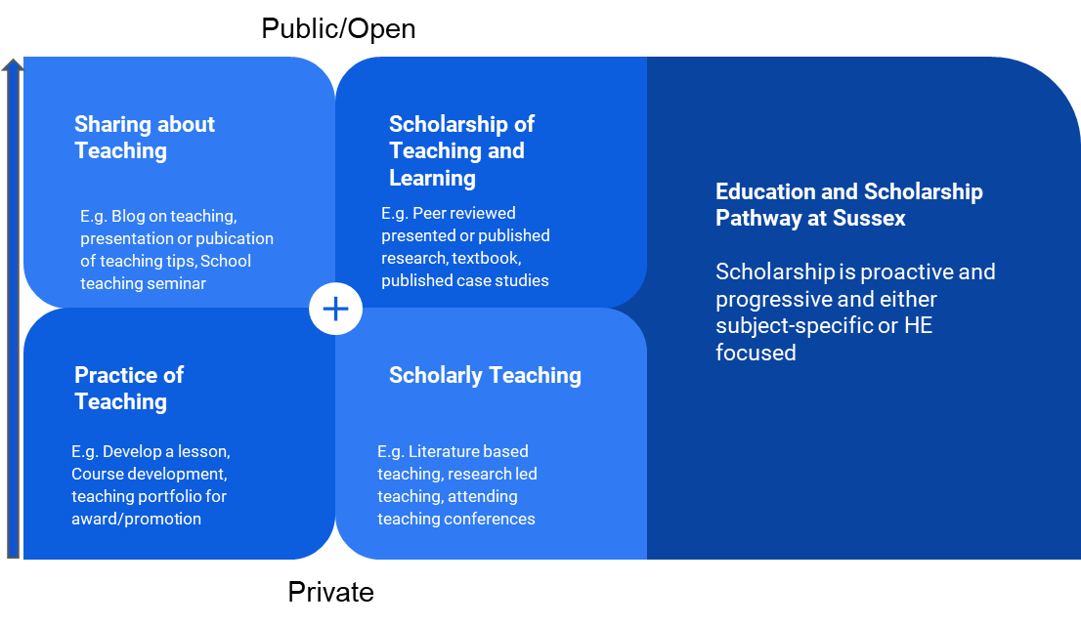
Provide details on your plans for the practice of teaching (table Bi) (e.g., new module design), scholarly teaching (e.g., research-led teaching), sharing about teaching (e.g., School Teaching and Learning Blog, Festival of Teaching and Learning Presentation, Conference presentation) and scholarship of teaching and learning (e.g., peer-reviewed research, published textbook or textbook contribution, case studies).
Consider anticipated outcomes resulting from your scholarship, this may include examples of engagement, impact and outputs. In completing this section you should reflect on which stakeholders/communities will benefit from your scholarship and how you might facilitate engagement or impact around the outputs of your scholarly activities. These may include reports, practitioner briefings, policy reports, blogs and other social media engagement, conferences and workshops (hosting and attending), meetings with parliamentarians and policymakers, giving oral evidence to select committees, stakeholder partnership and network development, media work, invited talks or keynote speeches, board membership, consultancy, secondments etc.
It is recognised that completion of the table will vary across the four categories depending on career stage and professional aspirations.

Bi Personal Scholarship Plan (12 months)

Category of Scholarship | Outline | Resources identified to support activities | Timeframe/Duration | Outputs/Engagement & Knowledge Exchange/Impact

B ii) Mentoring
Do you propose to engage in any of the University’s mentoring programmes as a mentee or mentor?
The current programmes are: Staff mentoring (University) and DARE to Transform (University). Members of the MAH College of Mentors are also available to provide guidance.
Rationale

C Reaching your scholarship objectives
Outline the support you will require from others (your academic colleagues, professional services colleagues, your line manager, Subject Head, and any other relevant person) in order to achieve your plans outlined above.

Please revise this document following your PSP meeting and submit the final version to your line manager no later than 1st of September.

Please add or delete rows as appropriate

