MAH SLT/date/Item



Executive Summary of Business
for MAH Senior Leadership Team meeting

Title | Student Experience plan (2023-24)
Status | Open (to be shared with the School after the meeting).
Author | Melanie Green (MAH Assoc. Dean, Student Experience)  M.J,Green@sussex.ac.uk
Consultation | Ed Hughes (incoming MAH Assoc. Dean, Education)  Hayley Bowerman (MAH Senior Education Manager)
Type | Report
Date | 19/09/2023
Summary of paper | The paper reports on the MAH Student Experience team operational plan for the 2023-24 cycle, under the areas of School culture and community, academic experience, student wellbeing support, NSS and central policy and process.
Equalities Impacts | The EDI impacts of the report have been assessed as: neutral
Recommendation | SLT is asked to note the paper.
Updates to previous versions | N/A
MAH Senior Leadership Team
<Student Experience plan 2023-24>

- Introduction

  - This report sets out strategic priorities and activities undertaken within the scope of the student experience portfolio for the academic year 2023-24. An overview diagram of the portfolio is provided in Appendix 1.

- School culture and community

  - Student voice was the strategic priority for the 22-23 cycle. In 23-24, we aim to build on the work in this area by (a) working closely with the Union to promote the reps’ scheme and recruit to our rep positions, co-opting if necessary; and (b) implement clearer structures and reporting processes so that the student voice is amplified via a clearer reporting route (see 2.2).

  - The activities of the MAH Student Forum (formerly the MAH Advisory Board) will be augmented by staff-student liaison groups, in which students can discuss course-specific queries and concerns with their BA convenors/subject heads, with matters then reported by student reps to the Forum and by staff to departmental meetings, boards of study and the MAH Student Experience Committee (see 2.4).

  - As in 22-23, the Forum will continue to provide reps with the opportunity to report matters of broader relevance to the School, and will continue to offer a voice to student connectors and other students employed by the School. The MAH Student Forum will report to the School Education Committee, which in turn reports to the University Education Committee. A diagram of the committees and reporting structures is in Appendix 2.

  - Staff activity in the student experience portfolio will also be supported by the MAH Student Experience Committee. The Committee will be chaired by the Assoc. Dean, Student Experience, and membership will include colleagues from the PS student experience team, one Director of Student Wellbeing (rotating), one Student Wellbeing Advocate (rotating) and two BA Convenors from different Board of Study clusters (rotating, by NSS priority area).

  - The MAH Student Experience committee will offer staff the space to work on initiatives to improve the student experience in priority areas (3). The Committee will report to the School Education Committee, which in turn reports to the University Education Committee. A diagram of the committees and reporting structures is in Appendix 2.

  - We have plans for co-creation work to continue under the themes of ‘storytelling’ and ‘success’, subject to the continuation of the Connector Programme.

  - In terms of school community, the 23-24 cycle begins with the MAH collective read in welcome week (Thursday 28 September). This year we are reading Emily St John Mandel’s dystopian novel Station Eleven, set in a near-future post-pandemic world, and raising urgent questions about the place of the arts and humanities in crisis times. We hope to plan an event with the author for our January collective read, and we encourage colleagues to organise department-level activities during the year (e.g. reading groups). We are providing copies of the book for students and staff.

  - In terms of EDI, the student experience team will work closely with Sandra Nelson, LGBTQ+ Portfolio Lead for the University Equality, Diversity and Inclusion Committee, to implement the MAH LGBTQ+ action plan.

- Academic experience (2023-24 priority)

  - Intersecting closely with NSS, academic experience is a strategic priority for 2023-24.

  - At the School level, work in this area includes support for the development of academic and employability skills; consistent and accessible learning resources (Canvas, reading lists, study spaces, equipment) and assessment criteria and feedback; accessible and flexible assessments; access to advice and guidance from teaching staff relating to learning from feedback, options and further study; access to advice and guidance relating to study abroad and placements.

  - At the University level, work in this area also includes targeted support for priority groups of students for whom we have evidence of attainment gaps (e.g. students from under-represented and deprived areas, BAME students, disabled students, care leavers, among others). See Access and Participation Plan.

  - In the MAH context, direct entry to second year (DETSY) students also represent a group with a significant attainment gap. In 23-24 we will work together across MAH to address this by means of a co-ordinated project between the three education portfolios. A working group will be convened to start in autumn 2023.

  - Employability
Further work is needed on the MAH employability strategy, drawing together curricular and experiential learning activities and linking up with activities including the Turner Prize and the BA showcase.

- Student wellbeing support

  - Engagement and retention: we continue with the system we established during the transition from the former schools into MAH. Details are under ‘Overview’ in the Student Wellbeing Support section of our Student Experience webpage.

  - This year we will build on the data collected we started in 22-23, in order to offer a clearer picture of (a) the level of need, and (b) the level of uptake.

  - We expect to be joined in 2023-24 by a student wellbeing officer located part-time in the School. We are working together with the Division of Student Experience to develop the role description and to explore the implications for the activities of our wellbeing team.

- NSS (Annual priority)

5.1 Please see draft MAH NSS School Action Plan and accompanying paper submitted to SLT, Sept 2023.

- Central policy and process (Ongoing annually)

  - The Assoc. Dean (Student Experience) continues to represent the School on a range of central projects this cycle, including Curriculum Reimagined and the Libraries Programme Steering Group.

- Student experience budget
Information will be forthcoming from Hayley Bowerman about this year’s budget and how to apply.

- Recommendation

  - SLT is asked to NOTE the paper.

Appendix 1: Student experience portfolio

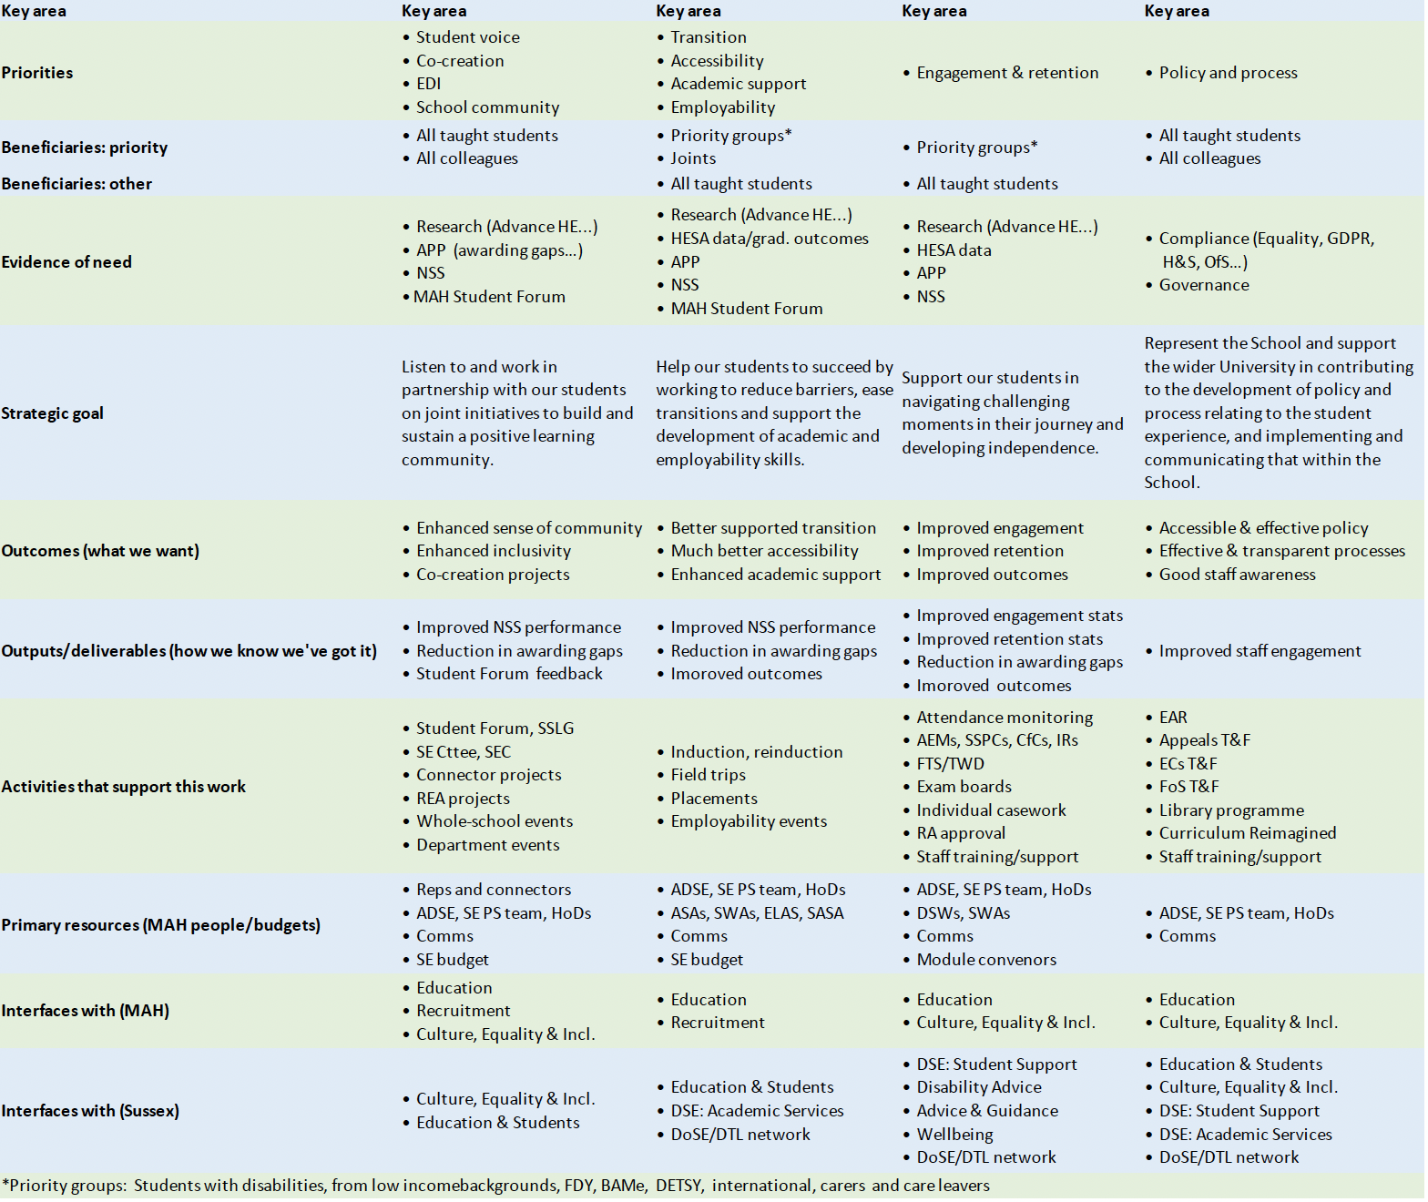

Appendix 2: MAH student experience-related committees

