University of Sussex Risk Assessment and Action Plan 2022-23

Executive Oversight: University Council, Audit and Risk Committee, University Executive Group
Approved by: University Executive Group
Date Approved: 16 March 2020
Last Updated: 23 June 2022
Date of Next Full Review: May 2023

Background:

Section 26 of the Counter-Terrorism and Security Act 2015 (the Act) places a duty on certain bodies (“specified authorities” listed in Schedule 6 to the Act), in the exercise of their functions, to have “due regard to the need to prevent people from being drawn into terrorism”.

The 2011 National Prevent Strategy has three specific strategic objectives, to:
- respond to the ideological challenge of terrorism and the threat we face from those who promote it;
- prevent people from being drawn into terrorism and ensure that they are given appropriate advice and support; and
- work with sectors and institutions where there are risks of radicalisation that we need to address.

In the Higher Education Sector, the Office for Students (OfS) monitors providers’ implementation of the statutory ‘Prevent duty’ in England. Relevant higher education providers are required to comply with the Prevent Monitoring Framework.

University of Sussex Risk Assessment and Action Plan:

Drawing on our compliance obligations, the National Prevent Objectives and consultation with our external partners and key staff and students, this risk assessment and action plan is situated within the University’s specific local and HE sector context. The approach taken is:

- Informed: by our students and our external partners;
- Risk Based: Drawing on our specific sector, local and institutional risk environment;
- Proportionate: in its assessment and mitigation of risk;
- Flexible: to respond to emerging threats and issues (ongoing and dynamic risk assessment);
- Transparent: In the assessment or risk and the communication and implementation of actions.

Local and Sector Risk Context:

The University monitors the local Prevent context through participation in the Brighton and Hove Prevent Board run by the City Council and involving, education, health, law enforcement and local government representatives and through regular liaison with our DfE Regional Prevent Coordinator. In turn, the University shares information about Prevent concerns with the group and contributes to the Counter Terrorism Local Profile (CTLP). Police information briefings, OfS briefs and Channel referral trends also form part of the risk context assessment. Risks are assessed using the University’s Risk Assessment Matrix (refer Appendix 1).

In the Brighton and Hove area, local Prevent activities relevant to the University include the potential influence of the far right in terms of graffiti and online material drawing in vulnerable individuals and the potential for protesters to be influenced by extremists seeking to subvert a specific issue to promote proscribed groups and activities. To address this the University pays specific attention to online activities of students on websites containing extremist material (see Risk No 2.1), monitors external speakers who may have links to extremist groups (see Risk No. 2.2), and makes appropriate referrals and educates staff so that they are aware of far-right symbols which might appear on campus or be displayed on an individual (see Risk No. 1.2).

The University also regularly liaises with our DfE Regional Prevent Coordinator who has provided training and advice to staff and kept the Prevent Lead abreast of emerging trends and issues. Information is also shared with University partners working with our students such as Study Group, IDS, and the University of Brighton (for example through our joint Medical School; see Risk Nos.1.4 and 3.1)

Consultation:

This Risk Assessment and Action Plan has been produced in consultation with the following Stakeholders:

- University of Sussex Prevent Steering Group
- Brighton and Hove City Council
- Department for Education Regional Prevent Coordinator
- University of Sussex Student Union, through the Executive Liaison Group.
- University of Sussex Executive Group (UEG)

Feedback from these groups and individuals has contributed to risk identification and assessment and to actions and strategies outlined below.

Prevent Risk Assessment and Action Plan
National Prevent Objective 1: Respond to the ideological challenge of terrorism and the threat we face from those who promote it
University of Sussex Outcome: Terrorism and extremism are better understood and responsible officers, frontline staff, and the University community are better equipped to recognise indicators and safeguard students and staff.
No. | Risk | Current Controls | Current Rating |  |  | Planned Mitigating Actions | Timing | Owner | Residual Risk Rating
 |  |  | Likelihood | Impact | Risk Rating |  |  |  | L | I | Risk
1.1 | Staff are unaware of the Prevent Duty and do not recognise and act to safeguard vulnerable students and colleagues. | Online Prevent training and seminars provided by the University. Online training mandatory for identified key staff. | 1 | 2 | 2 | 1.1.1 Improved online training, which has been updated with a more relevant case study on Incel culture  1.1.2 Better targeted relevant groups to receive training  1.1.3 Increased profile of Prevent as apart of Safeguarding.  1.1.4 Face-to-face training with identified staff facilitated and including local contextual information (e.g. far right symbols awareness)  1.1.5 Ongoing refresher training offered to key staff. | Ongoing  Ongoing  Ongoing  Ongoing  Ongoing | HR (IP)  HR (IP)  Prevent Lead (NE)  HR (IP)  HR (IP) | 1 | 2 | 2
1.2 | Staff are unaware of the University’s Prevent Policy and Guidelines so do not act to safeguard vulnerable students and colleagues. | University’s Policy and Guidelines on Website and Communicated. | 1 | 2 | 2 | 1.2.1 University Safeguarding Policy written and published on Website.  1.2.2 Updated Safeguarding webpage now encompasses Prevent and contains useful information, key contacts and guidance. The webpage will be updated regularly to incorporate any new relevant information.  1.2.3 Advise staff of University’s policy and guidance as part of online and face-to-face training. | Completed  Ongoing  Ongoing | Director for the Student Experience (JA)  Prevent Co-ordinator (LS)  HR (IP) | 1 | 2 | 2
1.3 | Students unaware of the Prevent Duty fail to identify vulnerable friends or fail to access support services for themselves when needed. | Information about support services available to students online. | 2 | 1 | 2 | 1.3 Student education materials on safeguarding has been updated to give it more visibility. Online materials will be updated as required. | Ongoing | Director for the Student Experience (JA) | 2 | 1 | 2
1.4 | The University fails to keep abreast of the changing ideological challenges of terrorism and ways of identifying those at risk of being vulnerable to extremism and terrorist related activity. | Ongoing monitoring of changing local & HE context through the Steering Group and regular meetings with external partners such as the Brighton & Hove Prevent Board, and our Department for Education Regional Prevent Coordinator.  Strong relationships and regular information sharing between University Security and Sussex Police. | 1 | 3 | 3 | 1.4.1 Contribution to and dissemination of learnings from the CTLP to wider University, as appropriate.  1.4.2 Ensure Prevent issues are discussed and trends and concerns continue to be shared with internal partners. | Ongoing  Ongoing | Prevent Lead (NE)  Director for the Student Experience (JA) | 1 | 3 | 3
National Prevent Objective 2: Prevent people from being drawn into terrorism and ensure that they are given appropriate advice and support
University of Sussex Outcome: Using a risk-based approach, individuals vulnerable to being drawn into terrorist related activities are identified at an early stage with support and intervention provided to reduce risk.
No. | Risk | Mitigating Action (existing) | Likelihood | Impact | Risk Rating | Planned Mitigating Actions | Timing | Owner | Residual Risk Rating
2.1 | Vulnerable individuals are drawn into terrorist related activities through online use and are not identified early and provided with support and intervention. | IT monitoring of internet activity relating to websites containing extremist material and follow-up action and referrals | 2 | 3 | 6 | 2.1.1 Early engagement with external experts and Channel referral process.  2.1.2 Consider current staff and student information and training to build digital resilience and awareness about online safety.  2.1.3 A process for IT monitoring has been established in line with the acceptable use policy of Jisc, the University’s internet provider. This ensures parity of treatment and updates the list of our flagged sites as appropriate.  2.1.4 Consider what options are available to the University to proactively discourage viewing of websites containing extremist material. | Ongoing  Ongoing and part of the cyber security programme  Ongoing  Ongoing | Prevent Lead (NE)  Prevent Lead (NE) and ITS  Prevent Steering Group to have oversight. Prevent Co-ordinator (LS) works collaboratively with ITS.  Prevent Steering Group to have oversight. Prevent Co-ordinator (LS) to work with ITS and DfE and Police Prevent Co-ordinators. | 1 | 3 | 3
2.2 | Failure to balance freedom of speech with Prevent monitoring duties to monitor and mitigate external speaker activity which risks drawing vulnerable individuals into extremism or terrorist related activity. | Freedom of Speech Code of Practice and External Speakers Procedures promulgated online.  External speakers risk assessed by relevant USSU or University officers and appropriate mitigations put in place. | 1 | 2 | 2 | 2.2.1 External Speaker Procedure and Freedom of Speech Code of Practice have been fully reviewed. There is a new online procedure, which includes a new External Speaker Request E-From, within the General Counsel, Governance and Compliance webpage which is managed by the Senior Manager, Governance and Compliance.  2.2.2 To consider the Higher Education (Freedom of Speech) Bill and any implications for the University when reviewing the policies outlined in 2.2.1 above. | Completed  Completed | Prevent Co-ordinator (LS)  Prevent Co-ordinator (LS) | 1 | 2 | 2
National Prevent Objective 3: Work with sectors and institutions where there are risks of radicalisation that we need to address
University of Sussex Outcome: Ensure partnerships within and outside of HE to share information and strategies in furtherance of Prevent Objectives
No. | Risk | Mitigating Action (existing) | Impact | Likelihood | Risk Rating | Planned Mitigating Actions | Timing | Owner | Residual Risk Rating
3.1 | Failure to engage with partners on local context leads to individuals being radicalised. | Ongoing meetings and workshops with key Prevent partners (BHCC, DfE) to share information and reduce risk of radicalisation. | 1 | 2 | 2 | 3.1.1 Continue to maintain regular engagements with internal stakeholders to share information and strategies in furtherance of Prevent Objectives.  3.1.2 Face to face training as required with DfE Prevent Co-ordinator and/or Police Prevent Co-ordinator | Ongoing  Ongoing | Prevent Steering Group  Prevent Co-ordinator (LS) | 1 | 2 | 2
Statutory Prevent Duty
University of Sussex Outcome: Meet and review OfS and wider Statutory Prevent Compliance obligations
No. | Risk | Mitigating Action (existing) | Impact | Likelihood | Risk Rating | Planned Mitigating Actions | Timing | Owner | Residual Risk Rating
4.1 | Failure to undertake timely reporting to the University Executive, Chairs’ Committee and Council leading to unfulfilled Prevent accountabilities. | Monthly Prevent Reports to the University Executive Group; termly Prevent Reports to Council to ensure appropriate governance and management oversight of Prevent obligations | 1 | 2 | 2 | 4.1.1 Ongoing review and refinement of training and reporting for UEG, Chairs’ Committee and Council.  4.1.2 Robust governance arrangements in place to ensure compliance. | Ongoing  Ongoing | Prevent Lead (NE)  Prevent Co-ordinator (LS) | 1 | 2 | 2
4.2 | Failure to discharge Prevent reporting requirements to the OfS and other related authorities. | Training and information provided to executive officers and close monitoring of OfS and other Prevent Duty reporting and compliance obligations | 1 | 2 | 2 | 4.2.1 Ongoing review and attention to reporting deadlines and obligations. | Ongoing | Prevent Lead (NE) | 1 | 2 | 2
4.3 | Failure to coordinate Prevent related information and improve understanding of student populations in the City leads to terrorist related activities. | Engagement with BHCC to improve understanding of student populations and ensure appropriate support and communication. | 1 | 3 | 3 | 4.3.1 Ongoing engagement with BHCC and DfE Prevent Coordinator to share intelligence and Prevent strategies. | Ongoing | Prevent Steering Group | 1 | 3 | 3
4.4 | Failure to comply with OfS Prevent Duty Framework as a result of the decisions made by the USSU to not engage with Prevent and UCU’s communication to its members suggesting they should not engage with Prevent. | On 21 July 2022 the new USSU Sabbatical Officers received training from the Head of Governance Services in relation to HE regulation. This also included sharing information about the University of Sussex Safeguarding Policy and the External Speaker Procedure and Freedom of Speech Code of Practice.  The Sabbatical Officers were invited to receive an input from DfE Prevent Co-ordinator on the Prevent Duty. They were also invited to receive an input from the Senior Manager, Governance and Compliance, on the University’s responsibilities under the Prevent Duty.  The Sabbatical Officers declined to receive these two Prevent inputs due to the Students’ Union current position on the Prevent Duty.  Instead, the Sabbatical Officers have been invited to meet with the Senior Manager, Governance and Compliance who will provide them with information on how the University discharges its duty under the Prevent Duty, and what it actually means on a practical level, in order to provide some context.  Reminding UCU of the contractual obligations of staff to engage with Prevent so that the University can discharge its legal obligations.  Offer of representation on the Prevent Steering Group. | 1 | 2 | 2 | 4.4.1 As new USSU Sabbatical Officers are appointed they will be required to attend a training session on various Governance aspects and will be invited to receive an input from the DfE Prevent Co-ordinator on the Prevent Duty. | Ongoing | Prevent Co-ordinator (LS) and Head of Governance Services (SP) | 1 | 2 | 2

University of Sussex Risk Management Matrix 2021
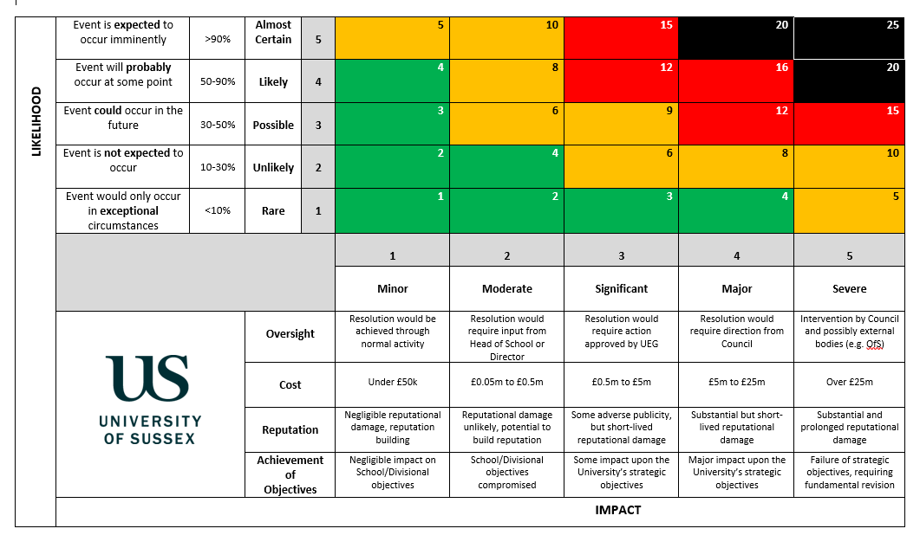

Staff includes the staff apprenticeship scheme
Action shared with BHCC and noted in their Action Plan
As above
Action shared with BHCC and noted in their Action Plan
https://www.officeforstudents.org.uk/publications/prevent-duty-framework-for-monitoring-in-higher-education-in-england-2018-19-onwards/

