The Fast Read Scheme of Work
Template – use for your own book choice
Section 1: Text overview and rationale
Brief overview of the text:
Introductory links:
Key themes:
Key vocabulary:

Section 2: Key reading strategies
The following section summarises Sutherland and Westbrook’s (2023) reading strategies that underpin The Fast Read process. These strategies have been woven through the Scheme of Work.
- Questioning, clarifying, summarising, predicting

- Inferring, by applying knowledge to the text (e.g. self-text, world-text, or text-text knowledge). Students must infer at the levels of word, sentence, paragraph, chapter and whole text.
- Word & sentence levels (e.g. inferring new vocabulary from the context, or inferring that ‘He’ in the 3rd sentence is the same as ‘Tommo’ in the first sentence)
- Paragraph level – inferring that the setting is a beach, even though the word ‘beach’ is not given in the text from, by connecting all the clues in a paragraph: pebbles, waves, Brighton, ice-cream. The same inference skills are required for the reading of short stories, where readers are invariably expected to infer setting, period, character details and relationships without any explicit reference (e.g. ‘Samphire’, O’Brien)
- Knowledge-based inferences: many inferences require students to apply knowledge to the text so you need to ensure that they have this knowledge and that they know how to apply it. e.g. historical knowledge of WW1; knowledge of autistic spectrum condition for The curious incident of the dog in the night-time, etc.
- Exploring examples of visual texts, where the viewer has to make inferences to ‘understand’ the picture/photograph is a helpful way of illustrating how to infer so students can transfer this approach to written texts. Teaching readers to keep asking questions, while applying their knowledge, is also particularly helpful. E.g. Based on the opening pages of The Curious Incident: ‘What kind of person would kill a dog with a pitch-fork?’ ‘And why? What has caused them to behave like this?’

- Making connections across the text. The best way of enabling students to make connections is by you knowing the text very well and modelling this, by pausing at key moments in the reading to ask: ‘When did we last see Walter Cunningham in the book? What was he doing and how do you think this connects with the incident here?’ Ask them to practise making connections like this in guided reading groups.

- Monitoring your comprehension – Stop! ‘I’m stuck! I don’t understand this bit at all…’ The purpose of guided reading is for all readers to monitor the group’s comprehension (see overleaf). But a good way of teaching this is to model how you read and get ‘unstuck’ when you come across a problem in reading, using a ‘thinking aloud’ approach: ‘I’m going to show you what I do when I read. I’m stopping here to clarify what these two words mean: scapegoat and xenophobia. Scapegoat means…but I’m going to try to infer what xenophobia means from the surrounding context, drawing on my understanding of what’s going on, and because I know what half the word – phobia – means (e.g. claustrophobia), so xenophobia might mean…’

- Using vocabulary strategies to infer new words
Show students how to infer the meaning of unfamiliar words in texts, using clues of: sentence-structure and grammar as well as clues in the surrounding, semantic context of the word. Encourage students to be detectives and look for clues in the shape of the word (morphology), e.g. to break the word into the root or stem & the suffixes/prefixes – militate = milit + ate: ‘ate’ is a common suffix used to create a verb from a noun: orchestrate, chlorinate, administrate. What other words do students know with ‘milit’ in them? (e.g. military).You can also use other texts to support new vocabulary, exposing them to the same word in different contexts – e.g. using non-fiction and media texts to teach the context of a novel such as Now is the Time for Running, set in Zimbabwe and South Africa and being about refugees.

- Understanding how stories are structured (story-structure & different genres), using graphic organisers and applying this understanding to the shared reader. Use narrative timelines, family trees, plot/event charts, tension graphs, story-mountains, emotion wheels, ‘oppositions’ charts of characters/events, etc. This helps students comprehend the plot & whole text, especially with dual or other complex narratives (e.g. Private Peaceful), Timelines and other diagrams can be displayed on walls & in books as a constant visual reminder. (see www.scholastic for some good examples).

- Exploring ideas with other readers (discussion)
See Voice21 Student Talk Tactics to help with developing discussion tasks: Voice21-ClassroomPracticeToolkit-StudentTalkTactics.pdf

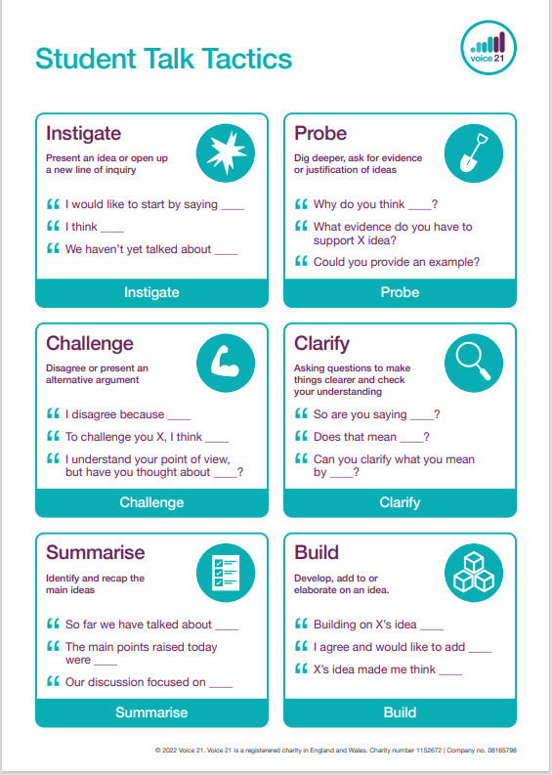

In addition, the following Reading Strategy cards have been produced to help with embedding these strategies in the classroom):

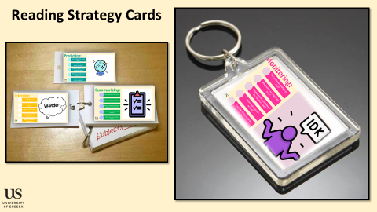
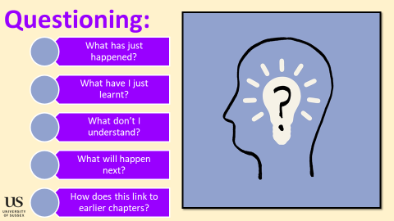 | 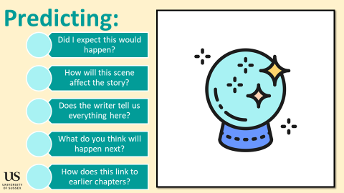 | 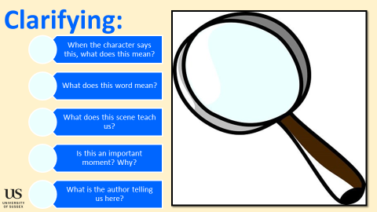 | 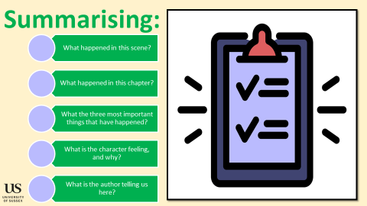
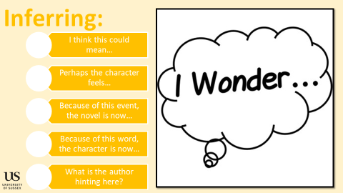 | 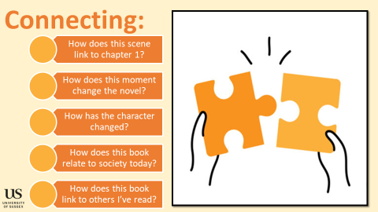 | 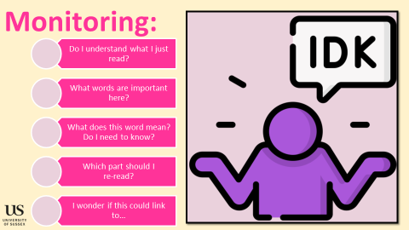 | 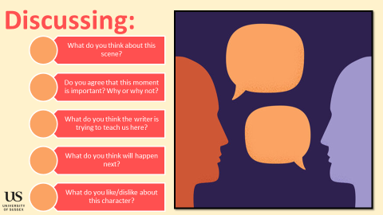

Section 3a: A bird’s eye view
Use this section to map the reading of the text you have chosen. Reading and the teaching of reading skills is the prime focus of the SoW. Ideally, all reading will be done by week 4.
Week | Lesson 1/  hour 1 | Lesson 2/  hour 2 | Lesson 3/  hour 3 | Key reading aim for the week
1 | Read chapters __ | Read chapters __ | Read chapters __ | - Explicit teaching of questioning, clarifying, summarising, predicting;  - Explicit teaching of using vocabulary strategies  -Modelling expressive reading
2 | Read chapters __ | Read chapters __ | Short piece of writing (not at all an assessment, but a brief piece of writing for marking) | - Explicit teaching of inference  - Setting up ‘reading groups’  - Explicit teaching of making connections across the text  - Introducing short reading groups (i.e. two – five minutes of group reading)  - Short piece of writing for feedback
3 | Read chapters __ | Read chapters __ | Read chapters __ | - Explicit teaching of monitoring your comprehension  - Embedding group reading tasks (i.e. ten minutes/full chapters)
4 | Read chapters __ | Read chapters __ | Give feedback from previous piece of writing | - Students use their repertoire of strategies to finish their reading  - Give students feedback based on previous writing
5 | Character/text analysis: | Character/text analysis: | Character/text analysis: | - Students use their previous plotting tasks to help them with three character analysis questions
6 | Character/text analysis: | Connect this text to another you’ve read | Connect this text to another you’ve read | - Students use their previous plotting tasks to help them with three character analysis questions

Section 3b: lesson by lesson
Questioning | Clarifying | Predicting | Summarising | Inferring | Connecting | Monitoring | Discussing

Week and lesson |  | Main task | Group tasks | Key reading strategies | Explicit vocabulary
Week 1 | Lesson/hour 1  Learning Objectives: | 5 minutes - starter:  5 minutes – new learning: show students key reading strategies; explain the ‘Fast Read’ approach.  Approx. 30 minutes: Begin extended reading  Approx. 20 minutes: Questions you may choose to use throughout your reading/at the end of your reading (NB. You may use questions at the end of the four chapters, or briefly punctuate and ask students to discuss during reading). |  | Predicting  Questioning  Clarifying
Week 1 | Lesson/hour 2  Learning Objectives: | 5 minutes - starter:  5 minutes – new learning: teach two new key words  -  -  Approx. 40 minutes: Begin extended reading  Final task: give students plotting task; this will require them to go back and summarise the text so far.  Option: model high-quality summaries under the visualiser/on the board.  Option: adapt the plotting task to suit students’ needs. |  | Clarifying  Summarising
Week 1 | Lesson/hour 3  Learning Objectives: | 5 minutes - starter:  5 minutes – recap of the four key skills explored this week.  Approx. 40 minutes: Begin extended reading  Students should start to bring the four skills together today and can explicitly name and use them.  Final task: give students plotting task; this will require them to go back and summarise the text so far. |  | Predicting  Questioning  Clarifying  Summarising
Week 2 | Lesson/hour 1  Learning Objectives: | 10 minutes - starter:  10 minutes – introduce the key strategies of inferring and discussing. Explain ground rules for group reading tasks.  Approx. 40 minutes: Begin extended reading.  Teacher begins reading, and then groups read following chapters aloud and together.  Teacher to have question tasks focusing on inference and discussion to follow reading. Have this ready in advance as groups will read at different paces – i.e., ‘when you are finished, move onto this…’ | Set up class reading groups. These should be carefully designed. Each lesson, the amount of group reading will increase. | Inferring  Discussing
Week 2 | Lesson/hour 2  Learning Objectives: | 10 minutes - starter:  5 minutes – new learning: teach two new key words:  -  -  Approx. 30 minutes: Teacher begins reading the first few pages, and then hands over to groups  Teacher to have question tasks focusing on inference and discussion to follow reading. Have this ready in advance as groups will read at different paces – i.e., ‘when you are finished, move onto this…’  Final task (use remaining time of lesson): inference task and independent writing |  | Inferring  Discussing  Connecting
Week 2 | Lesson/hour 3  Learning Objectives: | 10 minutes - starter:  Approx. 20 minutes: Students read together from the off. Teacher may pose some clarifying questions, but otherwise, students begin their reading.  30 minutes: final task  Short piece of inference/analytical writing. |  | Inferring  Discussing  Connecting
Week 3 | Lesson/hour 1  Learning Objectives: | 10 minutes - starter: students recap the reading skills we have covered using a very short extract.  Approx. 40 minute group reading: students get into their reading groups and to read chapters 22-24. Students should focus in on their inference, discussion and connecting skills. |  | Inferring  Discussing  Connecting
Week 3 | Lesson/hour 2  Learning Objectives: | 10 minutes - starter:  Approx. 40 minute group reading (plus the explicit teaching of monitoring):  Give students prompts to use whereby they read a section and check they have understood. Model this to show them how this looks. This element of reading may take more time as students should now be asking each other what words mean/how the text links together. Use the key cards to help students with these prompts. |  | Monitoring
Week 3 | Lesson/hour 3  Learning Objectives: | 10 minutes - starter:  Approx. 30 minute group reading:  Give students prompts to use whereby they read a section and check they have understood. Model this to show them how this looks. This element of reading may take more time as students should now be asking each other what words mean/how the text links together. Use the key cards to help students with these prompts. |  | Monitoring
Week 4 | Lesson/hour 1  Learning Objectives: | 10 minutes - starter:  Approx. 30 minute group reading:  10 minutes – final thoughts: students return to their summaries from the starter, and add to their thoughts now they have read the final chapters. |  | Students use their repertoire of strategies
Week 4 | Lesson/hour 2  Learning Objectives: | Lesson given over to allow for additional reading time. This lesson has been kept free to account for disruptions in the term/missed lessons/students still needing time to finish the book.
Week 4 | Lesson/hour 3  Learning Objectives: | Give feedback from previous piece of writing  Lesson left clear for teachers to give students feedback based on their earlier piece of writing (i.e. a reteach/DIRT lesson) – schools to follow their assessment/reteach policy.
Week 5 | Lesson/hour 1  Learning Objectives: | 10 minutes – starter  45/50 minutes – character/text analysis:  Students to re-read chapters  Students read independently or in groups using their reading skills.  Students refer to their earlier summaries from their ‘plotting’ task. |  | Students use their repertoire of strategies
Week 5 | Lesson/hour 2  Learning Objectives: | 10 minutes – starter  45/50 minutes – character/text analysis:  Students to re-read chapters  Students read independently or in groups using their reading skills.  Students refer to their earlier summaries from their ‘plotting’ task. |  | Students use their repertoire of strategies
Week 5 | Lesson/hour 3  Learning Objectives: | 10 minutes – starter  45/50 minutes – character/text analysis:  Students to re-read chapters  Students read independently or in groups using their reading skills.  Students refer to their earlier summaries from their ‘plotting’ task. |  | Students use their repertoire of strategies
Week 6 | Lesson/hour 1  Learning Objectives: |  |  | Students use their repertoire of strategies
Week 6 | Lesson/hour 2  Learning Objectives: |  |  | Students use their repertoire of strategies
Week 6 | Lesson/hour 3  Learning Objectives: |  |  | Students use their repertoire of strategies

