Sackler EEG/ECG
TRAINING MANUAL

GENERAL WORKING PROCEDURES

DIAL 3333 IN CASE OF EMERGENCY

NEAREST FIRE ALARM Corridor
NEAREST FIRE EXTINGUISHER By Lift
NEAREST EYEWASH BOTTLE Bookcase
NEAREST FIRST AID STATION By Lift
NEAREST EYE WASH STATION By Lift

WORKING WITH PARTICIPANTS

ILLNESS If either you or your participant is suspected of being ill, the research booking should be cancelled and if possible, rescheduled. Please advise
participants not to attend if they feel ill prior to the session.

SCENT-FREE You should provide a scent-free environment for your participants.

WORKING ALONE

REDUCING RISK If you suspect you are working alone in the building, there are two things
you can do to minimize risk: a) ring security (3333) to inform them
where you are working and how long you expect to be working, b) ring
an independent party to also let me know where you are working and how long you expect to be working. Either party can ring to check on you
thorough the working period, and you should call relevant parties when
you are leaving.
WEEKENDS Give special consideration to these issues at the weekend, when it is
more likely that you will be working alone.

HANDLING MONEY

REDUCING RISK Make sure money is always securely stored. Whenever possible, prepare
money without the participant present so the location of the money can be kept confidential.
EMERGENCY PROCEDURES

DIAL 3333 IN CASE OF EMERGENCY
There is a phone located under the TMS within the testing room

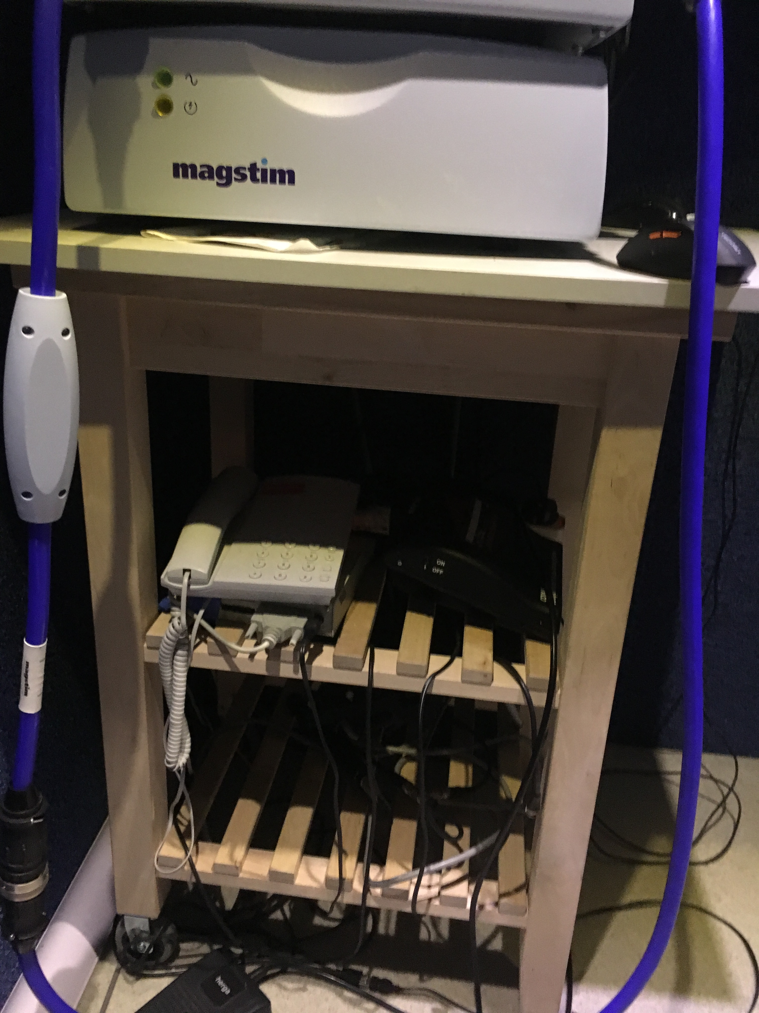

NEAREST FIRE ALARM Corridor
NEAREST FIRE EXTINGUISHER By Lift
NEAREST FIRST AID STATION By Lift

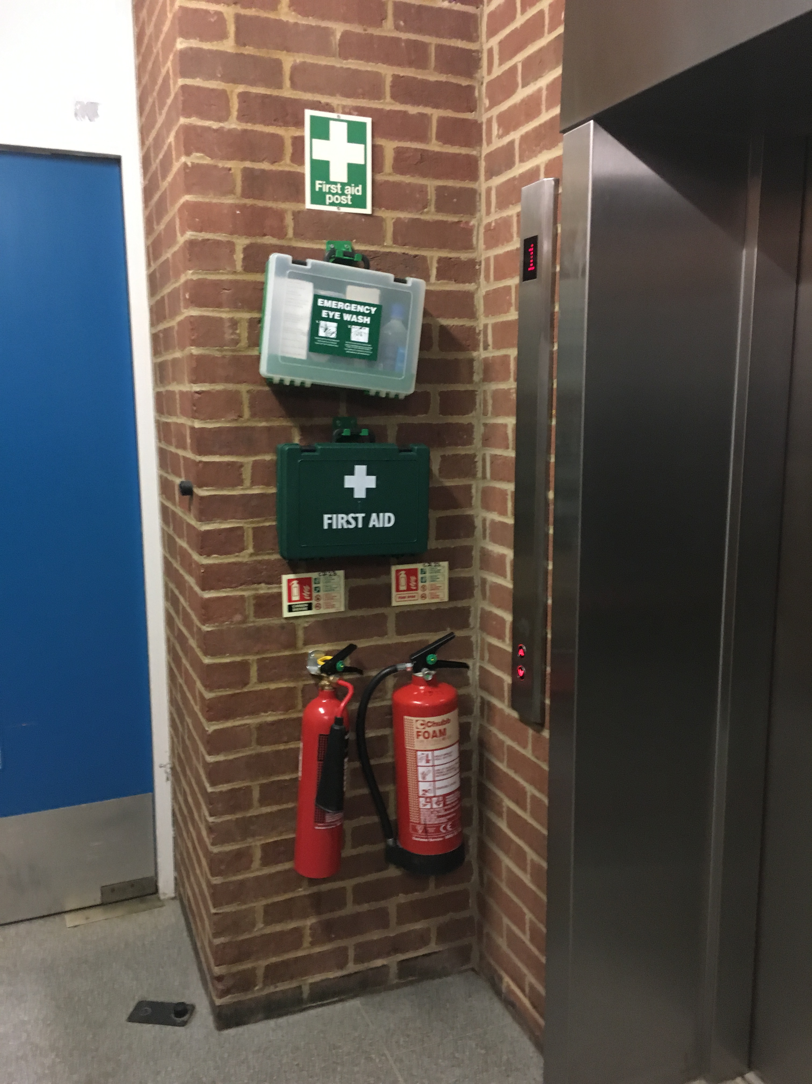

IN ALL CASES OF DOUBT OR WHEN SYMPTOMS PERSIST,
ALWAYS SEEK MEDICAL ATTENTION
METRICIDE USE

METRICIDE – Always keep the container lid tightly closed when not in use!
(ALWAYS wear lab coat, eye goggles and chemical gloves when using)

INGESTION If swallowed, may irritate mouth, throat and intestinal tract. Ingestion of glutaraldehyde may cause nervous system effects including nausea, dizziness, headache, and drowsiness. Do not ingest. Call physician or Poison Control Center immediately. Induce vomiting only if advised by appropriate medical personnel. Never give anything by mouth to an unconscious person.
EYE CONTACT Causes severe irritation with possible burns. Check for and remove contact lenses. Flush thoroughly with water for at least 15 minutes, lifting upper and lower eyelids occasionally. Get immediate medical attention (eye wash station).
SKIN CONTACT May cause skin irritation. Remove contaminated clothing. Flush thoroughly with mild soap and water. If irritation occurs, get medical attention.
INHALATION Vapors may cause irritation of the nose, throat and upper respiratory tract. Repeated inhalation of glutaraldehyde vapors may cause asthmatic symptoms in some individuals, including cough, wheezing and difficulty breathing. Remove to fresh air. If not breathing, give artificial respiration. If breathing is difficult, give oxygen. Get medical attention.
SPILL Dilute with water, absorb with an inert dry material (towels), sweep up and place in suitable container for disposal (regular garbage). Wash spill area with soap and water.

KEY ANT EEG SAFETY PROCEDURES

DIAL 3333 IN CASE OF EMERGENCY

NEAREST FIRE ALARM Corridor
NEAREST FIRE EXTINGUISHER By Lift
NEAREST EYEWASH BOTTLE Bookcase
NEAREST FIRST AID STATION By Lift
NEAREST EYE WASH STATION By Lift

Consumable disposal

Disposables such as cotton wool, alcohol pads and stickies can be disposed of in the regular waste.

Syringes and blunt needles should be disposed in a Sharps Box

Sharps Box must be returned to Life Science Stores when full

Metricide use

Always wear lab coat, eye goggles and chemical gloves when handling Metricide

Metricide, is replaced by lab manager every 28 days

DO NOT replace Metricide yourself.

See Metricide Log next to sink for replacement dates.

DO NOT use Metricide if it is past the deactivation date.

STANDARD OPERATING PROCEDURES

BEFORE SESSION

Participant should have washed hair before without applying hair products
Participant should wear layered clothing.
Has participant been to bathroom?

Prepare on disposable towel
- syringe with gel (always fill and refill syringe without needle attached)
- stickies
- tape measure
- alcohol pads - micropore tape

Switch on power at all wall sockets
Make sure the cage monitor and computer are running and displayed

Turn on baby-bottle warmer to heat the gel, the ideal temperature has been permanently marked on the dial. DO NOT adjust the temperature.

SETTING UP THE AMPLIFER

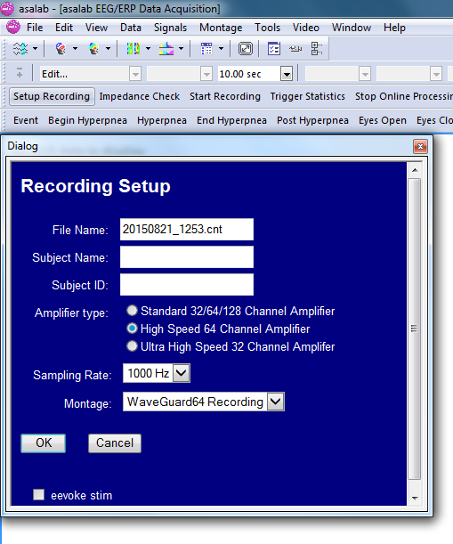

Start up ASALab > Setup Recording

- Change the filename appropriately
- Sampling rate is 1000Hz (1kHz)
- The standard Montage is WaveGuard64 Recording

Make sure ANT amplifier is turned ON

Click OK

EEG should be running (but not recording)

PARTICIPANT CAPPING

For privacy, please make sure the door is closed to the EEG area

Using tape measure, measure participant nasion (bridge of nose) to inion (bump at back of head). Ask the participant to hold the tape measure at the nasion to help you.
Measure head circumference and select cap size (if participant is close to a boundary, select smaller cap size)

Large 56-61cm (blue trim)
Medium 51-56cm (red trim)
Small 47-51cm (yellow trim)

When first fitting the cap, ask the participant to look up at the ceiling, place the front of the cap on the forehead and ask the participant to hold it in place and slowly bring their head down.

Fit cap symmetrically and ensure that Cz is halfway between nasion and inion measurement
FPz should be 10% up from nasion

Click on Check Impedences

This will show a top view of the electrode cap. The job now is to turn all the red circles into blue circles (i.e., lower impedences).

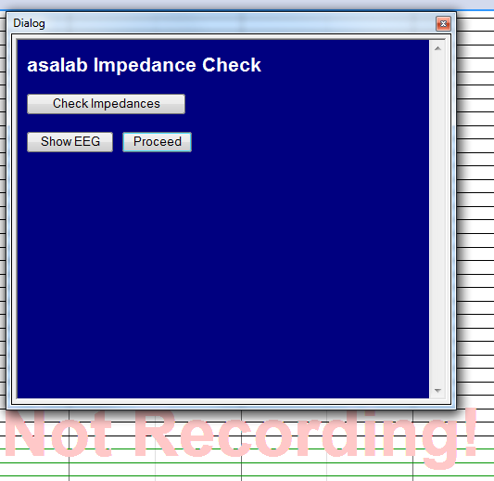
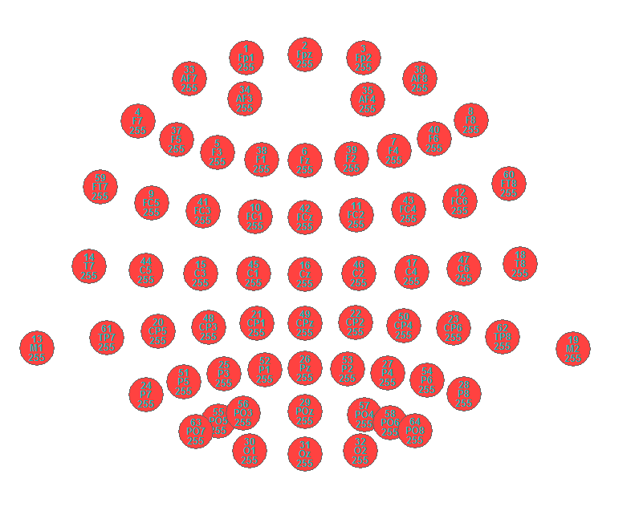

To insert the warm gel, part hair by moving syringe in a left to right motion, insert gel at the same time as drawing syringe upwards, to leave a column of gel.

DO NOT grind away at the scalp if it is not turning blue! Impedances will often lower as a function of time. If not, the issue is usually you need a little (though not much more) gel.

You will also need to attach bipolar HEOG and VEOG electrodes. Clean sites before hand using neuprep and alcohol swabs, sites should include VEOG, HEOG, forehead and mastoids. To insert gel on 4 external electrodes, attach stickies to drop-downs, tab parallel to the wire. Place a small amount of gel on the middle circle of the electrode using syringe. Fit the electrode with the tab (and lead) hanging down.

The current configuration on the headbox should be

Red Black
Channel 65 (HEOG) To right of right eye To left of left eye
Channel 66 (VEOG) Below left eye Above left eye

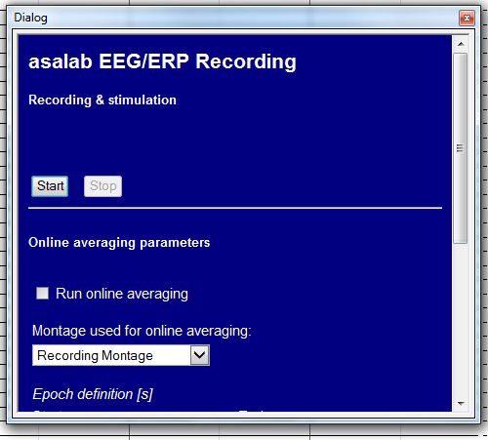

Click Start

The 'Not Recording!' prompt should disappear and the background of the EEG display should turn yellow. This means you are recording.

Do not use an operating cellular phone within 30 cm of the amplifier, the cables and the
electrodes to avoid excessive noise on the signals.

ECG Procedure
Information
ECG (electrocardiogram) measures the electrical activity of the heart muscle. As such, it is a much stronger signal than that measured by EEG. Familiarize yourself with the usual profile of an ECG signal (https://en.wikipedia.org/wiki/Electrocardiography) and the Triangle of Einthoven (https://en.wikipedia.org/wiki/Einthoven's_triangle). For the vast majority of our uses in cognitive neuroscience we are most interested in the largest positive peak in the ECG signature, the R wave. All other ECG signature landmarks (e.g., the t-wave, commonly associated with systole) can be computed/measured from the R-wave. In our lab’s experience, the R-wave is easily measured by attaching electrodes to the wrists (just behind the back of the hand), but occasionally it might be preferable to measure the ECG from electrodes attached the chest (for example, when participants must make extensive arm or hand movements). Please note, for obvious issues of participant privacy, placement of electrodes on the wrist rather than chest is much preferable. It is unlikely that hand/wrist movements such as button pressing, wrist flexion, etc. will interfere with ECG measured from the wrist. It is your job as a researcher to pilot your own experiment and check this out before participant recruitment.

In short: place ECG electrodes on the wrists rather than the chest unless the latter is absolutely vital. If a decision is made to measure ECG from the chest, this must be verified by a senior Sackler researcher (post-doc or above).

In all cases, the participant should be informed in advance how and why ECG will be measured (i.e., at the point of participant recruitment using written information sheets). ECG should also be outlined in the Instruction and Consent forms explicitly. Participants should also be asked verbally when they arrive that they understand that ECG will be measured, and how this will be done. In all situations, the participants’ comfort must be maintained. If a participant objects to ECG measurement, the measurement should be abandoned. This level of care is to ensure the safety and comfort of both participant and researcher.

ECG measurement:
The basic procedure for ECG measurement is simple. The “electrodes” are simple sticky pads with a press-stud backing (see pictures). To ensure a good signal, the areas where the electrodes will be applied should be cleaned using alcohol wipes. The electrode pads can then be applied. The two ECG electrode leads should then be attached to the sticky pads; in all cases, red lead goes to the participants’ left electrode site, the black to the right. The participant should do all of these stages after the experimenter has demonstrated the procedure. If the ECG electrodes are applied to the chest, the experimenter must leave the EEG booth to allow privacy. Please note, the profile of the ECG signal seen in the EEG software will be inverted compared to most ECG images you will see, because by default the EEG software plots negative voltage upwards on the Y-axis. Overleaf is an image of ECG application procedure.
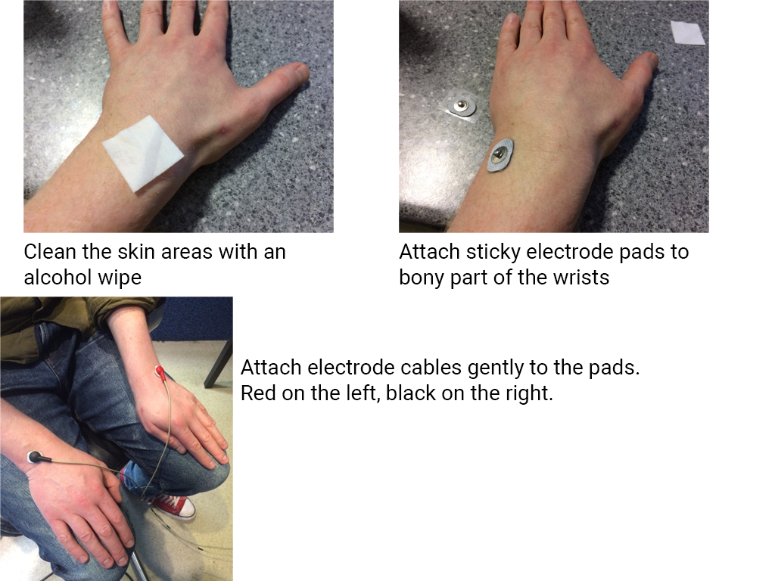
PARTICIPANT CLEANING

Make sure you have stopped recording and switched off the ANT amplifier.

First things first, detach the participant from the cap. Take off external electrodes by pulling on white tabs. Take off cap.

Place cap and electrodes in regular bowl and ensure connectors are well protected from water (use zip-loc bag) and away from the area the participant needs to use to clean themselves. Allow the participant as much time as they need.

POST-PARTICIPANT CLEANING

Disposables such as cotton wool, alcohol pads and stickies can be disposed of in the regular waste. Gel from syringe can be squeezed onto the deposable towel, which can be thrown in regular garbage.

Syringes and blunt needles should be disposed in a Sharps Box

Sharps Box must be returned to Life Science Stores when full

Participant’s towel should be placed in laundry bag.
Wash hands if you have handled a dirty towel.

CAP CLEANING

Prepare
- container of Metricide
- chemical gloves
- eye goggles
- lab coat
- disposable towel
- Timer
- washing up liquid

Always wear lab coat, eye goggles and chemical gloves when handling Metricide

Check the activation and deactivation date of the Metricide

If you’re within the deactivation you can use the Metricide
If you’re outside of the deactivation date you will need to contact the lab manager: D.schwartzman@sussex.ac.uk Tel: +44-1273-67-8213

Clean external electrodes separately using just water.
Clean cap under tap. All electrodes and cap holes should be free of gel (you can use a syringe or waterpik and squirt water through the cap holes- make sure you do this underwater!)
Rinse cap and electrodes with water

Replace lab coat, eye goggles and chemical gloves
Place the cap inside the Metricide bucket.
Make sure the connectors are SECURE OUTSIDE the bucket.
Ensure all parts of the cap are covered and submerge for 5 minutes using stopwatch
Thoroughly rinse the cap with warm water 3 times for a minute each, every time using fresh water from the tap.

LAST BITS

Place electrode cap on wig-stand and drop-down electrodes on coat rack
Ensure that the connectors are higher than the caps and away from water / moisture.
Make sure you note which cap you used and record any problems with recording in the ERP log on the recording computer.

Contact lab manager if you have any issues with the recording or equipment, please let him know if we are running low of any consumables.

BACK UP YOUR DATA!
CONFIRMATION

NAME: ______________________________________

I CONFIRM THAT I HAVE READ, UNDERSTOOD AND WHERE APPROPRIATE SIGNED THE FOLLOWING DOCUMENTS

SACKLER TRAINING MANUAL ______

OUT OF HOURS SOP ______

METRICIDE 28 SAFETY DATA SHEET ______

COSHH ASSESSMENT (SIGNED) ______

SCORED 100% ON EEG LAB QUIZ ______

SIGNATURE: _______________________________ DATE: _________________

