Reception Summer Term

Our Learning Journey is …

Buzz, Buzz, Buzz!!!
YUMMY HONEY
Where does honey come from?

YOUNG SCIENTISTS Learning to research
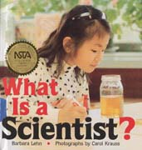

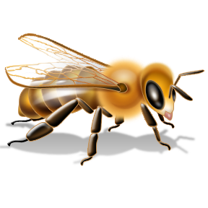
BEE EXPERT
Becoming Bee Experts

The bee’s busy role


THE BEEKEEPER
The job of a bee keeper
FLOWER POWER
Discovering the problems
effecting the bees population
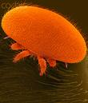
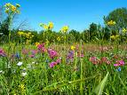

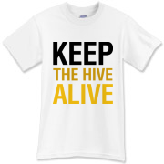

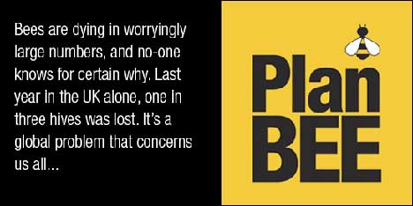

SAVE THE BEE
Becoming campaigners and raising the
awareness of the honey bees plight.

In school we will enrich this learning by..
cooking lots of delicious recipes that include honey.
Going on a bee hunt.
Seeing bees in a Laboratory environment and meeting real scientists.

Growing wildflowers, instruction by a professional gardener and interviewing her on developing a bee friendly habitat in our school.
Visit from a Bee Keeper.

Learning how to raise the publics awareness from a visiting newspaper journalist.

You might like to join in our Journey at home by…
Reading
Visiting
visit the local library and read anything
on bees, keepers, roles in the colony
farm shops who support local bee farms Infinity Foods wide selection of honey
Doing
making a hive
cooking with honey
go on a bee hunt
make a window box full
Watching
of flowers bees love
researching the bee on
the internet clips from the movie Bee Movie
visit websites: www.helpthehoneybees.com
www.britishbee.org.uk
Help!?
Do you have artefacts, experiences, information that could add to this work?

