Initial PEEP – Pending Student Engagement.
PERSONAL EMERGENCY EVACUATION PLAN
This PEEP has been produced in accordance with the requirement of Residential Plans Regulations 2025, and the Fire Safety (England) Regulations 2022.
Name: |  | Insert photograph here
Registration Number: |  | Insert photograph here
Department: |  | Insert photograph here
Residential Building: |  | Insert photograph here
Timetabled Areas: |  | Insert photograph here
Contact details: |  | Insert photograph here
AWARENESS OF PROCEDURE
Can you be notified (hear) by the existing fire alarm system? Yes/No (delete as appropriate)
PERSONALISED EVACUATION PROCEDURE
(A step by step account beginning with the alarm).
Condition (information provided by the disability advisory team)

Residential Accommodation

University Areas

Item No. | Actions Required | Owner
1
2
3
Item No. | Recommendations | Owner
1
2
3

METHODS OF ASSISTANCE (e.g., Methods of guidance, transfer procedures etc)

EQUIPMENT REQUIRED (including means of communication, use of evac-chairs etc)

MONITOR AND REVIEW
Rehearsals could take place during pre-planned fire drills. If there are any significant changes to locations or conditions this is important either the School or XXXX, then asks for a review of this PEEP.

Signed by H&S Advisor |  | Date
Signed by School |  | Date
Signed by Individual |  | Date
Please note: The HS&W team will default to an assumption that the signatories accept this PEEP unless otherwise notified.

Refuge Communication Overview
The refuge areas containing a communication system called “Alerter” (green boxes) which are pre-addressed so security will know where you are. | 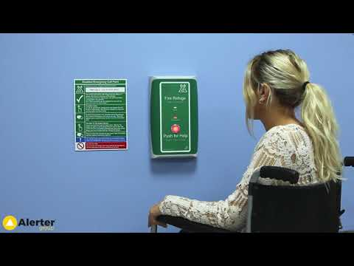
First, press the red button (no need to hold) and wait when security call back and have finished speaking. Then press and hold the red button to communicate, the system is in effect a walkie-talkie style communication press to talk.

The refuge areas (generally staircases) are a place of relative safety. It is important you let security know where you are, So the security team/fire wardens can assist in your evacuation if required. You can take with you a friend to stay with you during the incident. If after a period you decide you are well enough to self-evacuate, you must tell security this is what you are doing so they can account for you.

Current Bell Testing Times

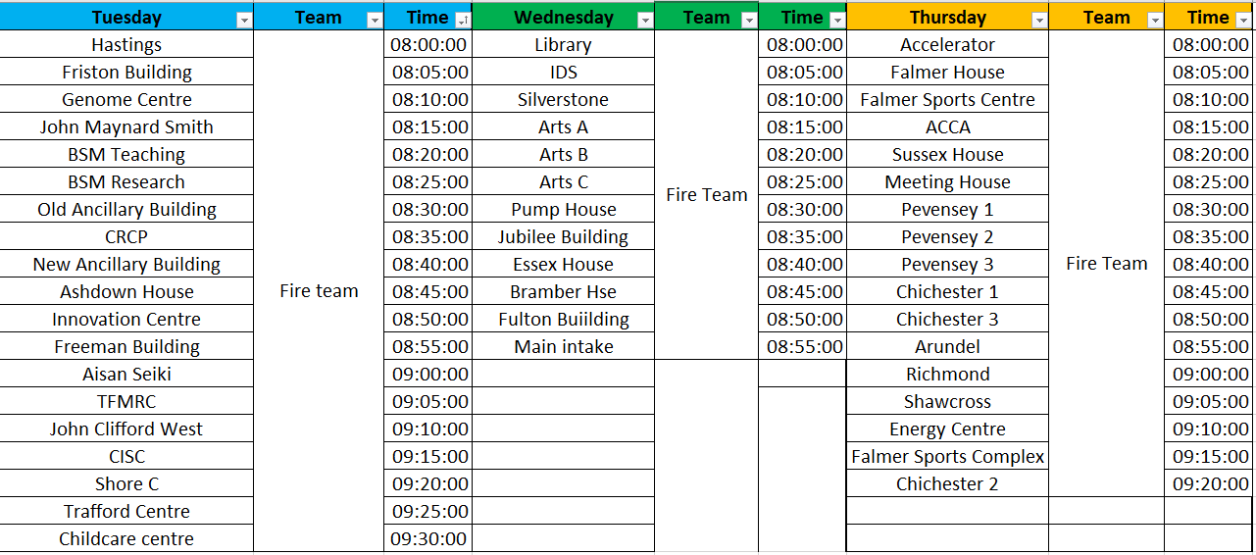

Disabled Students’ Room

Located on the first floor of Falmer House, through the common room on the left, accessible via stairs or lift. There is a keypad to enter the room, the code is written on the door: 2505.
The Disabled Students’ Room is a quiet space equipped with sofas and chairs for resting, as well as blankets, weighted blankets, pillows, fidget toys and ear defenders. There is a range of lighting options, including a dimmable main light. The room also has a kettle and free tea/coffee available for students.
Uncontrolled if in Hard-Copy – Master copy resides on Box
Document ID: HS F202 | Version: 3.2 | Date Issued: March 2025
Author: Graham Gray | Approver: Jed McDonald | Issuer: UHST

