

HEALTH AND SAFETY
Control of Noise at Work Policy
- Introduction
This policy reflects the requirement of legislation and the increasing knowledge about noise levels that can cause hearing damage. The Control of Noise at Work Regulations 2005 require the university to eliminate or reduce risks to individuals health and safety from noise at work. This is achieved by:
- The provision of information, instruction, and training.
- Health surveillance for those impacted by noise at work.
- Not exceeding the limits of noise exposure.

A noise risk assessment will identify where there is a risk from noise and identify suitable control measures. The assessment should include an estimate of individual’s exposure to noise and where health surveillance should be provided.

Noise at work can cause hearing loss that can be temporary or permanent. Individuals often experience temporary deafness after leaving a noisy place. Although hearing recovers within a few hours, this should not be ignored. It is a sign that if an individual continues to be exposed to the noise then their hearing could be permanently damaged.

This policy outlines the measures that must be in place to protect individuals; they include assessing the risks and taking measures to reduce noise exposure. Providing training and information for individuals on the risks from noise and the measures in place to reduce these and providing health surveillance where the risk assessment shows that this is appropriate.

  - Scope
This policy applies to all university employees and any person who may be affected by the work activities conducted by the university. This includes students, visitors and contractors.

The policy’s aim is to ensure that all Schools and Professional Services have a management system in place to protect employees from excessive noise within their areas, which could cause individuals hearing damage that is permanent and disabling.

This policy does not cover the environmental aspects of noise and noise pollution or the adverse effects on wellbeing which can arise from ‘nuisance’ noise.

  - Definitions
- Decibel (dB): this is the unit of measurement for loudness of a sound. The higher the dB, the louder the sound.
- Exposure: exposure whilst at work.
- Action Levels: the levels of exposure to noise averaged out over a working day or week or the maximum noise to which an employee is exposed in a working day.
- Exposure Limit Values: the levels of noise exposure that must not be exceeded.
- Control Measure: any measure to reduce the risk in the workplace, e.g. Standard operating procedures, mechanical devices, personal protective equipment, training, restricted access zones.
- Acoustic Shock: a sudden, unexpected noise event which is perceived as loud, transmitted through a telephone headset that may cause an adverse reaction.
- Noisy Work Environment: any working environment that reaches the action levels described below.
2. Roles and responsibilities
2.1. The Director of Estates, Facilities and Commercial Services
Is responsible for the implementation of this policy, insofar as it relates to the activities and equipment associated with the Estates and Facilities’ Department and for its communication to its staff as appropriate.
2.2. Heads of Schools/Departments
The Heads of Schools/Departments are responsible for ensuring that arrangements are in place to eliminate the risk from noise at work where possible. If noise cannot be eliminated, they must ensure that effective control measures are in place in their areas of responsibility that reduce noise exposure levels. Further they must ensure that noise control arrangements are communicated to all staff via safety operating instructions, safe systems of work or through published local rule documents, i.e. workshop/ laboratory /office manuals/ handbooks.
2.3. Responsible Managers
All Responsible Managers, (Team/Local Managers), have a responsibility to ensure that;
- There is a procedure in place to ensure noise risks are assessed and that action is taken to reduce the noise exposure.
- Action is taken to ensure that legal limits on noise exposure are not exceeded, this will include providing hearing protection if the noise limits cannot be reduced enough by using other methods.
- Staff are provided with information and training on health risks and control measures in place.
- Ensure noise factors are considered when hiring or purchasing new equipment.
- Noise levels are considered when installing or relocating equipment or activities.
- Maintenance arrangements are in place to ensure that equipment continues to operate correctly and so far, as possible does not become noisier over time.
- Suitable hearing protection is provided and maintained. Where hearing
protection is mandatory, ensure that adequate supervision is provided.
- Areas are designated hearing protection zones where necessary.
- Health surveillance is arranged where there is a risk to health following a risk
assessment.
- Records are kept of individual’s health surveillance attendance, fit for work
and any resulting recommendations.
- The risk assessment is reviewed and updated on a regular basis.
2.3. Occupational Health Service Provider
The university’s Occupational Health Service provider is responsible for;
- Organising and carrying out appropriate health surveillance programmes of hearing damage as required.
- Ensuring that health surveillance records are confidentially maintained.
- Notifying the Responsible Manager of health surveillance results and any resulting recommendations.
2.4. Staff
Members of staff have a responsibility to ensure that they;
- Comply with control measures outlined in risk assessments, this includes noise assessments.
- Use all equipment in accordance with instruction.
- Wear hearing protection in accordance with the university’s instructions.
- Report to their Line Manager immediately any symptoms that would be associated with noise at work.
- Report to their Line Manager any faults or difficulties with noise-control equipment.
- Co-operate with health surveillance programmes.
- Report any defects or difficulties with any equipment.

- Noise Levels
3.1. How noise is measured
Noise is measured in decibels, shown as db. An A weighting is written as ‘db(A) and
is the measure of average noise levels. A C weighting is written as ‘db(C) and is
used to measure peak, impact or explosive noises. A 3dB change in noise level is
actually either a halving or doubling of the sound pressure level but may only just be
noticed by the human ear.

There are several noise measuring devices available on the market and they should
fall into either type 1 or type 2 classifications. It should be noted that mobile phone
sound level apps are not acceptable as means of measuring noise at work.
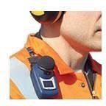
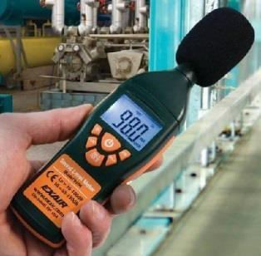
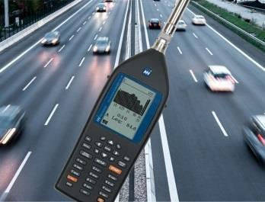


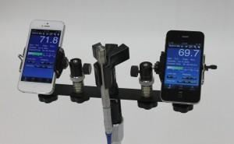

Octave Band General Type 1 & 2 Dose Meter
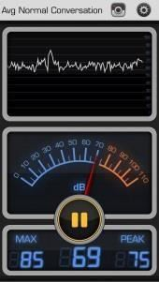

Mobile Telephone Apps
  - Action levels and exposure limits
The Regulations require specific actions at certain action values. If an individual is exposed to noise at or above a lower exposure action value, personal hearing protectors must be made available at their request. If an employee is exposed to noise above the upper exposure action level, then personal hearing protection must be provided, and the area designated as a hearing protection zone.

These relate to:
- The levels of exposure to noise averaged over a working day or week;
and
- The maximum noise, (peak sound pressure), to which an individual/s is exposed in a working day.
These values are:
- Lower exposure action values: daily or weekly personal noise exposure of 80 dB (A).
- Peak sound pressure of 135 dB (C).
- Upper exposure action values: daily or weekly personal noise exposure of 85 dB (A).
- Peak sound pressure of 137 dB (C).
There are also levels of noise exposure which must not be exceeded. These are called exposure limit values:
• Daily or weekly personal noise exposure of 87 dB (A).
- Peak sound pressure of 140 dB (C).
This is the maximum sound exposure levels permitted for any individual and takes hearing protection into account i.e. It is the actual sound exposure of the individual at the ears following any attenuation from hearing protection.
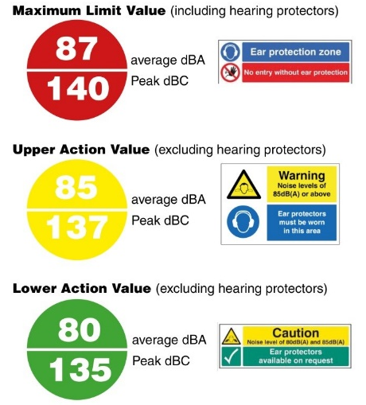

Where the exposure of an individual to noise varies from day to day, Responsible Managers may use a weekly personal noise exposure in place of daily personal noise exposure for the purpose of compliance with the noise regulation. The Health and Safety Executive’s (HSE) noise calculator can be found at http://www.hse.gov.uk/noise/calculator.htm
Noise that does not exceed these values can still prove to be annoying or distracting, which can contribute to the cause of an incident. Where this is the case further assessment should be considered and support from the Health and Safety team is available.
Appendix 1 contains a graphic which provides examples of noise levels generated in a range of activities
- Noise Risk assessment
The following outlines the stages required to complete an assessment of the risk to health created by noise. A clear understanding of the noise related risks and how these may affect individuals is crucial.
4.1. Stage 1 – Identity the hazards
In most cases it should be possible to identify those activities and workplaces where noise levels are significant. As a general guide to this, the following should be considered;
- If noise is intrusive but normal conversation is possible, likely noise level is approximately 80 dB (A).
- If you must shout to talk to someone who is 2 metres away, likely noise level is approximately 85 dB (A).
- If you must shout when the person is 1 metre away, then the noise will be approximately 90dB (A).

Any noise assessment must consider not only the noise level but how long an individual is exposed to it. For example, an individual working in an area where the noise level is 80 dB (A) would require an assessment if they are working in that environment for > 6 hours.

In order to identify whether there is a significant risk from noise the following should be considered;
- Ask individuals which if any tools, machines, processes involve regular exposure to noise. This will lead to a list of tools and jobs.
- Consult equipment handbooks which should declare noise levels. This may be provided by the manufacturer: however, manufacturers’ data will often come from testing under specific controlled conditions which are very different from normal working practices and therefore may significantly underestimate exposures in practice. Additional information may be sought from equipment suppliers.
- Ask individuals if they have any symptoms associated with work related noise levels.
- Observe specific working practices.

4.2. Stage 2 – Identify all person who may be at risk
If there is likely to be a risk the next stage is to identify who may be at risk. In considering the potential for people to be harmed, it is important to consider the possibility of hearing damage and risks to safety such as noise interfering with communications.
This can be achieved by making a list of employees who use noisy machinery or equipment and which jobs they do. Also list those who have outlined concerns or stated that they have symptoms of hearing loss.
Ensure that you consider others who may be affected by the work activity these will include students, visitors, and contractors.

4.3. Stage 3 – Assess whether current controls are adequate
The LEP,d is a worker's daily exposure to noise at work, (normalised to an 8-hour day), taking into account the average levels of noise and the time spent in each area. An estimate of the daily personal noise exposure (LEP,d) of individuals at risk should be made and compared with the exposure action and limit values. The estimates of noise levels must be reliable enough to be able to assess whether any exposure action levels are likely to be exceeded. Reliable information will include noise measurements for specific tools or equipment, if specific measurements are required.

If measurements are required, the university’s Health & Safety Team must be contacted. They will ensure a competent person is engaged to determine the level of exposure and recommend appropriate control measurements required.

The Health and Safety Executive (HSE) has produced noise exposure calculators which can help you work out your daily noise exposure, weekly noise exposures, and estimate the performance of hearing protection.
This resource can be accessed via the Health and Safety Executive website at: http://www.hse.gov.uk/noise/calculator.htm

Action should be taken to reduce risks from noise to as low as reasonably practicable. These controls should include the following;
- Consider whether the work can be done another way, which then eliminates or reduces exposure to noise.
- Replacing tools/equipment/vehicles with alternatives that create lower levels of noise.
- Shielding or enclosure (of either a piece of equipment or the operator).
- Ensuring all equipment is properly maintained.
- Reducing time exposed to noise e.g. regular breaks, job rotation etc. every halving of the time spent in a noisy area will reduce noise exposure by 3dB.
- Design and lay out the workplace to minimise noise exposure.
- Use absorptive materials within the building to reduce reflected sound, e.g. open cell foam or mineral wool.
- Keep noisy machinery and processes away from quieter areas.
- Design the workflow to keep noisy machinery out of areas where people spend most of their time.
- Providing hearing protection.

Hearing protection should only be used as an additional measure after noise has been reduced by other means or as a temporary measure when other methods of controlling noise are being developed or installed.

Hearing protection is not an alternative to noise control.

Individuals must be provided with hearing protection when;
- They ask for them and their noise exposure is between the lower and upper exposure action values. The aim of hearing protectors is to get below 85 dB (A) at the ear.
- Their noise exposure exceeds the upper exposure action values. In this case managers must ensure that individuals are wearing their hearing protection.

Responsible Managers need to identify hearing protection zones, i.e. areas where the use of hearing protection is compulsory and mark them with signs indicating that hearing protection must be worn.
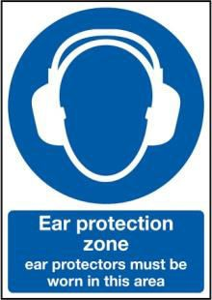

Access to hearing protection zones should be restricted and the workplace carefully monitored.
Individuals must be provided with training and information on
- The nature of risks from exposure to noise.
- The exposure limit values and upper and lower exposure action values.
- The significant findings of the risk assessment, including any measurements taken, with an explanation of those findings.
- The availability and provision of personal hearing protectors, how to use and care for the equipment.
- Why and how to detect and report signs of hearing damage.
- The entitlement to health surveillance,
and
- Safe working practices to minimise exposure to noise and their responsibilities to report any concerns or defects to equipment to their line manager.

4.4. Stage 4 – Record the findings
The noise assessment should include an action plan, which documents the measures already in place to reduce the risk from noise exposure and any further measures planned. The noise assessment can be a stand-alone document or can be incorporated into the overall risk assessment document for a School or Professional Service.

4.5. Monitor and review the risk assessment
It is the responsibility of the Responsible Manager to regularly check that controls introduced are effective. This will involve talking to employees, ensuring that hearing protectors are being worn and stored correctly, are well maintained and monitoring health surveillance results as necessary.

It is strongly recommended that the risk assessment should be reviewed if there is any change in noise levels and on an annually basis.

Examples of hearing protection -
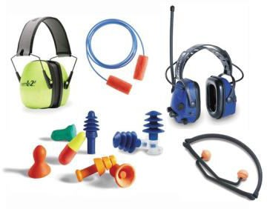
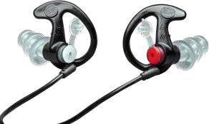
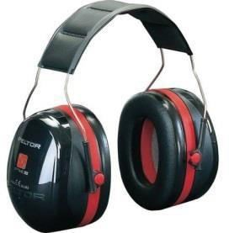

As stated in Section 3 above where Individuals are exposed to noise levels at or above 80db(A), but below 85db(A), they are entitled to request ear protection. Schools or Professional Services must provide this free of charge.
Information, instruction and training on the risk to hearing from the equipment, process or activity should be provided by the department and should include information about any hearing protection provided, where and how it should be used and the proper way to clean, store and maintain it.
At or above exposures of 85db(A), departments must devise, implement and maintain a noise control programme (section 5), in addition to providing ear protection and information, instruction and training. Where ear protection is provided the department must enforce its use and those exposed must use it.
Careful consideration should be given to the selection of hearing protection. Noise levels must be attenuated to less than 85dB(A) at the ear.
Hearing protectors must be suitable for the environment, comfortable for the wearer and compatible with other personal protective equipment such as hard hats, respirators or eye protection.
5. Labelling noisy machines
Where machine operators are required to wear ear protection because noise exposure is at or above 85db(A), a sign must be posted on the machine.


- Training
All individuals should be aware of the risks they may be exposed to and the findings of the risk assessment, this is also true of any noise monitoring. If the lower action value is reached, individual staff should be informed of:
- The likely noise exposure and the risk to their hearing this creates.
- What control measures are in place where to obtain hearing protection and how to report defect s in this equipment.
- What they should do to minimise risk including wearing PPE and safety
- working practices.
- The university’s health surveillance process.
- How to detect the first signs of hearing damage.

All staff that are required to use hearing protection must be trained in the correct use of it, how to look for defects and where to obtain hearing protection.

- Health Surveillance
It is the responsibility of Responsible Managers to identify staff requiring health surveillance for noise risks through the risk assessment process and ensure that they are referred to the university’s Occupational Health Service provider. Health surveillance is required if there is a risk that an individual is likely to be frequently exposed above the upper exposure action values, or are at risk for any reason, for example they already suffer from hearing loss.

Responsible Managers must ensure job descriptions specify hazards which may affect an individual’s existing long term health condition or impairment or that has the potential of causing a new health condition or impairment. Any job role where the risk assessment indicates that there is a risk to the health of staff exposed to noise must outline the hazard in the job description.

- References and further reading
- Controlling Noise at Work: The Control of Noise at Work Regulations 2005
- Guidance on Regulations;L108 HSE Books ISBN 7176 6164 4
- Noise at Work: A brief guide to controlling the risks; INDG 362 (rev2) HSE Books
  - Noise: Don’t lose your hearing; INDG 363 (rev2) HSE Books ISBN 7176 6510 5
- HSE Noise calculator; http://www.hse.gov.uk/noise/calculator.htm
- HSE Noise at Work website; http://www.hse.gov.uk/noise/index.htm

Appendix 1 – Examples of noise levels generated in a range of activities

