School of Education & Social Work

Guidance Note for Visiting Students

1 Due to recent changes in the visa regulations, which require a higher level of detail both at admissions and throughout a stay in the UK, all visiting students will need to apply via the PG on-line application system.

2 Students will be required to pay standard fees at either the Home or Overseas rate depending on their classification. If a student is here for one term, they only pay one third of the fee etc. If the School wishes to support a visiting student who cannot afford the fee, then the School must fund the equivalent amount from its own budget, although it needs to be recognised that having sufficient funds to sustain a visit to the UK is one of the criteria utilised in deciding in visa eligibility.

3 The students should access the on-line application system at web page:
www.sussex.ac.uk/study/pg/applying/

See attached example screen prints.

The first screen print shows where they should enter 'research degree', 'full time' and choose the subject area.

As they progress through the application checklist, students will eventually reach the 'academic interests' section. Here they are asked if they intend to only take a part of the programme (see 2nd screen print attached). In this field they should indicate that they are ‘visiting’ and the length of time for which they want to visit. Normally students will visit for one or two terms or one year; they should start at the same time as our standard start dates (ie January, April or October).

4 Thereafter students will appear on the system just the same as other research student applications, but the database will say ‘Visiting’. Research & Enterprise Co-ordinators should deal with their application thereafter in the same way as other research applications.

5 Following acceptance, students will receive a normal offer letter (from Admissions), but it will confirm they are visiting and not working for a qualification. If a student is here for more than six months, they also need a student visa and this is handled by the Admissions office.

Peter Aggleton/Angela Pater
Agreed at ESW Management Team on 19 May 2010

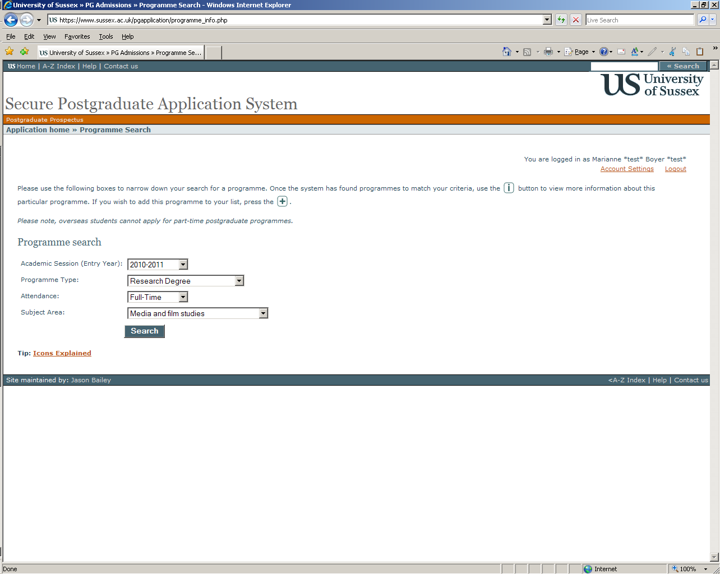

Screen 1 example

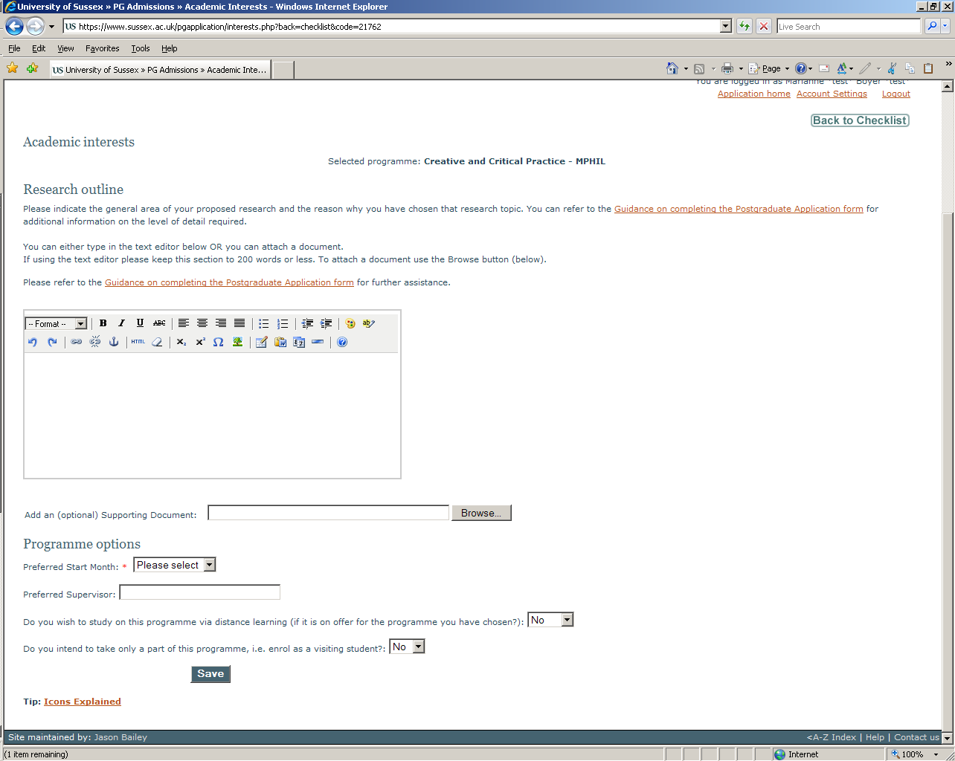

Screen 2 example

