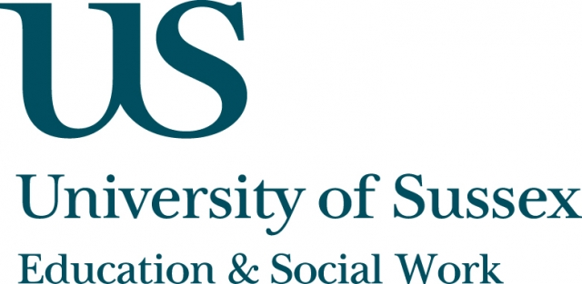

ESW Open Seminar Series
Centre for Innovation and Research in Childhood and Youth (CIRCY)

Monday 30th November, 5pm
Room 104, Fulton
Speaker
Professor Heinz Sünker, Bergische Universität, Wuppertal , Germany / Interdisciplinary Center: Childhoods. Societies and the
Center for International Studies in Social Policy and Social Services,
presents:
Social Pedagogy and Social Work (Soziale Arbeit) in Germany: Histories and contemporary problems
____________________________________

In this seminar, Professor Sünker will deal with the history of Social Pedagogy and Social Work in the context of a social history of the German Länder
(federal states) - a history which started in the 16th century. He will describe relevant developments prior to the establishment of the post-fascist welfare state in the German West (the former Federal Republic of Germany, FRG) entailing the analysis of the relationship between capitalism, democracy, social welfare and social control in different times.
Additionally, At the same time Professor Sünker will tackle concepts of working with people in need and people to control (between alms and poor laws).
He will also reconstruct contemporary theories of social pedagogy based on social theory and educational approaches aimed at overcoming the classical boundaries of their practice(s).
____________________________________
This seminar can be joined remotely by logging on to: https://adobeconnect.sussex.ac.uk/circy_sunker
A recording of this event will be available to view retrospectively
at: www.sussex.ac.uk/education/seminars

