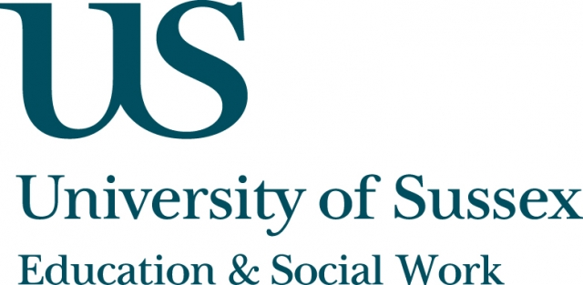

ESW Open Seminar Series
CIRCY

Monday 26th January, 5pm
Room 104, Fulton
Speaker
Professor David Oswell, Head of the Department of Sociology,
Goldsmiths, University of London, presents:
Re-Aligning Children’s Agency and Re-Socialising Children in Childhood Studies after Biopower
____________________________________

In contrast to strands of thinking that have foregrounded a political emphasis
on ‘child-centredness’, there has been a line of thinking that has stressed the distributed, ontologically heterogeneous, and dependent capacities of children. In the first line of thinking, children’s agency is often discussed in the context
of a sociological problematic concerning agency and structure; in the second, agency is often understood as distributed across ‘actor-networks’ or across ‘assemblages’. In much of the literature in the field, the distinctions between these two lines of thinking are often not made evident. However, where the differences are made evident discussion often centres on the distinction between human-centred and post-humanist epistemologies of children’s agency.
In this seminar, Professor Oswell frames these two lines of thinking about children and childhood in the context of broader shifts in sociological understanding concerning the ontology of agency, the questioning of the
scalar attributions of structure (macro) and agency (micro), and a methodological shift of focus from ethnography and discourse analysis to
what is often seen as a more ‘object-centred’ focus on devices, descriptions,
liveness and invention.
____________________________________
This seminar can be joined remotely by logging on to:
https://connectpro.sussex.ac.uk/circy_oswell26jan15
A recording of this event will be available to view retrospectively
at: www.sussex.ac.uk/education/seminars

