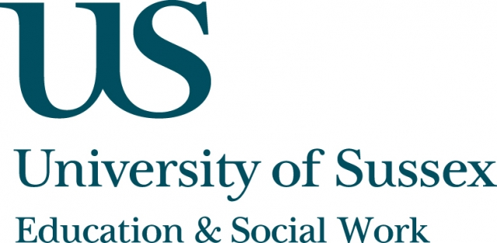

ESW Open Seminar Series
Centre for Innovation and Research in Childhood and Youth (CIRCY)

Monday 23rd November, 5.30pm
Room 104, Fulton
Speakers
Dr Rebecca Webb, Perpetua Kirby, Marthe Paluch, Louise Simms
and Elsie Whittington, University of Sussex,
present:
Thinking with’ Vulnerability and Resistance as a Dynamic of the Research/Researcher Process
____________________________________

In this seminar, five ‘early career researchers’ with connections to CIRCY present their experiences of reading, discussing and writing with dual concepts of ‘vulnerability’ and/as ‘resistance’ taken from some recent work of Judith Butler (2014).

Together, they engage reflexively with vulnerability and resistance as performative: firstly, in relation to their own substantive research interests; secondly, as a facet of their own subjectivities as early career researchers;
and thirdly, as an assertion of feminist thought/action to challenge some contemporary, political discourses of a paternalist, hard-nosed ‘normal’.

The panel will invite colleagues to become part of a broader discussion following their presentation.
____________________________________
NOTE: Remote participation will not be offered for
this event, nor will the event be recorded.

