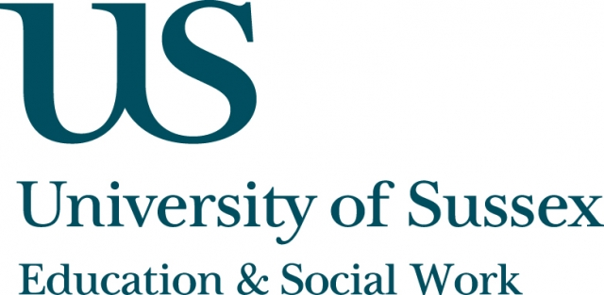

ESW Open Seminar Series
CIRCY

Monday 22nd September, 5pm
Room 104, Fulton
Speaker
Dr Sevasti-Melissa Nolas, Lecturer in Social Work,
Department of Social Work & Social Care, University of Sussex,
presents:
Joining up the dots on children’s participation in
public life: theoretical and methodological challenges
____________________________________

20 years after the ratification of the United Nations
Convention for the Rights of the Child (1989) which calls for children’s views to be heard in decisions that affect them, the international community is no closer to identifying what constitutes a ‘good enough’ model for understanding and supporting the development of children’s participation in
public life.
In this seminar, Dr Nolas will introduce the ‘Connectors’ study,
a five-year international study funded by the European Research Council whose aim is to develop new ways for thinking about participation in childhood. This comparative, cross-national study seeks to understand children’s participation in public life, and how an orientation to social action develops in childhood.
This seminar can be joined remotely by logging on to:
https://connectpro.sussex.ac.uk/circy_nolas31mar14
A recording of this event will be available to view retrospectively
at: www.sussex.ac.uk/education/seminars

