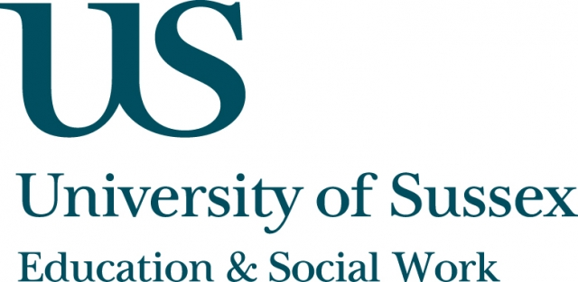

ESW Open Seminar Series
CIRCY

Monday 21st September, 5.30pm
Room 155, Jubilee
Speaker
Robin Banerjee, Professor of Developmental Psychology and
Dr Fidelma Hanrahan, Education and Psychology Research Fellow,
University of Sussex,
present:
Creative arts and family coaching interventions with
at-risk youths: How and why might they impact the socio-emotional and motivational development of marginalised youths?
____________________________________

The psychosocial processes underpinning the success of interventions with
at-risk youths remain little understood, despite interest in how alternative interventions - such as creative-arts interventions and family coaching models -- may offer new routes to re-engaging young people.
In this seminar, Professor Banerjee and Dr Hanrahan present findings from research with young people who took part in creative-arts projects and family-support interventions to support at-risk youths. Significant differences between at-risk and comparison young people were found, with analyses of survey
data showing that the at-risk sample reported significantly lower intrinsic, and significantly higher extrinsic, values. Furthermore, interviews with young people indicated that intervention practitioners offered uniquely nurturing relationships which in turn underpinned perceived changes in self-construals, motivation
and aspirations, and behaviour. The results are discussed in relation to key implications for practice - such as how interventions which successfully nurture intrinsic values may be particularly effective for at-risk youths.
____________________________________
A recording of this event will be available to view retrospectively
at: www.sussex.ac.uk/education/seminars

