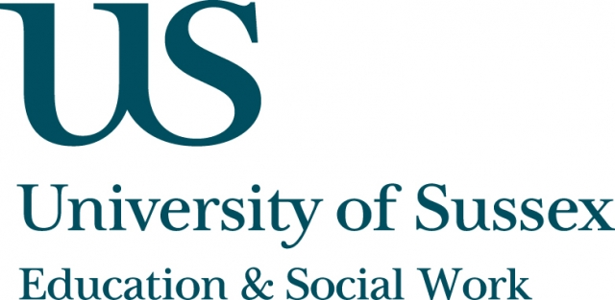

ESW Open Seminar Series
CIRCY

Monday 12th May, 5pm
Room 104, Fulton
Speaker
Kim Allen, Manchester Metropolitan University, with Laura Harvey and Heather Mendick, Brunel University
present:
’He sounds girly’: Disgust, humour and the construction of young masculinities in celebrity talk
____________________________________

Kim, Laura and Heather explore the role of celebrity in the negotiation of
young people’s gender and sexualities, analysing group interview talk in the context of wider discourses circulating online about Canadian pop star Justin Bieber and UK boy band One Direction. They examine how laughter and disgust work as practices to open up and close down the possibilities of different forms of masculinity.
Drawing on data from an ESRC-funded project on the role of celebrity in
young people’s classed and gendered aspirations, Kim, Laura and Heather take a critical, feminist discursive lens onto everyday talk about male
celebrities and their fans. They unpick the changing operation of masculinities through homophobia, sexism and transphobia. They argue that both online
and offline celebrity talk works as a form of collective identity construction, offering resources for young people to make sense of their own and others’ lives. While foregrounding young people’s voices, Kim, Laura and Heather’s presentation also speaks to young people’s relationship to new digital spaces for the negotiation and circulation of ‘celebrity gossip’ opened up by online technologies, including both vitriol aimed at celebrities and online communities of celebrity fandom.
This seminar can be joined remotely by logging on to:
https://connectpro.sussex.ac.uk/circy_celebrity12may14
A recording of this event will be available to view retrospectively at: www.sussex.ac.uk/education/seminars

