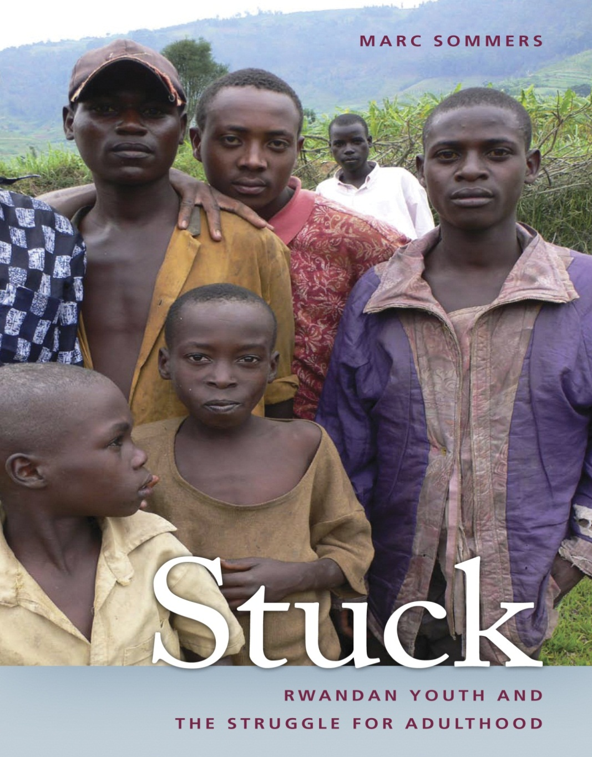
Public Lecture
Dr. Marc Sommers
Thursday 31st January 2013 @ 2.00-4.00pm
Room: Penvensey 1A7

Organised by the Centre for International Education (CIE), the Centre for Innovation and Research in Childhood and Youth (CIRCY) and the Security and Social Justice Research Theme

Abstract

Young people are transforming the global landscape. As the human population today is younger and more urban than ever before, prospects for achieving adulthood dwindle while urban migration soars. Devastated by genocide, hailed as a spectacular success, and critiqued for its human rights record, the Central African nation of Rwanda provides a compelling setting for grasping new challenges to the world’s youth.

Spotlighting failed masculinity, urban desperation, and forceful governance, Marc Sommers will talk about his new book, which tells the dramatic story of young Rwandans who are “stuck,” striving against near-impossible odds to become adults.

In Rwandan culture, female youth must wait, often in vain, for male youth to build a house before they can marry. Only then can male and female youth gain acceptance as adults. However, Rwanda’s severe housing crisis means that most male youth are on a treadmill toward failure, unable to build their house yet having no choice but to try. What follows is too often tragic. Rural youth face a future as failed adults, while many who migrate to the capital fail to secure a stable life and turn fatalistic about contracting HIV/AIDS.

Stuck: Rwandan Youth and the Struggle for Adulthood tells the story of an ambitious, controlling government trying to govern an exceptionally young and poor population in a densely populated and rapidly urbanizing country. Dr. Sommers’ pioneering book sheds new light on the struggle to come of age and suggests new pathways toward the attainment of security, development, and coexistence in Africa and beyond.

Bio
Marc Sommers is an internationally recognized youth expert and a visiting researcher with Boston University’s African Studies Center. Sommers was a 2011–2012 Fellow at the Woodrow Wilson International Center for Scholars and a USIP Jennings Randolph Senior Fellow in 2009–2010. He is the author of six previous books, including Islands of Education: Schooling, Civil War, and the Southern Sudanese (1983–2004) and Fear in Bongoland: Burundi Refugees in Urban Tanzania, which received the Margaret Mead Award in 2003.

