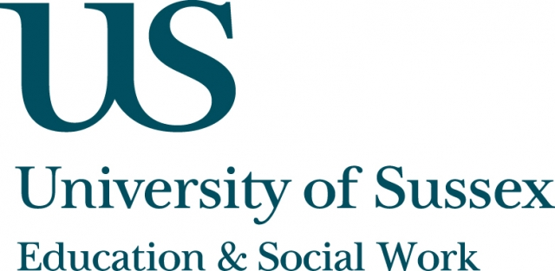

Occasional Speaker Seminar
CIRCY

Tuesday 20th November, 5pm
Room 104, Fulton
Speaker
Dr Ofra Koffman, Leverhulme Postdoctoral Fellow,
King’s College, London
presents:
The revolution will be led by a 12 year old girl:
Girl power and global biopolitics
____________________________________

In recent years there has been a ‘turn’ to adolescent girls within global health and development initiatives. An alliance of corporate bodies, charitable foundations and NGOs have been promoting the view that adolescent girls
hold the key to ending world poverty and improving wellbeing in the developing world. Investment in adolescent girls, they argue, will unleash a force of financial growth that will put an end to the cycle of poverty: A girl that is better educated will marry later and have fewer children. As a result, her health – as well as that of her children – will improve. This sequence of economic advancement and health improvement is termed ‘The Girl Effect’.
In order to promote this agenda, the United Nations Foundation launched a campaign entitled ‘Girl Up’ whose aim was to mobilise American teenage girls. American girls were invited to support adolescent girls in the Global South via social media, fundraising and by purchasing ‘Girl Up’ merchandise.
Awareness-raising ‘girl conferences’ were also held across the US.
In this seminar, Dr Koffman will examine the media outputs and off-line events brought about by this initiative, interrogate the notion of girlhood, ‘sisterhood’ and the north/south divide.
This seminar can be joined remotely by logging on to:
https://connectpro.sussex.ac.uk/circy_koffman20nov12
This seminar will also be recorded and available to view retrospectively at:
www.sussex.ac.uk/education/newsandevents/events/seminarscurrent

