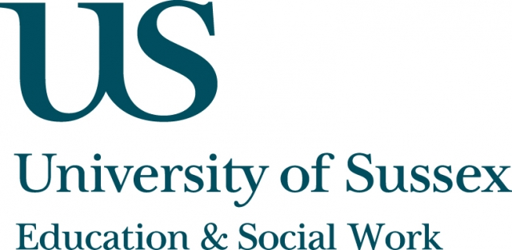

A CIRCY-hosted Workshop with Presentations

Friday 28th February, 4-7pm
Room 104, Fulton
Research for the real world:
Informing policy and practice with
children, young people and families
____________________________________

An open workshop for researchers, students, practitioners and policy-makers interested in how research can make
an impact on policy and practice in services for children, young people and their families.
There will be short presentations on children in care,
sex education and working with bereaved families, looking at how research projects in these areas have informed policy and practice. There will also be an international perspective from France.
The workshop will be followed by presentations from Dez Holmes, Director of Research in Practice, and Baroness Doreen Massey, Chair of the All Party Parliamentary Group on Children, who will discuss lessons learned from the Children and Families Bill.
____________________________________
This workshop/event is free to attend and refreshments will
be provided.
To reserve a place, contact j.farlie@sussex.ac.uk

