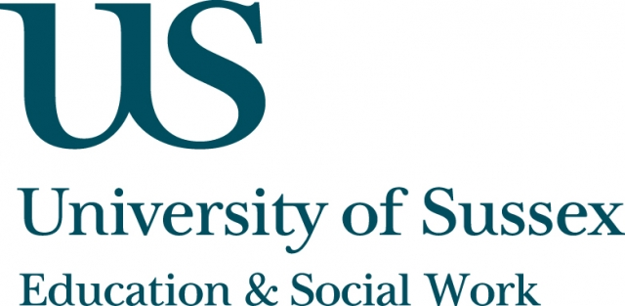

ESW Open Seminar Series
CIRCY

Monday 8th April, 5pm
Room 104, Fulton
Speaker
Jane Fortin, Emeritus professor, Sussex Law School,
University of Sussex presents:
Taking a longer view of contact:
The perspectives of young adults who experienced parental separation in their youth
____________________________________

Over the last decade there has been increasing debate over whether
legislation should be introduced encouraging separating couples to share
their children’s time more equally between them. The government has
recently introduced draft legislation with this objective in mind. In this
seminar, Professor Fortin explains why a recent research study suggests
that the government’s legislative intentions are not evidence-based.
Funded by the Nuffield Foundation, the research produced independent empirical evidence on how a large, representative sample of young adults,
who experienced parental separation as children, viewed the contact arrangements they had at the time - and what they now believed had made
the contact a more or less successful experience. Statistically significant,
the findings have already been referred to in the Parliamentary process underpinning the Children and Families Bill. Concentrating on the
factors associated with successful contact, Professor Fortin explores the advantages of retrospective research with young adults, compared with research involving ‘divorcing’ children.
____________________________________
This seminar can be joined remotely by logging on to:
https://connectpro.sussex.ac.uk/circy_fortin8apr13
This seminar will also be recorded and available to view retrospectively at:
www.sussex.ac.uk/education/newsandevents/events/seminarscurrent

