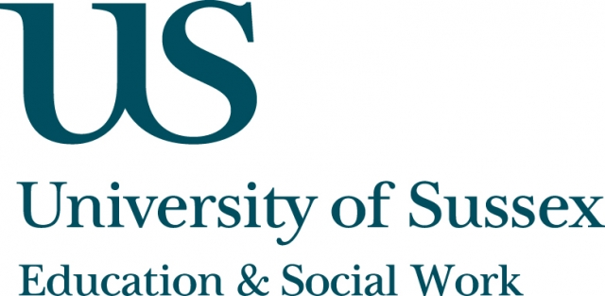

ESW Seminar Series
CIRCY

Monday 10th December, 5pm
Room 203, Fulton
Speaker
Professor Roger Hart, Director of the Children’s Environments Research Group, Graduate Center, City University of New York
presents:
Changing Childhood in a New England Town
____________________________________

In this seminar, Professor Hart will discuss the results of a new study designed to contribute to the debate on the changing nature of
childhood by documenting how and why the out-of-school lives of the
children of a particular town changed over a period of three decades. Professor Hart’s final report on the study takes advantage of a unique opportunity to revisit another comprehensive study conducted in the
mid-1970s of the geography of children aged 4-12, whose original
focus was the children themselves. Professor Hart’s new study
involves both the perspectives of these same children – now parents –
as well as on the out-of-school lives of their children today.
It secondarily involves the grandparents.
The study brings parenting into the centre of the research to address questions of its role within the set of larger forces that influence
children’s activities and experiences. One of the main focuses of the seminar will be the methodological challenges and insights gained from the study, particularly those related to how children’s free time and their relations with adults have changed within the course of one generation.
____________________________________
This seminar can be joined remotely by logging on to:
https://connectpro.sussex.ac.uk/circy_hart10dec12
This seminar will not be recorded on the speaker’s request

