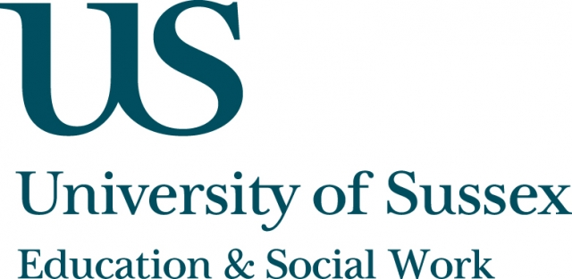

ESW Open Seminar Series
CIRCLETS

Monday 17th June, 5pm
Room 203, Fulton
Speaker
Dr Sara Bragg, Senior Research Fellow, University of Brighton, presents:
‘Sexualisation’ as global cause and
participatory sport
____________________________________

In recent years, ‘sexualisation’ has been taken up at high profile and official levels around the world and passed into our ‘common sense’ thinking about childhood.
In this seminar, Dr Bragg will explore some arguments around how and why this is the case. She will examine some of the forms this concern with ‘sexualisation’ has taken, and how these function as practices of ‘reading’ culture and to construct notions of self and other.
She will also argue that the ‘sexualisation’ debate brings to the fore
some specifically contemporary anxieties about digital image
proliferation, and the meaning of the ‘mainstreaming of sex’, through which we can discern shifting notions of citizenship, of public and
private, and ethical responsibilities.
Dr Bragg will conclude with comments about what all this means for pedagogic practices and notions of children’s and young people’s
‘voice’.
____________________________________
This seminar can be joined remotely by logging on to:
https://connectpro.sussex.ac.uk/circlets_bragg17june13
This seminar will also be recorded and available to view retrospectively at:
www.sussex.ac.uk/education/newsandevents/events/seminarscurrent

