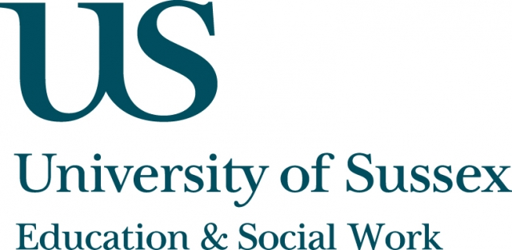

ESW Open Seminar Series
CHEER

Monday 21st October, 5pm
Room 104, Fulton
Speaker
Professor Gemma Moss, Institute of Education,
University of London
presents:
Uncertain Knowledge:
Exploring quantitative data from a qualitative perspective
____________________________________

In this seminar, Professor Moss considers whether qualitative research traditions can interact with quantitative traditions in ways that work for
the common good.
To date, critical exploration of PISA data and their role in policy discourse has tended to focus either on the reliability of the test instruments employed to assess participants’ literacy levels, or on the use of the findings – expressed
as country-by-country orderings – within policy discourse.
By contrast, Professor Moss considers PISA data as an example of
specialised knowledge-making that travels out into policy domains, in the process losing the caveats, qualifications and uncertainties that characterise statistical thinking.
Professor Moss focuses on the use of the term “reading engagement” as a
key variable that explains variation in reading performance in the OECD reports, exploring how far this acts as a case study for the social construction
of statistical data. Professor Moss will conclude by asking when, and under what terms, numerical data have a useful function to play; and the role qualitative research traditions have in making this happen.
This seminar can be joined remotely by logging on to:
https://connectpro.sussex.ac.uk/cheer_moss21oct13
This seminar will also be recorded and available to view
retrospectively at: www.sussex.ac.uk/education/seminars

