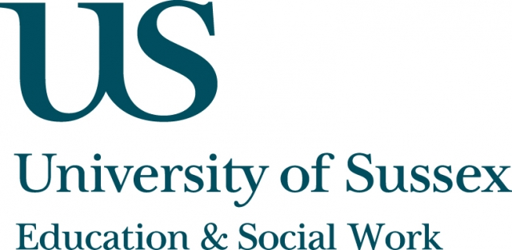

ESW Seminar Series
CHEER

Tuesday 31st May, 5pm
Room 104, Fulton
Speaker
Professor Gert Biesta,
Stirling Institute of Education, University of Stirling
presents:
‘Learner, student, speaker: Why it matters how
we call those we teach’
____________________________________

Professor Gert Biesta discusses why it matters the name we give those we teach – particularly if our ambition is not ‘simply’ the transfer of knowledge, values and dispositions but have an orientation towards emancipation.

Gert will engage with discussions about educational emancipation, specifically how it has developed within critical educational thought and practice
Gert will also focus on ideas put forward by Jacques Rancière whose views provide starting points for a different way to engage with the emancipator ambition in education.
* Tea and coffee served from 5pm
** The seminar is available to join via live web streaming at:
https//connectpro.sussex.ac.uk/biesta31may/

