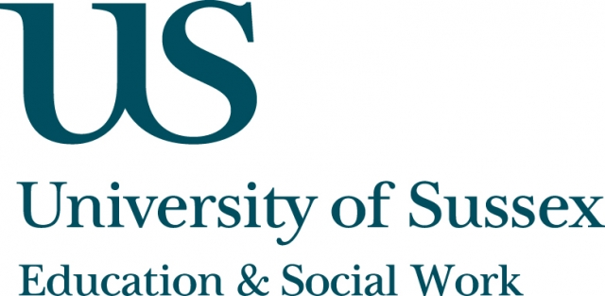

ESW Seminar Series
CHEER

Monday 17th January, 5.30-7pm
Room 104, Fulton
Speaker
Professor Sue Clegg, Leeds Metropolitan University,
presents:
‘Time and Reflexivity: Theoretical Resources for Research into Higher Education Policy and Practice’
____________________________________

Professor Clegg will discuss theories of time and reflexivity
and suggest that these are important theoretical resources
for thinking about higher education policy and practice.
She will outline the significance of theories of time on
conceptualisations of the future, and offer a critique of the
discourse of employability and the multiple mis-descriptions
of practice this involves in terms of the life chances of
individuals. She will argue that, at the existential level, this
is not the only temporality.
She will explore broader conceptions of reflexivity and the
sorts of personhood entailed within this discourse, drawing on Archer’s work (2007) on multiple forms of reflexivity.
She will conclude with how we might re-frame our understanding of higher education from the standpoint of
time and reflexivity.
* Tea and coffee served from 5pm
** Participants can join this seminar remotely by logging in at:
https://connectpro.sussex.ac.uk/clegg18ene/

