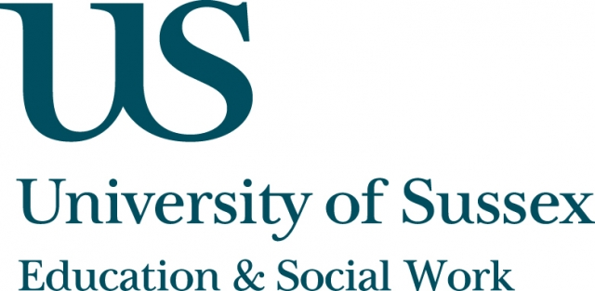

Occasional Speaker Seminar
CIRCY

Tuesday 29th January, 5pm
Room (TBA), Fulton
Speaker
Dr Benjamin Zeitlyn, Lecturer in International Education & Development, Department of Education, University of Sussex
presents:
The Sylheti Bari and the Londoni Flat
____________________________________

In this seminar, Dr Zeitlyn will examine the ways in which migration from rural homesteads in Sylhet, Bangladesh, to urban flats in London has affected the practices of British Bangladeshi families around gender and childhood.
Drawing on the work of Pierre Bourdieu on the ‘Kabyle House’, he will describe relations between the spatial arrangement of homes and practices. Analysing the ‘Sylheti bari’ (rural homestead) and contrasting it with the Londoni (British Bangladeshi) flat, Dr Zeitlyn will describe the significance of the way in which ideas of ‘inside’ and ‘outside’ have translated from one setting to another.
He will also show how the translation of these ideas to the urban landscape in London affects British Bangladeshi practices surrounding headscarf wearing, children’s play and socialising,
as well as attitudes towards school and language.
____________________________________
This seminar can be joined remotely by logging on to:
https://connectpro.sussex.ac.uk/circy_zeitlyn29jan13
This seminar will also be recorded and available to view retrospectively at:
www.sussex.ac.uk/education/newsandevents/events/seminarscurrent

