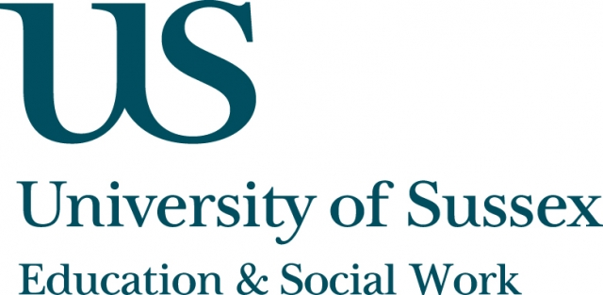

Occasional Guest Speaker Seminar
CIRCLETS

Monday 20th May, 5pm
Room 104, Fulton
Speaker
Michael Fielding, Emeritus professor of Education,
Institute of Education, University of London
presents:
Schools for Deep Democracy:
in praise of radical traditions of publicly-funded education
____________________________________

At a time when parliamentary democracy is facing recurring challenges, particularly – although not exclusively – from young people, it is especially reprehensible that neither our schools nor our publicly-funded systems of education take democracy as seriously as they could or should.
There are, however, exceptions and it is to our alternative radical democratic traditions of state education that we can usefully turn to challenge the current ‘dictatorship of no alternative’ to the tyranny of the market and the unguent condescension of our ruling elite.
Drawing on his 20 years as a teacher in some of England’s radical comprehensive schools and over two decades of engaged research and
writing within three universities, Professor Fielding will not only argue that
we should ‘build a new world in the shell of the old’, but will offer examples
of what a radical democratic school looks and feels like in practice.
____________________________________
This seminar can be joined remotely by logging on to:
https://connectpro.sussex.ac.uk/circlets_fielding20may13
This seminar will also be recorded and available to view retrospectively at:
www.sussex.ac.uk/education/newsandevents/events/seminarscurrent

