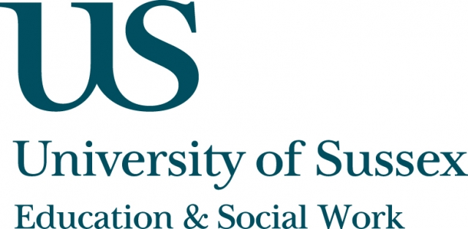

ESW Open Seminar Series
CHEER

Thursday 9th October, 2pm
Room 203, Fulton
Speaker
Dr Steinunn Helga Lárusdóttir, University of Iceland presents:
Is Iceland the Promised Land for Feminism?
____________________________________

Iceland has been ranked as a world leading country in gender equality
for years. For a long time, women´s rights have been secured by legislature and the country is frequently cited as a model for the political empowerment of women.

Iceland has held the top spot for the fifth consecutive year on the World Economic Forum’s Global Gender Gap report. Formal and legal equality should, however, not been seen as synonymous with real equality where women and men enjoy equal status, opportunities and power.

In this seminar some of the main strengths in the area of gender equality in Iceland will be highlighted as well as weaknesses that have been acknowledged and are presently being addressed by Icelandic authorities.

__________________________________
This seminar can be joined remotely by logging on to:
https://connectpro.sussex.ac.uk/cheer_helga9oct14
This seminar will also be recorded and available to view
retrospectively at: www.sussex.ac.uk/education/seminars

