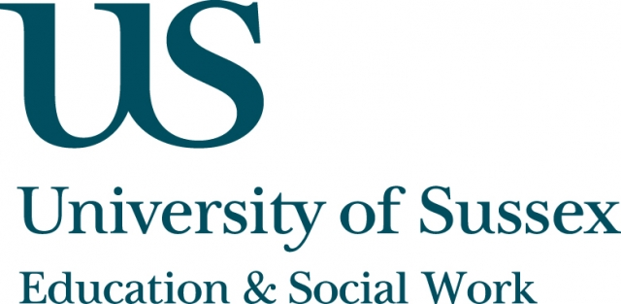

ESW Open Seminar Series
CHEER

Monday 8th December, 5pm
Room 104, Fulton
Speaker
Sharon Gewirtz, Aniko Horvath and Alan Cribb, Department of
Education & Professional Studies, King’s College London, present:
Reconstructing academic identities:
Lessons from life history
____________________________________

This seminar will be based on 20 life history interviews with social science and humanities academics from a range of backgrounds and institutional settings. Sharon, Aniko and Alan will use the data to explore relationships between personal and professional identities against the background of the policy and institutional changes that have coincided with participants’ career histories.
In their analysis, the trio hopes to unpack some of the diversity of ‘value discourses’ within the participants’ narratives, and highlight the gaps and collisions between vocational and institutional norms. In particular, how fully participants’ lives and accounts are
captured by ideas - such as the academic entrepreneur, or the neoliberal academic subject.
They will also draw out some of the implications for the
construction and enactment of contemporary academic professionalism.
____________________________________
NOTE:
On the speaker’s request, this seminar will not be recorded nor will remote participation be available.

