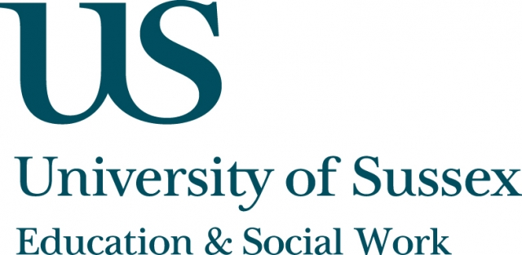

ESW Open Seminar Series
CHEER

Monday 2nd November, 5.30pm
Room 155, Jubilee
Speaker
Philip Brown, Distinguished Research Professor,
School of Social Sciences, Cardiff University, presents:
Employability, Opportunity and the
Prospects for Social Mobility
____________________________________

There has been renewed policy interest in higher education and social mobility as a route to a fairer society.
In this seminar, Professor Brown will argue that the current policy agenda will fail because it ignores the sociological evidence that social fluidity depends on reducing inequalities in relative life-chances, rather than simply improving the employability skills of graduates.
In assessing the prospects for social mobility, he will also suggest that existing sociological theories - most notably based on the
study of origins and destinations in relation to class mobility - need to be extended if we are to understand the prospects for higher education, employability and social mobility.
__________________________________
This seminar will also be recorded and available to view
retrospectively at: www.sussex.ac.uk/education/seminars

