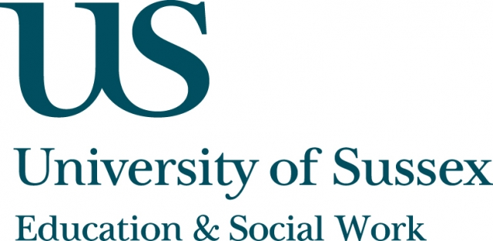

ESW Open Seminar Series
CHEER

Monday 24th November, 12pm
Room 104, Fulton
Speaker
Professor Maithree Wickramasinghe, University of Kelaniya,
presents:
See no evil, hear no evil and report no evil:
Sexual and gender–based violence in Sri Lankan universities
____________________________________

Sri Lankan universities have been identified as specific sites of gender inequality / inequity in which sexual and gender-based violence (SGBV) takes place (with institutional license in the case of ragging). However, as in many other contexts, it remains a hidden practice; its incidence under-reported
and its perpetrators under-penalized, despite the penal code and other laws that reinforce its gravity as a criminal act. Attempts at redress - legal or otherwise - are posited as being coloured by ideological and sub-cultural norms, structural biases, societal politics and institutional micropolitics that
may influence, delay or divert possible means of justice and reparation.
Relying on a number of studies as well as her own research and experiences, Professor Wickramasinghe will highlight the problems and specificities of
SGBV within Sri Lankan universities, including notions of subculture and impunity, institutional inertia and backlash, as well as the gap between administrative sanction and action when it comes to redress.
She will also discuss institutional and personal challenges, achievements
and obstructions related to addressing the issue.
__________________________________
This seminar can be joined remotely by logging on to:
https://connectpro.sussex.ac.uk/cheer_srilanka24nov14
This seminar will also be recorded and available to view
retrospectively at: www.sussex.ac.uk/education/seminars

