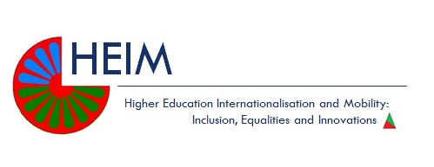

Higher Education Internationalisation and Mobility: Inclusion, Equalities and Innovation

Work Package 3

Supporting Roma Students in Higher Education

Briefing Report: Network of Roma Early Stage Researchers, Roma Education Fund, May- June 2016

Introduction
This report is part of the Higher Education Internationalisation and Mobility (HEIM) project which focuses on policies, interventions and methodologies oriented to promote equity and inclusion of Roma communities in higher education internationalisation.
In the next sections, the main rationale and purpose of the Work Package are presented, followed by a description of the principal features of the network that was its main outcome, the procedures developed for the network to be constructed and sustained, and the main achievements and issues encountered in the process.

Rationale and purpose of the network establishment
Work Package 3 (WP3) of the HEIM project focused on communication. To narrow down its scope and relate it to the general aim of the project – how principles of equity and inclusion can be applied to internationalisation strategies and programmes in higher education – the project coordinators and participants opted to establish a new research network of Roma Early Stage (ES) Researchers. In its initial state, the network was composed of the Roma Education Fund (REF)’s beneficiaries who had studied or were studying social sciences at postgraduate level i.e. for Master’s and Doctoral degrees. These people are spread out in many European universities concentrated especially in Central and Eastern Europe so the network offers opportunities for contact, especially where there are a few Roma researchers.
Other Roma ES researchers can apply to join the network and there are plans to recruit more once the network has been consolidated.
The core objective of the Network was to support Roma ES researchers by connecting them to their peers around Europe. In this way, existing informal mentoring and/or supporting relationships would be channelled into an umbrella group, putting in touch also people who didn’t know each other before and, in turn, providing new possible opportunities of collaboration, mutual help, and peer support. In this sense, it represents a concrete widening participation intervention as it aims to support and sustain Roma students who often find themselves isolated or in a minority in their places of study.

Participants
Originally, the WP3 envisaged the participation of one Established Researcher from Sussex and one Early Stage Researcher for each one of the partner universities, to be seconded to the REF Budapest office. However, neither Umeå nor Seville were able to second Early Stage Researchers, so some changes were made. The final team seconded to REF was composed of one Established Researcher; John Pryor, Professor of Education and Social Research from the University of Sussex, and 2 Early Stage Researchers; Caterina Mazzilli, Doctoral Researcher at the Centre for Migration Studies and Daniel Leyton, Doctoral Researcher in Education in the Centre for Higher Education and Equity Research (CHEER), both from University of Sussex.

Timetable
The WP3 lasted 2 months (May and June 2016) for the Early Stage Researchers, while the secondment of the Established Researcher is planned for 1 month. Professor Pryor will return to complete the final week of his secondment later in the year.

Deliverables
The Roma Early Stage Researchers Network was fully functioning and by the end of June 2016 had exactly one hundred participants.

Initiation and development of the Network:

https://www.facebook.com/groups/REFScholarshipProgramRomaResearchNetwork/
A Facebook Group was seen as the most effective way of setting up a research network. The reason for this was the diffused and frequent use of Facebook among young people in general and young researchers in particular, not just for personal, but also for professional reasons that included information exchange and networking. Facebook is a flexible online platform providing an ideal space for the type of information to share with participants – studies, research and job opportunities, as well as, news, reports and research on Roma issues. Also, the immediacy and ease with which this tool can be used is a considerable advantage and it seems to generate the community dynamic needed to foster support and critical discussions, based on respect.
An initial debate with the REF Scholarship Program staff focused on the best format for the formation of a supportive and intimate space where a Roma intellectual identity and leadership would be developed. Two possibilities taken into consideration were a Facebook Page (which is openly visible to all Facebook users) or a closed Group (the access to which is limited to its members). An important concern was to avoid people who were not in sympathy with its objectives joining the group. Postings which used discriminatory language, and possible on-line abuse from non-Roma participants, would be inimical to the intentions of providing a supportive and safe space for discussion and information. Starting with REF’s contact list also offered an opportunity for it to advertise and promote its services as an organisation that supports students in higher education. Thus, we opted for a closed group.
At this stage, before launching it, we focused on the contents. It was essential to post a few links before the members could access the group, and so not to leave the home page empty. The phase concerned with securing content covered most of the secondment because, even though it started before the group launch, it continued also when it was fully functioning.
We decided to search for several kinds of sources, all useful for Early Stage Researchers, and to organise them into a database. It would have to be managed by us but shared with the REF Scholarship Programme’s staff. This decision had a double purpose: first, to give them the chance to draw from its resources and post on the Facebook Group what they found appropriate and, second, to leave them a set of resources to use once our secondment would be over, and thus to keep the network alive and active. Sustainability has been a key concern of the project. We also wrote a document with some instructions to work on the database.

Organisation of the database
The database was organised in general categories following the purposes of the Roma Research Network:
- Fostering collaboration over research and action, exchange of information about research-related events as well as scholarships and research funding opportunities;
- Promoting the exchange of skills, resources and expertise;
- Acting as a forum for sharing views on Roma issues for debate and discussion.

Regarding the sources per se, we organised them into categories: academic scholarships/PhD and research funding, researchers networks, jobs and internships opportunities, workshops/conferences/publishing opportunities, training courses, reports/news on Roma-related topics, life as a researcher. A detailed description of them, including specific examples and screenshots of posts, are copied here below.
1. Academic scholarships/PhDs/Research funding: This includes permanent websites with information about scholarships, research funding opportunities and PhD study opportunities and also direct links to specific opportunities. Here it has been important to add the date of deadlines.
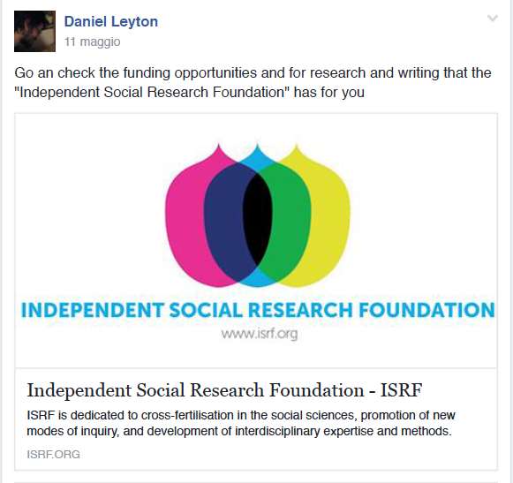

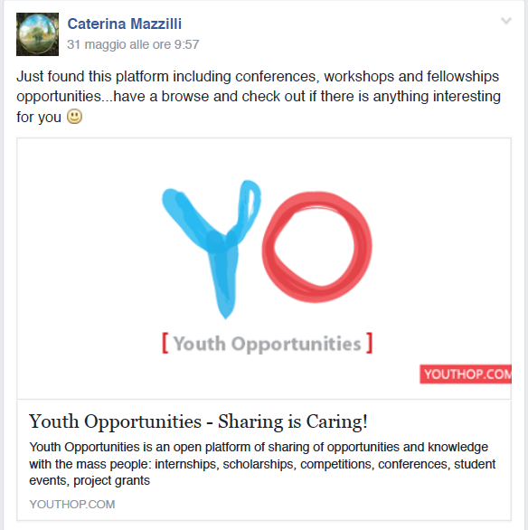

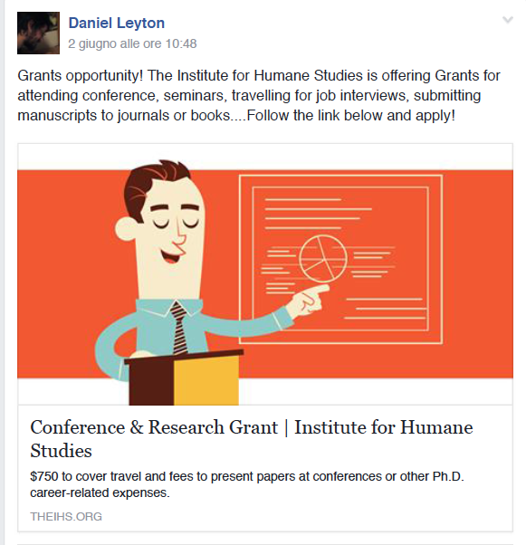
- Researchers' networks (including those in Facebook): Links with other permanent research networks that may be of interest to Roma researchers, with useful information and resources regarding job and research opportunities, collaboration, seminars/congresses, and academic life.

3. Jobs and internship opportunities: This includes permanent websites with information about jobs and internships and also direct links to specific opportunities. Here it is important to add the date of deadlines.


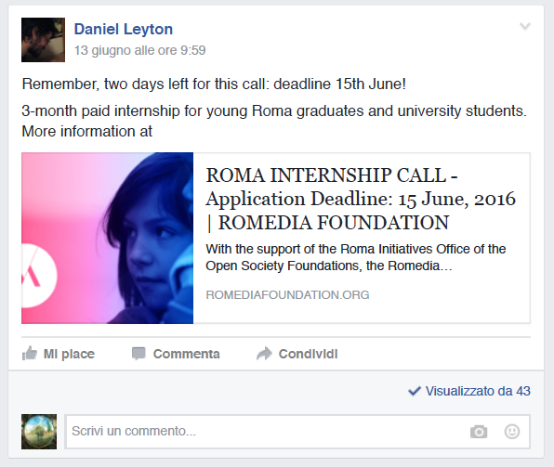

- Workshops, conference, publishing opportunities: Links informing about forthcoming workshops, conferences, seminars and calls for papers where Roma researchers may be interested in participating.
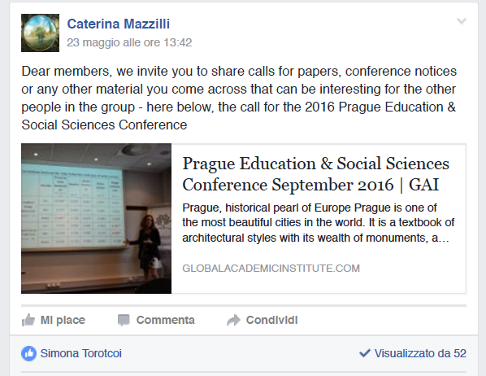

5. Training courses and summer schools: focusing particularly on research training, methodology, English language, what might be of interest for the network. Those that are free of change or for a nominal fee are especially relevant.
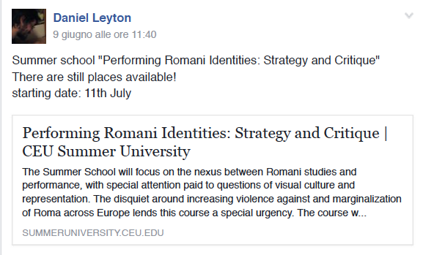
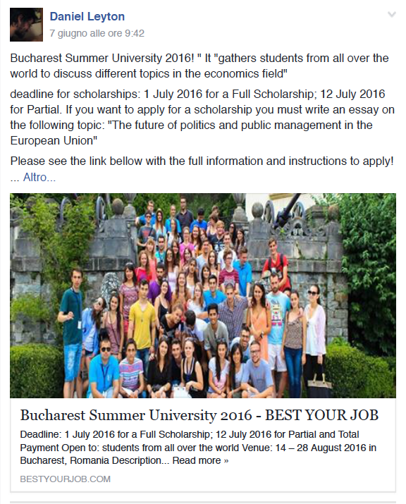
6. Relevant research news and reports: links to posts, videos, articles, podcasts informing about relevant research findings on Roma issues and others that are likely to be of significant interest to group members.
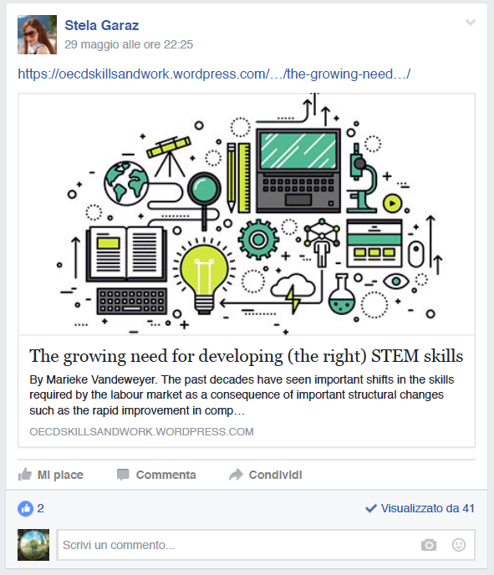
7. Blog posts about/for Early Career Researchers: links to posts regarding issues and themes associated with academic life and early career researchers’ challenges and opportunities.
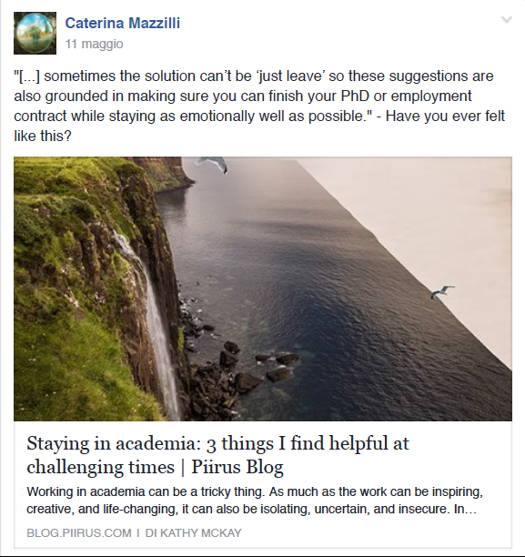

8. Life stories of HEIM participants / REF beneficiaries: posts and links containing life stories of REF beneficiaries that might be an inspiration for the network.
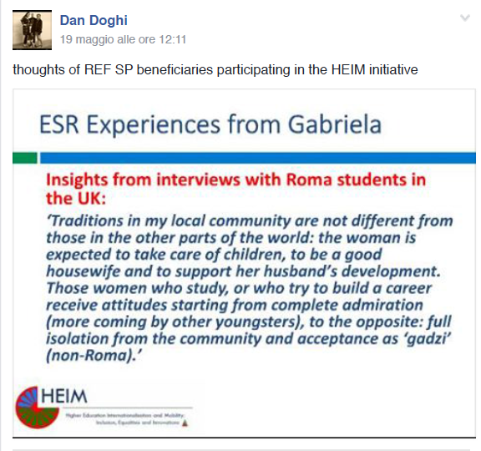
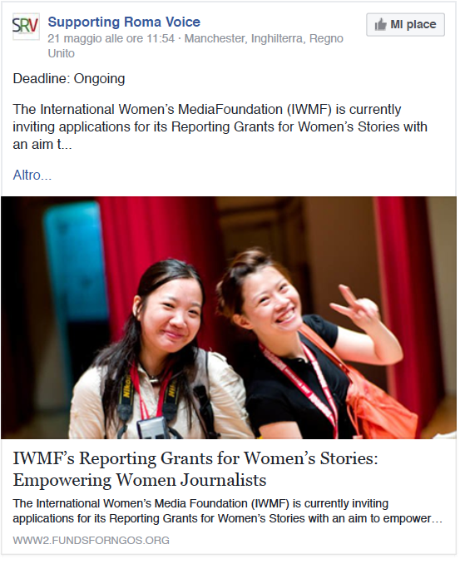

- Debate and discussion: posts which aim to start a discussion about controversial issues for example research ethics on conducting fieldwork as an insider/outsider researcher.
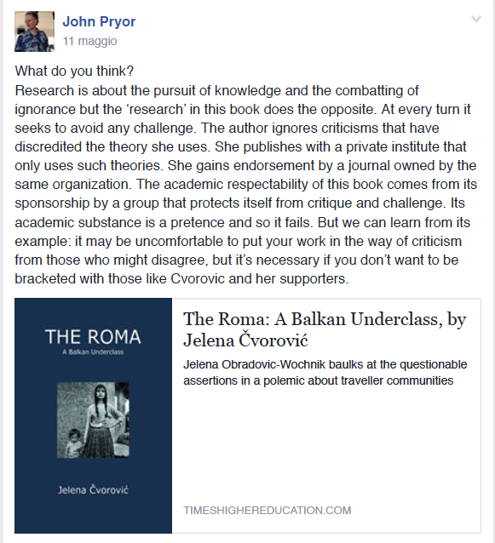
An extra category took shape once the Group had started:
- Posts asking for collaboration, feedback, proof reading of research outputs and articles.

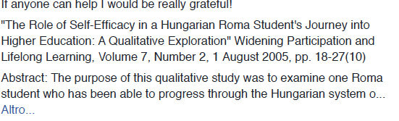

Additionally, we thought it would be a good feature for the group to upload some short video-clips in which (REF’s) Roma postgraduate students and researchers shared their academic experiences. Being aware that this is the kind of post most difficult to get, because it involves sharing personal experiences, we decided to leave it for a future point, when the group is better established.

Members
A list of people to invite to the group was compiled by a member of the REF team working with their records of past and current applicants to the REF’s Scholarship Programme. In addition to the status of postgraduate student or researcher, the prospective members of the network would need a good command of the English language. This was important as within an intensely international group a common language was required. Although this requirement would exclude some Roma ESRs, it was felt that they would be very many, as some facility with English is demanded now for virtually all post-graduate work in the social sciences. This selection process was completed while we were setting up the database, during the second week of secondment.

Once selected, an invitation email was sent to them from the email address of the REF’s Scholarship Programme. The email included a brief description of the purposes of the Facebook Page and some basic rules of interaction between participants, which they could find on the group too.

They are copied here below:

Status and Purpose
The Roma Research Network is an initiative of the Roma Education Fund (REF) established within the Higher Education Internationalisation and Mobility: Inclusion, Equalities and Innovations (HEIM) project, set up through the collaboration of the Universities of Sussex, Seville and Umeå with the REF.

This group is the main connecting hub of the network, constituting a virtual community of current, former and prospective Roma postgraduate students and researchers, primarily from the pool of REF Scholarship Program beneficiaries.

It fosters collaboration among its members over research and action, exchange of information about research-related upcoming events and scholarship and research funding opportunities. It promotes the exchange of skills, resources and expertise, which can be widely applied to several research projects and initiatives. It acts as a forum for sharing views on Roma issues for debate and discussion and an outlet for sympathetic critiques and mutual support.

This feature constitutes also a stimulating environment in which members bring their personal contribution in what is envisaged to become an active student community.

Who are our members? Who can be our members?
The network is intended to act as a support group for the emergent Roma research community. Current and former Roma Education Fund Scholarship Program beneficiaries form the core of original members of the group. However, all those who are interested in researching Roma issues or issues with a high degree of relevance for the Roma community and who are willing to accept the rules of sympathetic critique are invited to take part. As the focus of the group is research, members will mostly be those conducting or using research in universities and civil society organizations.

Outline rules for interaction between members
• Interaction between Roma Research Network members must be held in an environment of mutual respect and solidarity.
• The form of communication and interaction between members should be made emphasising the content of messages and its relevance for the network’s purposes.
• All the messages and post within the group must avoid discriminatory, racist, sexist or homophobic expressions
• All the messages and posts within the group must be kept within the group. They must not be put in circulation in other groups, media or people outside the group. The one exception to this would be if members of the group were being asked to comment on the draft of a text for publication elsewhere. In this case the author of the text should make this explicit when posting it.
- In case of violation of the conditions of interaction between members occurs, the administrator may decide to exclude the non-compliant members.

Achievements
The REF Scholarship Programme - Roma Research Network (the final name of the group) was launched on the 13th May 2016.
The invitation email was sent to around 310 email addresses. Of these, inevitably some were either wrong or no longer functioning, so we actually managed to reach around 150 people. We considered this just as a first round of contacts, as we planned both to broaden the criteria according to which members to include and to rely on the already existing members to include some of their contacts e.g. a snowballing technique, in the spirit of social networking.
One issue that arose from the beginning regards the possible inclusion in the group of people who are not Roma. On the one hand, a wider opening of the group towards non-Roma people studying/researching Roma-related topics could provide new perspectives, insights and research incentives, as well as an important amount of global support. On the other since the primary aim is to support Romani people as researchers it may be better not to include others.
As of 13th July 2016, the group counted exactly 100 members. They are located according to the original database gathered in Albania, Bulgaria, Croatia, Czech Republic, Hungary, Kosovo, Macedonia, Moldova, Romania, Serbia, Slovakia, Russia, Turkey, and Ukraine. A significant increase in membership requests took place after the CHEER/HEIM Impact event of the 19th May when more people became aware of the project’s progress.The event was streamed online and promoted in the Facebook Group, and some of the participants in the network engaged in the online discussions and opinions simultaneously to the seminar. See http://www.sussex.ac.uk/education/cheer/researchprojects/rise/impacts
During the secondment we endeavoured to post at least two links every day, also paying attention to differentiate the sources (for example, if one day we published 3 links, the first might be about a conference, the second about a report on Higher Education and the third about an internship). Other people on the REF’s staff were also posting links. In addition, a previous REF intern was also very active and supportive and may take over the moderation of the group.
People viewing the published posts varied from a minimum of 10 to a maximum of 45. They tended to be more interested in grants and scholarship opportunities than in reports, news or in blogs about being a researcher. In line with what seems to be the norm for such groups the main activity of the majority of members was with viewing rather than ‘liking’ or posting a comment. Those that were recorded included a request for information “Hi, does anybody know scholarship for summer school?” which was answered. Other comments were to be appreciative of the Group (“This group is a great idea!”). Similarly a couple of responses to a request for feedback from the REF Scholarship Manager are shown below:
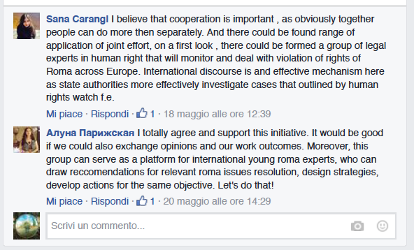

Issues and Challenges
The main issue we have identified concerning the Facebook Group is the lack of engagement of the participants as producers of contents and interaction.
We have identified at least four contextual reasons for the lower engagement as producer of contents and interactions. First, the institutional nature of the network under the umbrella of their funding organisation – the Roma Education Fund may be significant. Much of the content regarding Roma issues such as social exclusion, discrimination, racism or legal struggles over recognition are subjects of public discussion among Roma communities. That reflects different positions regarding activism, public policy or the role of philanthropy – all discourses and imaginaries which acquire a specific meaning and context at REF as well as in other contexts of struggle over rights. In this scenario, it is likely that participants will take a position of moderation, oriented to avoid controversies. This might be reinforced by the fact that the Facebook Group is governed by rules regulating ways of expressions; all of them open to different interpretations of, for example, what it means to be respectful, or to develop a positive or constructive critique.
Second, the fact that the network, its aims and rules, were established without the participation of the specific Roma Early Stage Researcher community can diminish the sense of entitlement or ownership in regard with the space opened by the Facebook Group.
A third important element to take into consideration in relation to the lower active participation of the members of the network is the language used. The official language is English and, even though a good level of English of the possible participants was identified, there is no certainty about the English level of members in practice. In the contacts we had with some of them by email we noted a reluctance to write in English because of the difficulties experienced. Lack of proficiency in writing in a second language and lack of confidence in its practice work as a barrier against participation in a community where a second language must be used.
We also noticed that there are quite a few similar Facebook Groups for Roma students, though they do not have the same research focus, set up either by REF or Central European University (CEU), like the REF Scholarship Program - Alumni and Beneficiaries Network, Roma Teachers International - REF Alumni or CEU Roma Access Program and we have been wondering whether the scarce participation we are still facing depends on this proliferation of groups or by the fact that we, working now as group administrators, are non-Roma and this perhaps triggers trust issues.

Positive influences of HEIM on our capacity development
The project allowed us as secondees from an academic to a non-academic organisation to develop new skills related to the project’s aims, meaning to learn something new from a partnership with a non-academic body.
First of all, we became familiar with a completely new body of knowledge, related to advocacy regarding Roma communities: awareness about racial and discrimination issues and affirmative action policies for Roma inclusion in Higher Education – especially in Central and Eastern Europe.
As the REF staff is composed of Roma and non-Roma people coming from different countries and with different backgrounds, we also had to adapt to the huge amount of diversity in the office and to learn how our work fits their interests and aims.
We have learnt to work in a different environment and context, a non-academic one with different complexities, priorities and dynamics and governed by different policies and funding regimes. This experience will be very valuable in will that the skills and understanding acquired will help us to work more easily in our academic career with the non academic sectors.
In addition, we have been able to contribute to REF‘s work and to the development of the project by offering our academic knowledge and skills, which have been very useful in, for example, building the source database. The secondment, in our view, was an excellent opportunity for knowledge exchange between academic and non- academic stakeholders, and between diverse countries and ethnicities.

Final Remarks
According to research, Roma students and researchers face several challenges regarding access, participation, belonging and institutional pressures of giving something back and being models for their communities (Hinton-Smith et al, 2016; Kolev et al. 2013; McGarry, and Agarin 2014; Mohanty 2003). Being aware that those challenges and barriers describe just some of the complex experiences with which Roma students deal, we hope that Roma researchers members of the Facebook Group can take possession of the network and reconfigure it in order to create a supportive community that can deploy academic paths and source of symbolic and affective support as well as a space of inclusion in research communities within Roma and non Roma researchers. We hope that, within this space, researchers can foster reflexivity, further discussions and cooperation between them, and raise awareness regarding common issues they face as individuals and collective beings.
We believe that such a space of intellectuals, researchers, and advocates of Roma people has the opportunity to encourage the desire to develop many hopes and projects that can lead to collective and individual flourishing.

References
Hinton-Smith, T., Danvers, E. & Jovanovic, T., 2016. Roma women in European Higher Education: Exploring Tensions of Individual and Shared Responsibility in Policy and Experience. Gender and Education (forthcoming)

Kolev, D., Krumova, T., Pamporov, A., Radulescu, D., van der Zwaan, S. and Balcik, T.,2013. Beyond anti-Roma stereotypes: The world is not just white and black. Plovdiv, BuAstartalgaria

McGarry, A. and Agarin, T., 2014. Unpacking the Roma Participation Puzzle: Presence, Voice and Influence, Journal of Ethnic and Migration Studies, 40:12,1972-1990.

Mohanty, C., 2003. Feminism Without Borders: Decolonising Theory, Practicing Solidarity. Durham, NC, USA, Duke University Press

