TITLE OF THE PAPER

Name Surname^{1,}*, Name Surname¹, Name Surname², Name Surname²

¹ Institution, complete address
² Institution, complete address
*Corresponding Author: xxx@xx.xx

ABSTRACT

The first major section of the manuscript is an abstract. The abstract should summarize the contents of the paper, discuss the contribution to the field as well as present the most important results. Authors are responsible for typing accuracy and proofreading of the manuscript. The manuscript has to be in line with the style format of this document and has to be technically correct in order to be accepted.

INTRODUCTION

Each manuscript should begin with an introduction, which gives some background on the topic, states briefly the objective of the paper and how it relates to other works in the field. The manuscript should report original research or technical developments and their applications. It should contain quality scientific or technical information. Manuscripts of a commercial nature will be rejected and will not be authorized for presentation. The process of acceptance or rejection of papers will be under the authority of the Conference Organizing Committee. The Organizing Committee will not be held responsible for any errors appearing in the final text. Authors assume sole responsibility for their manuscript, both for its form and its substance. Remember to check the manuscript carefully before submission. The manuscript should be submitted by only one author.

HEADINGS FORMAT

The titles of the main sections have to be centered, numbered and in 12-point bold type capital letters. With the exception of the abstract, nomenclature, references, and acknowledgements section headings have to be numbered. Blank lines need to be placed above and below each main section title.

Sub-Section Headings
Sub-sections headings have to be in lower case, 11-point bold type letters. A blank line has to be placed above, but not below them.

2.1.1 Sub-sub-section headings: Sub-sub-sections should be avoided. If they are used, they should be justified left, in normal small letters, with the text beginning to the right.

FORMAT OF THE MANUSCRIPT

Reference Number
Place the paper ID number, which will be announced on the received authors notification, at the top right corner of the header in a bold type, replace the “###” in the header of this document with the paper ID number. The paper ID number should be followed by a page number (for example, “154, Page 1” for the first page). Please repeat this procedure for the second page, as they have different header layouts.

Manuscript Title
Center the manuscript title with font size of 14-point bolded with a blank line below the title.

Authors
All authors should be listed by their full name with the family name appearing last, i.e., how the name is written in English (e.g., Yu Li Cho, John Smith, Tae-yong Kim). The affiliation of the corresponding author should be given first. The affiliation and contact information of all co-authors should be listed as well. When necessary, supercripts should be used to indicate which affiliation goes with which author. The affiliation(s) should be centered and in upper/lower case letters. The different parts of the affiliation(s) should be separated by commas, and if more than one line is necessary, the different lines should be of about the same length.

Number of Pages
The entire manuscript (i.e., text, figures, tables, bibliography, etc.) must not be longer than 8 pages including graphs, tables and figures. Any manuscript having excess pages will not be accepted.

Text Format
Times or Times New Roman font type MUST be used for any text in the document including captions, footnotes, and header information. All text has to be single spaced, black, and in 11-point type. All paragraphs must be single-spaced with a double space between each paragraph. The paragraph format is “justified”. If manuscript is prepared in the Asian format, please indicate in Page Set Up “No Grid Lines”. Asian single spacing appears as 1 1/2 spacing in Western formats. Paragraphs are not to be indented. Use single-line spacing between lines except where symbols or equations require 1 1/2 line spaces.

Paper Size and Margins
Authors are asked to provide the manuscript in A4 (21cm x 29,7cm) following the margin settings explained in this section.

IMPORTANT: All text of the manuscript must be located within A4 paper format page. The margins are given in Table 1. All margins (top, bottom, left and right) have to be set at 2.54 cm.

Table 1: Page margins for manuscripts

Margin  Position | Top | Bottom | Left | Right
A4 | 2,54 cm | 2,54 cm | 2,54 cm | 2,54cm

Format of Citations
Within the text of the manuscript, bibliographical sources are to be cited by giving the last name(s) of the author(s) and the year of publication. The year should always be in parentheses. The two possibilities are illustrated as follows:
Albert (1957) showed that the blend was azeotropic.
or: It was shown that the blend was azeotropic (Albert, 1957).

When there are two authors, the names of both should be cited, e.g.:
Albert and Klaus (1981) observed that the blend was azeotropic.
or: It was observed that the blend was azeotropic (Albert and Klaus, 1981).

When there are three authors or more, only the lead author of the source should be cited. The names of the other authors should be designated by et al. in italics, e.g.:
Lee et al. (1982) observed that the blend was azeotropic.
or: It was observed that the blend was azeotropic (Lee et al., 1982).

When the same author and the same year of publication are cited from more than one source, the sources should be distinguished in the text by adding the small letter "a" to the year of publication of the first source cited, "b" for the second source, and so on, i.e.,
Klaus (1980a) discovered … and further on in the text:
Klaus also pointed out (1980b) that …

Figures and Tables
Each table must be numbered (Table 1, 2, 3, etc.), with the caption centered above the table and table number in bold as shown in Table 1. Each figure must be numbered (Figure 1, 2, 3, etc.), with the caption centered below the figure and figure number in bold as shown in Figure 1. Figures and tables should be incorporated into the main body of the text. It is best to position them at the top or bottom of a page and to leave one blank line to separate them from the rest of the text. Authors have to make sure that all tables and figures appear in their entirety on one page. All tables and figures must be sharp and clear. We recommend a resolution of least 300 dpi. All axis and data series must be labeled correctly. All text within the table and diagrams should be in English.

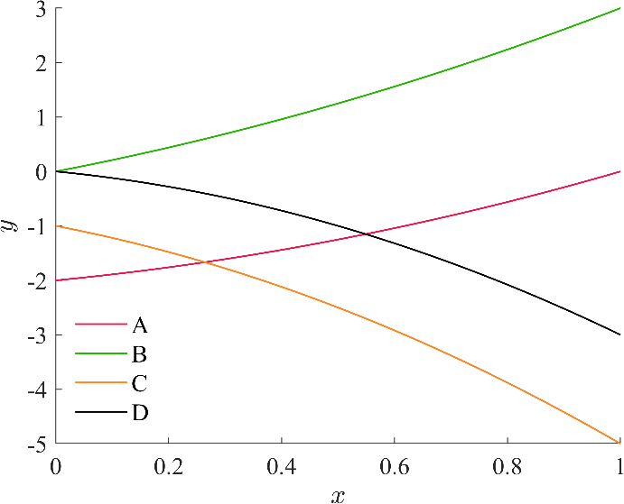

Figure 1: Sample figure

Format of Equations
Equations are to be centered, numbered in order (i.e., (1), (2), (3), etc.) on the right-hand side of the page and cited in the text with its number, e.g., “… as listed in equation (1)”. Use 1.5 spacing, if necessary, for equations.

Symbols used in equations should be explained directly below the equation in which they first appear or in a nomenclature section at the end of the manuscript. E.g., a method (Cheap and Fee, 1986) to estimate the cost of attending meetings is given in Equation (1). Formatting of equations has to be checked before submittal of the manuscript.

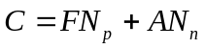 (1)

Units Format
SI units only.

Footer and Page Numbering
Authors are asked to include the one-line footer centered on each page of their manuscript. The footer has to be placed 1.27 cm from the bottom edge of the page. The required footer is included in the footer of the author template of this conference. The page number should be appended to the paper ID number in the header.

SUBMISSION OF MANUSCRIPT

Upload your manuscript by using the submission link available on https://www.lut.fi/en/orc2025
The system’s upload limit is 50 MB.

Manuscripts will only be published after the registration fee is paid in full by the early-bird registration deadline. If your manuscript is rejected, but you are already registered as required presenting author for the conference, the registration fee will be fully refunded until the early-bird registration deadline.

COMMERCIALISM

Commercialization in the manuscript and during the oral presentation is not permitted. Manuscripts are meant to advance the general state of the art. The conference is no place to promote sales. If included in the manuscript, the paper will either be rejected or the commercialization will be cut out. We request, except for the first slide and author identification in the manuscript, that company names, logos and other references to proprietary equipment are not included in the manuscript, on the slides, or in the oral presentation. However, it is acceptable to describe equipment that was used in experimental tests when necessary for others to be able to reproduce the results.

CONCLUSIONS

Conclusions can be in paragraph form or bullet items. Remember the following:
- Do not wait until the last minute to submit your paper.
- Do not expect to get an extension for submitting your paper.
- If you do not submit your paper according to the guidelines specified in these instructions, there is NO GUARANTEE that your paper will be included in the conference proceedings.

NOMENCLATURE

The nomenclature should be located at the end of the text using the following format:
A hotel cost (US$/night)
C total cost (US$)
N number (–)

Subscript
n nights
p participants

REFERENCES

References are to be placed at the end of the manuscript in alphabetical order by the last name of the first author. All sources cited in the text have to be listed in the list of references in alphabetical order of the author's name or of the lead author’s name if there are several authors at the end of the manuscript. The sources have to be presented as follows:

1-Article from a periodical
Family Name(s) of the author(s), first name initial(s), year of publication, title of article, title of periodical in italics and abbreviated according to international standards, volume number, issue number: first and last page.

2-Paper published in conference proceedings
Name(s) of the author(s), first name initial(s), year of publication, title of article, title of the conference in italics, publisher of proceedings: first and last page.

3-Book
Name(s) of the author(s), first name initial(s), year of publication, title of the book in italics, name of publisher, place of publication, number of pages. Establishments can be considered authors when they assume main responsibility for the text and their publications reflect their collective opinions or activities.

4-Book chapter
Name(s) of the author(s), first name initial(s), year of publication, title of chapter, In: name(s) and initial(s) of the co-coordinator(s), title of the book in italics, name of publisher, place of publication: first and last page.

For example:
Black, S., 2018, Introduction to Engineering, TechPress, New York, 500 p.
Brown, L., Green, M., White, R., 2019, Innovations in Renewable Energy, Proc. Global Energy Conf., IEEE: p. 200-210.
Cheap, I.R., Fee, W., 1986, Conference Attendance of a Shoestring Budget, Int. J. Cost-Effective Research, vol. 7, no. 4: p. 78-93.
Grey, T., Johnson, P., 2017, Neural Networks and Deep Learning, In: White, R., Modern AI Techniques, AI Publishing, London: p. 50-75.
Smith, J., Doe, A., Lee, K., 2020, Advances in Quantum Computing, Int. J. Comp. Sci., vol. 15, no. 2: p. 123-130.

ACKNOWLEDGEMENTS

An acknowledgement can be located at the end of the text to indicate the sponsor of the study presented and/or to acknowledge additional contributors to the paper.

