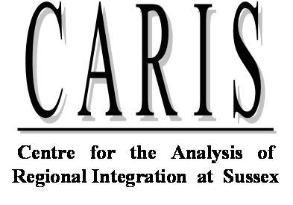

Fifth Annual Conference
The Future of GSP

Thursday September 30, 2010

at
Freeman Centre, Room G24
University of Sussex
9:00 -9:30 Coffee and Registration , Welcome Remarks by Peter Holmes

9:30-11:15 Session I Do GSPs Work and What are Policy Implications?
Chair – Alasdair Smith (CARIS)
Discussants – San Bilal (ECDPM)
Marcelo Olarreaga (University of Geneva)
Xavi Cirera (IDS)
“The impact of GSP Preferences on Developing Countries' Exports. Gravity Modelling at the Product Level”

Jim De Melo (University of Geneva, CEPR)
“Market access for LDCs post- Doha Round and discussions of new empirical results”

Michael Gasiorek (CARIS)
“Mid-term Evaluation of the EU’s GSP schemes: what have we learned?”

11:15-11:45 Coffee

11:45-13:00 Session II How Secure are GSPs?
Chair – Kerry Brown (Chatham House)
Discussants – Jodie Keane (ODI)
Kamala Dawar (Graduate Institute, Geneva)
Oliver Morrissey (Nottingham University)
“Trade Preferences to Africa: If the EU wants Reciprocity what about China?”

L. Bartels (University of Cambridge) and C. Haberli (WTI)
“Bringing Predictability and Security to Developing Countries Tariff Preferences”

13:00 -14:00 Lunch

14:00-15:30 Session III Panel Discussion The Future of GSP Schemes
Chair- J. Rollo (CARIS)
Panel Members:
Patrick Low (WTO), Iain Mansfield (DBIS/DFID), Sheila Page (ODI)

15:30-16:00 Tea

16:00-17:00 Session IV Book Launch by Jean-Pierre Chauffour
Chair- Peter Holmes (CARIS)
Preferential Trade Arrangement Policies for Development: A Handbook
edited by Jean-Pierre Chauffour and Jean-Christophe Maur
World Bank Trade and Development Series

