Quality Enhancement Strategy

- Introduction

Following QAA Institutional Review in 2013 it was recommended, in the context of developing the institutional Teaching and Learning Strategy, the institution should more clearly define and promote the approach to enhancement. This should specifically identify areas or activities to be addressed, with timescales.

- Definitions and approaches

The QAA’s Higher Education Review Handbook (June 2014) defines enhancement as 'taking deliberate steps at provider level to improve the quality of learning opportunities'.

The University’s approach to enhancement enables this recommendation to be met. Quality enhancement at Sussex is based on the following principles:

- Securing continuous improvement in the student academic experience and academic outcomes is a core strand of the University Teaching, Learning and Assessment Strategy.
- This objective is embedded in the University’s quality model through examples such as Periodic Review, Annual Course Review and Course validation.
- The University’s Teaching and Learning Committee (UTLC) has overall responsibility for the delivery of quality enhancement. This responsibility is delegated to the Teaching and Learning Strategic Enhancement Sub-Committee (TLSESC) which maintains oversight of the various institutional activities as set out in the actions table below.
- The student voice is a key driver for the identification and implementation of enhancement activity.
- The University is committed to expanding its use of data and metrics to secure continuous improvement.

- Enhancement Model

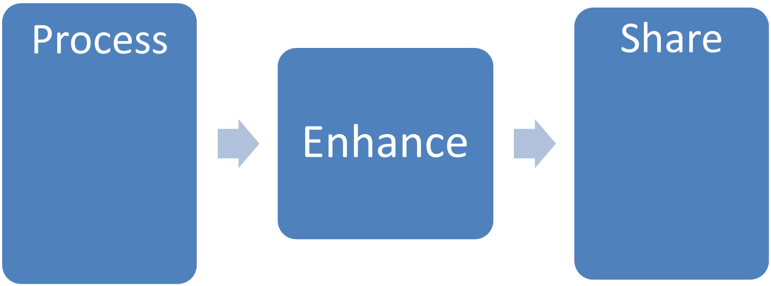
- Annual Course Review
- Periodic Review
- NSS
- Student Engagement
- Student Reps
- Professional Development of Teaching
- Committees
- Annual Enhancement Event
- Teaching and Learning Conference
- Teaching awards
- Online resources
- People
- Dissemination of good practice

- Actions

This enhancement strategy collects together in a single document the various enhancement activities in train and is provided to support TLSESC in its oversight of quality enhancement.

Theme | Aims | Actions and Responsibility | Progress
Teaching, Learning and Assessment | - Provide professional support and recognition for teaching development. | - Re-development of the HEA accredited PGCertHE with clear routes to professional recognition. (Course Team and ADQE)  - Continue to prepare for principle and senior fellows of the HEA. (PGCertHE Course Team and ADQE)  - Formally recognise contributions to teaching and learning through the introduction of awards including Sussex Teaching Fellowship in AY 2015/16. (Teaching Awards Panel and ADQE)  - Put out a call for interest in application for National Teaching Fellowships. AY 2014/15 and ongoing.  - Organise an annual Teaching and Learning Conference for staff at the University to support staff and enable them to showcase their work. AY 2014/15 (ADQE) | 1.1 HEA accreditation received for re-developed PGCertHE. Nine out of 11 schools continue to engage with the Starting to Teach module. Bespoke offerings are available for English and MPS staff.  http://www.sussex.ac.uk/adqe/enhancement/devawardsrecognition  1.2Further development of the PGCertHE will be undertaken.  1.3  http://www.sussex.ac.uk/adqe/enhancement/devawardsrecognition  1.4 One NTF appointed in 2015 – Dr Michelle Lefevre http://www.sussex.ac.uk/staff/newsandevents/?id=30830  1.5  http://www.sussex.ac.uk/adqe/enhancement/teachinglearningenhancement/tandlconf
Teaching, Learning and Assessment | - Review assessment policy and practice. | - Work with HEA consultants and engage key Teaching and Learning staff in reviewing and enhancing assessment practice at Sussex to develop clear action plans in AY 2014/15. (ADQE)  - Create a feedback section in Study Direct bringing together all relevant assessment information to enable students to make the most of their feedback during AY 2013/14. (ITS)  - Develop clear principles of assessment and norms. (Assessment and feedback task and finish group)  - Revisit the University’s approach to grade conversion for study undertaken abroad to ensure this remains consistent and fit for purpose. (Study Abroad working group) | 2.1 Report from the HEA to be shared with TLSESC, UTLC and the Curriculum Quality Away day in autumn 2015  2.2 See Study Direct https://studydirect.sussex.ac.uk/login/  2.3 Approved by UTLC and to published as part of the ADQE Quality Guide 2015/16  2.4 Approved by UTLC and Implemented on a no detriment basis  http://www.sussex.ac.uk/adqe/standards/studyabroad
Teaching, Learning and Assessment | - Introduce electronic submission and feedback for all students. | - Introduce electronic submission, marking and feedback for all text-based assessments for stage 1 UG students for AY 2014/15 supported by clear policy, training and guidance. (ESEF Project Team)  - Scope for phase 2 currently in development and likely to include second year text-based assessments for AY 2015/16. (ESEF project Team) | 3.1 and 3.2 http://www.sussex.ac.uk/adqe/standards/examsandassessment/esubmission/  http://www.sussex.ac.uk/tel/submission  3.2  http://www.sussex.ac.uk/its/projects/current/esubmission2
 | - Inclusive teaching, learning and assessment. | - Create rules and guidance to support development of inclusive teaching, learning and assessment for AY 2016/17. (ADQE with academic input)  - Schools to reflect on the achievement of international students compared to home/EU students as part of the Annual Course Review (ACR) of 14/15 provision. (All Schools) | 4.2 ACR report due at spring UTLC.
Student Engagement | - Work in partnership with staff, students and the Students’ Union, listen, respond and recognise outstanding contributions, providing transparency on how this is done and clarity of expectation for all. | - Review mechanisms and opportunities for students to engage with quality assurance and enhancement, with a view to:  - Increase chances to participate in a meaningful way (meetings and surveys);  - providing clarity on the opportunities available and the resultant impact for AY 2015/16. (Student Engagement Working Group)  - Develop a Student Engagement Policy which documents clearly all of the mechanisms for engaging with students and responding to the student voice aligned to chapter B5 of the QAA’s Quality Code during AY 2015/16. (ADQE informed by the Student Engagement working Group)  - Develop a Student Charter in consultation with staff and students to set out expectations of both the University and its students and to promote an ethos of partnership for publication in AY 2015/16.  - Run the Postgraduate Taught Experience Survey (PTES) in 2015 and every two years in the future. (ADQE) | 5.1 Proposed introduction of mid-year engagement surveys and an end of year course evaluation survey to phase out MEQs. See report on progress to TLSESC and UTLC  5.2 Student Engagement Framework in progress to capture work of the Student Engagement Working Group  5.3 Awaiting update  5.4 Results for 2015 showing 81% overall satisfaction for PGT students at Sussex. Results to be shared with TLSESC and UTLC autumn 2015.
Resources | - Support innovative uses of technology in teaching, learning and assessment accessible across the campus. | - Create and recruit to a Technology Enhanced Learning Office during the AY 2013/14.  - Develop an institutional policy for lecture recording for AY 2014/15. (Head of TEL)  - Installation of lecture recording equipment in more teaching spaces across campus. (ITS/Teaching facilities Forum) | 6.1 http://www.sussex.ac.uk/tel/  6.2 http://www.sussex.ac.uk/tel/learningtechnologies/lecturecapture  http://www.sussex.ac.uk/s3/?id=237  6.3 The IT Services lecture capture improvement project is funded for 14/15 and 15/16.  http://www.sussex.ac.uk/its/projects/current/lecturecapture1
 | - Ensure that IT is accessible, integrated and robust. | - Upgrade the University’s internet connection to increase capacity to 10 gigabits per second during AY 2013/14. (ITS)  - Increase access to Wi-Fi across campus including student residences in AY 2013/14. (ITS) | 7.1 and 7.2 Completed
Provision of Information | - Provide clear signposting to available support for all students of the University. | - Review sources of support for students to create a framework of available academic and pastoral support to enable clear signposting and integration of services taking account of the requirements for joint honours students for AY 2015/16.  - Review the student handbook to provide useful, up to date, easily accessible information for students for in light of CMA guidance AY 2015/16. (ADQE)  - Develop and implement guidance on student engagement with studies for AY 2015/16. (student Services/Student Engagement Working Group/ADQE)  - Creation/redrafting of a suite of policy and procedure documents around placements management AY2015/16. (CEC) | 8.1 In progress.  http://www.sussex.ac.uk/adqe/standards/examsandassessment/jointhons  Course handbook template also provided to Schools.  8.2 The 2015/16 handbook to be published before the start of term  http://www.sussex.ac.uk/students/essentials/studenthandbook/  8.3 In progress and for discussion at the next Student Engagement working Group  8.4 In progress. Agenda item for spring TLSESC.
Provision of Information | - Provide clear and easily accessible information on policies / roles / expectation / workloads to staff and students. | - Creation of a policy for Academic Advising AY 2015/16.  - Develop a framework of principles and standards for joint honours provision for AY 2015/16.  - Review Sussex Choice and Pathways and ensure that its operation is clear to all and enables wider access for students for implementation AY 2015/16.  - Continue to develop the ADQE website with easily accessible and up to date policies, information and templates. (ADQE) | 9.1 In progress. Recommendations for Academic Advising accepted by UTLC and an implementation group to be out in place in autumn 2015.  Guidance around SSPCs being reviewed.  9.2 In progress.  http://www.sussex.ac.uk/adqe/standards/examsandassessment/jointhons  9.3 Working/task and finish group  http://www.sussex.ac.uk/adqe/curriculum/sussexchoice  9.4 In progress  http://www.sussex.ac.uk/adqe/
Provision of Information | - Commit to timely review and evaluation of policies/new initiatives to ensure continued clarity and intended benefits are achieved. | - Confirm a schedule for reviewing, mapping, updating and publishing of all quality assurance and enhancement policies to ensure efficiency of operation and continued alignment to the QAA’s Quality Code in AY 2015/16. (ADQE) | 10.1 In progress. The Quality Handbook is to be published in autumn 2015.

Clare Wolstenholme
Academic Development and Quality Enhancement
September 2015

