Overview and Guidance for Portfolio Approval Sub Committee Stage 1 and 2
------------------------------------------------------------------------------------------------------------------------

Course Approval/Withdrawals Rationale

Introduction
When proposing a new course or the suspension/withdrawal of a course at the University of Sussex, a range of interrelated factors must be considered to ensure strategic alignment, academic quality, student experience, and financial sustainability, in line with the University Value for Money Policy.
This rationale outlines the key components informing course approval/suspension/withdrawal decisions, guided by Senate-agreed thresholds, institutional strategy, and practical considerations around resourcing and delivery.

The rationale is designed to be used throughout the entire course lifecycle. From the early stages of conception of a course, through Faculty Education Committee approval at Stage 1, Portfolio Approval Sub-Committee approval at Stage 2, and into validation. Through regular review of a course, and into any requirement for suspension and withdrawal.

The rationale is designed to make the course lifecycle process both rigorous and flexible, enabling innovation while maintaining academic standards and effective operations and delivery.
PASC timelines can be found at: Portfolio Approval Sub-Committee - Information and Template Paperwork : Curriculum : Academic Quality and Partnerships : University of Sussex

There are two key questions teams should consider in the development of new provision, and in the suspension/withdrawal of provision.
Should Sussex Do This? Should Sussex Stop Doing This?
These questions should be explored using self-service marketing tools (link) and existing evidence (as suitable) to understand if there is a market for this. If it is expected there is, the idea should proceed to PASC Stage 1. If the market has changed and is in decline consideration should be given to should a course be retired or renewed.
How Should Sussex Do This?
This question explores all of the components detailed below and includes the Unique Selling Point of a new course, how it will be delivered. At the same time it asks how a course will be retired and what teach out will look like.

New Courses
To help address these two questions, the following diagram highlights the components to be considered:

Start:
- Does the course meet Senate thresholds?

If Over Threshold?
If so, usually approved (unless one component below is a red flag):
Module Efficiency
Market Trend (Growing or Declining?)
Completely New Market
Resource Costs
Partnerships/Agreements
Student Experience

If Under Threshold?
Two possible outcomes:
- NOT Approved
- Sometimes Approved/Extra things to Consider:
Module Efficiency
Market Trend (Growing or Declining?)
Completely New Market
Resource Costs
Partnerships/Agreements
Student Experience
Strategic Importance

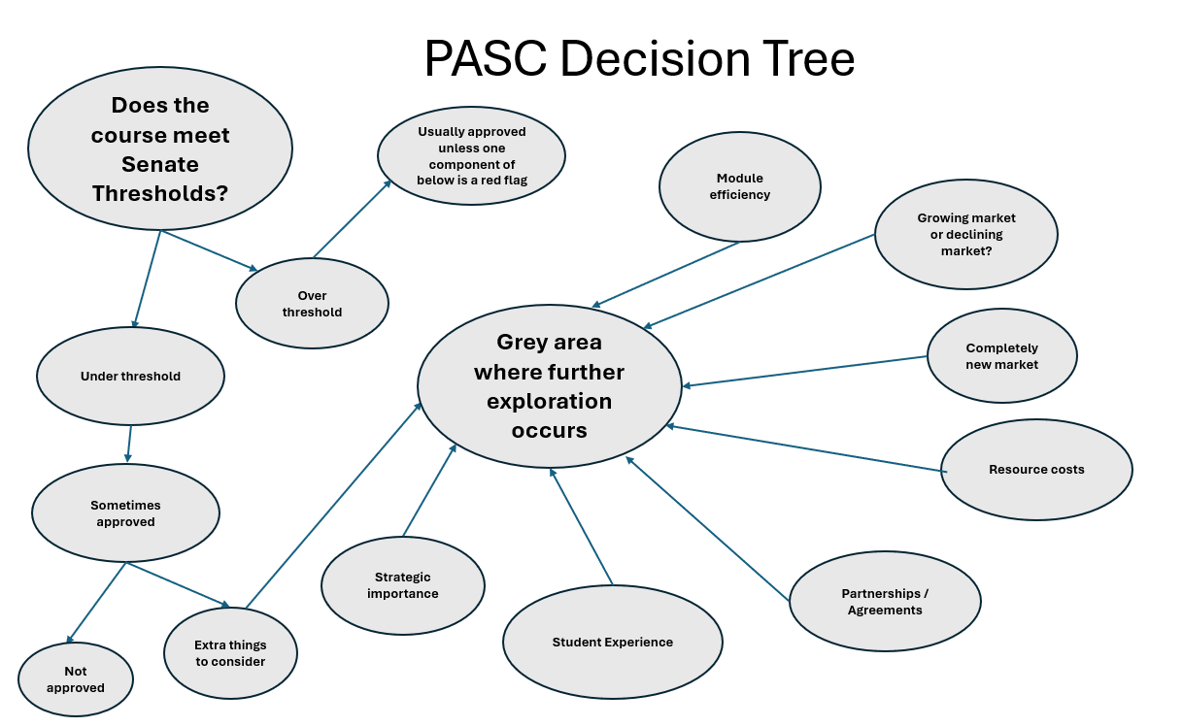

1. Strategic Alignment
1.1 Alignment to University Strategy.
Courses must support the broader University Strategic Plan to ensure an attractive and distinctive taught portfolio and deliver on:
• student number recovery
• income growth
• reputation building
• efficiency and effectiveness.
The taught portfolio must:
- Align with the University strategy (Sussex 2035) and be informed by institutional educational and research strengths.
- Deliver on key performance indicators (e.g., student experience and outcomes, employability, widening participation, internationalisation).
- Address sectoral trends or policy drivers (e.g. skills shortages, national initiatives).
1.2 Faculty-Level Priorities.
Proposals will be evaluated in the context of faculty-level academic planning and available resources through Annual Business Planning and Student Experience and Outcome planning.
2. Financial Viability and Efficiency

In line with the Value for Money Policy members of the University Executive Board, Executive Deans of Faculties, Directors of Professional Services, budget holders, and management decision making boards and groups (PASC 1 and 2 is part of these groups) shall create and embed a culture of Value for Money awareness, and ensure the Value for Money policy is integrated into all aspects of University work.
2.1 Financial Modelling.
All course proposals must be accompanied by robust financial modelling including:
- Expected tuition fee income (domestic and international).
- Scholarships or discounts applied.
- Resourcing needs (staff, space, marketing, etc.).
- Cost-efficiency of delivery (e.g., reliance on existing modules).
2.2 Minimum and Maximum Viable Cohort Sizes.
Each course should model:
- Minimum viable student numbers, below which the course would not be financially or educationally viable. This includes minimum numbers to achieve student satisfaction with the group size.
- Maximum capacity, including implications for double/triple teaching, placement availability, or teaching space.
2.3 Module Efficiency.
Consideration should be given to module efficiency. This should involve consideration of:
- Reused existing modules
- Minimise optional modules that add timetabling complexity, but balance ensuring a unique and attractive offer.
- Be aligned to the Sussex Academic Framework.
3. Senate Thresholds

Senate thresholds have been established to define the minimum number of students on courses. These have to still apply, however PASC recognises that nuances exist. This document sets out where considerations and exceptions can be considered.
3.1 Established Senate thresholds state:
- Minimum of 30 students per cohort on an undergraduate course to be reached at steady state (defined as 3 years).
- Minimum of 15 students per cohort on a postgraduate course to be reached at steady state (defined as 3 years).
- Thresholds include courses taught together i.e. ‘with a placement year’, ‘with a year abroad’ etc. and integrated master’s.
- Minimum numbers for ODL and non-standard provision should reflect robust financial modelling.
3.2 Considerations and Exceptions.
Considerations should be given where:
- Module efficiency is high, and costs are low.
- A course is part of a larger portfolio contributing to overall viability.
- A strong case is made for strategic or market importance.
- Online Distance Learning (ODL) courses will follow separate financial thresholds based on digital delivery models.
- Overall fee income and operating surplus for reinvestment. The equivalent of 15/30 Home fee-paying students, but potentially with fewer students where the market evidence expects to recruit overseas students.
- Efficiency or Faculty contribution. An increase in fee income and operating surplus for reinvestment, where there are less direct costs to the faculty (e.g. additional teaching or PS costs included in the proposal). The contribution required should be based on Faculty financial planning targets and vary by faculty.

4. Market Context and Innovation.

Consideration should be given to a number of market factors:
4.1 New to Market
Consideration should be given to new courses for:
- The University (Sussex’s first in the area) especially where there is demand in Graduate jobs or insight from employers of in-demand skills
- The sector (emerging fields like quantum technologies, AI) especially where Sussex’s expertise is outstanding.
- There are pipeline agreements e.g. related to research grants, government initiative.
- Courses are aligned to data-driven strategic marketing priorities, especially when the market is large and growing,
In such cases, additional evidence should include:
- Market trend analyses.
- Projected student demand (even without competitor benchmarks).
- Alignment with funding or partnership opportunities.
- Competitor and Sector Analysis Benchmarking against similar offerings across the UK and internationally is encouraged where applicable.
5. Course Portfolio Considerations
5.1 Cognate Course Groups.
Where a proposed course is part of a family of related programmes, it may benefit from:
- Shared core modules.
- Combined student numbers for threshold calculations.
- Integrated delivery models.
5.2 Impact on Student Experience.
Proposals should demonstrate how the course contributes positively to:
- Teaching quality.
- Cohort identity.
- Access to placements, year abroad, and support services.
6. Special Cohorts and Delivery Models
6.1 January Starts Consideration must be given to:
- Whether students join existing September modules.
- Whether additional resources are required.
- There may be lower thresholds where no new modules are developed.
6.2 Part-Time Students.
A standardised model should be developed for how part-time students count toward threshold calculations and resourcing needs.

7. Late-to-market Proposals

7.1 Course proposals are expected to follow the standard agreed AQP timelines.
Exceptionally, courses can be considered outside of these timelines, reasons for this may include:

- High level of student numbers available immediately, and thus should not be delayed.
- Reputational importance: if Sussex can launch this course ahead of competitors it would be good for the University’s reputation.
- Importance to a strategic market/country.
- Part of a suite of courses to be launched and delaying this would delay the others launching later.

8. Student Retention and Progression Modelling Forecasts should incorporate:
- Progression patterns across years
- Impact of placement years or year abroad programmes
- Variability in numbers between stages (e.g., 15 students in Year 1 ≠ 15 in Year 2).

9. Intellectual coherence/specialist knowledge:
Before launching a course faculties need to be confident that the correct expertise is in place to deliver the course, and that the expertise is resilient to/protected against future staff changes.

Scoring

Clarity and Attractiveness of the Offer Courses should be reviewed by the proposing teams, Members of Stage 1 and Stage 2 PASC. For transparency and consistency, we have provided the matric below. This data is not collected or required to be submitted, but will used to form the basis of discussions.

Clarity of Offer
Area | Level of Clarity  ←Low High→
Is the course title clear and attractive? | 1 2 3 4 5
Is it clear why students should study this? | 1 2 3 4 5
Is it clear why students should study this at Sussex? | 1 2 3 4 5
Does it meet Senate thresholds? | 1 2 3 4 5
Is it of strategic importance? | 1 2 3 4 5
Is there module efficiency? Ie, does the course use existing modules? | 1 2 3 4 5
Is it a growing market or a declining market? | 1 2 3 4 5
Is it a completely new market? | 1 2 3 4 5
Are there high resource costs? | 1 2 3 4 5
Does the course have partnerships/agreements in place? | 1 2 3 4 5
Will the course give good a good level of student experience? | 1 2 3 4 5

Process for PASC

Portfolio Approval Sub Committee (PASC) is the decision-making board with delegated authority under Senate to approve new degrees/suspensions and withdrawals.
The process for PASC depends on the activity requirement. The process for each activity is detailed below.

New Degree Course
Proposals for a new course follows the Stage 1 and Stage 2 process. This enables Stage 1 to occur at Faculty level, and if a proposal progresses to Stage 2, it is reviewed at a central governance level (PASC). If a proposal progresses past Stage 2, it moves into Validation.

Change of Degree Title
This should be prepared at Faculty level, and submitted for single sign off at a PASC.

Suspension/Withdrawals
This should be prepared at Faculty level, and submitted for single sign off at a PASC.

New/withdrawal of Pathways
This should be prepared at Faculty level, with the support of the Board of the School of Progressive Futures and Sussex Choice Oversight Board, and submitted for single sign off at a PASC.

Timelines
Timelines can be found at: Portfolio Approval Sub-Committee - Information and Template Paperwork : Curriculum : Academic Quality and Partnerships : University of Sussex

 | PASC Timelines | Curriculum Reimagined driven changes | UG and PG recruitment cycle timelines
Sept 26 courses
July 2025 | PGT Prospectus published | MAH pressing ahead with 26/27 UG course changes and CR alignment course specs and module descriptors  All information to be updated and correctly on the prospectus by July/Aug 2025
Sep-25 | UG/PGT applications open | MAH Title Changes | UCAS application system opens for UG  Application deadline for UG International Country Scholarships, and for PG Sussex Alumni Scholarship, and International Country Scholarships
Oct-25 |  |  | UG Open Day  PG application system opens for 2026  Careers Fair 2025 at AMEX stadium
Nov-25 |  |  | UG Open Day  Masters Open Day (online)
Jan-26 |  |  | 'Soft' deadline for main UG 2026 applications
Feb-26 |  |  | UCAS Extra Opens (UG)
Mar-26 |  |  | Masters Open Day (campus)
Apr-26 |  |  | Application deadline for UG+PG Chancellors International Scholarship
Jun-26 | Final Deadline for Validation Event | MAH PGT tbc | Final decisions for all UG 2026 applications. Later applications go through Clearing
Jul-26 |  |  | International Baccalaureate results published
Aug-26 |  |  | A Level results published  UG Clearing opens  PG Application deadline (international)  Application deadline for UG Sussex Bursary and for PG Chancellors Masters Scholarship
Sep-26 | Course launch |  | Final deadline for late UG 2026 entry applications  PG application deadline
Jan 27 courses (PGT only)
Feb-25 | Deadline for PGT new course proposals and title changes to be approved by PASC
Jul-25 | PGT Prospectus published
Sep-25 | PGT applications open
Oct-26 | Final Deadline for Validation Event
Nov-26 |  |  | PG deadline for January starts
Jan-27 | Course launch
Sep 27 courses
Oct-25 | Deadline for UG new course proposals and title changes to be approved by PASC | UG SEM, SocSci, USBS: first draft of course spec due Autumn 2025 BoS for local feedback  UG SEM, SocSci, USBS: second draft Autumn FEC 2025 for FEC approval an AQP input
 |  | UG SEM, SocSci and USBS Approval panels as necessary Nov/Dec 2025
Jan-26 | UCAS deadline |  | UG Prospectus finalised
Feb-26 | Deadline for PGT new course proposals and title changes to be approved by PASC | UG SEM, SocSci, and USBS course level information to be correct on Banner and CMS by Feb 2026 to pull correctly through to the prospectus
Mar-26 | UG print and online prospectus published
Apr-26 |  |  | Review 2027 PG online prospectus
Jul-26 | PGT Prospectus published | UG SEM, SocSci, USBS UG and PGT module level detail (descriptors and assessments etc) to be developed over summer 26 ready for canvas publication and students starting in Sept 2027  PGT course level changes need to have gone through the same process ready for July 26 prospectus publication - exact timeline tbc | 2027 PG course pages updated and new courses launched late July
Sep-26 | UG/PGT applications open |  | UCAS application system opens for UG
Jun-27 | Final Deadline for Validation Event
Sep-27 | Course launch
Jan 28 courses (PGT only)
Feb-26 | Deadline for PGT new course proposals and title changes to be approved by PASC
Jul-26 | PGT Prospectus published
Sep-26 | PGT applications open
Oct-27 | Final Deadline for Validation Event
Jan-28 | Course launch
Sep 28 courses
Oct-26 | Deadline for UG new course proposals and title changes to be approved by PASC | BAU - course level changes move beyond CR and into the normal timeframes for making structural course changes (ie any info on the course spec that the prospectus shows)
Jan-27 | UCAS deadline | Module detail changes no longer material info and will move to Faculty level approval
Feb-27 | Deadline for PGT new course proposals and title changes to be approved by PASC
Mar-27 | UG print and online prospectus published
Jul-27 | PGT Prospectus published
Sep-27 | UG/PGT applications open
Jun-28 | Final Deadline for Validation Event
Sep-28 | Course launch

