

Approved
Hotels and Guest Houses List

Category: Standard Hotels

Hotel / bed and breakfast information | Approximate special rate if available

Imperial Hotel  First Avenue  Hove  T: + 44 (0) 1273 777320  F: + 44 (0) 1273 777310  W: www.imperial-hove.com/index.html  Although located in Hove, this hotel is still within easy walking distance to Brighton and the seafront. All rooms are spacious and well equipped with everything you might need!  Free WIFI access  Restaurant/Brasserie open everyday.  Bar Open everyday  5 Meeting Rooms  On street parking vouchers @ £4.50 per day.  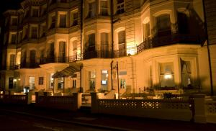 | Quote ‘University of Sussex rate’ when making a booking.  Monday to Thursday  Single room with en-suite £55 per night  Double/twin room with en-suite £85 per night (single occupancy £75)  Executive double (Superior) room with en-suite £95 per night (single occupancy £85)  Weekend Rates (Friday –Saturday)  Bed and Breakfast  Single room with en-suite £64 per night  Double/twin room with en-suite £105 per night  Executive double (Superior) room with en-suite £120 per night  Full English breakfast and VAT included.  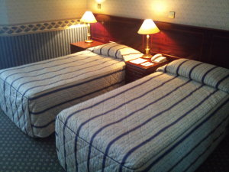

Langfords Hotel  8-16 Third Avenue  Hove  T: + 44 (0) 1273 738222  F: + 44 (0) 1273 779426  W: www.langfordshotel.com/  Situated just off from the colourful and lively Brighton and Hove seafront and within easy walking distance of Brighton’s main attractions. All rooms are spacious and comfortable.  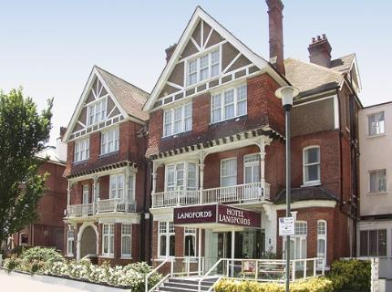 | Quote ‘University of Sussex rate’ when making a booking.  Midweek  Single room £50.00  Double/ twin £80.00  Family rooms £95.00  Weekend  Single room £67.50  Double/twin £105.00  Family room £125.00  These rates include breakfast.  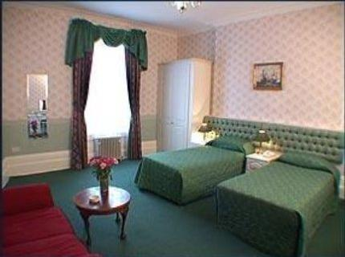

Premier Inn  144 North Street  Brighton  BN1 1RE  T: 0870 990 6340  F: 0870 990 6341  W: www.premierinn.com  This hotel is fantastic value particularly for families wanting somewhere right in the centre of Brighton. Close to Churchill Square, the Lanes and Brighton Dome, the location of this hotel is ideal.  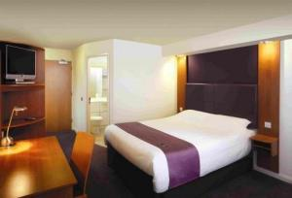 | Although this hotel is an approved hotel, we do not have a University discounted rate as it is not the hotel’s company policy to offer discounted rates.  Please do not therefore ask for University of Sussex rate as there is not one (the rate is already very affordable).  All year round rate of:  £65 Monday – Thursday  £68 Friday – Sunday  For a room which can accommodate 2 adults and up to 3 children under 15 years.  There is no on-Site Car parking at this Premier Travel Inn. There is a NCP car park nearby at a discounted rate of £8 for 24 hrs.  Two children under 15 years old get breakfast free when one adult purchases a full English breakfast

Travelodge (Seafront)  West Street  Brighton  BN1 2RQ  T: 0871 984 6405  F: 01273 772 147  W: www.travelodge.co.uk  Due to the location of this hotel some exterior noise may be heard from traffic and nearby nightclubs.  Early Check-in and Late Check-out service available at this  hotel. Early Check-in from 12 noon and Late Check-out  available until 2.00 pm, subject to available rooms. Charged on  arrival at £10.00 for each service.  To check availability contact the hotel directly | Although this hotel is an approved hotel, we do not have a University discounted rate. At certain times they have special offers of cheap rates, please ask for the current best rate.  Please do not therefore ask for University of Sussex rate as there is not one (the rate is already very affordable).  Rates from £60 per room per night  There is no on-Site Car parking at this Travelodge. There is a NCP car park nearby

Travelodge  165-167 Preston Road  Brighton  BN1 6AU  T: 0871 984 6017  F: 01273 554 917  W: www.travelodge.co.uk  This Hotel is situated on the main A23 into Brighton opposite Preston Park.  Early Check-in and Late Check-out service available at this hotel.  Please pre-book by selecting each service from the Extras page when booking | Although this hotel is an approved hotel, we do not have a University discounted rate. At certain times they have special offers of cheap rates, please ask for the current best rate.  Please do not therefore ask for University of Sussex rate as there is not one (the rate is already very affordable).  Rates from £71 per room per night  There is car parking on site.

