

Approved
Hotels and Guest Houses List

Category: Mid Range Hotels

Hotel / bed and breakfast information | Approximate special rate if available

Best Western Brighton Hotel  Kings Road  Brighton  BN1 2PQ  T: + 44 (0) 1273 820555  F: + 44 (0) 1273 821555  W: www.thebrightonhotel.co.uk  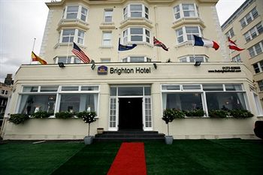  The Grade II listed Best Western Brighton Hotel is located directly on the seafront, opposite the famous West Pier and band stand. Just two minutes from the buzz of the city and just a stones throw from the beach The Best Western Brighton Hotel the perfect hotel in which to reside while in Brighton.  The elegant lounge and bar have perhaps the most enviable sea views of any hotel in the city. The hotel boasts 55 well appointed rooms, many of which command direct | Quote ‘University of Sussex rate’ when making a booking.  Sunday to Thursday  Please contact hotel for current rates  High speed wireless internet access is available free of charge in all our rooms and public areas.  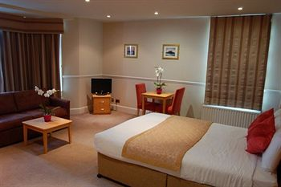

Deans Place Country Hotel  Seaford Road  Alfriston  East Sussex  BN26 5TW  T: +44 (0)1323 870248  F: +44 (0)1323 870918  Web: www.deansplacehotel.co.uk  Email : mail@deansplacehotel.co.uk  Deans Place has 36 individually styled bedrooms, four function suites and an elegant restaurant.  With ample parking four acres of grounds and an outdoor swimming pool the hotel is an idyllic retreat in a beautiful Sussex setting.  In summer dine alfresco on our garden terrace or pre-book our private barbecue area for your event. Alternatively in winter roaring log fires in our welcoming bar set the scene.  The hotel is licensed for civil weddings and partnership ceremonies both indoors and in our gardens and is also available for private dining and celebration events. Business users will find Deans Place the perfect undisturbed place to work and unwind, and the hotel successfully combines modern day meeting facilities with the peace and tranquility you would expect from a country hotel.  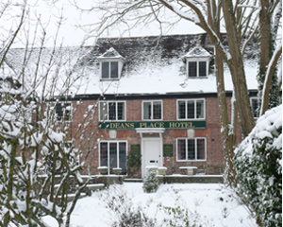 | Quote ‘University of Sussex rate’ when making a booking.  Sunday to Thursday  Quote “University Sussex rate” when making a booking.  Please contact the hotel for current rates.  ach of our 36 en-suite individually styled bedrooms has satellite TV and a DVD player, tea and coffee making facilities, direct dial telephone and bathrooms stocked with luxury toiletries. We also offer complimentary wi-fi connection throughout the whole hotel. However, most importantly we also always ensure that your welcome is of the high standard that you would expect and your stay is one to be relished.  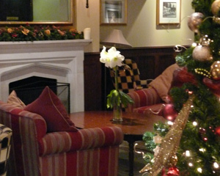

Granville Hotel  124 Kings Road  Brighton  BN1 2FY  T: +44 (0)1273 326302  F: +44 (0)1273 728294  Website www.granvillehotel.co.uk  Email Granville@brighton.co.uk  The Granville situated right on the seafront opposite Brighton’s historic West Pier, just 5 minutes from the shops & restaurants.  With 24 individually themed rooms, each with a unique style, every stay is a fresh and exciting experience.  Just 2 minutes walk from The Brighton Conference Centre and next door to the Hilton Metropole; the Granville is popular with international and domestic business travelers. Planning a small residential conference at the hotel is easy. There is meeting space for up to 40 delegates. Free Broadband wireless internet access.  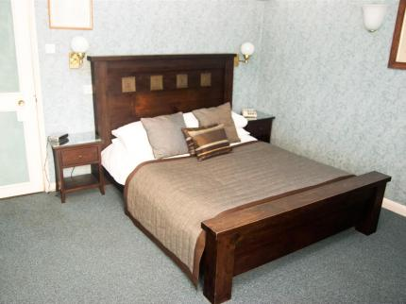 | Quote “University Sussex rate” when making a booking.  Double/twin room single occupancy £65.00  Double/twin room double occupancy £80.00  Sea view double with Jacuzzi for single occupancy £85.00  Sea view double with Jacuzzi for double occupancy £100.00  Superior Room with Jacuzzi for double occupancy £165.00  Subject to availability we will upgrade Sussex University guests.  Rates may change on Friday and Saturday nights please ask.  All rates include Full English Breakfast, Free Wireless Internet.  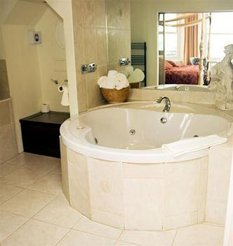

Holiday Inn Brighton-Seafront  Kings Road  Brighton  T: 44 (0) 01273 828280  F: 44 (0) 1273 220757  W: www.hibrighton.com  Email: Reservations@hibrighton.com  The Holiday Inn Brighton-Seafront sits adjacent to the West Pier on the main beach road/seafront with Brighton train station just a mile away and the city’s cost effective taxi companies readily available – getting to us could not be easier. Buses run from Churchill Square (within 5 minuets walk of the hotel) direct to the University.  The Brighton Centre, host to many exhibitions and concerts is just a 3 minute walk away.  Enjoy dinner in the Garden Room Restaurant and all the Hallmarks of Holiday Inn – A great Breakfast, A good nights Sleep, Fantastic Loyalty Scheme – Priority Club (free to join and earn points every time you stay) and all our staff demonstrate a “Can Do” Service attitude.  All bedrooms and public areas are fully air conditioned and both restaurant & bar offer un-interrupted views of the sea & horizon. Seaview rooms are available at a supplement and please indicate if these room types are of interest to you at the point of your enquiry.  Fully DDA (1995) compliant with 4 Accessible spaces to the front of the Hotel, ramp access to reception, lift to all floors and Reception, Bar & Restaurant on the ground floor with no steps. Accessible rooms available upon request. | Quote ‘University of Sussex rate’ when making a booking.  Single occupancy: 15% off our published best flex B&B rates inclusive of VAT.  Double occupancy:15% Discount off our published best flex B&B rates Inclusive of VAT.  Rates are subject to availability all week and can be booked by calling the Hotel direct  Bright, secure, limited car parking available at £13.50 per night, which cannot be pre-booked and allocated on a first come first serve basis..  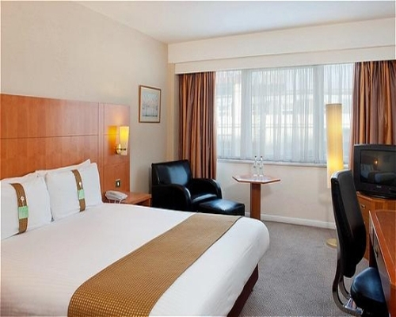  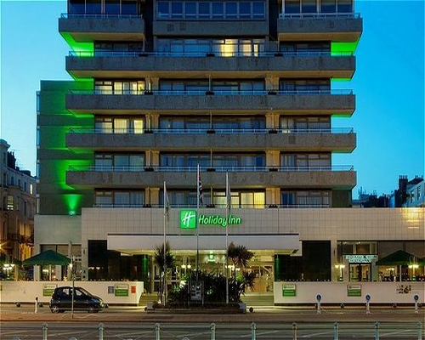

Jurys Inn Brighton  New England Quarter  Brighton  BN1 4GQ  T: +44 (0) 1273 862121  F: +44 (0) 1273 862111  www.jurysinns.com  This new Hotel opened 30 November 2007.  Superior Budget Accommodation  Jurys Inn Brighton is a mere five-minute walk from the retail centre of the city and tourist attractions such as Brighton Dome, Theatre Royal Brighton and the Gardner Centre. The hotel is also within walking distance of the seafront and the Brighton Centre.  Jurys Inn Brighton offers guests excellent 3-star comfort in the heart of the city centre. Our spacious and comfortable rooms can accommodate two adults and two children, three adults sharing, or one person in complete comfort.  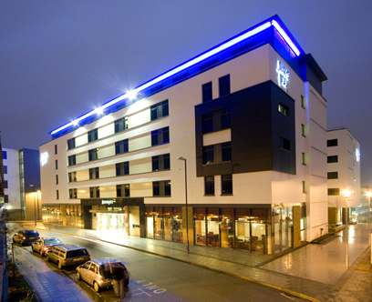 | Quote ‘University of Sussex rate’ when making a booking.  Rates from 1st January to 31 December 2012  Sunday - Thursday  B&B £80.00 (single occupancy)  B&B £87.00 (double occupancy)  subject to availability. Sunday – Thursday  Friday and Saturday Room only £129.00 subject to availability  Our spacious and comfortable rooms can accommodate two adults and two children, three adults sharing, or one person in complete comfort.  Hotel Services & Facilities  * 234 Standard Bedrooms  * Innfusion Bar  * Inntro Bar  * Il Barista Coffee Bar  * 9 Dedicated Meeting Rooms  * Laundry/Dry – Cleaning  * Wireless Broadband  * Public Parking Nearby – Charges Apply  * Multi-Channel Flat Screen TV’s  * Air Conditioning  * Comfortable Duvets and White Linen  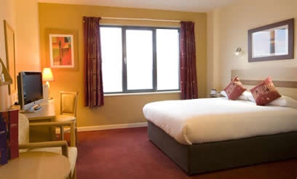

The Kings Hotel  139-141 Kings Road  Brighton  Sussex  BN1 2NA  T: +44 (0) 1273 820854  F: +44 (0) 1273 828309  W: www.kingshotelbrighton.co.uk  Originally three magnificent private residences the 3 star Kings hotel in Brighton dates back to Regency times. A stones through from the beach the Kings hotel is located prominently on the seafront adjacent to the famous West Pier.  Within walking distance are the Brighton Centre, the Royal Pavilion, Brighton Pier, the Laines and many fashionable shops and restaurants.  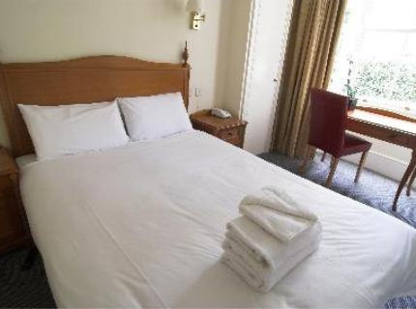 | Quote ‘University of Sussex rate’ when making a booking.  Sunday - Thursday  Single Room: from £40.00  Double/ Twin for Single Occupancy: from £49.00  Double/ Twin: from £59.00  Friday/Saturday  Single Room: from £65.00  Double/Twin: from £125.00  All prices include Cooked Breakfast and VAT.  Bookings for Saturday nights in summer are subject to a 2 night minimum stay.  Parking available on a first come first served basis and is charged at £15 per car per night.  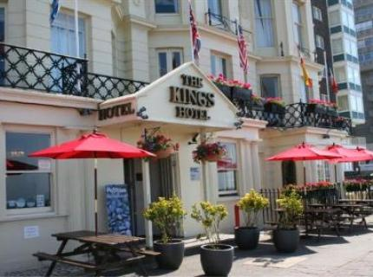

Lansdowne Place Hotel  Lansdowne Place  Brighton  Sussex  BN3 1HQ  T: +44 (0) 1273 736266  F: +44 (0) 1273 729802  W: www.lansdowneplace.co.uk/  Situated adjacent to the Brighton waterfront, Park Inn Lansdowne Place has recently undergone a major refurbishment to restore its past glory, whilst creating a stylish, contemporary feel.  The speciality restaurants provide different atmospheres and cuisine for every occasion. | Quote ‘University of Sussex rate’ when making a booking.  Sun-Thurs Queens from £75 per room per night  Fri-Sat and Bank Holidays from £110 per room per night.  Subject to availability  Continental Breakfast  All prices inclusive of VAT  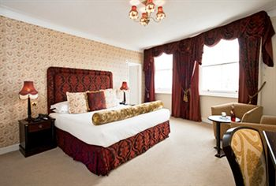

Queens Hotel & SPA  1 Kings Rd  Brighton  T: +44 (0)1273 321222  F: +44 (0)1273 203059  W: www.queenshotelbrighton.com/  This hotel overlooks the famous Brighton pier and promenade. All rooms and suites are spacious and tastefully furnished with an individual character and charm to each one. Sea facing rooms offer glorious panoramic views across the English channel  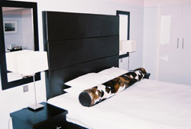 | Quote ‘University of Sussex rate’ when making a booking.  Sunday – Thursday inclusive  Single room (sea view) from £75  Double from (sea view) £85  Suites from £125  Weekend room rates from £120 double and £95 single  All prices include hot & cold buffet breakfast , use of the Leisure Centre, WIFI and VAT  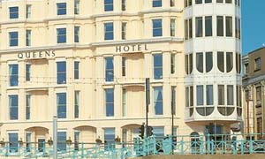

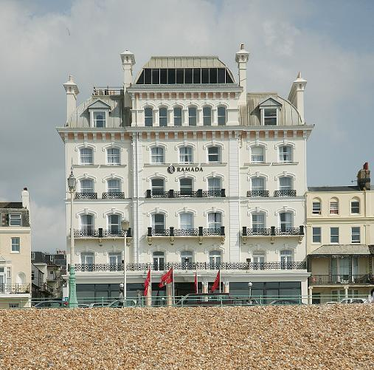  Mercure Brighton Seafront  149 Kings Road,  Brighton  BN1 2PP  T: 0844 815 9061 –  Select Option ‘2’  F: 01273 821752  E-Mail:  sales.mercurebrightonseafront @jupiterhotlels.co.uk  W: www.mercure.com  Choose the beachfront Mercure Brighton Seafront Hotel for Regency grandeur and fine sea views – a pebbles through from the city sights and nightlife.  The truly magnificent Grade II listed building which dates back to 1864 is perfectly positioned to enjoy the calm of the seaside and a short stroll from the cosmopolitan city centre.  Mercure Brighton Seafront offers excellent comfort in either a Standard room, or treat yourself to a contemporary Sea View Feature Room. | Please quote ‘University of Sussex Rate’ when making a booking.  Special Rate:  Rooms from £79.00 per night*  The accommodation rates are inclusive of Full English Breakfast.  Please contact our sales team if you need to discuss long term accommodation rates.  Limited car parking available on site chargeable at £15.00 per night.  Please ask about special Weekend and Dinner, Bed & Breakfast Rates.  Complimentary Wi-Fi Access available throughout the Bar and Lounge.  *In the event of the special rates not being available, our specialist reservations team will offer you the best possible rate for your stay.  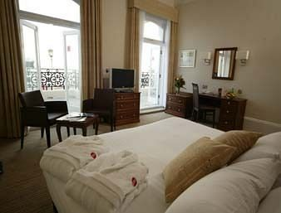

Umi Hotel Brighton (formerly the Belgrave hotel)  64 Kings Road  Brighton  Sussex  T: +44 (0) 1273 323221  F: +44 (0) 1273 321485  W: http://www.umihotelbrighton.co.uk/  The Hotel's location at the corner of the famous Lanes area means it is at the very heart of Brighton life. Most rooms have panoramic views over the Promenade and Seafront, making them amongst the most sought-after in town.  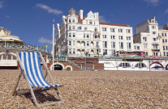 | There is an access code for all users coming via the University of Sussex. Please see below the access code when booking.  Please click on  http://www.umihotelbrighton.co.uk/index.php/online_booking.php  and type in the following access code (NEWS 123). This will entitle you to a 10% discount on the advertised rates all through the year.  Double/Twin Room From £69  Suites/Family Rooms from £99.00  Triple Rooms from £79.00  Air conditioned Rooms  Free access to Swimming pool and local Gym.

