

Approved
Hotels and Guest Houses List

Category: Bed & Breakfast and Small Hotels

Hotel / bed and breakfast information | Approximate special rate if available

Avia Hotel (B&B 8 rooms)  36 Upper Rock Gardens  Brighton  BN2 1QF  T: + 44 (0) 1273 682939  F: + 44 (0) 1273 626287  E; enquiries@alviahotel.co.uk  W: www.alviahotel.co.uk/  The Alvia Hotel offers visitors a warm welcome in a non-smoking, highly professional hotel. The Victorian hotel has been recently refurbished. Located in Kemptown, the liveliness of Brighton is never far away!  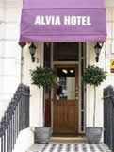  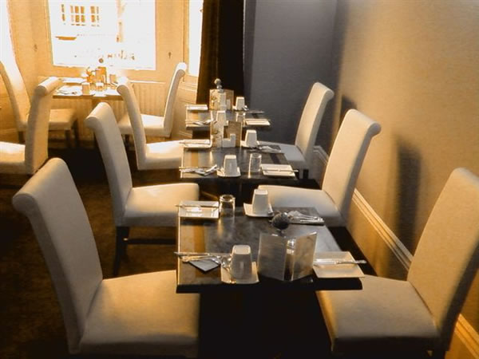 | Quote ‘University of Sussex rate’ when making a booking.  Midweek offer: £55 per night standard double and twin room en suite.  Weekend offer: from £65-£85 per night.  Special prices for the University of Sussex  Single room with shower £30-£45  Single en suite from £40-£75  Double/Twin from £60 - £85  All prices include a Full English breakfast and VAT.  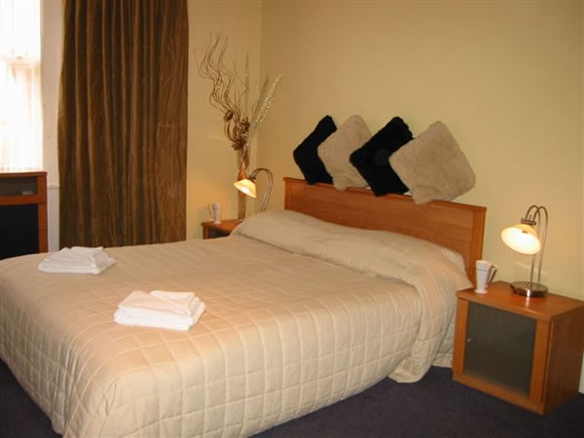

Amherst Hotel (B&B 8 rooms) 35 Upper 2 Lower Rock Gardens  BRIGHTON  BN2 1PG  T: + 44 (0) 1273 670 131  F: + 44 (0) 1273 673 571  E-mail:reservations:amblecliff.co.uk  W: www.amhersthotel.co.uk  Stylish and Decorated to a high standard Amherst Brighton offers contemporary accommodation only five minutes walk from the buzz of Brighton’ centre.  All individually designed non-smoking rooms have en-suites, direct dial telephones, either LCD or widescreen TV’s, DVD/CD players, wireless and hard wired internet access, mini fridge, tea/coffee facilities with generous snacks.  With powerful showers and luxurious H2K organic toiletries you will feel ready for anything.  Our quality pocket sprung double or king size beds with crisp percale sheets and feather duvets will ensure you of a comfortable night’s sleep.  Excellent service and your comfort are our priorities. | Quote ‘University of Sussex rate’ when making a booking.  Weekdays:  Single occupancy double from £70  Luxury Double from £75  Junior Suite from £90  Great rates for 3 or more days  Weekends:  Luxury Double from £110  Junior Suite from £150  All rates are per room per night and include full English breakfast and VAT.

Amblecliff hotel (B&B 14 rooms) formerly the Esteban Hotel  35 Upper Rock Gardens  BRIGHTON  BN2 1QF  T: + 44 (0) 1273 681161  F: + 44 (0) 1273 390829  E-mail:reservations:amblecliff.co.uk  W: www.amblecliff.co.uk  The Amblecliff is conveniently located in the heart of fashionable Brighton, close to bus links for the University sites, a short stroll away from the sea, pier and a host of stylish shops, cafes, bars and restaurants. Our guest rooms have been carefully designed to meet the needs of a wide variety of visitors to Brighton, whether on business/pleasure or both. We are here to make your stay truly memorable. If you are arriving by car, we have parking available (£5.50 per night) (limited availability).  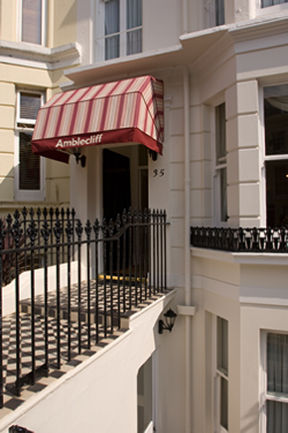 | Quote ‘University of Sussex rate’ when making a booking.  Midweek rates from Monday to Thursday inclusive  Standard Single en suite rooms £50 per night  Single en-suite room £60 per night  Double en suite rooms £85 per night  Superior – Kings/Twins and Four Posters  £100 per night  The Suite £100 per night  Weekend rates Friday- Sunday inclusive  Standard Single rooms £60 per night  These rates include breakfast.  Single en suite room £70 per night  Double en suite £95 per night  Superior Kings/Twins and Four posters £120 per night  The Suite £135 per night for 2 or £200 for 4 persons.  (Weekends – 2 night minimum)  For Minimum night stay please refer to our website www.amblecliff.co.uk  All rates are inclusive of VAT a full English, Vegetarian and Continental Breakfast.

Brighton Pavilions (B&B 10 rooms)  7 Charlotte Street  Brighton  BN2 1AG  T: +44 (0) 1273 621 750  F: +44 (0) 1273 622 477  W: www.brightonpavilions.com/  One of Brighton’s finest small boutique style hotels, with luxurious accommodation at B&B rates. High quality architect designed interiors offer uniquely themed and immaculate rooms. All rooms have free WIFI, direct dial telephones and fridge with complimentary cold drinks and chocolates – a perfect choice for those seeking a short break with a special touch of luxury or those business wanting quietly efficient accommodation and service. Flat screen TV’s with DVD in all double rooms.  Full English or vegetarian breakfast is served in the elegant Palm Court or, for all 2 night bookings in a luxury 4-poster, room service breakfast is standard along with a bottle of champagne, fresh flowers and the use of towelling bathrobes.  All rooms are non-smoking.  We don’t have single rooms so single occupancy means at least a double room! We offer free upgrades when possible.  Quality Pocket sprung beds, luxurious Egyptian Cotton bedding, breakfast in bed, broadband ports, LCD/widescreen digital TVs, DVD/CD players in every room. Stylish, friendly and spotlessly clean with excellent service levels. | Must quote ‘University of Sussex rate’ when making a booking.-  Midweek 2011 Monday-Thursday  Single with shower only  December .-March -£42  April – November - £45  Double en-suite single occupancy  December – March - £65  April – November - £68  Double en-suite  December _ March - £85  April – November - £100  Weekends 2011 2 night minimum)  Single with shower only  December .-March -£42  April – November - £45  Double en-suite single occupancy  December – March - £90  April – November - £96  Double en-suite  December _ March - £90  April – November - £96  Luxury 4-poster double en-suite £145  December – March - £125  April – November £140  Multiple night Midweek special offers may be available, call for rates  Family Room available sleeps up to 4, call for rates.  All prices are per room per night and include full English breakfast and VAT.  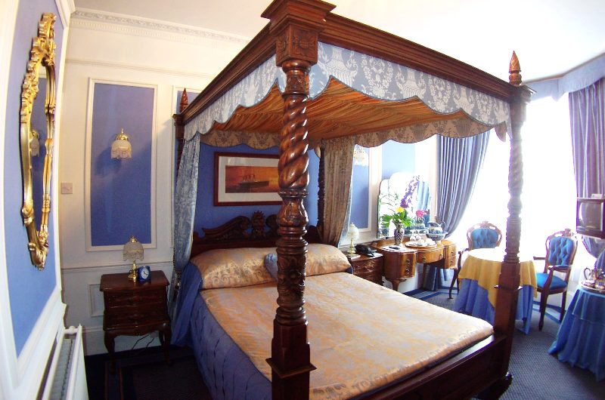

The Brighton White House (B&B 10 rooms)  6 Bedford Street  Brighton  BN2 1AN  T: +44 (0) 1273 626 266  W: www.whitehousebrighton.com/  The White House is a contemporary ‘boutique’ bed and breakfast in the heart of Kemp Town, just 100 yards from the seafront. Some rooms have sea views, two have balconies all are modern and stylish. Located near the seafront and just a short walk from the centre of Brighton.  The White House is perfectly suited for both business and leisure guests. All ten rooms have been uniquely decorated in a contemporary style and the atmosphere is friendly and relaxed.  Breakfast is taken in the dinning room, or outside if you prefer. The extensive breakfast menu is freshly prepared by the owner-chef using only best quality ingredients. Fair trade tea and coffee making facilities are available in each room along with a colour TV and free WIFI. Luxury rooms also have DVD players. The White House is no smoking throughout. | Quote ‘University of Sussex rate’ when making a booking.  Single room from £45  Double room en-suite single occupancy from £65  Double room en-suite from 85  Double room with sea view or balcony en-suite from £110.  All prices include full English breakfast and VAT.  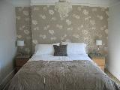

Cavalaire (B&B 10 rooms)  34 Upper Rock Gardens  Brighton  BN2 1QF  T: +44 (0) 1273 696 899  F; +44 (0) 1273 600 504  W: www.cavalaire.co.uk  A mere pebbles throw from the beach, this elegant Victorian guest house offers comfortable rooms all individually furnished which add to its charm. It is a non smoking hotel, with easy access to the M23.  Four star Guest House and a Gold Award from visit Britain 2008/9/10.  Breakfast award 2009/10.  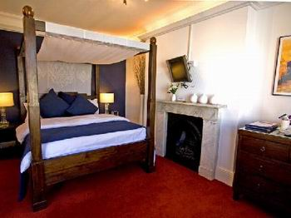 | Quote ‘University of Sussex rate’ when making a booking.  Mid week rate Mon-Thurs  Double/Twin- Single occupancy from £75  Double occupancy from £95  Mid week rate Mon-Thurs  Four poster – Single occupancy from £95  Double occupancy from £120  Weekend rate  Double/Twin from £79 single or double  Four Poster from £120 single or double  All prices include full English breakfast and VAT.

Colson House Guest House (B&B 8 rooms)  17 Upper Rock Gardens  Brighton  Sussex  BN2 1QE  T/F: + 44 (0) 1273 694922  E-mail: info@colsonhouse.co.uk  W: www.colsonhouse.co.uk  Colson House offers a warm welcome and friendly service in uniquely themed accommodation. We have 8 boutique style en suite double rooms, each one themed around a movie icon, and each one scrupulously clean with crisp white linen and bright decor. Choose from the King size four poster Clark Gable room, the gorgeous Bette Davis room with private balcony, or maybe the split level Audrey Hepburn room. Great value for money and a wonderful atmosphere in our centrally located guest house. | Quote ‘University of Sussex rate’ when making a booking.  Rates inclusive of VAT, Full English/Vegetarian breakfast  Midweek rates, Mon - Thurs  Standard Double Rooms £49 - £69  Superior Doubles £59 - £79  King size Four Poster/Balcony Room £69 - £89  with highest discounts for stays of 2 days or more midweek  Weekend Rates (2 night minimum)  Standard Double Rooms £59 - £79  Superior Doubles £69 - £89  King size Four Poster/Balcony Room £79 - £99  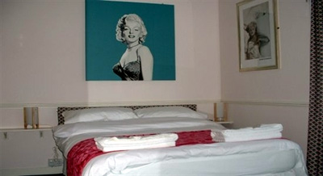

THE DOWNS HOTEL  Warren Road  Woodingdean  Brighton  East Sussex  BN2 6BB  T: +44 (0) 1273 390860  W: www.downs-hotel.co.uk  Email: info@downs-hotel.co.uk  The Downs Hotel is only 6 minutes drive from Sussex University and less that 10 minutes from the heart of Brighton. We are a friendly family run pub hotel offering FREE parking and FULL English breakfast. Our elevated position gives us stunning views over the countryside and down to the sea.  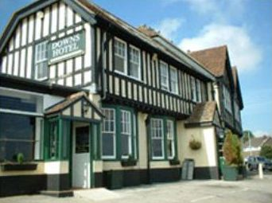 | Quote ‘University of Sussex rate’ when making a booking.  Call 01273 390860 to book  Room Rates from:  Single shared facilities - £30 - £35  Single en-suite - £40 - £45  Twin/Double shared facilities - £60  Twin/Double en-suite - £70  4 Poster en-suite - £80  Triple en-suite -£100  Quad en-suite - £120  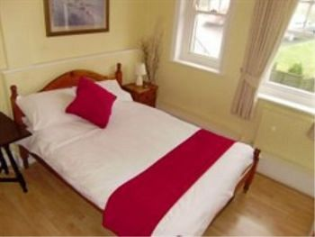

Five (10 Rooms)  5 New Steine  Brighton  BN2 1PB  T: +44 (0) 1273 686547  W: www.fivehotel.com  info@fivehotel.com  We are a contemporary Georgian townhouse comprising of 10 en-suite bedrooms, many sea facing and all have tea/coffee, flat screen TV/DVD and some I pod docks. Complimentary wi-fi throughout.  Five is a launch point for everything the city has to offer, a stone’s throw from the beach, a stroll to the conference centre, the pier, Royal Pavilion, shops, bars, restaurants and a short bus ride to the University and Marina.  Guests get together in our sunny bay fronted breakfast room and enjoy freshly prepared ‘Sussex breakfast’ using local and many organic ingredients.  We have been awards 4 Gold stars, highly recommended by the AA and appear in “The Good Hotel Guide’ and Guardian Best Bed and Breakfast Guide. | Quote ‘University of Sussex rate’ when making a booking.  Room Rates University of Sussex rate  Sunday- Thursday  Single en-suite £45  Double en-suite for single occupancy £65  Double en-suite £75/£80  Family en-suite (max3) £90  Friday/Saturday  Single en-suite £55  Double en-suite for single occupancy £80  Double en-suite £100  Family en-suite (max 3) £150  Prices include breakfast and VAT  .  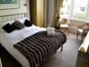
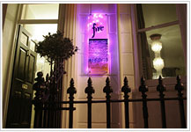

George IV Guest House (8 rooms)l  34 Regency Square  Brighton  BN1 2FJ  T: + 44 (0) 1273 321196  W: www.georgeivbrighton.co.uk  George is a beautifully located Regency townhouse, looking down to the sea across one of Brighton’s finest squares. Rooms at the front are really spacious, warmly decorated and have marvellous views. The balcony room is a particular favourite where gentlemen have been known to propose, couples to honeymoon and everyone to go all wide-eyed. Otherwise our spacious single rooms and standard double rooms are also really nice, and back on to a quiet mews. All rooms are en-suite  We are a pebbles throw from the main conferences centres and close to everything else Brighton has to offer.  All rooms have tea, hot chocolate and filter coffee; fresh milk is available from the fridge in reception, along with mineral water (50p), decaff coffee and speciality teas. There is free WIFI throughout and a PC in reception if you leave the laptop at home.  If driving there’s an underground car park over the road from thus (£12.50 per day).t  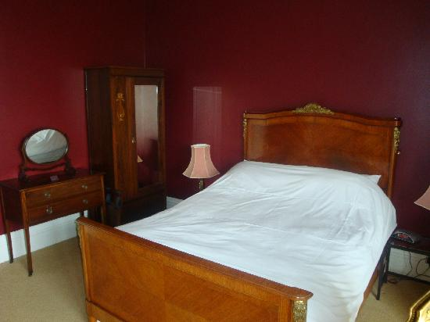 | Quote ‘University of Sussex rate’ when making a booking.  SPECIAL OFFER: 5% discount on room rates for two-night minimum stay, Sunday to Thursday.  £10 reduction for single occupancy of double room.  From £50 per room per night  Single en-suite £50  Standard double en-suite from £72  Sea-view Double en-suite from £100  Balcony double en-suite from £115  Sea-view triple en-suite from £140 (£20 discount for children under 12)  All prices are per room per night and include VAT.  Breakfast is not included, Continental-style breakfast mainly Fair trade/free range/organic, and is served in the room for between £5.50 & £9.50 per person.  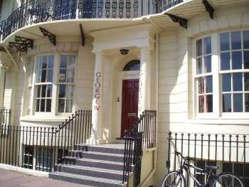

Grey’s Hotel  11 Charlotte Street  Brighton  BN2 1AG  T: + 44 (0) 1273 603197  W: www.greyshotel.co.uk  Grey’s is a new hotel in the heart of Brighton’s Kemp Town offering luxury accommodation and excellent service at affordable prices. Our rooms are all individually designed with flat-screen TVs, White Company toiletries and white Egyptian cotton bed linen.  We are located just five minutes walk away from the centre with its many restaurants, cafes and shops, and a stone’s throw from the beach.  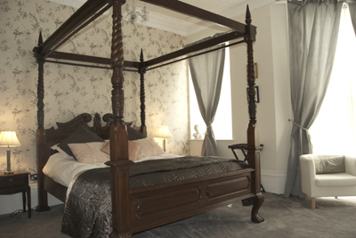 | Quote ‘University of Sussex rate’ when making a booking.  From £45 per room per night  Midweek Rates Sunday - Thursday  Single en-suit £45 prpnt  Double en-suite £80 prpnt  Double en-suite single occupancy £65 prpn  Superior en-suite £110 prpn  Superior en-suite single occupancy £90 prpn  Weekend Rates (2-night minimum stay) prpn  Single en-suit £55 prpnt  Double en-suite £98 prpn  Double en-suite single occupancy £80 prpn  Superior en-suite £138 prpn  Superior en-suite single occupancy £115 prpn  All prices are per room per night and include breakfast and VAT.

The Griffin Guest House (B&B 9rooms)  14 Madeira Place  Brighton  BN2 1AG  T: + 44 (0) 1273 691257  http://www.griffinbrighton.co.uk/Contact.htm  The Griffin is a Georgian Townhouse in the heart of Brighton. The Griffin Guest House is a few yards from St. James St. and also just off the seafront, you can be on the Pier in less than two minutes. The Griffin has undergone a thorough renovation in recent times and offers clean modern accommodation, lodged in a charming building dating from 1760, the hotel has nine rooms, each with its own en suite Whirlpool bath or shower newly refurbished Guest House in the heart of Brighton’s Kemptown. The Griffin Guest House is a few yards from St. James St. and also just off the seafront and within two minutes walk of the Palace Pier. It has been recently thoroughly renovated. Lodged in a charming building dating from 1760, the hotel has nine rooms, each with its own en suite Whirlpool bath or shower  All rooms are available Sunday through Thursday at SPECIAL WEEKNIGHT RATES. We have a policy of a two night minimum booking on weekends and three nights during bank holidays. Additional nights are available at the special Weeknight Rate. (Special rates do not apply during conferences, bank holidays and Pride.) Information about these offers and all our rates can be obtained by emailing us at info@griffinbrighton.co.uk.  We are a “Themed Hotel” and we have decided to theme are rooms as Bedrooms!  The Griffin has recently undergone a major refurbishment. Totally redesigned by architect Chris Cage of C Change, The Griffin now offers en suite facilities in every room, except our Suite, where the two rooms share a private bathroom  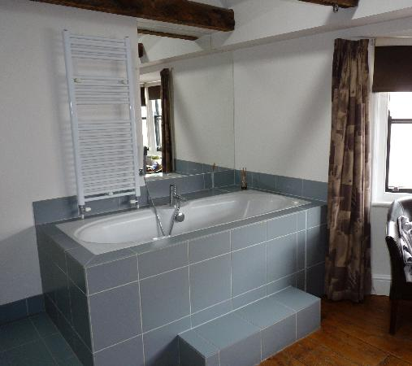 | Quote ‘University of Sussex rate’ when making a booking.  Low Season Rates from 1st November – 31 March  Week Day Rate Monday - Thursday  Small Single with en-suite shower from £45  Double en-suite from £70  Weekend Rates Sunday – Thursday  Small Single with en-suite shower from £60  Double en-suite from £85  Please note we usually have a two night minimum stay policy at weekends and three nights during bank holidays single night stays, when available may incur a higher charge.  Booking directly with us assures you of the best possible deal with no commission or booking fee charges  All our rates include a full cooked breakfast, with different options  . 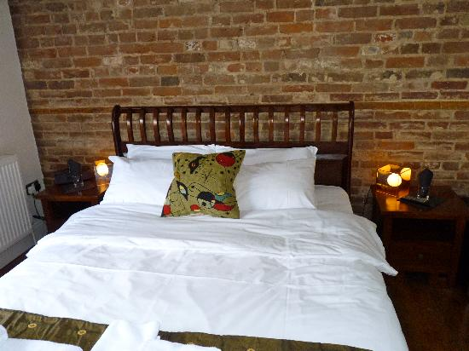

Gullivers Hotel (B&B - 10 Rooms)  10 New Steine  Brighton  BN2 1PB  T: + 44 (0) 1273 695415  W: www.gullivershotel.com/  This hotel is set in a graceful period square and retains much original charm. Although in a quiet setting, the lively hustle and bustle of Brighton is not far away. All rooms are fresh, modern and  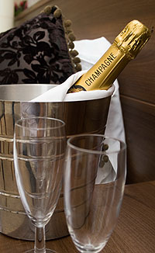  comfortable. | Quote ‘University of Sussex rate’ when making a booking.  Please note that this offer is valid from Sunday to Thursday, and subject to availability  Single from £29 -£43.50 per room  Standard Double from £49 single occupancy, £44.00 without breakfast)  Triple room from £79- £135 per room  Family from £89 - £150 per room  All rates include our Award Winning Sussex Breakfast, Wireless & VAT.  Add a 2 Course dinner at our award winning New Steine Bistro for just £8.50 per person per night.  Please note this offer is valid from Sunday to Thursday and subject to availability.  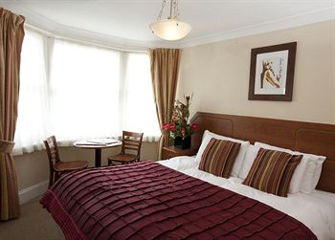

Hill Road Studios  13 Hill Road  Lewes  East Sussex  BN7 1DB  T: + 44 (0) 1273 477723  M: 07881 988836  M: 07775 688017  W: www.hillroadstudios.com  Email : pmyles@btclick.com  Two detached studio apartments with breakfast supplied self catering with a mini kitchen, en-suite with flat screen TV and broadband wi fi. Recently re-built to a very high standard in a premier location in the County Town of Sussex with private off road parking. Stunning views from the plot. Both studios are flexible, accommodating from just one person to three in each studio, allowing a party of six to stay on site. A ten minute drive to the University makes this a choice of convenience for visitors to campus. The Studios are both gated. Kathy and Paul have eleven years experience providing this service and have been awarded 4 stars and a silver award accolade from Visit Brighton. .  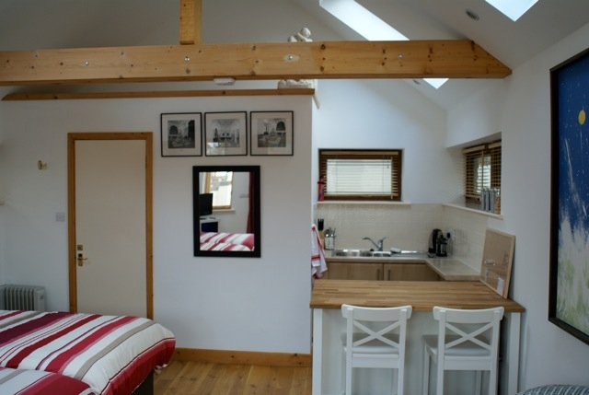 | 10% discount off these rates at all times if “University of Sussex Rate” is quoted.  The Studio  £45 for single occupancy  £75 for double occupancy  £95 for Family occupancy  The Garden Studio  £65 for single occupancy  £95 for double occupancy  £125 for family occupancy  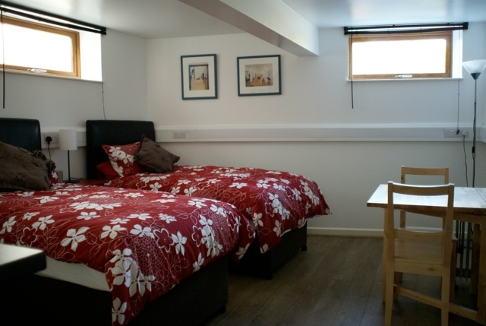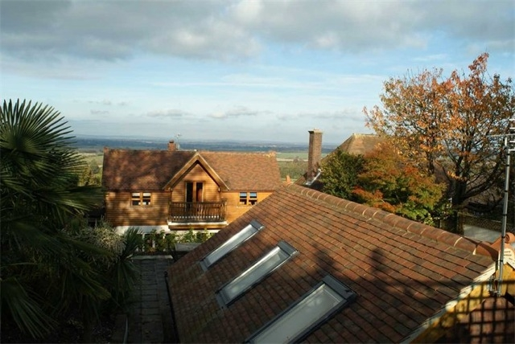

Lanes Hotel (Hotel-34 Rooms)  70-72 Marine Parade  Brighton  BN2 1AE  T: + 44 (0) 1273 674 231  F: + 44 (0) 1273 674 230  W: www.laneshotel.co.uk/  Email enquiries@laneshotel.co.uk  This elegant Victorian hotel is ideally situated for  beautiful panoramic views across the sea front.  Each room is uniquely furnished adding to the  period charm of this hotel. | Quote ‘University of Sussex rate’ when making a booking.  Mid-week  double rooms from £50- £90  Family rooms 2 double beds from £50  Family rooms 3 double beds from £75  Weekend  Double rooms from £90- £135  Family rooms 2 double beds from £150  Family rooms 3 double beds from £225  Single occupancy from £35-£45  All rooms are en-suite and prices include Full English breakfast with VAT

New Steine Hotel (B&B 11 Rooms)  12a New Steine  Brighton  BN2 1PB  T: + 44 (0)1273 681546  F: +44 (0)1273 679118  W: www.newsteinehotel.com/  Newly refurbished set in a beautiful Georgian square, this hotel is perfectly located for exploring Brighton’s exciting seafront and the main shopping centre. The quiet location means it is excellent value for those looking to have a relaxing stay.  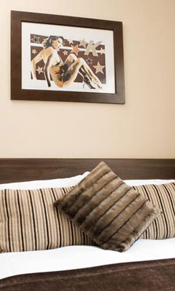 | Quote ‘University of Sussex rate’ when making a booking.  Please note that this offer is valid from Sunday to Thursday, and subject to availability.  Single from £35 -£42.50 per room  Standard Double/Twin from £59 single occupancy, (£54.00 without breakfast)  Deluxe Double from £79  Triple from £79 - £135 per room  Family from £89 - £150 per room  All rates include our Award Winning Sussex Breakfast, Wireless & VAT.  Add a 2 Course Dinner at our award winning New Steine Bistro for just £8.50 per person per night.  Please note this offer is valid from Sunday to Thursday and subject to availability.  (AA Breakfast & Dinner Award 2008)  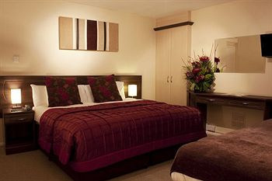  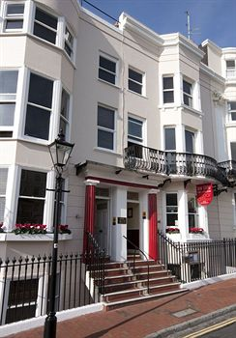

Oriental (B&B 9Rooms)  9 Oriental Place  Brighton  BN1 2LJ  T: +44 (0) 1273 205 050  F: +44 (0) 1273 205 050  E-mail: info@orientalbrighton.co.uk  http://www.orientalbrighton.co.uk/  The Oriental is a beautiful Regency period guesthouse boasting elegant but affordable contemporary styled rooms and a unique and funky cocktail bar. Popular with many visitors to the University, we offer a home from home focusing on the service we provide our guests  ensuring they get the most out of their stay in Brighton, whether for business or pleasure. We can be found in the centre of Brighton very close to the seafront and all Brighton’s attractions as well as its transport links to the University. Visit our website or contact us direct for more details of our rooms and offers. | ‘Quote “University of Sussex Rate’ when making a booking.  Mid week rates from Sunday to Thursday  Single room from £54  Luxury Double and Twin rooms from £79 (£70 single occupancy)  Superior Double rooms from £110  Friday and Saturday  Single room from £60  Luxury Double and Twin rooms from £95  Superior Double rooms from £130  Discounts are available of up to 20% for stays of 2 nights or more.  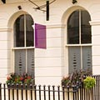 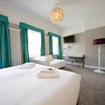v

Paskins Town House (B&B 19 Rooms)  18/19 Charlotte Street  Brighton  BN2 1AJ  T: + 44 (0) 1273 601203  F: + 44 (0) 1273 621973  W: www.paskins.co.uk/  A “green” hotel, environmentally friendly and serving organic food, in the heart of one of Victorian England’s most perfectly preserved conservation areas.  Running off Marine Parade, this tranquil street is lined with fine four storey buildings, built around 1810, with intricate cast iron balconies and gracious bow fronts. | Quote ‘University of Sussex rate’ when making a booking.  From £35 per person per night.  All prices include full English or Vegetarian Breakfast and VAT  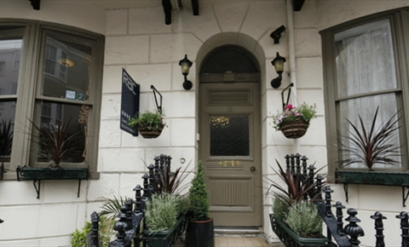  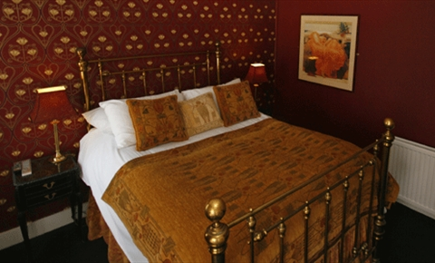

The Twenty One (B&B7 Rooms  21 Charlotte Street  BRIGHTON  BN2 1AG  T: + 44 (0) 1273 686450  E-mail: enquiries@thetwentyone.co.uk  W: www.thetwentyone.co.uk  Welcome to the Twenty One, we hope you will enjoy the fact that our refurbished period property is located in a quiet residential side street, yet right at the heart of the lively cosmopolitan Kemp Town area of Brighton. This year we have been accredited with the ‘AA 4-star Highly commended’ award and ‘Visit Britain 4-star Gold award’  We are a few steps from the seafront, (our principal rooms have the benefit of side sea views), and within easy walking distance of all the major attractions, such as The Royal Pavilion, The Lanes, North Laine, Brighton Pier, Brighton Marina, and The Brighton Centre. You will find dozens of bars and restaurants a short walk from Charlotte Street in the St James’s Street area of Kemp Town.  For your special comfort, all rooms have brand new full en-suite shower rooms, remote control TV, hair dryer, toiletries, tea & coffee making faculties, a mini fridge is also found in all rooms with complimentary mineral water.  For your convenience our full English breakfast is cooked to order at a time that suits you (up to 10.00am). A vegetarian option is also available.  We have 3 x standard double en-suite rooms (rooms 4,5 & 7) We have 1 x super-king double en-suite room (room 8) We have 1 x king double en suite room (full bathroom en-suite) (room 6) We have 1 x large double en-suite room (full bath room en-suite) (room 3) We have 1 x single en-suite room (room 2) | Quote ‘University of Sussex rate’ when making a booking.  Midweek Rates: Monday-Thursday (prpn = per room per night)  Single en-suite (room 2) £45 prpn  Double en-suite (room 4) single occupancy £70 prpn, double occupancy £80 prpn  Double en-suite (rooms 5 &7) single occupancy £80 prpn, double occupancy £90  Large double en-suite (room 3) £109 prpn  King-size en-suite (rooms 6 & 8) £99 prpn  Weekend Rates: Friday, Saturday & Sunday nights (2 night minimum stay) prpn-per room per night  Single en-suite (room 2) £60 prpn  Double en-suite (room 4) single occupancy £90 prpn, double occupancy £99  Double en-suite (rooms 5 &7) single occupancy £99 prpn, double occupancy £115  Large double en-suite (room 3) £149 prpn  King-size en-suite (rooms 6 & 8) £139 prpn  All prices are per room per night and include full English and VAT  All rooms can be viewed on our website at : www.thetwentyone.co.uk  *OFFER:* STAY FOR 4 NIGHTS - -PAY FOR ONLY 3 (cheapest night free. MIDWEEK NIGHTS ONLY – DOES NOT APPY FRI, SAT NIGHTS)  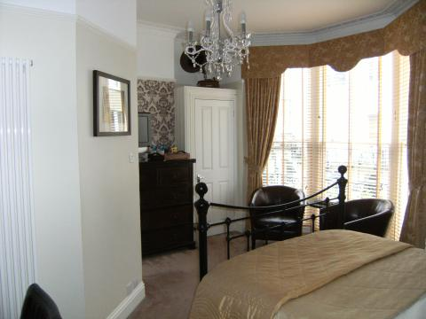

Urban House Retreat (B&B 28 Rooms)  20/21 New Steine  Brighton  BN2 1PD  T: + 44 (0) 1273 688085  F: + 44 (0) 1273 721418  W: www.Urbanhousebrighton.co.uk  From the outside we have the charm of a classical regency building with 200 years of history. Step through the door, however, and you are transported into another world, from the elegant casino lighting, seductive black and oak wood bar, through to the beautiful honey coloured travertine rock of the newly created spa.  We aim to bring something special to Brighton; a stylish, small, privately owned hotel with a great location, bang in the heart of the city. “Sleek, stylish and beautiful “ - Ian Wright, football legend. | Quote ‘University of Sussex rate’ when making a booking.  These Rates apply Sunday – Thursday and are available until 31 March 2011  Single Room from £40  Double room from £55 per room  Price includes continental breakfast.  