
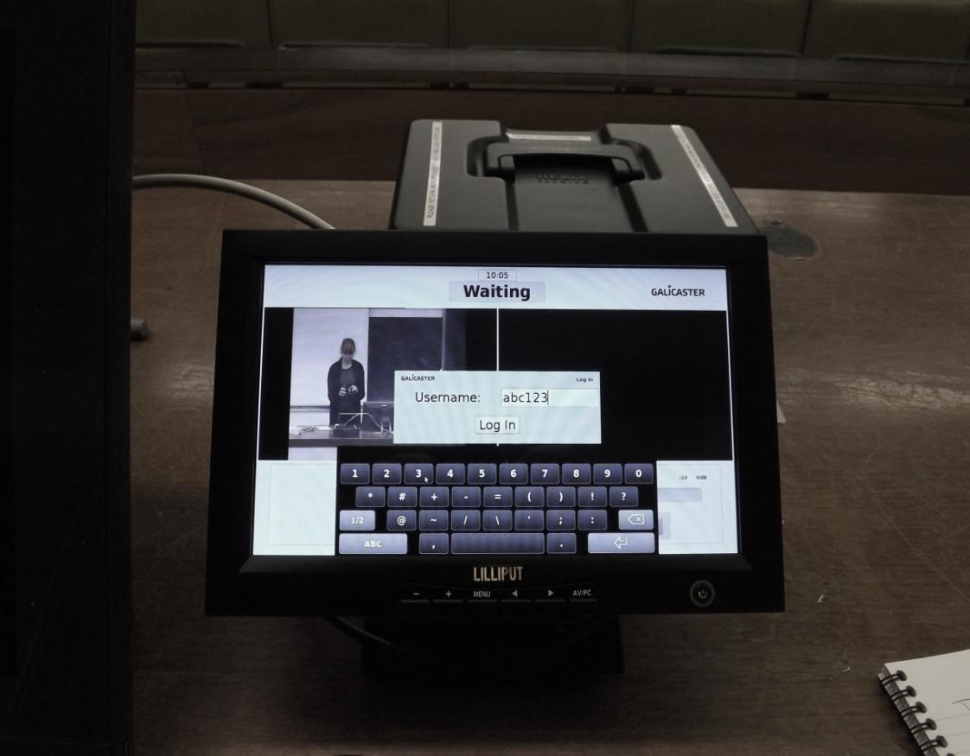
Touch the screen to get started
Enter ITS username, press Login*
1

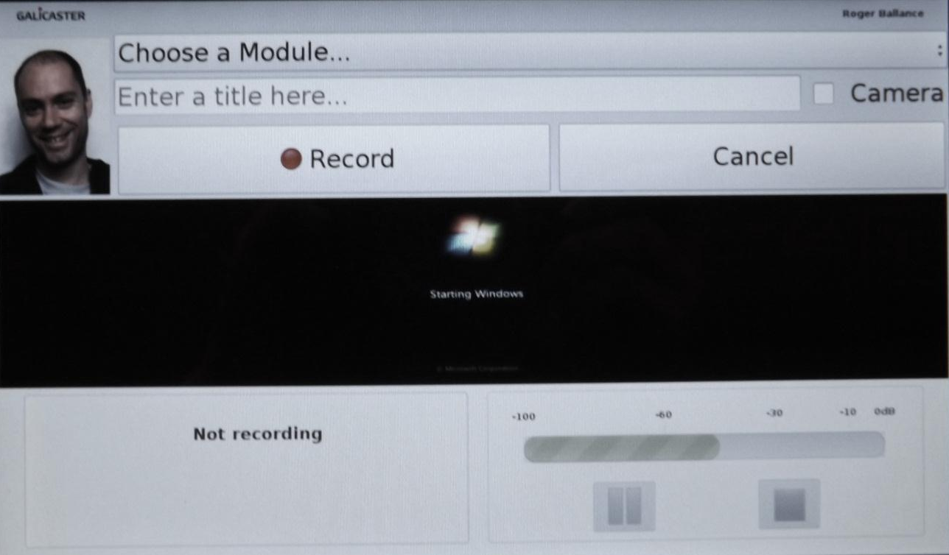
2
Tick Camera to include lectern area in the recording
3
4
5

Press to pause
The screen displays what is being recorded.

Press to Stop recording and log off
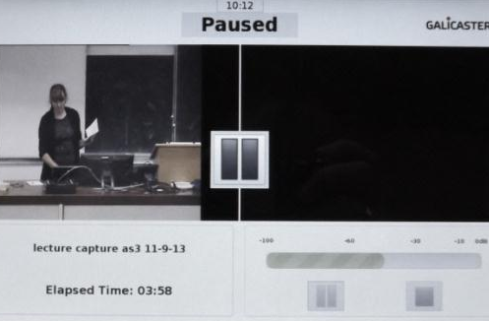
Press to
continue recording

- Claim your recording via Study Direct using the + Add Resources button
- *If you mistype or fail to enter your username you can still claim your recording

