SACKLER CENTRE
TMS TRAINING MANUAL

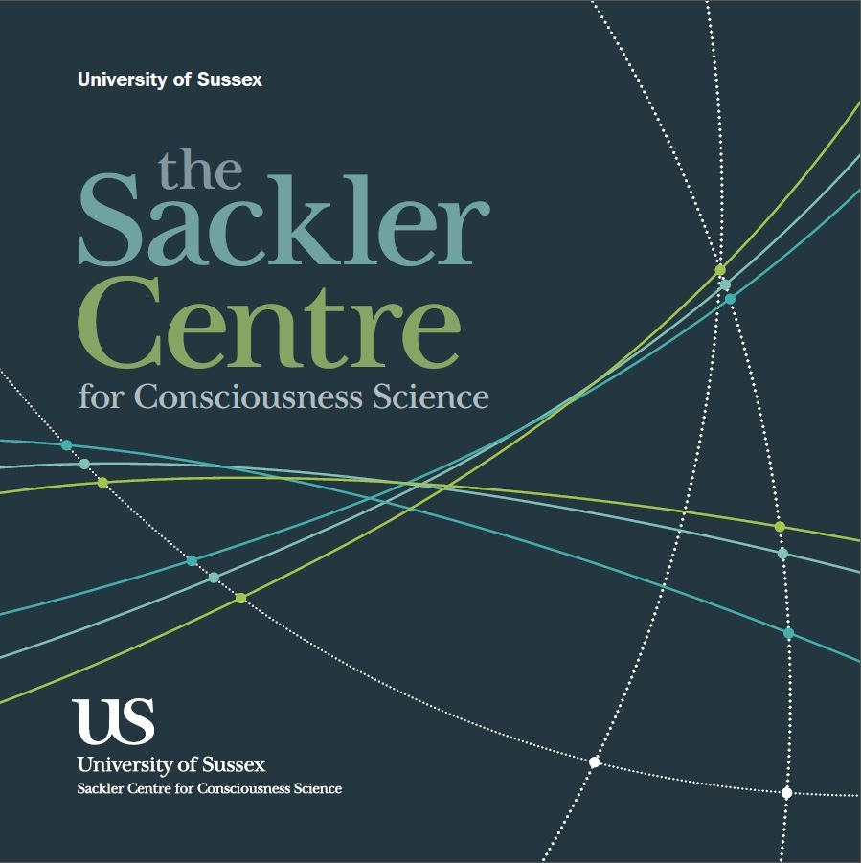

GENERAL WORKING PROCEDURES

DIAL 3333 IN CASE OF EMERGENCY

NEAREST FIRE ALARM Corridor
NEAREST FIRE EXTINGUISHER By Lift
NEAREST FIRST AID STATION By Lift

WORKING WITH PARTICIPANTS

ILLNESS If either you or your participant is suspected of being ill, the research booking should be cancelled and if possible, rescheduled. Please advise
participants not to attend if they feel ill prior to the session.

SCENT-FREE You should provide a scent-free environment for your participants.

WORKING ALONE

REDUCING RISK If you suspect you are working alone in the building, there are two things
you can do to minimize risk: a) ring security (3333) to inform them
where you are working and how long you expect to be working, b) ring
an independent party or Dr David Schwartzman who is the lab manager to also let them know where you are working and how long you expect to be working to also let me know where you are working and how long you expect to be working. Either party can ring to check on you thorough the working period, and you should call relevant parties when you are leaving.
WEEKENDS Give special consideration to these issues at the weekend, when it is
more likely that you will be working alone.

HANDLING MONEY

REDUCING RISK Make sure money is always securely stored. Whenever possible, prepare
money without the participant present so the location of the money can be kept confidential.
EMERGENCY PROCEDURES

DIAL 3333 IN CASE OF EMERGENCY
There is a phone located under the TMS within the testing room

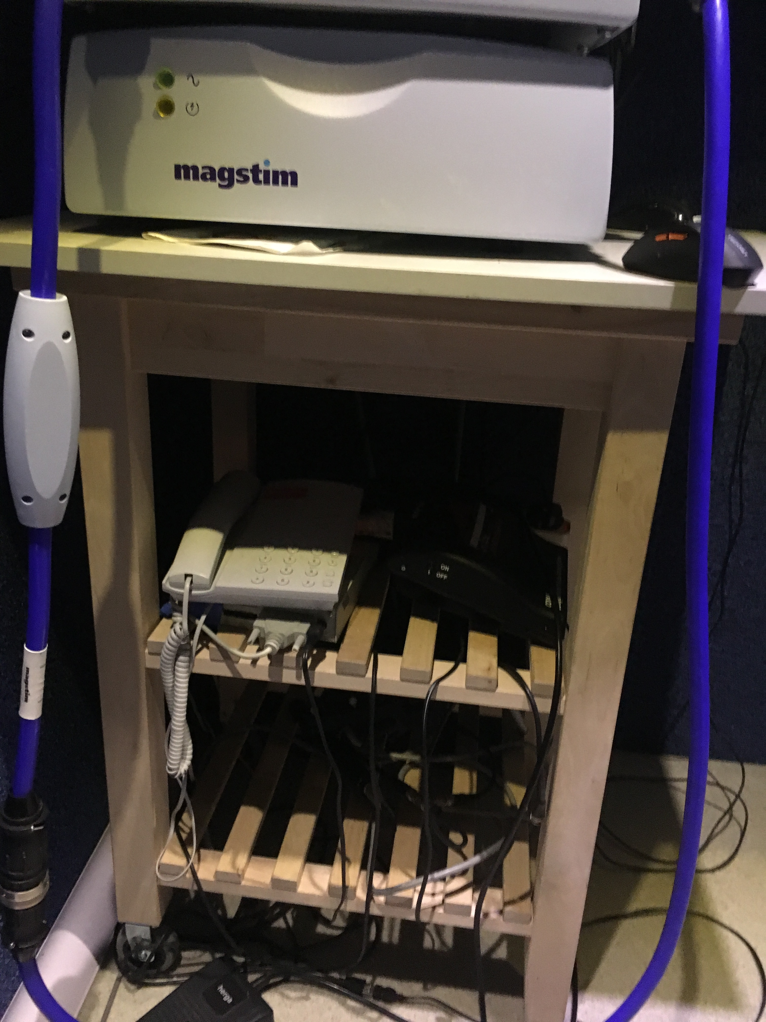

NEAREST FIRE ALARM Corridor
NEAREST FIRE EXTINGUISHER By Lift
NEAREST FIRST AID STATION By Lift

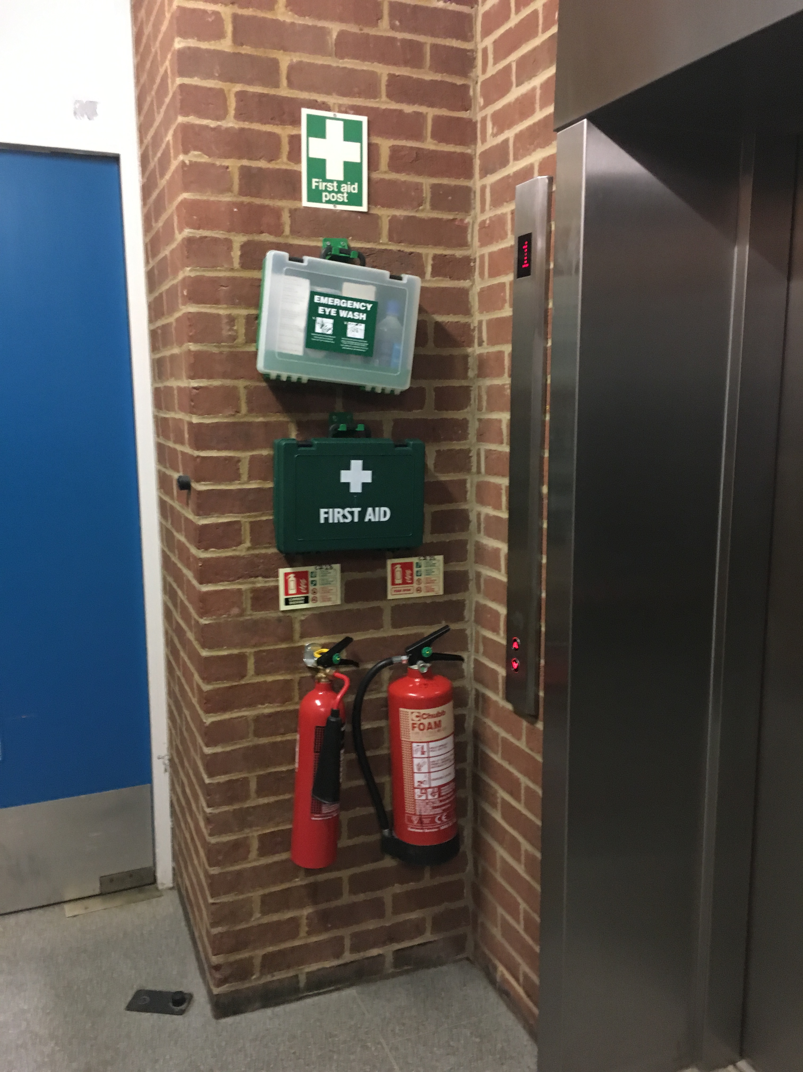

IN ALL CASES OF DOUBT OR WHEN SYMPTOMS PERSIST,
ALWAYS SEEK MEDICAL ATTENTION

What to do in the Case of an Adverse Reaction

1. Assess the participant immediately based on your Emergency first aid at work training. This will include responsiveness, awareness and brief questioning about their situation.

2. If anything is highlighted by this questioning, call Emergency site services 3333

3. If they deem it fit, they will call an ambulance.

To minimise the risk of adverse reaction, during the experiment keep constant communication between you and the participant, this allows you to monitor for any adverse side effects and for the participant to indicate their level of comfort or ask questions at any point during the testing.

After each experimental condition in which TMS is administered and throughout the experiment the experimenter should constantly assess the participant to make sure they are OK.

Finally, if you are also recording the participants EEG you have a direct window into their brain activity, which can be used to detect the onset of any potential seizure activity, under which circumstances stop the experiment immediately.

Any adverse reaction has been shown to be immediately linked to TMS stimulation making it extremely unlikely that anything would occur post-stimulation.

However, following completion of the experimental sessions while the participant washes their hair and is debriefed about the experiment you can monitor for any adverse side effects.

If any adverse reaction occurs, following assessment by Emergency site services, if they deem the participant to be fit and well, you should encourage the participant to stay with you for an hour to make sure that they do not display any further reactions. You should assess the participant throughout this time and if anything is highlighted call Emergency site services for additional assessments. If after 1 hour has passed and the participant shows no additional symptoms they will be free to leave. You should make the participant aware of the reasons behind their reaction (seizure) and advise them to seek a medical consultation to investigate their condition further.

If you have any questions about best conduct or procedures please contact the lab manager: D.schwartzman@sussex.ac.uk Tel: +44-1273-67-8213
STANDARD OPERATING PROCEDURES

In order to run a TMS experiment in the SACKLER lab, proof of current first aid responder training will be required.

BEFORE SESSION
The strong magnetic field employed can affect electrical equipment and ferrous metal implants. All participants will therefore be screened for the presence of any such implant.

Participant should have been sent exclusion criteria via email via attending

Participant should wear layered clothing.

Has participant been to bathroom?

Further reading on the safety of TMS can be found here:

Rossi, S., Hallett, M., Rossini, P. M., Pascual-Leone, A. Safety of TMS Consensus Group. Safety, ethical considerations, and application guidelines for the use of transcranial magnetic stimulation in clinical practice and research. Clinical Neurophysiology 2009; 120(12): 2008-2039.

Turn on the infrared camera, this must be on during the experiment to monitor the participant when you are not in the testing room.

SETUP
Turn on MAGSTIM at the mains
Turn on the top magnetic stimulator and wait for 5 seconds.
Arm the machine by pressing the green button – DON’T LEAVE ARMED FOR EXTENDED PERIODS OR WHEN YOU ARE NOT USING IT. ONLY DURING STIMULATION!
(The indicator that the machine is armed is shown by a tick. The red button disarms the machine and the yellow button sends a pulse.)
When you are setting the threshold for single pulse stimulation, remember to disarm the switch on the coil.
ONCE PARTICIPANT ARRIVES

Read out exclusion criteria questionnaire and get them to sign it.
If they answer yes to any of the questions they may NOT take part in the study

Single Pulse Stimulation

Finding Motor Cortex Threshold – using Measurement

Instructions “First we will find your motor threshold, which involves seeing what intensity of pulse on your motor cortex causes your fingers to twitch. For this I need you to put on this cap and I need to take some measurements of your skull to work out some brain locations.”
Make sure all previous dots on cap are removed. Put the swimcap on the subject’s head – make sure there are no hair clips or similar in hair before you do this. Make sure the swimcap is tight and symmetrical.
To locate the motor cortex and find the threshold, mark the halfway point between the back ridge (inion) and nose ridge (nasion) and put a sticker here. Accurate measurement is essential!
Do the same with the midpoint between the ear ridges and adjust this central sticker accordingly. Adjust the central hole in the net where these lines cross. This is the vertex.
Check with participant that this really is the vertex by placing a finger on spot.
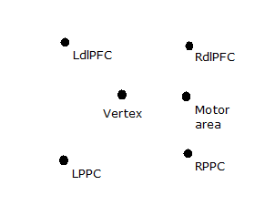
The motor area will be 5 cm lateral to the vertex on the interauricular line.
Finding the Threshold: Align the middle of the coil with motor area spot, angled to brain, wings facing ears. Ask the participant to gently squeeze together their middle finger and thumb.
Do single pulses, watching for twitches – go up and down in 5% increments starting at 50%. You should never go above a threshold over 80%.
If you haven’t found a pulse at 65%, try a different area (e.g. 2cm higher than original dot). You will almost certainly have to move areas around. Use the motor map by the TMS machine as a guide if twitches are reported elsewhere.
Keep telling the subject to relax and shake out their hand every so often.
Once finger twitch is found three times consistently for a given threshold, try going down a little (by 1 or 2%) to get the minimum value that you can get a consistent motor twitch. THIS IS THE ACTIVE MOTOR THRESHOLD (AMT). Write this figure down for the subject.

TMS with Neuro Navigation
Visor2 allows real-time tracking of the subjects head and TMS coil in space, proving you have their MRI scan (nifti or DICOM). This allows the precise targeting of TMS sites.

The motor strip can be identified on the scan and stimulated selectively to find the AMT using the same procedure as above.

Consult Visor 2 manual for more details about setup etc.

Theta Burst Stimulation
Theta Burst Stimulation (TBS) protocols have emerged as a method to transiently alter cortical excitability in the human brain through repetitive transcranial magnetic stimulation (rTMS). TBS involves applying short trains of stimuli at high frequency repeated at intervals of 200ms.

The trains of stimulation need to be set on the Magstim TMS screen prior to testing.

Check to make sure you have the correct duration and number of pulses.

Having found the AMT check the tolerability at the target site for 80% of this threshold. E.g. if threshold is 50% on TMS machine, and you are going to stimulate DLPFC, give one or a few pulses at 50% x 0.8 = 40% as set on the circular dial on the TMS machine, and triggered by the yellow button.
TEST for each target site via yellow button a few times at least. If participant is uncomfortable or twitching a lot, try changing the location very slightly (up to 1cm) and the angle a little (but not too much).

Transcranial Magnetic Stimulation (TMS) Screening Questionnaire
(adapted from Keel et al, 2000)

Please indicate under each question, with a Yes or No if you have you ever:

- Had an adverse reaction to TMS?
- Had a seizure?
- Do you frequently faint?
- Had an EEG for medical reasons?
- Had a stroke?
- Had a serious head injury (e.g. concussion, neurosurgery)?
- Do you have any metal in your head (outside of the mouth) such as shrapnel,
surgical clips, or fragments from welding or metalwork?
- Do you have any implanted devices such as cardiac pacemakers, medical
pumps, or intracardiac lines?
- Do you suffer from frequent or severe headaches?
- Have you ever had any other brain-related condition?
- Have you ever had any illness that caused brain injury?
- Are you taking any medications (apart from contraceptives)?
- Does anyone in your family have epilepsy?
- Do you suffer from tinnitus?
- Do you need further explanation of TMS and its associated risks?

CONFIRMATION

NAME: ______________________________________

I CONFIRM THAT I HAVE READ, UNDERSTOOD AND WHERE APPROPRIATE SIGNED THE FOLLOWING DOCUMENTS

SACKLER TRAINING MANUAL ______

OUT OF HOURS SOP ______

COSHH ASSESSMENT (SIGNED) ______

SCORED 100% ON TMS LAB QUIZ ______

SIGNATURE: _______________________________ DATE: _________________
CONFIRMATION

NAME: ______________________________________

I CONFIRM THAT I HAVE READ, UNDERSTOOD AND WHERE APPROPRIATE SIGNED THE FOLLOWING DOCUMENTS

RE:COGNITION TRAINING MANUAL ______

OUT OF HOURS SOP ______

METRICIDE 28 SAFETY DATA SHEET ______

METRICIDE 28 ACTIVATOR SAFETY DATA SHEET ______

COSHH ASSESSMENT (SIGNED) ______

SCORED 100% ON ERP LAB QUIZ ______

SIGNATURE: _______________________________ DATE: _________________

