RE:COGNITION LAB
TRAINING MANUAL

GENERAL WORKING PROCEDURES

DIAL 3333 IN CASE OF EMERGENCY

NEAREST FIRE ALARM Outside Lab
NEAREST FIRE EXTINGUISHER Outside Lab
NEAREST EYEWASH BOTTLE Above sink
NEAREST EYEWASH STATION Pev2 4A

WORKING WITH PARTICIPANTS

ILLNESS If either you or your participant is suspected of being ill, the research booking should be cancelled and if possible, rescheduled. Please advise
participants not to attend if they feel ill prior to the session.
SCENT-FREE You should provide a scent-free environment for your participants.

WORKING ALONE

REDUCING RISK If you suspect you are working alone in the building, there are two things
you can do to minimize risk: a) ring security (3333) to inform them
where you are working and how long you expect to be working, b) ring
an independent party to also let me know where you are working and how long you expect to be working. Either party can ring to check on you
thorough the working period, and you should call relevant parties when
you are leaving.
WEEKENDS Give special consideration to these issues at the weekend, when it is
more likely that you will be working alone.

HANDLING MONEY

REDUCING RISK Make sure money is always securely stored. Whenever possible, prepare
money without the participant present so the location of the money can be kept confidential.
EMERGENCY PROCEDURES

DIAL 3333 IN CASE OF EMERGENCY

NEAREST FIRE ALARM Outside Lab
NEAREST FIRE EXTINGUISHER Outside Lab
NEAREST EYEWASH BOTTLE Above sink
NEAREST EYEWASH STATION Pev2 4A

IN ALL CASES OF DOUBT OR WHEN SYMPTOMS PERSIST,
ALWAYS SEEK MEDICAL ATTENTION

METRICIDE
(ALWAYS wear lab coat, eye goggles and chemical gloves when using)

INGESTION If swallowed, may irritate mouth, throat and intestinal tract. Ingestion of glutaraldehyde may cause nervous system effects including nausea, dizziness, headache, and drowsiness. Do not ingest. Call physician or Poison Control Center immediately. Induce vomiting only if advised by appropriate medical personnel. Never give anything by mouth to an unconscious person.
EYE CONTACT Causes severe irritation with possible burns. Check for and remove contact lenses. Flush thoroughly with water for at least 15 minutes, lifting upper and lower eyelids occasionally. Get immediate medical attention Eyewash bottles are above the sink. Eyewash station locate Pev2 4A.
SKIN CONTACT May cause skin irritation. Remove contaminated clothing. Flush thoroughly with mild soap and water. If irritation occurs, get medical attention.
INHALATION Vapors may cause irritation of the nose, throat and upper respiratory tract. Repeated inhalation of glutaraldehyde vapors may cause asthmatic symptoms in some individuals, including cough, wheezing and difficulty breathing. Remove to fresh air. If not breathing, give artificial respiration. If breathing is difficult, give oxygen. Get medical attention.
SPILL Dilute with water, absorb with an inert dry material (towels), sweep up and place in suitable container for disposal (regular garbage). Wash spill area with soap and water.

KEY ANT EEG SAFETY PROCEDURES

DIAL 3333 IN CASE OF EMERGENCY

NEAREST FIRE ALARM Outside Lab
NEAREST FIRE EXTINGUISHER Outside Lab
NEAREST EYEWASH BOTTLE Above sink
NEAREST EYEWASH STATION Pev2 4A

Participant handling

Always wear examination gloves when prepping and deprepping the participant

Consumable disposal

Disposables such as cotton wool, alcohol pads and stickies can be disposed of in the regular waste.

Syringes and blunt needles should be disposed in a Sharps Box

Sharps Box must be returned to Life Science Stores when full

Metricide use and disposal

Always wear lab coat, eye goggles and chemical gloves when handling Metricide

To activate Metricide, add the solution and the activator together in a large, sealable container. Write the activation date and the deactivation date (28 days from activation date) on the top of the container.

DO NOT use Metricide if it is past the deactivation.

To dispose of the Metricide solution, run down the drain with large quantities of water.
STANDARD OPERATING PROCEDURES

BEFORE SESSION

Participant should have washed hair before without applying hair products
Participant should wear layered clothing.
Has participant been to bathroom?

Prepare on disposable towel
- syringe with gel (always fill and refill syringe without needle attached)
- stickies
- tape measure - examination gloves
- alcohol pads - micropore tape

Switch on power at wall sockets W2/R4/10 and W2/R4/11
Make sure the cage monitor and computer are running and displayed

SETTING UP THE AMPLIFER

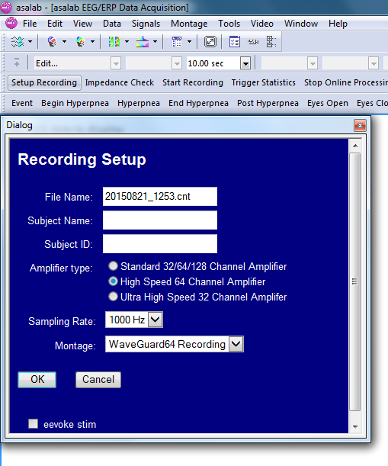

Start up ASALab > Setup Recording

- Change the filename appropriately
- Ensure amplifier type is High Speed 64 Channel
- Sampling rate is 1000Hz (1kHz)
- Montage is WaveGuard64 Recording

Make sure ANT amplifier is turned ON

Click OK

AMPLIFIER NOT FOUND?

Unplug and replug the middle USB behind the machine
(this is the USB that connects to the Amp)

EEG should be running (but not recording)

PARTICIPANT CAPPING

For privacy, please pull the curtain across the EEG area

Always wear examination gloves when prepping and deprepping the participant
Using tape measure, measure participant nasion (bridge of nose) to inion (bump at back of head). Ask the participant to hold the tape measure at the nasion to help you.
Measure head circumference and select cap size (if participant is close to a boundary, select smaller cap size)

Large 56-61cm (blue trim)
Medium 51-56cm (red trim)
Small 47-51cm (yellow trim)

When first fitting the cap, ask the participant to look up at the ceiling, place the front of the cap on the forehead and ask the participant to hold it in place and slowly bring their head down.

Fit cap symmetrically and ensure that Cz is halfway between nasion and inion measurement
FPz should be 10% up from nasion

Click on Check Impedences

This will show a top view of the electrode cap. The job now is to turn all the red circles into blue circles (i.e., lower impedences).

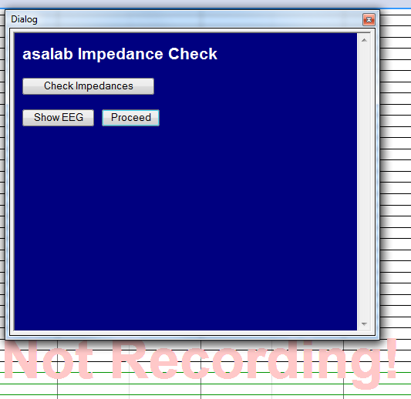
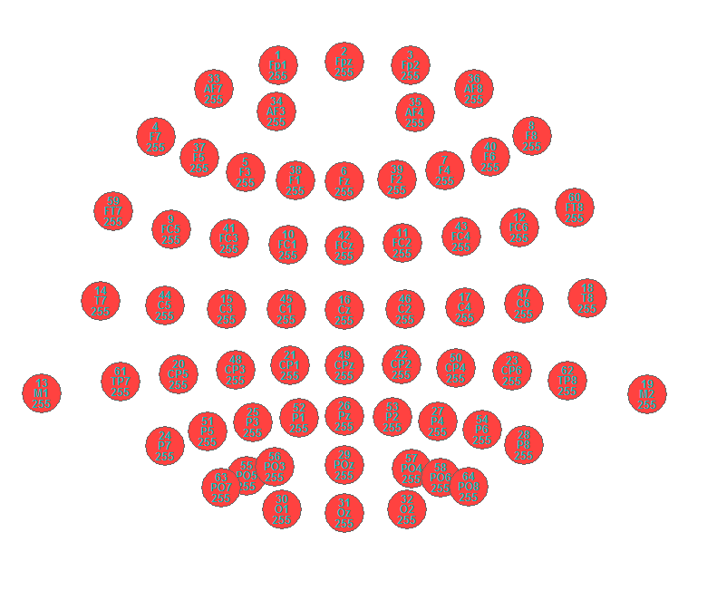

TO SWITCH BETWEEEN THE RECORDING AND PRESENTATION MONITOR IN THE CAGE, JUST PRESS THE BLACK BUTTON BEHIND THE MONITOR

To insert gel, part hair by moving syringe in a left to right motion, insert gel at the same time as drawing syringe upwards, to leave a column of gel.

DO NOT grind away at the scalp if it is not turning blue! Impedances will often lower as a function of time. If not, the issue is usually you need a little (though not much more) gel.

You will also need to attach bipolar HEOG and VEOG electrodes. To insert gel on 4 external electrodes, attach stickies to drop-downs, tab parallel to the wire. Place a small amount of gel on the middle circle of the electrode using syringe. Fit the electrode with the tab (and lead) hanging down.

The current configuration on the headbox should be

Red Black
Channel 65 (HEOG) To right of right eye To left of left eye
Channel 66 (VEOG) Below left eye Above left eye

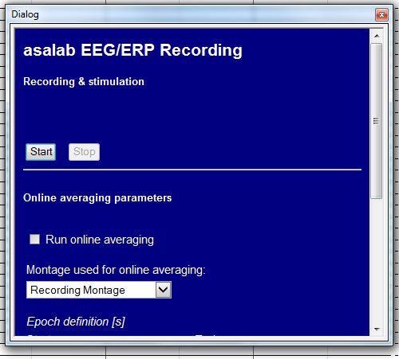

Click Start

The 'Not Recording!' prompt should disappear and the background of the EEG display should turn yellow. This means you are recording.

Do not use an operating cellular phone within 30 cm of the amplifier, the cables and the
electrodes to avoid excessive noise on the signals.

PARTICIPANT CLEANING

Make sure you have stopped recording and switched off the ANT amplifier.

First things first, detach the participant from the cap. Using examination gloves, take off drop-down electrodes and place on top of cap. Take off cap.

Place cap and electrodes in regular bowl and ensure connectors are well protected from water (use zip-loc bag) and away from the area the participant needs to use to clean themselves. Allow the participant as much time as they need.

POST-PARTICIPANT CLEANING

Disposables such as cotton wool, alcohol pads and stickies can be disposed of in the regular waste. Gel from syringe can be squeezed onto the deposable towel, which can be thrown in regular garbage.

Syringes and blunt needles should be disposed in a Sharps Box

Sharps Box must be returned to Life Science Stores when full

Participant’s towel should be placed in laundry bag.
Wash hands if you have handled a dirty towel.

CAP CLEANING

Prepare
- container of Metricide
- examination gloves
- chemical gloves
- eye goggles
- lab coat
- disposable towel
- stopwatch
- washing up liquid

Always wear lab coat, eye goggles and chemical gloves when handling Metricide

Check the activation and deactivation date of the Metricide

If you’re within the deactivation you can use the Metricide
If you’re outside of the deactivation date you will need to

a) dispose of old Metricide
b) activate a new batch of Metricide

To dispose of the old Metricide solution, run down the drain with large quantities of water.

To active a new batch of Metricide, add the solution and the activator together in a large, sealable container. Write the activation date and the deactivation date (28 days from activation date) on the top of the container.

With examination gloves, put a drop of washing up liquid on cap and run under warm water
Remove stickies from drop-down electrodes and place on towel
All electrodes and cap holes should be free of gel (you can use a syringe or waterpik and squirt water through the cap holes- make sure you do this underwater!)
Rinse cap and electrodes with water

Remove examination gloves and replace with lab coat, eye goggles and chemical gloves
Place the cap inside the Metricide bucket.
Make sure the connectors are SECURE OUTSIDE the bucket.
Ensure all parts of the cap are covered and submerge for 10 minutes using stopwatch
Thoroughly rinse the cap with warm water 3 times for a minute each, every time using fresh water from the tap.

LAST BITS

Hang electrode cap and drop-down electrodes up on rack
Ensure that the connectors are higher than the caps and away from water / moisture.
Make sure you note which cap you used and record any problems with recording in the ERP log on the recording computer.

NOW BACK UP YOUR DATA!
CONFIRMATION

NAME: ______________________________________

I CONFIRM THAT I HAVE READ, UNDERSTOOD AND WHERE APPROPRIATE SIGNED THE FOLLOWING DOCUMENTS

RE:COGNITION TRAINING MANUAL ______

OUT OF HOURS SOP ______

METRICIDE 28 SAFETY DATA SHEET ______

METRICIDE 28 ACTIVATOR SAFETY DATA SHEET ______

COSHH ASSESSMENT (SIGNED) ______

SCORED 100% ON ERP LAB QUIZ ______

SIGNATURE: _______________________________ DATE: _________________

