MARS Leads
The theme is lead by Clara Strauss and Fergal Jones in Sussex Partnership NHS Foundation Trust and by Graham Davey and Frances Meeten at the University of Sussex.

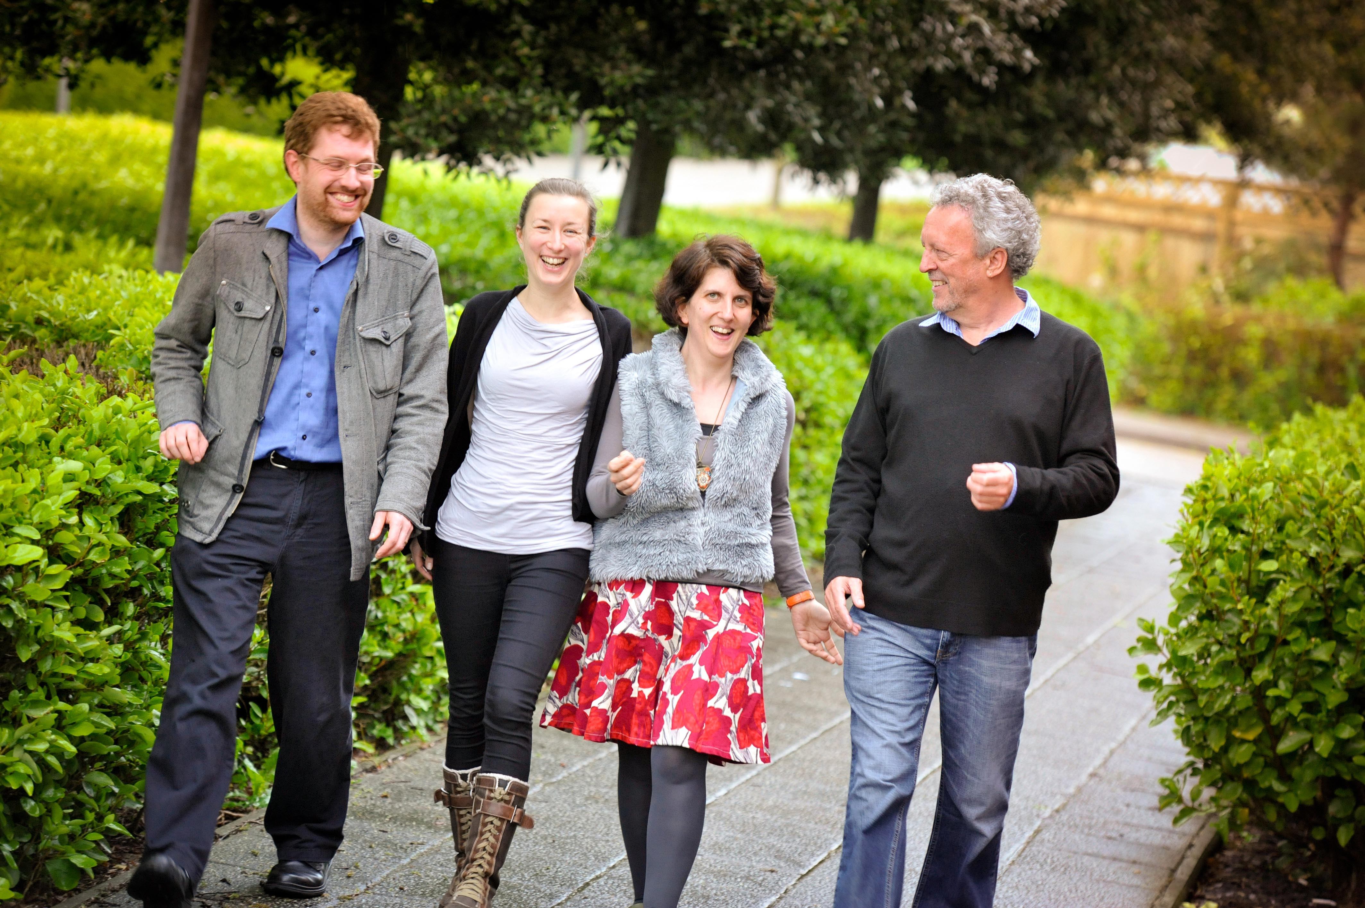
Fergal, Fran, Clara and Graham

You can contact them at:
clara.strauss@sussexpartnership.nhs.uk
fergal.jones@sussexpartnership.nhs.uk
grahamda@sussex.ac.uk
f.m.meeten@sussex.ac.uk



MARS Website
For information about the MARS group and planned events please visit our website:

www.sussex.ac.uk/mars


MARS
Mood and Anxiety Research in Sussex
A collaboration between Sussex Partnership NHS Foundation Trust, University of Sussex and Brighton and Sussex Medical School

The three aims of MARS are to:
- Increase the number of high quality, funded mood and anxiety research studies.
- Increase the number of peer-reviewed publications in mood and anxiety research.
- Work with clinicians and service users, to find ways of implementing mood and anxiety research findings to improve the lives of service users.

MARS Research
Examples of recent MARS research include:

- An RCT evaluating the effectiveness of information provision in Bipolar Disorder
Richard Bowskill & Rob Horne

- Developing an intervention for chronic worry based on ‘mood as input’ theory
Graham Davey, Fergal Jones & Ruth Chandler

- A pilot RCT of group person-based cognitive therapy for chronic depression
Clara Strauss, Paul Chadwick & Mark Hayward

- Investigating an iatrogenic model of depressive disorder
Richard Whale & Renata Fialho

- An RCT evaluating the effectiveness of an online mindfulness training course
Kate Cavanagh, Clara Strauss & Fergal Jones

- Mechanisms of catastrophic worry
Graham Davey & Frances Meeten

- Mechanisms of Interferon Induced Depression in Patients with Hepatitis-C
Neil Harrison

- Preventing childhood anxiety through intervening with anxious parents
Sam Cartwright Hatton & Suzanne Dash


MARS Events
We have held a number of successful events to showcase MARS research. Our launch event was held at the University of Sussex in March 2011 and since then we have held two evening seminars.
The first MARS conference was held in November 2011 where we had two excellent keynote speeches from Dr Kate Cavanagh (University of Sussex) and from Professor Paul Chadwick (Institute of Psychiatry). Our second conference was held in November 2012 with Dr Fran Meeten (University of Sussex) and Professor Adrian Wells (University of Manchester) as keynote speakers.

MARS – Getting Involved
If you are a mood or anxiety researcher and would like to get involved in MARS please feel free to contact Dr. Clara Strauss at clara.strauss@sussexpartnership.nhs.uk
We are keen to collaborate with researchers who will support MARS to work towards their aims.



