

SCHOOL OF LAW, POLITICS AND SOCIOLOGY

Health & Safety Policy

Date: February 2019
Review Date: February 2020
Full Review Date: February 2022

The University Health and Safety Policy, signed by the Vice Chancellor, provides a statement of commitment to ensure the health, safety and welfare of all associated with the activities of the University.

Heads of School are responsible, through the Vice-Chancellor, to the University Council, for ensuring health, safety and wellbeing in the School and that there is a health and safety management system in place.

- Interim Head of School Statement
The health, safety and wellbeing of the staff, students and visitors to the School of Law, Politics and Sociology is of paramount importance and the School is committed to achieving a safe and healthy working environment.

The Interim Head of LPS Prof Sue Millns has designated the School Administrator Lynn Gibbs as the School Health and Safety Co-ordinator (appendix A) and she will:

● take a lead role in the promotion of health and safety matters,
● provide a first level of advice, and
● act on behalf of the Interim Head of School in respect of these matters.

Duties include:
- Being familiar with the University Health and Safety Policy
- Providing a first point of contact to members of the School on matters of health and safety.
- Acting with the delegated authority of the Head of School in matters of health and safety and/or urgency.
- Referring promptly to the Head of School or the University’s Director of Health and Safety any health and safety problems which cannot be resolved locally.
- Liaising with the University’s Director of Health and Safety.
- Setting up and attending meetings of the School Health and Safety Committee.
- Conducting and co-ordinating annual health and safety inspections and any follow-up action required.
- Ensuring that accidents, near misses and instances of occupational ill health are reported.
- Ensuring that all members of staff are instructed in the action to be taken in the event of fire.
- Disseminating health and safety information and policies to members of school staff and students where appropriate.
- Identifying new members of the school and arranging for them to receive adequate induction with respect to health and safety.
- Assisting in identifying members of the school for appropriate health and safety training and appointing Fire Wardens and local first aiders.
- Monitoring in the school that: a high standard of housekeeping is maintained, adequate health and safety records are maintained, risk assessments are completed, policies are conveyed to staff and that systems are set up to check that first-aid boxes, fire fighting equipment etc. are provided and maintained.
- Ensuring that an Annual Safety Report is sent to the Safety Office by the 30 September each year.

2. Safety Policy

2.1 All Employees and Students
All employees and students of the Uinversity of Sussex, whilst engaged in any University activity both on and off campus, must take all reasonable steps to ensure their own safety and that of others. In particular, they shall:
- comply with health and safety standars and arrangements that have been issued.
- report any accidents or unsafe conditions to the School Health & Safety Co-ordinator.
- make proper use of any necessary health and safety measures including equipment.
- attend induction and additional training relevant to their specific activities.
- not interfere with or misuse anything that is provided win the interst of health and safety.

2.2 First Aid
First Aiders receive training through the University’s Health, Safety and Environment Office. The Security Office holds the responsibility for contacting First Aiders (dial 3333). The School first aid boxes are located in the Freeman Foyer (entrance) and at the School Office counter. LPS First Aiders see Appendix B.

2.3 Fire Safety Policy & Deaf Messaging Service
There is a procedure for ensuring safe and speedy evacuation in the event of the fire alarm sounding. If the fire bell sounds, leave what you are doing and exit the building by the quickest safest route and congregate by the nearest fire assembly point (a green sign with a tick).

Do not re-enter the building until permitted to do so. If you have any students or members of the public with you please escort them to the appropriate assembly point.

There are floor wardens appointed for each corridor in the building, who are responsible for ensuring safe and speedy evacuation whenever the fire alarm sounds, and then reporting to the responsible person, the nominated member of the Estates Division, at the Assembly Point. LPS Floor Wardens Appendix B.

Deaf Messaging Service (DMS) allows you to connect to the University fire alarm system simply by sending a text message from your mobile phone, once connected you will receive a notification by text message when the fire alarm for that building is activated. For further information http://www.sussex.ac.uk/hso/firesafety/deafmessaging

2.4 Health & Safety Policy
The School Administrator will keep all relevant safety information up-to-date: the School’s Health & Safety Policy and all risk assessment forms. Information is also provided on the Safety Notice board which is located in the staff room Freeman G32.

2.5 Accidents/Incidents
If you have an accident, however minor, or witness a dangerous occurrence, notify the School’s Health & Safety Co-ordinator who will ensure that the incident is recorded on the Sussex Direct incident reporting system.

2.6 Smoking
In line with University policy, smoking is prohibited in all areas of the School, including offices and within two metres of the building.
2.7 Lone and Out-of-Hours Working
Lone and out-of-hours working on campus should be undertaken having made reference to the University Lone Working Policy: http://www.sussex.ac.uk/hso/policies/hsopolicies
If you need to be in the building outside normal working hours (i.e. before 9am or after 5pm or anytime at weekends or minimum service days) and an alarm sounds you must leave the building by the nearest available exit. In an emergency: to summon the emergency services (Fire, Ambulance or Police) or if you need first aid assistance, dial 3333 to contact University Security.

2.8 Display Screen Equipment (DSE) & Eye Tests
If you use display screen equipment, a risk assessment will be carried out of your computer equipment, furniture, room etc. If you feel at any time that you require alterations to be made or need additional equipment (e.g. a footrest, wrist rest or document holder) or suffer any muscular problems, let the School Administrator know immediately. The Occupational Health Advisor can be requested to undertake a further assessment.

All Persons identified as DSE Users will have access to a free bi-annual eye test. Eye Health is very important and if not managed can lead to both short and long-term health conditions, including increased eye strain and headaches. Please see http://www.sussex.ac.uk/hso/policies/subject_areas/general/eyetests. The eye test request form expenditure code is LD001-03.

2.9 Manual Handing
Do not try to lift or move heavy objects, stationery, furniture or equipment. The School Administrator will make a risk assessment for tasks involving the movement of heavy items. If you need to move a heavy item, please ring the School Office who will arrange for a Premises Assistant, who will have been trained in manual handling, to do so. A kick-step is available from the School Office if you need to reach up to high shelves etc.

2.10 Risk assessments
Risk assessments have been undertaken on the work activities of staff and are kept by the School Administrator.:
- Use of Display Screen Equipment
- Manual Handling of Stationery, Furniture and Equipment
- Use of Multifunctional Devices (MFDs)
- Use of Office Equipment
- Working in School Office Open to the Public

2.11 Occupational Health
The Occupational Health Service offers advice on health, safety and wellbeing at work. The service works to prevent work related ill health, reduce risks to health from occupational hazards and promote health and safety. If a manager is concerned about the health of an employee, they should consider referring the person to Occupational Health for advice http://www.sussex.ac.uk/humanresources/occupationalhealth.
Employees can self refer, issues discussed will be in confidence and details will not be passed on to any other member of University staff, please see link above. Occupational Health can also provide referral to counselling services to employees, where this is deemed to be of benefit to the individual.

2.12 Employee Assistance Programme
Sometimes we can all find it a struggle to balance the demands of work, family and relationships.
As a member of staff you have access to a range of benefits that can be found on the Staff Reward and Benefits page.
There you will find a link to our Employee Assistance Programme (EAP) partners Care First. Care First are a specialist highly professional organisation that can provide a range of help at difficult times. There is a 24 hour / 365 days-a-year telephone help line that can provide counselling and specialist advice on a range of matters - and a lifestyle ‘App’ that has been clinically approved. In some circumstances, if face-to-face counselling is appropriate this will be arranged with a suitable counsellor that is convenient to you. You can call the EAP helpline on 0800 015 5630.
The service is confidential and staff can self-refer themselves. There is no need to inform your line manager and Care First will keep all their contact with you to themselves. Whether is it a family matter, moving house, moving job, a major life event, neighbourhood concerns, consumer rights, or even a brush with the law, they can provide advice and help - and signpost you to more specialist services if they think that you need to access them.
All the staff at Care First are qualified and experienced in their field. Register with Care First now (username: lifestyle1234 / password: carefirst).

3. Legislation and Regulations

The main regulations governing our procedures are The Management of Health and Safety at Work Regulations 1992. The Workplace (Health, Safety and Welfare) Regulations 1992 concern the working environment and include welfare provisions. There are three sets of regulations relating to specific tasks: Manual Handling Operations Regulations 1992; Health and Safety (Display Screen Equipment) Regulations 1992; and Inspection, Monitoring and Auditing of Health and Safety Management 1994. There are further regulations, Provision and Use of Work Equipment Regulations 1992, which deal with equipment. These regulations are incorporated in the University Local Rules issued by the University Health, Safety and Environment Office. Copies are held in the Health, Safety and Environment Office. As appropriate, other Local Rules may be issued to certain staff.

4. Local Rules

4.1 Health and Safety (Display Screen Equipment) Regulations 1992
These regulations apply to all users of personal computers and a Display Screen Equipment risk assessment is required for all members of staff.

4.2 Electricity at Work Regulations 1989

Compliance with the Electricity at Work Regulations 1989 is the responsibility of the School Administrator who arranges regular testing of all electrical equipment in offices throughout the building. Staff should be aware that electrical equipment, which does not display a current sticker to show that it has been tested, might be removed by the School Administrator.

4.3 Driving at Work Policy 2008
The School Administrator (Fleet Manager) ensures that staff are aware of the university’s ‘Driving at Work Policy’. Staff should be aware that if they drive for work purposes (this includes driving to conferences, meetings, away days, training courses, visiting students on placements etc., but not normal home to work commuting) they need to have their driving licence/counterpart, car insurance and MOT certificates checked in advance and that they will need insurance that covers business travel.

4.4 Manual Handing Operation Regulations 1992
Supervisors or the School Administrator should make risk assessments for tasks involving the movement of heavy items, e.g. stationery, furniture, etc. Staff of the School should not move heavy items, but ask a premises assistant who has been trained in manual handling to do so.

4.5 Management of Health and Safety at Work Regulations 1992
Risk assessments have been undertaken on the work activities of staff and students, and recorded. They will be reviewed regularly and further risk assessments will be carried out if new work practices are introduced.

Mechanisms which are put in place to ensure safety policies and procedures are carried out will be audited and monitored by the University of Sussex.

The reporting of audits and reviews of risk assessment controls following any incidents will be done on a regular basis by the School Administrator (Health and Safety Co-ordinator) and reported to the School Executive Board.

4.6 New and Expectant Mothers Regulations 1994
The Management of Health and Safety at Work (Amendment) Regulations 1994 (MHSW), explicitly requires that special attention is given to identifying and controlling risks that may affect women who are pregnant, who have given birth in the previous six months or who are breastfeeding. The objective is to avoid adverse effects being suffered either by the woman herself, by the foetus or by the new-born child. See http://www.sussex.ac.uk/hso/wellbeing/nems

Please see the School Administrator for further information on a risk assessment, rest room provision and storage of breast milk.

Prof Susan Millns ………………………………………………………………………
Interim Head of School

11 February 2019

Appendix A

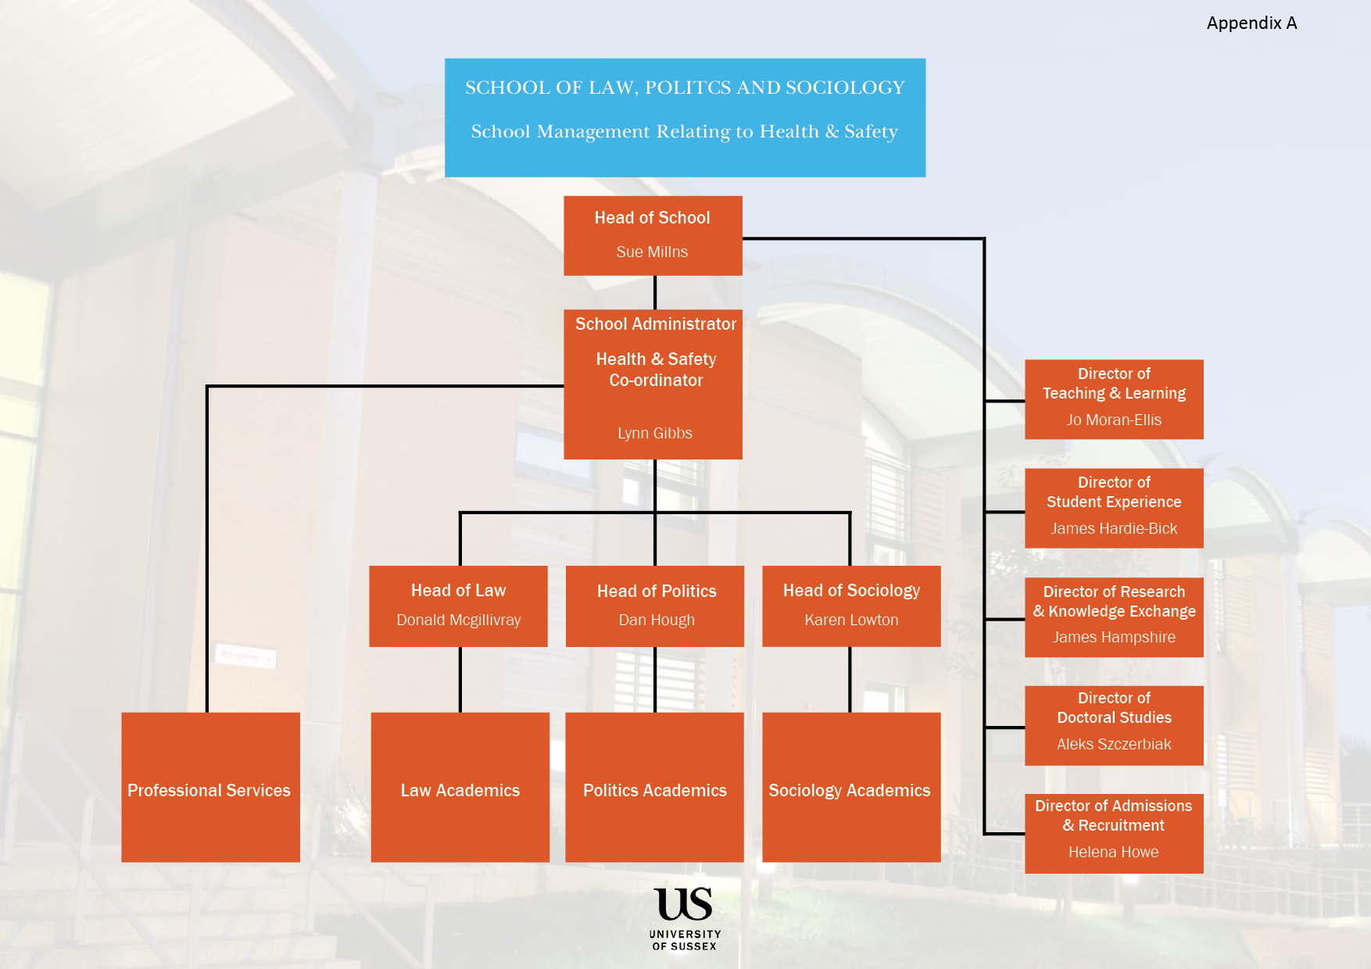
Appendix B

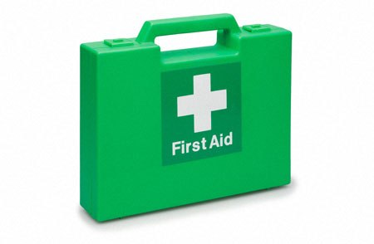

School of Law, Politics and Sociology

Freeman Building First Aiders

Location | First Aiders
Freeman  Academic Office G09 | Kamala Dawar
Freeman  School Office G41 | Lynn Gibbs
Freeman  School Office G41 | Jane Lambert
Freeman  School Office F23 | Chris Turnbull
Freeman  School Office G41 | Celia Williams

22 February 2019
Appendix C
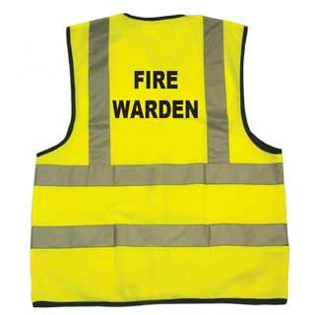

School of Law, Politics and Sociology
Freeman Building Fire Wardens

Building | Fire Wardens
Ground Floor  G01-G16 | Barry Maughan
Ground Floor  G17-G31 | Lynn Gibbs
Ground Floor  G32-G51 | Jane Lambert
First Floor  F01-F23 | Chris Turnbull
First Floor  F17B  F24-F40 | Laura Arnold
First Floor  F41-F59  F17C | Sally Parsons

Fire Wardens should report to Security at the front entrance of Freeman and then assist by directing people away from entrances to the fire assembly point (located on the corner of the car park opposite). They should also ensure that access roads and paths are kept free for the emergency services. Persons may only return to the building when advised to do so.

22 February 2019

