Section 1
General Information
A | School / Department: | LPS
B | Brief description of the activity:  Start to finish, step by step | Foyer (ground floor), which is in use every day as thoroughfare, reception/waiting area and for occasional events. Study areas are also in use daily.
C | Location(s) covered by this risk assessment:  Include building and room number if applicable | Freeman Building foyer.
D | Equipment and materials used: | Tables, chairs, AV/DSE equipment, water cooler, vending machine.
E | Name(s) / Group(s) involved in the activity:  Consider Staff, Students, Visitors, Contractors and members of the public | Staff, Students, Visitors, Contractors, members of the public.
F | Name of person completing this risk assessment:  Students and PhD students should only complete risk assessments for their projects. Sign off for all student projects should be by the student’s supervisor. | Lydia de Montfort  Sally Parsons | Signature |  | Date: | 5/10/2023
G | Risk assessment approved by:  The individual approving the risk assessment should be familiar with the work being undertaken. This should in most cases be the assessor’s supervisor, line manager or the principal investigator. |  | Signature |  | Date:
H | Send a copy to School/Department Safety Coordinator

Section 2 Hazards & Controls
See the accompanying guidance document on the safety section website for further information on how to complete this form.
 |  | Risk with current control measures |  |  |  | Risk after additional control measures
Potential  hazards | Who might be harmed and how? | What current controls are in place to avoid harm? | Likelihood 1-5 | Severity 1-5 | Risk (L R) | What further control measures are required to reduce risk? | Likelihood 1-5 | Severity 1-5 | Risk (L R) | Who  will do this? | When must this be done? | Completed on:
Slips, Trips & Falls | Staff, students,  and visitors  Sprains  or fractures  if they trip over  debris, trailing cables, or slip-on spillages | - All staff to be trained to maintain good housekeeping standards.  - Cleaning staff to empty bins and remove loose rubbish and debris regularly.  - Equipment and materials to be stored in a safe designated area.  - Flooring to be kept and maintained in a serviceable condition.  - Any trailing cables to be covered with suitable rubber matting.  - All areas well lit, including stairs. | 3 | 3 | 9 | - All spillages to be cleaned up immediately.  - Creation of new study area under the stairs eliminated risk of people walking into the corner of the stairs and causing injury to themselves, as this corner is now inaccessible.  - Surplus furniture to be removed and either disposed of or put into storage.  - Deliveries to be put into temporary storage immediately upon receipt and not left in the foyer. | 2 | 3 | 6 | Staff
Manual  handling of  paper, office  equipment etc. | Staff, students,  and visitors  Soft tissue injuries or back pain from handling heavy/bulky objects | - Staff receive training in good manual handling techniques/working at height (if applicable) as new starters.  - High shelves to be used for the storage of light objects only – heavier items to be stored on lower shelves.  - All staff trained as new starters that they should not try to lift objects that look or appear too heavy to handle. | 3 | 3 | 9 | - Basic training to be provided to all new staff online through Learn Upon.  - Trolley/stepladder to be purchased and used to transport boxes of paper and other heavy items when collecting deliveries etc. | 2 | 3 | 6
Electrical equipment | Staff, students,  and visitors  Electric shocks or burns from using faulty electrical equipment | - Ensure equipment is placed on a flat surface uncluttered from other  items (clear workspace).  • Ensure laminator is not left unattended whilst switched on.  • Ensure waste paper is stored in recycling bin/box to be re-used.  • Ensure area is tidied regularly, and fire escape routes are kept  clear.  • First aid box located at School Office counter  - All portable electrical equipment to be tested for electrical safety at correct intervals and labelled with the date of the test.  - All fan heaters replaced during 2022-23 academic year with oil-filled heaters.  - CO2 and foam fire extinguishers located inside School Office and  around building  - Loose cables to be removed and put away in cupboards or tied up if removal is not practicable.  - Water cooler is serviced as per manufacturer’s instructions.  - Vending machine is in good condition and is serviced and maintained regularly by contractor. | 1 | 5 | 5 | - Electrical cables and plugs to be regularly visually inspected by the user for damage.  - Any defective equipment to be reported immediately to the Admin Office or Line Manager, then suitably labelled, and taken out of use until the repair has been affected.  - Electrical equipment must always be operated in accordance with manufacturers' instructions.  - Check water cooler log book to ensure that the water cooler is being serviced as often as necessary for optimum hygiene and safety. | 1 | 5 | 5
Display screen equipment | Staff risk posture  problems and pain,  discomfort or injuries,  eg to their hands/  arms, from overuse  or improper use or  from poorly designed  workstations or  work environments.  Headaches or sore eyes  can also occur, eg if the  lighting is poor. | - DSE training and assessments of workstation from CD ROM  carried out by all new starters early on in induction. Any actions  to be carried out asap.  - Reassessment to be carried out at any change to work feature,  eg equipment, furniture or the work environment such as  lighting.  - Workstation and equipment set to ensure good posture and to  avoid glare and reflections on the screen.  - Shared workstations are assessed for all users.  - Work planned to include regular breaks or change of activity.  - Lighting and temperature suitably controlled.  - Adjustable blinds at window to control natural light on screen  - Noise levels controlled.  - Eye tests provided for those who need them, dutyholder to pay  for basic spectacles specific for VDU use (or portion of cost in  other cases).  - Laptop users trained to carry out own DSE assessment for use  away from office. When used at office, laptop should be used  with docking station, screen, keyboard and mouse. | 3 | 3 | 9 | - Additional members of staff need to be trained to enable DSE assessments to be carried out early in induction for all staff. Training pending new courses being added.  - Updated information to be sent to all staff (to include new starters) as a reminder of the need for DSE assessment.  - Send all staff DSE assessment templates to enable them to carry out their own assessments for home working – as most staff are now eligible for hybrid working. | 2 | 3 | 6
Stress | Staff, students.  Aggression and violence.  All staff could be  affected by factors such  as lack of job control,  bullying, not knowing  their role etc. | - Staff understand what their duties and responsibilities are.  - Staff can talk to supervisors or manager if they are feeling unwell  or ill at ease about things at work.  - ‘No bullying’ policy. | 3 | 3 | 9 | - To mitigate the risks we have a number of colleagues who have recently undertaken mental health first aid training to provide support to students and staff.  - University has a Wellbeing website to provide resources to staff.  - EAP provides support to employees if required.  - Hybrid working helps to support work-life balance.  - Signposting to above services included in University and LPS H&S policies. | 2 | 3 | 6
Fire | Staff, students, visitors, contractors, members of the public.  If trapped, individuals could  suffer fatal injuries from  smoke inhalation/burns. | - Signage is in place next to fire alarms and on fire doors and directing to fire doors, as well as instructions on actions to take in the event of an emergency.  - Fire wardens are trained, more to be added.  - Staff and students to be reminded to keep fire exits clear.  - Central University policies are in place for fire extinguishers. | 1 | 5 | 5 | - Signage to be improved by more signs being added and updated.  - Awaiting additional fire warden training for building staff to be set up to increase the number of fire wardens.  - Ensure the actions identified as  necessary by the fire risk assessment  are completed. | 1 | 5 | 5
Working at height | Staff  Falls from any height  can cause bruising and  fractures. | All new staff complete basic online training via Learn Upon. | 2 | 3 | 6 | An appropriate  stepladder to be bought and staff  shown how to use it safely. | 2 | 3 | 6
Security of building – open doors | Staff, students, visitors, contractors  The fire door next to the Moot Room is sometimes propped open by students for easier access, which is a fire and security risk. |  | 2 | 5 | 10 | Sign to be added next to door as a reminder to keep it closed when not in use.  Staff to be reminded to close the door if they see it propped open. | 1 | 5 | 5

Continue additional pages if required

Section 3 Risk Matrix

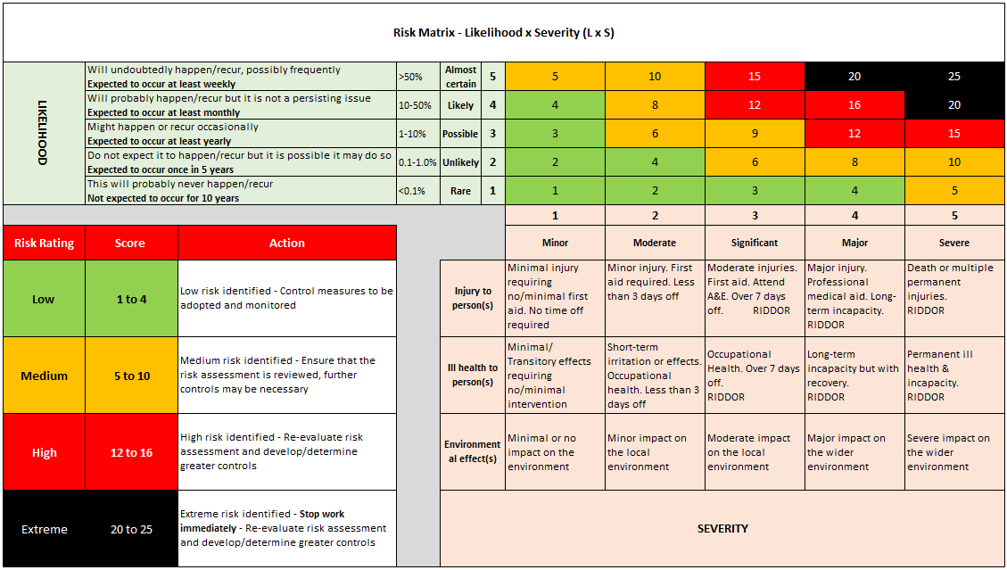
Section 4 Communication of Risk Assessment to Users

This assessment can either be communicated to groups or Individuals as part of a School or Divisional process or signed off by individual users.

School or Divisional Process
The contents of this risk assessment will be communicated to builder users in the University training programs.

Sign off by users
All individuals carrying out activities covered under this risk assessment should sign below after reading it.
By signing this document, you confirm that; you have read and understood this risk assessment and that it is an accurate representation of work practice
Name | Signature | Date | Name | Signature | Date

Section 5 Record of Risk Assessment reviews
Risk assessments should be reviewed annually, if there is a significant change in the process or after an incident/near miss
Date of review: |  | Reviewed by: |  | Comments / date of next review:
Date of review: |  | Reviewed by: |  | Comments / date of next review:

9.3 Appendix 3 - Suitable and sufficient risk assessment checklist

Is my risk assessment approach suitable and sufficient?
(If you can answer ‘yes’ to all the questions, then your approach is likely to be considered suitable and sufficient for risk assessment purposes).

☐ | Have you ensured commitment from all parties (senior management, employees, and their representatives)?
☐ | Have you made a proper check of hazards?
☐ | Have you identified all people at risk?
☐ | Have you considered human factors?
☐ | Have you dealt with significant risks, and demonstrated the use of the hierarchy of controls when determining additional control measures?
☐ | Have you followed all the steps in the risk assessment process?
☐ | Have you focused on prevention and organisational level solutions?
☐ | Have you involved the workforce? (e.g., by seeking their suggestions, advice, and comments on potential solutions to problems).
☐ | Have you considered both routine and non-routine work? (e.g., improvements to working conditions, changes in the way work is organised, etc.).
☐ | Have you included all parts of the organisation’s work? (e.g., design, construction, operation, and maintenance, etc.).
☐ | Have you sought to develop and adopt solutions that are ‘reasonably practicable’?
☐ | Have you communicated the outcomes of the risk assessment with all affected employees?

