Corporate Information Services
http://www.sussex.ac.uk/its/help/bishelp.php
Sussex Direct: Student Representatives

This system allows students to see a list of their student representatives, including their contact details and notices. Student Representatives now have a page to enter these notices which will be published to the students they represent through Sussex Direct.

Students

How Do I See My Student Representatives’ Details?

- Logon to Sussex Direct
- Click on the ‘Student Reps’ option under your ‘Study’ tab.

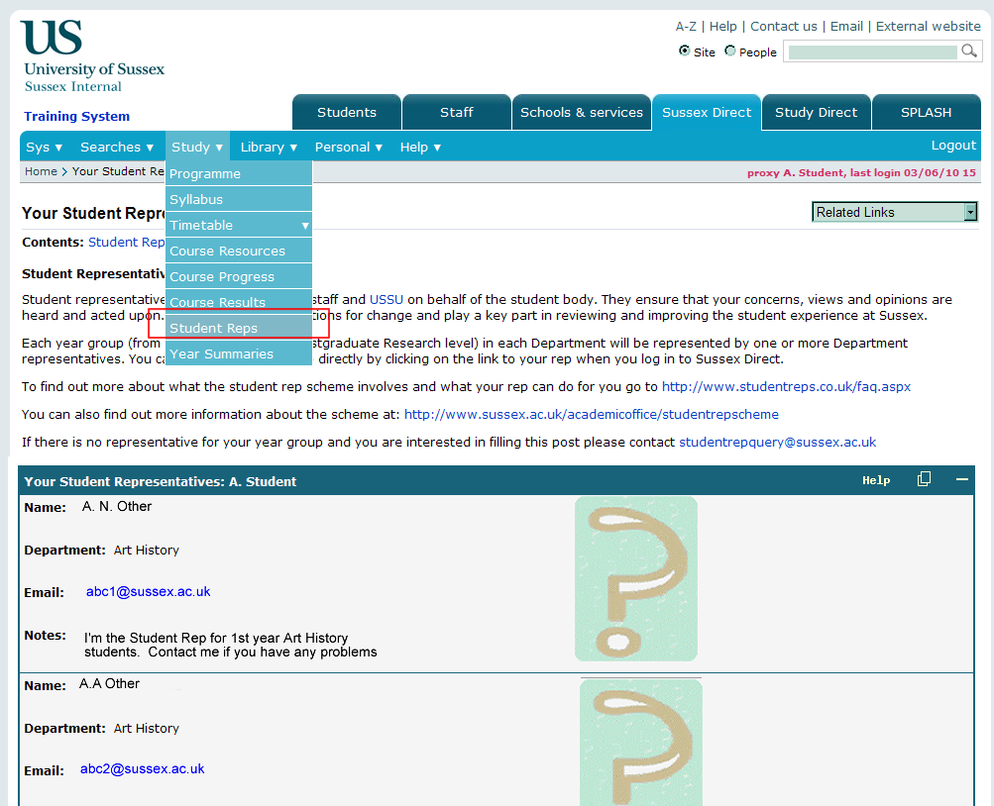

- You will see a list of all the Student Representatives for your department, along with their photo, email address and any ‘Student Representatives Notes’ that they have entered.

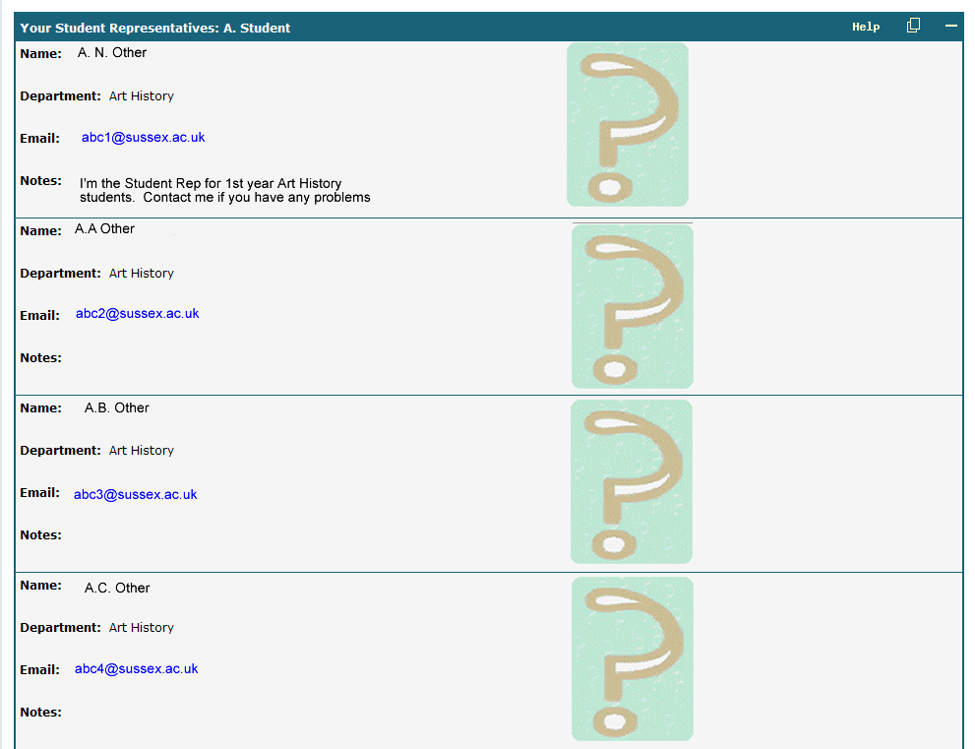

Student Representatives
If you are a Student Representative, you will be able to write some information about yourself that your students will be able to see.

How to Enter Notes for the Students I Represent

- Logon to Sussex Direct
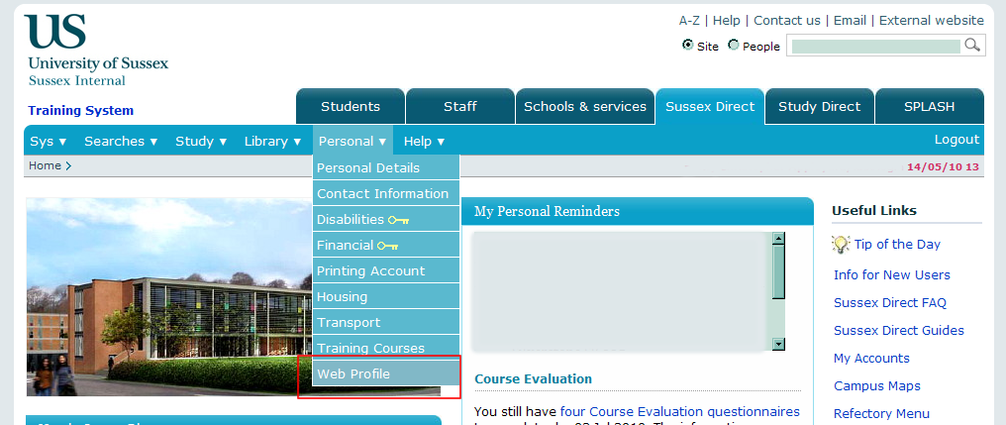

- From your home page, select the Web Profile option from the Personal tab
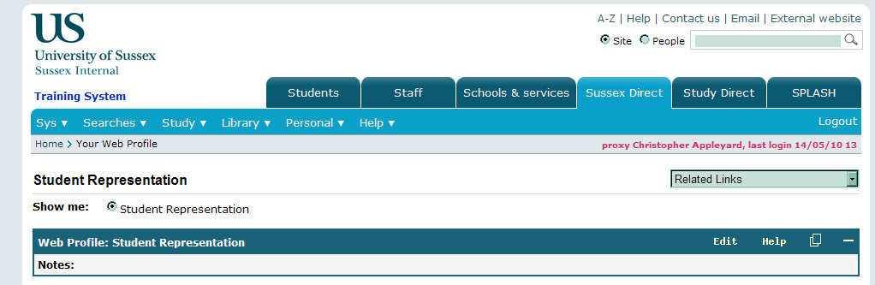
Click to Edit/Enter notes

- Click on the Edit button to enter your notes
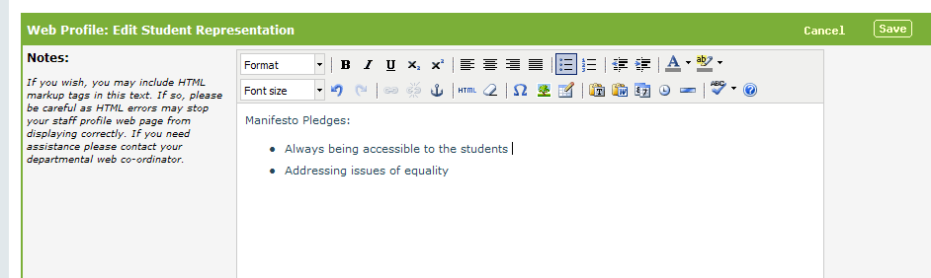

- Once you have entered your notes, click on the ‘Save’ button to commit your changes.

Student Reps: Sussex Direct profile guidance

You can write a short statement of up to 200 words that the students you represent will be able to see when they access your profile. Please say something nice about yourself, keeping it relevant to your role as a Student Rep.. You might like to include your manifesto pledges, details of any regular open meetings you set up to meet with the students you represent, or an outline of the work you have done in your role so far. If you have created a Facebook group for your department, you might want to link to it from here. Remember to refer to the social networking guidelines [ http://www.studentreps.co.uk/emailsoc.aspx ] if you want to do this.

